Data Analysis using scikit-learn

Using the scikit-learn library, I set out to perform data analysis using clustering. To have a better understanding I used two clustering algorithms on a single dataset. The dataset used was iris.

The Iris data set has 5 attributes: sepal length, sepal width, petal length, petal width and species.For the purposes of our clustering, we’ll consider the first four attributes or a subset.

Two clustering algorithms have been chosen:
1. K-means clustering: We partition all our instances into k clusters, by associating them with the nearest of the k means there are. Over several iterations, instances stop changing their associations with the means and start sticking to one mean. That is when we the algorithm comes to an end, unless you’ve specified the number of iterations before hand.

2. mean shift clustering: this algorithm shifts the mean along a shift vector in the direction of maximum density of instances, progressing towards convergence with each shift.

The Code:
k-means:

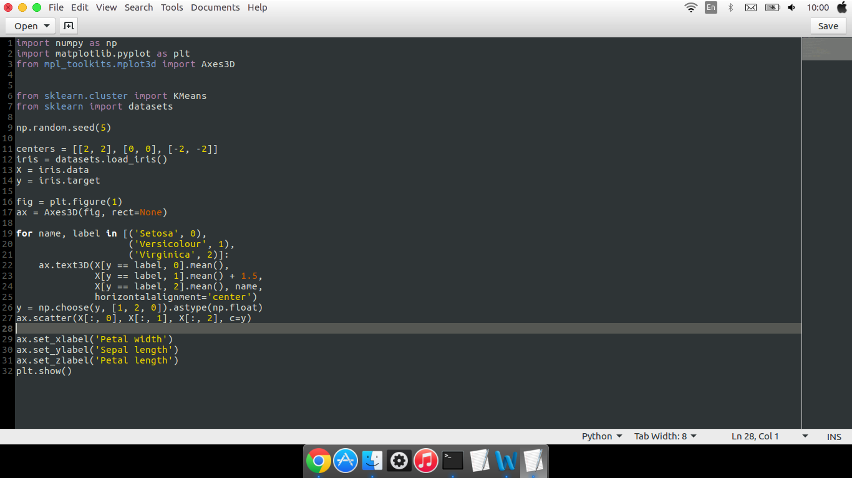

Mean-shift:
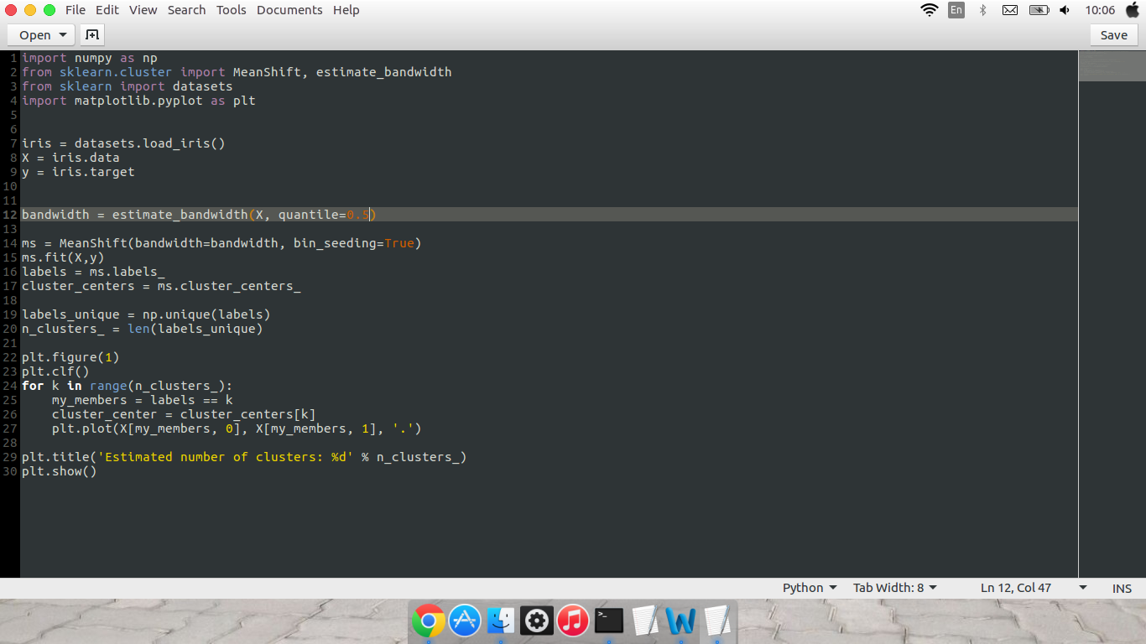

The output:
