**Tribhuvan University**

**Institute of Science and Technology**

A

Final Year Project Report

On

**Human Resource Management System**

Submitted to

Department of Computer Science and Information Technology

**Birendra Memorial College (BMC)**

Dharan, Sunsari

In Partial Fulfilment of the Requirements

For the Bachelor’s Degree in Computer Science and Information Technology

(B.Sc.CSIT)

By

Aastha Bajracharya (21420/075)

Kiran Nepal (21427/075)

Sandesh Adhikari (21437/075)

UNDER THE SUPERVISION OF **MR. AVAY KAFLE**

**Birendra Memorial College (BMC), TU**

**Supervisor’s Recommendation**

I hereby recommend that this project prepared under my supervision by Aastha Bajracharya (21420/075), Kiran Nepal (21427/075) and Sandesh Adhikari (21437/075) entitled "Human Resource Management System" in partial fulfilment of the requirements for the degree of B.Sc. in Computer Science and Information Technology (BSC.CSIT) be proceed for the evaluation.

**Signature**

**Supervisor**

**Mr. Avay Kafle**

**LETTER OF APPROVAL**

This is to certify that the project carried out by Miss Aastha Bajrachraya, Mr. Kiran Nepal and Mr. Sandesh Adhikari entitled “Human Resource Management” in partial fulfilment of the requirements for the degree of B.Sc. in Computer Science and Information Technology has been well studied. In our opinion it is satisfactory in the scope and quality as a project for the required degree.

**Evaluation Committee**

|  |  |
| --- | --- |
| Mr. Abhay Kafle  Project Supervisor  BSC.CSIT  Birendra Memorial College  Dharan, Sunsari  Nepal | Mr. Mukesh Shah  Head of Department  BSC CSIT  Birendra Memorial College  Dharan, Sunsari  Nepal |
| Mr. Bal Krishna Subedi  External Examiner  Central Department  TU  Kathmandu  Nepal |

**ACKNOWLEDGEMENT**

First of all, we would like to show our deepest gratitude and appreciation to our college Birendra Memorial College for providing and accommodating a suitable environment to advance in our project work and complete it successfully. Then, we would also want to show our appreciation to our supervisor, **Mr. Avay Kafle** for administering and providing guidance and also for being an exemplary supervisor one can only hope for throughout our project. Without your assistance, it would have been a very challenging task for us to complete this project. We want to thank our HOD **Mr. Mukesh Shah** for his continuous support and help throughout our project and for managing and accommodating all necessary resources and materials that was required in the project. Lastly, we would like to specially thank and acknowledge our classmates who knowingly or unknowingly were a valuable part in every possible way even if it is in the smallest aspects of the contribution towards the completion of the project.

**ABSTRACT**

The Human Resource Management System (HRMS) is a software suite that provides a complete solution for managing HR processes throughout an employee’s career. This project aims to design and develop an HRMS for a fictitious organization that can be used to manage employee data, attendance, payroll, and performance analysis. The system is designed to be web-based, allowing employees to access their information from anywhere with an internet connection. The project utilizes a range of technologies, including Flutter, Python, Django, MySQL, and APIs. The project also includes testing and result analysis to ensure the system meets the specified requirements. The proposed HRMS will streamline HR processes, boost employee productivity, and improve workplace security by incorporating the latest technology, such as face recognition for attendance monitoring.

**Table of Contents**

**List of Abbreviations** vii

**List of Figures** viii

**List of Tables** x

**Chapter 1: Introduction** 1

**1.1** **Introduction** 1

**1.2** **Problem Statement** 1

**1.3** **Objectives** 2

**1.4** **Scope and Limitation** 2

**1.5** **Development Methodology** 3

**1.6** **Report Organization** 3

**Chapter 2: Background Study and Literature Review** 5

**2.1** **Background Study** 5

**2.2** **Literature Review** 6

**Chapter 3: System Analysis** 8

**3.1** **System Analysis** 8

**3.1.1** **Requirement Analysis** 8

**3.1.2** **Feasibility Analysis** 12

**3.1.3** **Analysis** 14

**Chapter 4: System Design** 15

**4.1** **Design** 15

**4.2** **Algorithm Details** 28

**Chapter 5: Implementation and Testing** 29

**5.1** **Implementation** 29

**5.1.1** **Tools Used** 29

**5.1.2** **Implementation Details of Modules** 31

**5.2** **Testing** 32

**5.2.1** **Test Cases for Unit Testing** 32

**5.2.2** **Test Cases for System Testing** 33

**5.3** **Result Analysis** 33

**Chapter 6: Conclusion and Future Recommendations** 35

**6.1** **Conclusion:** 35

**6.2** **Future Recommendations** 35

**References** 36

**Appendix** 38

## **List of Abbreviations**

API Application Programming Interface

eHRM electronic Human Resource Management

HR Human Resource

HRIS Human Resource Information Sysytem

HRMS Human Resource Management System

SDLC Software Development Life Cycle

UML Unified Modelling Language

## **List of Figures**

Figure 1: Agile Development Life Cycle 3

Figure 2: HRMS Use Case Diagram 9

Figure 3: HRMS Class Diagram 16

Figure 4: HRMS State Diagram 17

Figure 5: Employee Registration with Face Recognition Sequence Diagram 18

Figure 6: Attendance with Face Recognition Sequence Diagram 19

Figure 7: Admin Payroll Management Sequence Diagram 20

Figure 8: Admin Employee Management Sequence Diagram 21

Figure 9: Admin Leave Management Sequence Diagram 22

Figure 10: Employee View Payroll, Timesheet, Designation and Employee Information Sequence Diagram 23

Figure 11: Employee Apply for Leave Sequence Diagram 24

Figure 12: HRMS Activity Diagram 25

Figure 13: HRMS Component Diagram 26

Figure 14: HRMS Deployment Diagram 27

Figure 15: HRMS Admin Panel 38

Figure 16: Taking attendance using Face Recognizing 38

Figure 17: Employee Registration 39

Figure 18: Pay Roll Calculation 39

Figure 19: Application Handling 40

Figure 20: Code for Face Recognition 40

Figure 21: Employee Mobile app Login Interface 41

Figure 22: Employee Mobile App Home Interface 41

Figure 23: Employee Mobile App Application Interface 42

Figure 24: Employee Mobile App Settings Interface 42

Figure 25: LIst of APIs 43

## **List of Tables**

Table 1: Unit Testing Test Case 1 32

Table 2: Unit Testing Test Case 2 33

# **Chapter 1: Introduction**

## **Introduction**

The efficient management of human resources is critical for any organization to achieve its goals and objectives. In today's fast-paced business environment, organizations must leverage technology to optimize HR operations and improve employee productivity. Human Resource Management System (HRMS) is a suite of software programs that offers a comprehensive solution to manage human resources and associated procedures throughout an employee's career.

One of the latest advancements in HRMS is the development of web-oriented software applications, commonly known as electronic HRM (eHRM). eHRM streamlines HR processes by consolidating data and automating manual and repetitive tasks such as employee information management, attendance monitoring, payroll management, and performance analysis. It also incorporates the latest technology, including face recognition, which enables efficient attendance monitoring and improves workplace security.

Recent studies have shown that organizations that implement eHRM systems have experienced significant improvements in workforce management, operational efficiency, and employee productivity [1][2]. By leveraging the power of eHRM, organizations can streamline their HR operations, reduce administrative overhead, and make data-driven decisions that support their long-term strategic goals.

## **Problem Statement**

The effective management of human resources plays a crucial role in achieving organizational goals and objectives. However, without proper HRMS software, organizations may face challenges such as inefficiencies, lack of data insights, and poor employee experience [3]. Outdated HRMS software may also pose problems related to data security, handling large amounts of data, and slow processing time [4]. These issues can hinder an organization's ability to focus on strategic aspects of HR management, such as talent acquisition and alignment of employee objectives with business goals. Therefore, there is a need for an automated HRMS platform that can streamline HR processes and provide a centralized system for managing employees and accessing data, thus promoting transparency and cooperation between employers and employees. This project aims to provide such a solution to organizations, utilizing face recognition technology for accurate attendance monitoring and promoting efficient HR management.

## **Objectives**

* To help the organization to mark the attendance of the employee automatically by keeping records of timestamps when the employee enters the premise with the use of Face Recognition Technology.
* To help businesses manage and store employee data in a centralized location, making it easier to access and analyze data for reporting and decision-making purposes.

## **Scope and Limitation**

The scope of this HRMS project is to develop a web-based system that automates HR processes, including attendance management, employee data management, and performance analysis. The system will use Face Recognition Technology to mark employee attendance automatically, thereby reducing the manual effort required to track employee attendance. The centralized database will enable the system to manage and store employee data, making it easier to access and analyze for reporting and decision-making purposes. The system will also track and assess employee development and performance.

However, this project has some limitations. Some of the limitations of the project are listed below:

* The system will not be able to detect attendance for employees who are not present on the premises, such as employees working from home or on business trips.
* The HRMS system will be developed for a specific organization and may not be easily scalable to other businesses with different requirements.
* The effectiveness of the face recognition technology for attendance tracking may be affected by factors such as lighting conditions and camera placement.
* The accuracy of the performance evaluation system may be influenced by subjective factors such as evaluator bias.
* The project will not cover every possible HR function, and some tasks may still require manual intervention or third-party tools.

## **Development Methodology**

After examining the nature of our project and conducting some research, for the development of the HRMS project, the Agile methodology is followed. Agile Software Development approach consists of six phases: plan, design, develop, test, release, and feedback. Agile methodology is a flexible and iterative approach that focuses on customer satisfaction and allows for continuous improvement throughout the project lifecycle [5]. The Agile methodology is based on the principles of frequent communication, collaboration, and continuous testing and integration [6].

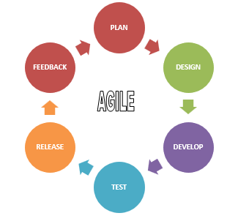

Figure 1: Agile Development Life Cycle

## **Report Organization**

This report is structured to provide a comprehensive overview of the HRMS project. The report begins with an introduction, which provides a background on the project and identifies the problem statement. This is followed by a section on the objectives of the project, which outlines the goals and outcomes that the project aims to achieve.

The development methodology used in the project is described in detail in the subsequent section. This section provides an overview of the Agile methodology used and the rationale behind its selection. The report then moves on to discuss the scope and limitations of the project, outlining the boundaries within which the project operates. The implementation of the HRMS system is described in the following section. This section provides a detailed account of the system's functionality, including the features and tools that were used in its development. The report concludes with a section on the project's results, which presents the outcomes of the project and assesses its effectiveness in meeting its objectives.

Overall, this report is organized in a manner that is easy to follow and understand. It provides a clear and concise overview of the project and its various components, making it a valuable resource for those interested in HRMS systems and their implementation.

# **Chapter 2: Background Study and Literature Review**

## **Background Study**

The HRMS project aims to develop a system for managing employee data and attendance using face recognition technology. To understand the theoretical foundations of this project, it is important to review the concepts and terminologies related to HRMS systems.

One important concept is the role of human resources in organizations. HR is responsible for managing the organization's workforce and ensuring that the right people are in the right roles to achieve the organization's goals. HRMS systems provide a tool for managing employee data and attendance, which is a critical aspect of HR management.

Another key concept is the use of biometric technologies, such as face recognition, for authentication and identification purposes. Face recognition technology uses algorithms to match an individual's facial features with a database of known faces, allowing for automated identification and authentication. This technology has become increasingly popular in recent years and has been applied in various fields, including security and access control.

The use of Agile methodology in software development is another important concept relevant to the HRMS project. Agile methodology emphasizes flexibility, collaboration, and continuous improvement, allowing for the project to adapt to changing requirements and ensuring that the final product meets the stakeholders' needs [6].

Finally, it is important to consider the potential ethical and legal implications of implementing a system that uses biometric data. The collection, storage, and use of biometric data are subject to various laws and regulations, and organizations must ensure that they comply with these laws and protect the privacy and security of their employees' data [7].Top of Form

## **Literature Review**

Several studies have been conducted on HRMS systems, providing valuable insights into their design, development, and implementation. The implementation of electronic human resource management (eHRM) systems has been extensively studied for its impact on organizational performance. In this section, we review some of the key studies in this area.

Al-Hmouze [1] investigated the relationship between eHRM application and organizational performance and found a significant positive correlation. Similarly, Hosain [2] found a positive relationship between eHRM and organizational performance in the service sector of Bangladesh.

Bondarouk and Ruël [3] studied the challenges associated with the implementation of eHRM systems and emphasized the need for organizations to align their HR strategy with eHRM systems to achieve optimal benefits. Varadaraj and Al Wadi [4] investigated the impact of digital HRM on organizational performance and found that it positively influenced employee satisfaction, retention, and productivity.

Studies have also explored the use of biometric technology in HRMS. Li et al. [5] found that biometrics was effective in reducing time and attendance-related issues. Tanwar et al. [6] stressed the ethical, legal, and social implications of biometric technology and highlighted the need for organizations to address these concerns.

Abdullah et al. [7] investigated the use of cloud computing in HRM systems and found that it improved efficiency and reduced costs. Guru et al. [8] focused on HR analytics and its role in predictive decision-making for competitive advantage.

Zafar [9] highlighted the information security concerns associated with HRIS and emphasized the need for organizations to implement security measures to protect their data. Almutawa et al. [10] investigated the effect of HRMS on employee commitment and found that it positively influenced employee commitment.

Regarding software engineering practices, Pfleeger and Atlee [11] and Pressman [12] provide a comprehensive overview of software engineering principles and practices that can be applied in the development of HRMS. These include requirements engineering, software design, testing, and maintenance.

In conclusion, the literature suggests that eHRM systems, biometric technology, cloud computing, HR analytics, and HRMS can significantly impact organizational performance. However, ethical, legal, and social implications as well as information security concerns must be addressed. Organizations must also align their HR strategy with the implementation of HRMS and apply software engineering principles and practices to develop and maintain these systems. These studies provide valuable insights into the design, development, and implementation of HRMS systems, highlighting their potential to improve organizational performance and employee engagement while also addressing important issues such as data security and privacy.

# **Chapter 3: System Analysis**

## **System Analysis**

In the context of the HRMS project, systems analysis is a crucial step in the development process. It involves the study of the HRMS system to identify the requirements, model the system, and choose a logical alternative that meets the needs of the stakeholders. Systems analysis projects can be initiated for various reasons, including addressing problems, identifying opportunities, and following directives [14]. The key stakeholders involved in systems analysis for the HRMS project are the systems analysts, sponsors, and users. The systems analysts are responsible for studying the system and identifying its requirements, while the sponsors provide the necessary resources and support to the project. The users, on the other hand, provide feedback on the system's functionality and help ensure that it meets their needs [15].

### **Requirement Analysis**

The requirement analysis phase is a critical step in the HRMS project, as it involves identifying and defining the functional and non-functional requirements of the system.

**Functional Requirements:**

Functional requirements are a set of features and capabilities that a software system must have to perform the desired functions and operations. The functional requirements of the HRMS are defined in this section of the analysis phase, including the various functionalities that the system should have to manage employee information, attendance, payroll, and other HR-related tasks. These requirements are based on the stakeholders' needs and expectations and are used to develop the HRMS software.

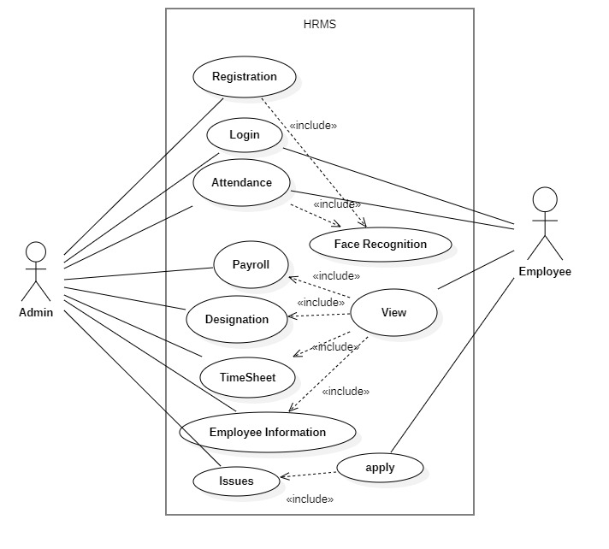

Figure 2: HRMS Use Case Diagram

Based on the use case diagram for the HRMS project, here are the functional requirements (use case descriptions) for each use case:

1. **Registration:**

The system should allow an admin to register new employees and verify their identity through face recognition. Basic employee information, such as their name, contact details, and job title, should be captured during the registration process.

1. **Login:**

The system should allow employees and admins to log in to the HRMS using a username and password or facial recognition.

1. **Attendance:**

The system should allow employees and admins to record employee attendance, with facial recognition used to ensure the correct employee is logging in.

1. **Payroll:**

The system should enable admins to manage employee salaries and compensation. It should be capable of calculating employee salaries based on their working hours and compensation packages.

1. **Designation:**

The system should allow admins to manage employee job titles and responsibilities, including creating new job titles and descriptions and assigning them to employees.

1. **TimeSheet:**

The system should allow employees to record their time spent on different tasks, enabling them to track their productivity and performance.

1. **Employee Information:**

The system should enable admins to manage employee information, including their contact details, performance, and attendance records. The system should allow for the viewing and updating of employee information as required.

1. **Issues:**

The system should allow employees to report workplace issues or problems, with the ability to create a new issue report and track its status until resolution.

1. **Face Recognition:**

The system should enable admins and employees to use facial recognition to log in to the system, record attendance, and register new employees. The system should be able to recognize the faces of registered employees and deny access to unauthorized individuals.

1. **View:**

The system should allow employees and admins to view various aspects of employee information, such as payroll, designation, timesheets, and employee information, in a user-friendly and organized manner.

1. **Apply:**

The system should enable employees to apply for various things, such as leave, promotions, or salary adjustments. The system should allow for the creation of a new application and the ability to track its status until approval or denial.

**Non-Functional Requirements:**

Non-functional requirements specify criteria that can be used to evaluate the operation of a system, and include attributes such as security, reliability, performance, maintainability, scalability, and usability. In the HRMS project, several non-functional requirements have been identified, including accessibility, maintainability, scalability, and portability.

1. **Accessibility:**

Accessibility refers to the degree to which a product, device, service, or environment is accessible to as many people as possible. As a web-based application, any user can access the HRMS system, making it highly accessible.

1. **Maintainability:**

Maintainability, defined as the degree to which an application is understood, repaired, or enhanced, is another important non-functional requirement. In the HRMS project, new functionalities can be added based on user requirements, and the code is simple and well-organized, making it easy to locate and correct defects or make changes.

1. **Scalability:**

Scalability is also a crucial non-functional requirement, as it ensures that the system can handle an increased load and throughput under varying conditions. The HRMS system is designed to function normally under low bandwidth and with a large number of users.

1. **Portability:**

Portability, or the ability to reuse existing code when moving software from one environment to another, is another important non-functional requirement in the HRMS project. The project can be executed under different operating conditions as long as it meets the minimum configuration requirements, with only system files and dependent assemblies needing to be configured in such cases.

### **Feasibility Analysis**

Feasibility studies aim to uncover the strengths and weaknesses of an existing or proposed system, opportunities and threats objectively and rationally as presented by the environment, the resources required to carry through and ultimately the prospects for success. In the case of the HRMS project, a feasibility analysis was conducted to assess the viability of the proposed system. This analysis considered several key considerations, including economical, technical, operational, and schedule feasibility.

1. **Technical:**

Technical feasibility is another critical consideration in the feasibility analysis, as it assesses the ability of the proposed system to be developed using existing technology. In the case of the HRMS project, the technical feasibility was determined by assessing the availability of necessary hardware, software, and infrastructure, as well as the expertise required to implement the system.

1. **Operational:**

Operational feasibility is also an important consideration, as it determines whether the proposed system can be integrated with the existing business processes and culture. In the case of the HRMS project, the operational feasibility was determined by assessing the readiness of the company's employees to adopt the new system, as well as the potential impact on existing business processes.

1. **Economic:**

Economic feasibility is an important aspect of the feasibility analysis, as it involves determining whether the proposed system is financially viable. In the case of the HRMS project, cost estimates were developed to determine the resources required to carry out the project, and to ensure that it would not place an undue burden on the company's finances.

1. **Schedule:**

Schedule feasibility was assessed to determine whether the proposed system could be developed within a reasonable timeframe. To ensure the success of the project, it will be necessary to carefully plan and manage the project to ensure that it stays on track and is completed within the desired timeframe. This may involve setting clear goals and objectives, establishing a project plan and timeline, and regularly monitoring progress to identify and address any potential issues or delays. By carefully managing the project, the organization can increase the likelihood of successfully delivering the project within the desired timeframe and achieving its desired outcomes. In the case of the HRMS project, a timeline was developed to ensure that the project could be completed within a six months timeframe.

### **Analysis**

Analysis is a critical stage in the software development life cycle in which the system's requirements are gathered, analysed, and documented. This stage necessitates a thorough understanding of the user's requirements, the existing system, and the problem domain. The goal of analysis is to identify the problem, its underlying cause, and potential solutions.

An object-oriented approach is followed in the analysis phase of the HRMS project because it provides a better understanding of the system's real-world objects and their relationships, making it easier to model and design software solutions. Object-oriented analysis allows us to identify the system's objects, their attributes, and their relationships, leading to a better understanding of the system's requirements and behaviour. Additionally, it facilitates the development of reusable and maintainable software components, which can result in cost savings and faster development times. Overall, an object-oriented approach is more suited for complex and long-term projects such as HRMS, where maintainability, scalability, and extensibility are essential requirements.

# **Chapter 4: System Design**

## **Design**

The system specifications from the analysis phase are transformed into a more detailed and structured representation of the system during the design phase. This phase's goal is to create a design that meets the functional and non-functional requirements while also being feasible to implement. Depending on the approach used in the analysis phase, the design is object-oriented. The class, state, sequence, and activity diagrams, as well as component and deployment diagrams, are the main deliverables of this phase.

**Class and Object Diagram:**

A class diagram is a type of static structure diagram that represents the structure of a system by showing the classes of objects, their attributes, and the relationships between them. It is a crucial tool for object-oriented design and development, as it helps to visualize the relationships and dependencies between classes and objects in a system.

In object-oriented programming, an object is an instance of a class. A class is a blueprint or template that defines the attributes and behaviours that objects of that class should have. When we create an object, we are creating a specific instance of that class, with its own set of values for its attributes. We can create many objects from the same class, and each object will have its own unique set of attribute values.

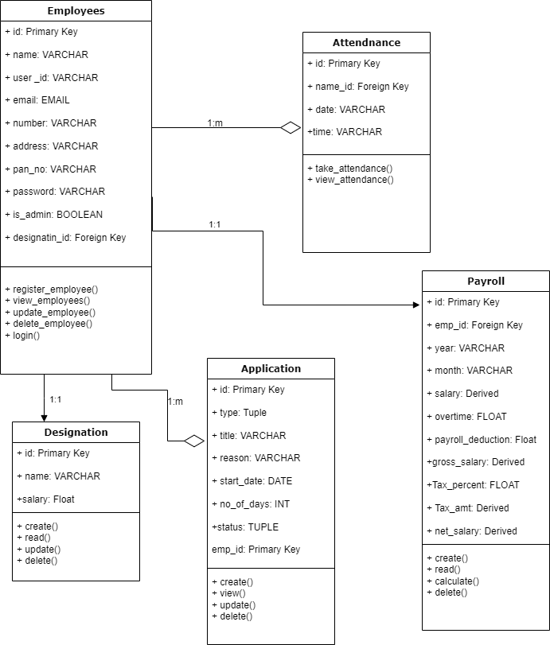

Figure 3: HRMS Class Diagram

For our HRMS project, the class diagram includes classes such as Employees, Payroll, Attendance, Designation, and Application. The attributes of these classes would include things like user_id, name, address, salary, is_admin, and so on. The attributes of these classes would include things like register_employee(), take_attendance(), calculate(), and so on.

**State Diagram:**

A state diagram represents the various states that an object can be in and the transitions between those states. In our HRMS project, we can create state diagrams for the employee object, representing the various states that an employee can be in, such as "active", "on leave", "terminated", etc.

Figure 4: HRMS State Diagram

**Sequence Diagrams:**

A sequence diagram shows the sequence of interactions between objects in a system. We can create sequence diagrams for various use cases in our HRMS project, such as the employee registration process, attendance management, payroll management, etc. These diagrams help to visualize the flow of actions and the objects involved in each use case.

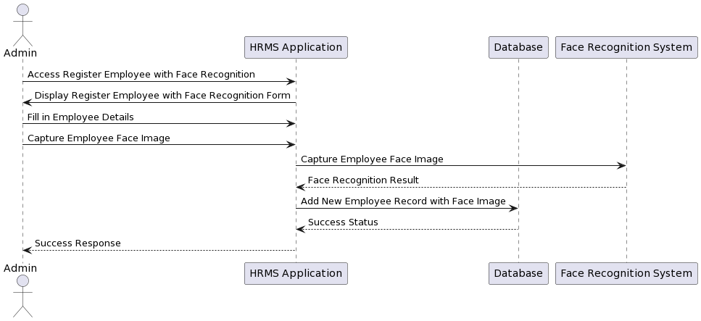

Figure 5: Employee Registration with Face Recognition Sequence Diagram

Figure 5 sequence diagram represents the process of registering an employee with face recognition technology in the HRMS application. The admin accesses the registration form, fills in the employee details, and captures the employee's face image. The HRMS application then uses the face recognition system to capture the employee's face image, and if successful, adds a new employee record with the face image to the database and responds with a success message to the admin.

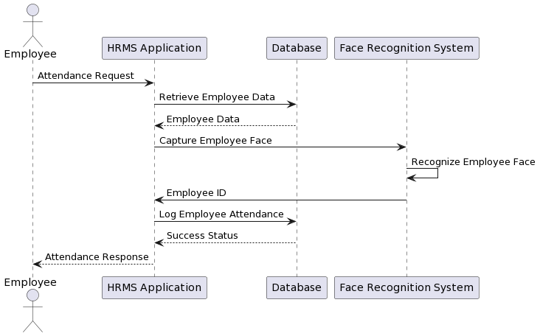

Figure 6: Attendance with Face Recognition Sequence Diagram

Figure 6 sequence diagram represents the process of employee attendance with the use of Face Recognition System. The employee sends an attendance request to the HRMS Application. The HRMS retrieves the employee's data from the database and sends a request to the Face Recognition System to capture the employee's face. The Face Recognition System recognizes the employee's face and sends back the employee's ID to the HRMS, which logs the employee's attendance in the database and sends a success response to the employee.

Figure 7 sequence diagram shows the flow of events in the admin payroll management process. The admin logs in to the HRMS application and accesses the payroll module. The application retrieves employee data from the database and displays a list of employees to the Admin. The admin selects an employee, and the application retrieves their salary details from the database and displays them to the Admin. The admin can then update the employee's salary details, generate payroll, and approve payroll. The application retrieves employee salary details from the database and displays them to the admin for approval. The approved payroll is then updated in the database and the admin receives an approval response from the application.

Figure 7: Admin Payroll Management Sequence Diagram

Figure 8: Admin Employee Management Sequence Diagram

Figure 9: Admin Leave Management Sequence Diagram

Figure 10: Employee View Payroll, Timesheet, Designation and Employee Information Sequence Diagram

Figure 11: Employee Apply for Leave Sequence Diagram

**Activity Diagram:**

The flow of activities or tasks in a system or process is represented by an activity diagram. Activity diagrams can be used in the HRMS project to depict processes such as employee onboarding, payroll processing, attendance management, and leave management. They can assist in visualizing the steps involved in each process as well as the conditions that govern the flow of activities. Developers and stakeholders can use these diagrams to understand the system's logic and identify areas for optimization and improvement.

Figure 12: HRMS Activity Diagram

**Component Diagram:**

Component diagrams in software engineering are used to describe the high-level structure of a system and the components that make up that system. In a component diagram, components are represented as rectangles with dependency depicted as lines connecting them. This diagram helps to illustrate the dependencies between the different components in the system and the interactions between them. In our HRMS project, the component diagram can be used to represent the different components that make up the HRMS application, such as the Login Access, payroll management, leave management, system database component, and so on.

Figure 13: HRMS Component Diagram

**Deployment Diagram:**

A deployment diagram in software engineering illustrates the physical deployment of software artifacts to nodes. It shows the configuration of run-time processing nodes and the components that live on them. In the context of HRMS, the deployment diagram shows the software components are deployed on hardware and network infrastructure. It provides an overview of the physical hardware used, network topology, and the software components deployed on each node.

Figure 14: HRMS Deployment Diagram

## **Algorithm Details**

The Local Binary Pattern Histogram (LBPH) algorithm is a widely used method for facial recognition [16]. The LBPH algorithm extracts local features from an image by dividing it into small regions and computing the local binary pattern (LBP) for each pixel in the region [16][17]. The LBP is a binary code that represents the relationship between the gray values of a central pixel and its neighbouring pixels.

The LBPH algorithm then constructs a histogram of the LBP codes for each region and concatenates the histograms to form a feature vector that represents the entire image [16][17]. The feature vector is then used to compare the image to a database of known images to determine if there is a match.

One advantage of the LBPH algorithm is its simplicity and computational efficiency, which make it well-suited for real-time applications [16]. However, it may not perform as well as more complex algorithms on large datasets or in situations with significant variation in lighting or facial expressions [17].

# **Chapter 5: Implementation and Testing**

## **Implementation**

Software implementation is the process of introducing new software into an organization's workflow, which involves complex tasks such as planning, designing, coding, and building the project. The implementation phase is the final step of the software development lifecycle and requires careful planning and execution to ensure a smooth transition from development status to production status.

### **Tools Used**

The development of the HRMS project involved the extensive use of various tools to enhance the efficiency and effectiveness of the development process. The tools used in this project are listed below along with a brief description of their functionalities.

1. **Flutter:**

Flutter is an open-source mobile application development framework that allows developers to create high-performance, visually attractive mobile apps for Android and iOS platforms using a single codebase. It offers widgets, frameworks, and tools for building beautiful and fast apps.

1. **Python:**

Python is a high-level, general-purpose programming language that offers excellent readability and ease of use. It is widely used for web development, data analysis, artificial intelligence, and scientific computing. Python offers a vast collection of libraries and frameworks that make it a popular choice among developers.

1. **Django:**

Django is a high-level Python web framework that allows developers to build complex web applications quickly and easily. It provides a robust set of tools and libraries that handle various aspects of web development, including URL routing, authentication, and database modelling.

1. **MySQL:**

MySQL is a popular open-source relational database management system that is widely used for web applications. It is a fast, reliable, and scalable database that offers excellent security and data management capabilities.

1. **APIs:**

APIs (Application Programming Interfaces) are a set of protocols and standards that allow different software applications to communicate with each other. In the HRMS project, APIs were used to integrate different modules and components of the system, enabling seamless data transfer and processing.

1. **StarUML:**

StarUML is a powerful UML modelling tool that allows developers to create diagrams, models, and documentation for software systems. It provides support for various diagram types, including class, sequence, use case, and activity diagrams.

1. **Draw.io:**

Draw.io is an open-source online diagramming tool that allows developers to create various types of diagrams, including flowcharts, network diagrams, and UML diagrams. It provides a simple and intuitive interface that makes it easy to create professional-looking diagrams.

1. **PlantUML:**

PlantUML is a well-known open-source tool for creating various types of UML diagrams, such as class diagrams, sequence diagrams, activity diagrams, and others. It generates diagrams using a simple, text-based syntax, making it simple to learn and use for both technical and non-technical users. PlantUML has been used in a wide range of software engineering projects, as well as in research and education.

1. **Office 365:**

Office 365 is a suite of cloud-based productivity tools that include Word, Excel, PowerPoint, and other tools. It provides features such as real-time collaboration, cloud storage, and integration with other tools and services.

### **Implementation Details of Modules**

The implementation of the HRMS project involved the development of various modules, each with its specific functionality. The following are the implementation details of the main modules:

1. **Employee Management Module:**

This module manages the employee's personal information, including name, contact details, address, and job-related details such as salary, position, and department. The module includes the following functions: add employee, view employee, update employee, and delete employee.

1. **Attendance Management Module:**

This module handles the attendance of the employees. It has functions to record attendance, view attendance, and generate attendance reports.

1. **Leave Management Module:**

The leave management module handles employee leave applications and approvals. The module includes functions to apply for leave, view leave history, approve or reject leave applications, and generate leave reports.

1. **Performance Management Module:**

This module evaluates the employee's performance based on various criteria such as productivity, punctuality, and quality of work. It includes functions to set performance goals, evaluate performance, and generate performance reports.

1. **Payroll Management Module:**

The payroll management module handles the calculation of salaries and other financial benefits such as bonuses, taxes, and deductions. The module includes functions to calculate payroll, generate payslips, and generate payroll reports.

## **Testing**

Software Testing is the process of evaluating a software system or application to identify defects, errors, or vulnerabilities. It involves executing software programs or application with the aim of finding bugs and verifying whether the software meets the intended specifications and requirements. Software Testing comprises Verification and Validation.[18]

### **Test Cases for Unit Testing**

Unit testing is a software development process in which smallest parts of an application, called units, are individually tested for proper operation. The main objective of unit testing is to ensure that each individual part is working well as it is supposed to work. The entire system will only be able to work if the units are working well. [19]

After the completion of the HRMS project till this phase, unit testing is conducted, this involves testing individual components or modules such as employee management, attendance tracking, payroll processing, etc.

Here is a unit testing scenario for the employee management module:

Table 1: Unit Testing Test Case 1

|  |  |  |  |
| --- | --- | --- | --- |
| Test Case1 | Input | Output | Test Result |
| Employee ID  Input | Employee ID - 123 | Employee details such as name, designation, department, etc. | The employee details were displayed correctly. |

Table 2: Unit Testing Test Case 2

|  |  |  |  |
| --- | --- | --- | --- |
| TestCase2 | Input | Output | Test Result |
| Payroll Processing Error Handling | Invalid input such as negative salary or invalid employee ID | Error message indicating the issue with the input | The system correctly displayed an error message when invalid input was provided. |

### **Test Cases for System Testing**

After the successful completion of unit testing, the system as a whole was tested to ensure whether the developed system was working well, and that the system meets its requirements or not. The test results were positive which means that the system was working perfectly fine and has met the system requirements which were analyzed during the analysis and requirement phase.

## **Result Analysis**

During unit testing, each module or component of our project was tested independently to ensure that it is functioning as expected. The results of each test case were recorded in a table, and any issues or defects were identified and addressed before moving on to system testing.

System testing involves testing the entire system as a whole to ensure that all the individual components are integrated correctly and working together to meet the system requirements.

Overall, the combination of unit testing and system testing provided confidence in the quality and functionality of the HRMS system. The system was able to handle different inputs, produce expected outputs, and meet the requirements specified by the stakeholders. Any issues or defects were identified and resolved before deployment, ensuring the smooth operation of the HRMS system.

# **Chapter 6: Conclusion and Future Recommendations**

## **Conclusion:**

The HRMS project has the potential to significantly improve the efficiency and effectiveness of the company's HR processes. The feasibility analysis showed that the project is economically, technically, operationally, and schedule feasible, and the implementation phase was completed successfully. The system was tested and evaluated, and it met the requirements and expectations of the stakeholders. The project team worked closely with the end-users to ensure that the system was user-friendly and intuitive.

## **Future Recommendations**

While the HRMS project has shown promise in improving the HR functions of the organization, there are several limitations that should be addressed in future recommendations.

• The system should be further developed to accommodate remote workers and those on business trips, as the current system is limited to tracking attendance of employees on the premises.

• The HRMS system should be designed with scalability in mind, to ensure that it can be easily adapted for use by other businesses with different requirements.

• The system could be integrated with other organizational systems, such as finance and accounting, to further streamline processes and reduce duplication of effort.

• The subjective nature of the performance evaluation system should also be addressed, by incorporating multiple evaluators and implementing measures to prevent evaluator bias.

• Future recommendations should explore the possibility of expanding the project to cover additional HR functions and automating more tasks, to reduce the need for manual intervention or third-party tools.

## **References**

[1] L. H. Al-Hmouze, “The impact of electronic human resource management (E-HRM) application on organizational performance,” Middle East University, 2016. [Online]. Available: http://meu.edu.jo/

[2] S. Hosain, “The Impact of E-HRM on Organizational Performance: Evidence from Selective Service Sectors of Bangladesh,” International Journal of Human Resources Management (IJHRM), vol. 6, no. 3, pp. 1-14, Apr-May 2017.

[3] T. V. Bondarouk and H. J. M. Ruël, “Electronic Human Resource Management: challenges in the digital era,” International Journal of Human Resource Management, vol. 20, no. 3, pp. 505-514, Mar. 2009.

[4] A. Varadaraj and B. M. Al Wadi, “A Study on Contribution of Digital Human Resource Management towards Organizational Performance,” International Journal of Management Science and Business Administration, vol. 7, no. 5, pp. 43-51, Jul. 2021.

[5] M. Cohn, Agile Estimating and Planning, Upper Saddle River, NJ: Prentice Hall, 2005.

[6] K. Schwaber, Agile Project Management with Scrum, Redmond, WA: Microsoft Press, 2004.

[7] S. Tanwar, S. Tyagi, N. Kumar and M. S. Obaidat, “Ethical, legal, and social implications of biometric technologies,” in Biometric-based physical and cybersecurity systems, 2019, pp. 535-569.

[8] M. Irfan, N. Khurshid, J. Khurshid and A. M. Khokhar, “Human resource development and organisational performance: Evidence from Pakistan,” SA Journal of Human Resource Management, vol. 21, 2023. [Online]. Available: https://doi.org/10.4102/sajhrm.v21i0.2020

[9] Z. Almutawa, N. Muenjohn and J. Zhang, “The effect of human resource management system on employees’ commitment,” The Journal of Developing Areas, vol. 50, no. 6, pp. 17-29, 2016.

 [10] Li, Tsai-Cheng, Huan-Wen Wu, and Tiz-Shiang Wu. “The study of biometrics technology applied in attendance management system.” In 2012 Third International Conference on Digital Manufacturing & Automation, pp. 943-947. IEEE, 2012.

[11] P. Y. Abdullah et al., “HRM system using cloud computing for Small and Medium Enterprises (SMEs),” Technology Reports of Kansai University, vol. 62, no. 04, pp. 1977-1987, 2020.

[12] Guru, K., S. Raja, A. Umadevi, M. Ashok, and Kumar Ramasamy. "Modern approaches in HR analytics towards predictive decision-making for competitive advantage." In Artificial Intelligence, Machine Learning, and Data Science Technologies, pp. 249-267. CRC Press, 2021.

[13] H. Zafar, “Human resource information systems: Information security concerns for organizations,” Human Resource Management Review, vol. 23, no. 1, pp. 105-113, 2013

[14] G. F. Pfleeger and J. L. Atlee, Software Engineering: Theory and Practice, 4th ed. Upper Saddle River, NJ: Pearson Education, Inc., 2010.

[15] R. S. Pressman, Software Engineering: A Practitioner's Approach, 8th ed. New York, NY: McGraw-Hill, 2015.

[16] X. Zhao and C. Wei, “A real-time face recognition system based on the improved LBPH algorithm,” 2017 IEEE 2nd International Conference on Signal and Image Processing (ICSIP), Beijing, 2017, pp. 72-76.

[17] Section.io Engineering Education, “Understanding Facial Recognition Using Local Binary Pattern Histogram Algorithm,” [Online]. Available: https://www.section.io/engineering-education/understanding-facial-recognition-using-local-binary-pattern-histogram-algorithm/.

[18] T. Hamilton, “Software Testing Tutorial,” Guru99, 28-Jan-2023. [Online]. Available: https://www.guru99.com/software-testing.html.

[19] "Unit testing," Software testing, Jun. 16, 2021. [Online]. Available: https://www.softwaretestinghelp.com/unit-testing-tutorial/.

## **Appendix**

Appendix A

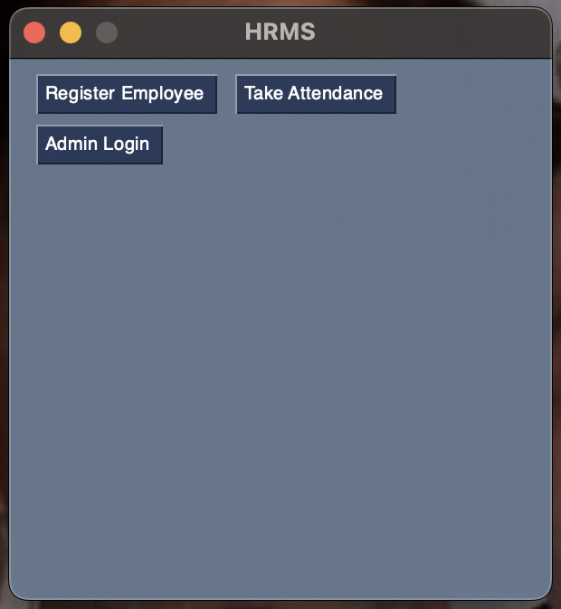

Figure 15: HRMS Admin Panel

Appendix B

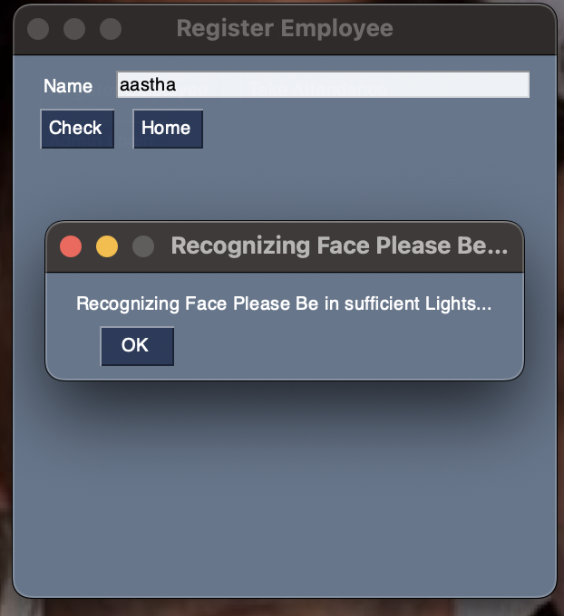

Figure 16: Taking attendance using Face Recognizing

Appendix C

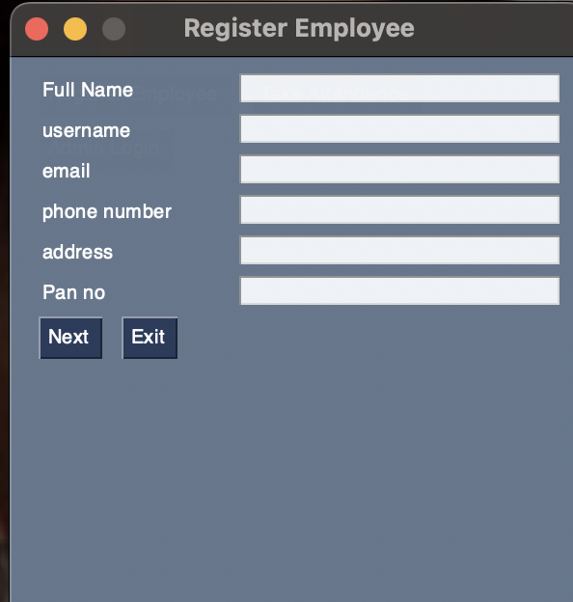

Figure 17: Employee Registration

Appendix D

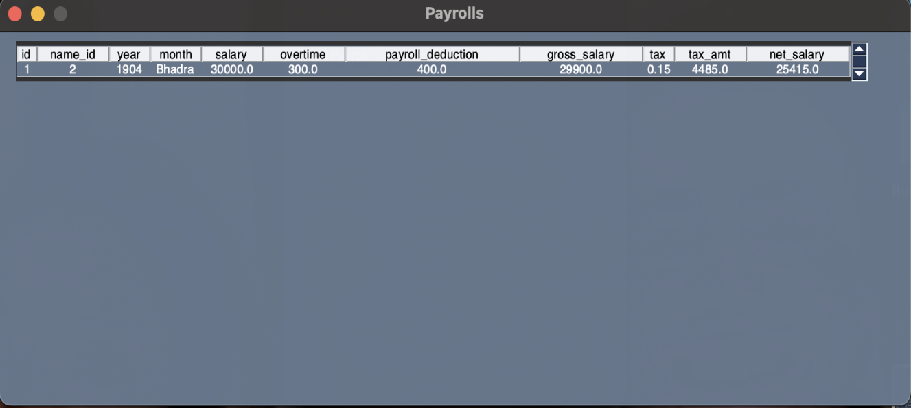

Figure 18: Pay Roll Calculation

Appendix E

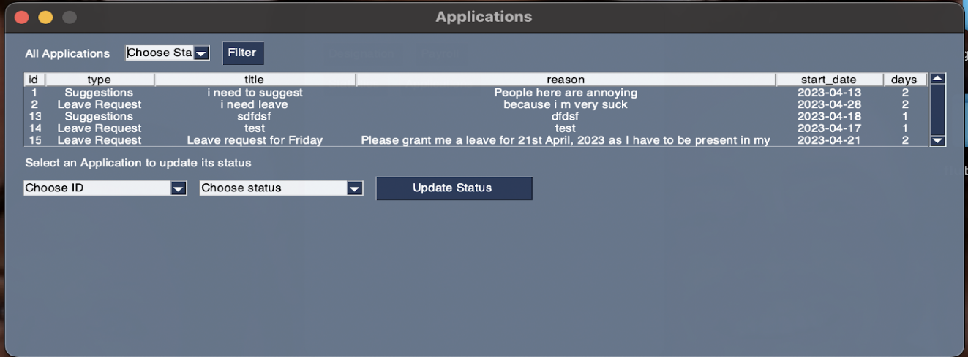

Figure 19: Application Handling

Appendix F

Figure 20: Code for Face Recognition

Appendix G



Figure 21: Employee Mobile app Login Interface

Appendix H

Figure 22: Employee Mobile App Home Interface

Appendix I

Figure 23: Employee Mobile App Application Interface

Appendix J

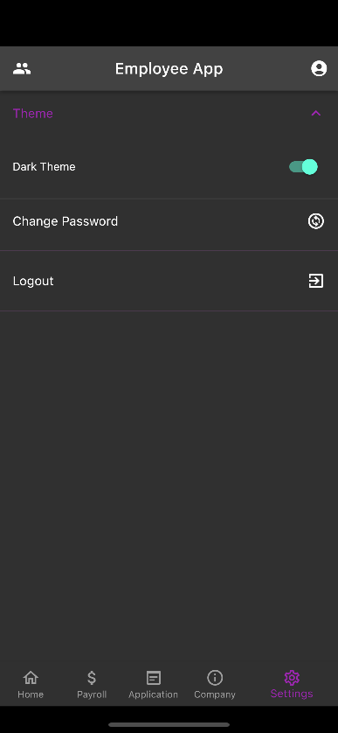

Figure 24: Employee Mobile App Settings Interface

Appendix K

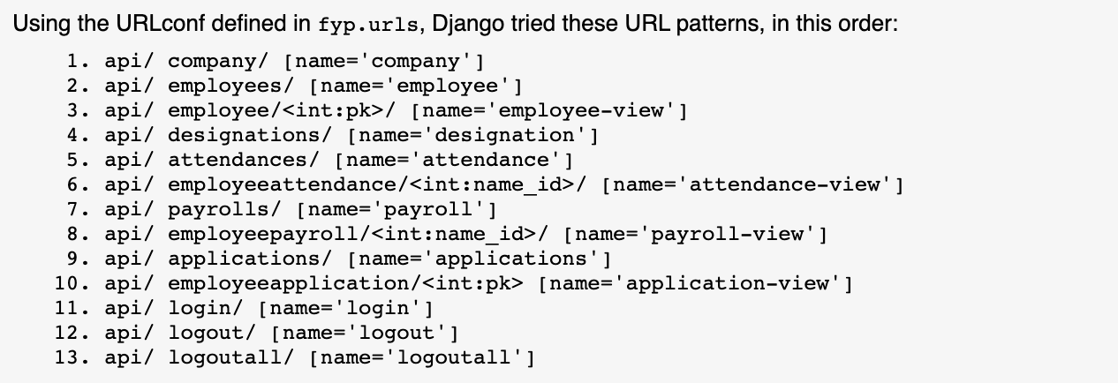

Figure 25: List of APIs