DevOps Certification Training

# Module 3: Git And Jenkins

Assignment – 2

## Problem Statement

You are working as a DevOps Engineer in a company named Sanders & Fresco Pvt ltd. You have been asked by your manager to create a Maven Project using Jenkins and build a war file of that project. As a proof of concept, you have been given a web application to build. And once done with building the war file, deploy it over the tomcat server.

Steps to solve:

* Open Jenkins and create a Maven project using it.
* You will have to create the following jobs, which are as follow:
* Compile
* Code Review
* Unit test
* Package
* Deploy

## Solution:

1. Configure Maven in Jenkins

Go To: Manage Jenkins > Global Tool Configuration

In the JDK Section

> Click Add JDK

> Uncheck Auto install Java

> Name: myjava

Java Home : /usr/lib/jvm/java-1.8.0-openjdk-1.8.0.312.b07-1.amzn2.0.2.x86_64

(Get the path from mvn --version copy only till 64)

Scroll down to Maven Section

> Add Maven

> Name: mymaven

> Install automatically should be checked and version should be latest

Click on Apply and Save

All configurations and settings are complete

### 1.Compile

1. Create a freestyle project

1. Add Description

1. Click on Source Code management and provide the Git Source

1. Build Trigger – Set to trigger the build whenever there is a new commit using Poll SCM

1. a. From Build – Select Invoke top-level Maven targets

b. Select the maven version, enter the command “compile” and save

1. Now Build “1. Compile” and check the logs

### 2.CodeReview

1. New Item > 2.CodeReview > Freestyle Project> OK

1. Add the Git Repository

1. Click on Build and Select mymaven. In Goals enter “pmd:pmd”

1. Click on Apply and then Save. Then Build

1. After the build is successful, Go to Workspace> target

1. The pmd.xml file is generated

1. Open and view it

1. It is not in a readable format. So we will take help from Jenkins
2. Go to Dashboard> Manage Jenkins> Manage Plugins
3. Install the Plugin “Warnings Next Generation”

1. It should get installed

1. Now go to the 2.CodeReview job and click on Configure
2. Click on Post Build Actions and Add Post Build Actions and select Record Compiler Warnings

1. Tool > PMD
2. Enter the path target/pmd.xml

1. Now build the code again

1. Once the Build completes, we will see a new tab called PMD Warnings

### 3.UnitTest

1. This will also be a Freestyle Project
2. In Source code management enter the same Git repo
3. Go to Build and select Invoke Top level maven Targets

1. Build the project and it will execute the test cases
2. Surefire test reports will be available in the path – target/surefire-reports but this will also not be readable
3. Junit Plugin will be needed to read, and it is installed by default.
4. So go to Post-build Actions and Select Publish jUnit test result report

1. The post build files will only be generated after the first build. So the xml files wont be available in the first build.
2. Go to the newly generated Test Result tab

### 4.CodeCoverage

1. This will also be a Freestyle Project
2. In Source code management enter the same Git repo
3. Go to Build and select Invoke Top level maven Targets
4. Select Maven Version and Goals

1. In the Goals, we are entering “cobertura:cobertura -Dcobertura.report.format=xml” as this will generate the report in XML. By default, the report will be generated in html.
2. Save and Build to generate the report
3. The **coverage.xml** report will be in the Workspace > target/site/cobertura folder

1. Install the plugin Cobertura
2. Go to the Project 4.CodeCoverage and Click on Configure
3. Click on Postbuild Actions and Select **Publish Cobertura Coverage Report**
4. Enter the path as **target/site/cobertura/coverage.xml** and click on Save
5. Go to Console Output and check the build log
6. Now on the left side a new link ‘Coverage Report’ will be available. Click there

### 5.Package

1. This will also be a Freestyle Project
2. In Source code management enter the same Git repo
3. Go to Build and select Invoke Top level maven Targets
4. Select Maven Version and Goals
5. In the Goals, enter “package”

1. We won’t build the file now. It will be done once all the above projects are connected to create a pipeline

## Create Pipeline

Now all the 5 projects have been created

#### Compile

1. Go to 1.Compile >> Configure >> Post-build Actions
2. From Add post-build action, select Build other projects

1. In the Projects to build, enter 2.CodeReview

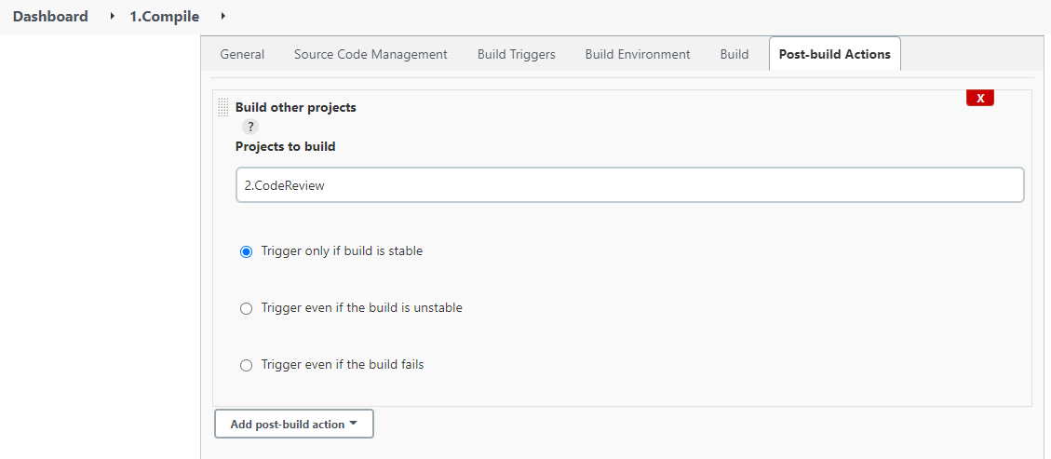

1. Click on save

#### CodeReview

1. Follow Similar step as above and Add “3.UnitTest”

#### UnitTest

Same Steps as above

#### CodeCoverage

Same steps as above.

#### Install Plugin

Now go to Plugin Manager and Install the pipeline “Build Pipeline”

1. Click on New View and name it “buildpipeline” and Select the type as Build pipeline View

1. Click on Create
2. In the Pipeline Flow, Initial job is set by default

1. Click on OK and this Pipeline will be generated

## Run Pipeline

1. Click on Run

1. Click on Package job and Go to Console Output

1. At the bottom it will show that the war file is generated

