OEM Repository - a Second Look
By Iordan K. Iotzov

Introduction
Access to comprehensive and reliable data is essential for any methodical analysis or forecasting. Oracle Enterprise Manager (OEM) repository contains a wealth of raw and partially processed database-related information that can be put into use for various projects. Looking for historical patterns is vital in troubleshooting performance problems. OEM repository data, in conjunction with the data in Oracle Automatic Workload Repository (AWR), dynamic performance views, and trace files can provide a broad view of the state of a system. Resource management and forecasting are other areas where OEM repository data can be of enormous help. Since the repository resides in an Oracle database, we not only get access to the data, but we can also utilize the computing power of the Oracle server, specifically its analytical and statistical built-in functions and packages.
Most of the useful data in the OEM repository is collected to support functionalities related to OEM metrics. The data is initially gathered by OEM agents that are deployed on each monitored machine (Error: Reference source not found).
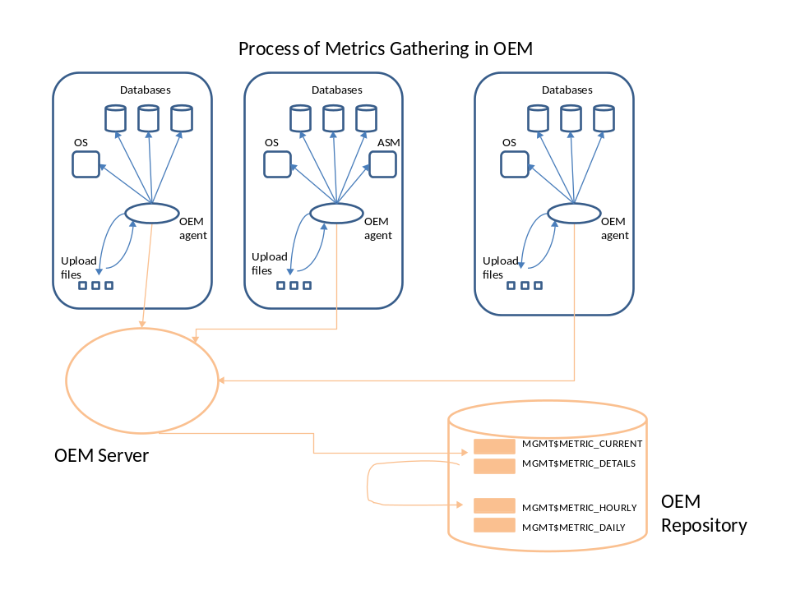
Figure 1: Overview of metric-gathering in OEM
Each metric has its own collection frequency that in most cases can be easily changed via the “Metric and Policy” OEM tab. For metrics that do not have thresholds, such as the Tablespace Allocation metric, changing the frequency can be accomplished with the command line utility emcli. We can also control the retention period for many metric-related repository tables in OEM – detailed information can be found in Oracle® Enterprise Manager Advanced Configuration 10g Release 5 (10.2.0.5) and in Metalink Note [ID 430830.1] (Grid Control Repository: How to Modify the Retention and Purging Policies for Metric Data?)]
After being transmitted from an OEM agent, the metric data goes into MGMT$METRIC_CURRENT and MGMT$METRIC_DETAILS views. Those views hold the most recent entry and the most recent 25 hours of raw data respectively. As most of the time we are looking for cumulative information, we are usually dealing with views that are aggregated from raw data at a regular interval. MGMT$METRIC_HOURLY view contains count, average, minimum, maximum, and standard deviation aggregated every hour for the last 30 days. MGMT$METRIC_DAILY stores the daily aggregations for one year. Detailed documentation of OEM repository views can be found in Oracle® Enterprise Manager Extensibility 10g Release 2 (10.2) for Windows or UNIX and in Metalink Note 831243.1 (Examples: Creating Custom Reports).
OEM User Defined Metrics (UDM) are collected and stored the same way as all other metrics. The UDMs that are generated by a shell script have a metric_name of “UDM”, while those that come from a SQL statement are under “SQLUDM” metric_name. Even though Oracle comes with several hundred predefined metrics, UDMs are very useful because they allow us to aim at a specific target parameter. Often the overall performance characteristics, such as CPU utilization and I/O wait, are not as important as the performance of the most critical business transaction. UDMs are ideal for this type of customizations.

Useful Applications
Troubleshooting performance problems often necessitate evaluating different hypothesis about the root cause of an issue. The data in OEM can be used to accept or reject a wide range of theories. Moreover, by utilizing Oracle DB links, the information in OEM can be easily combined with AWR data for an even more comprehensive view of the performance of the enterprise.
OEM provides access to the data it collects in a variety of ways. OEM metrics have good GUI screens and some ability to customize the output.
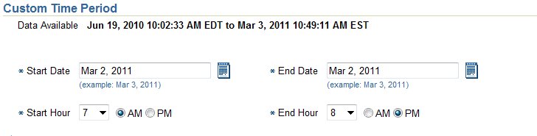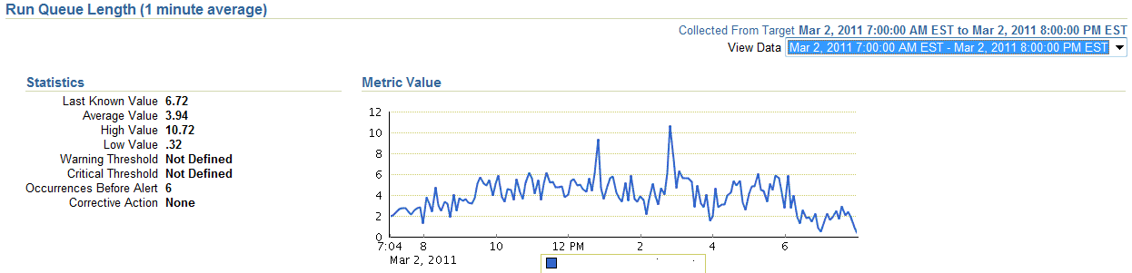
Figure 2 : Customization of metrics display
The flexibility of those screens is rather limited though (Error: Reference source not found). A quite typical request for run queue length during business hours (7 am – 8 pm), averaged over 30 days, cannot be satisfied with the existing built-in functionality. That problem can be easily solved by working directly with the data in the repository:
select
avg(average)
from
mgmt$metric_hourly
where
rollup_timestamp > sysdate – 30
and target_name = 'dbtest01'
and metric_name = 'Load'
and column_label = 'Run Queue Length (1 minute average)'
and to_char(rollup_timestamp,'D') not in ('1','7')
and rollup_timestamp between trunc(rollup_timestamp,'DD') + 7/24
and trunc(rollup_timestamp,'DD') + 20/24

2.97053285256410256410256410256410256411

The OEM repository stores data for all databases in an enterprise, making it the ideal place to implement procedures that monitor and enforce enterprise-wide policies. We can monitor Force Logging status of all production databases by utilizing UDMs and OEM repository tables. Each production DB would pass along its Force Logging status to the repository with an UDM (Error: Reference source not found).
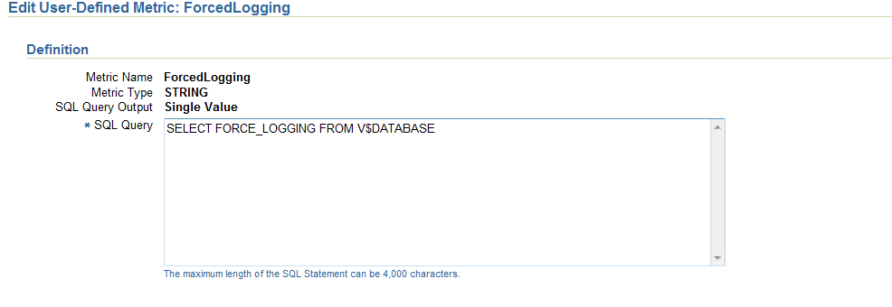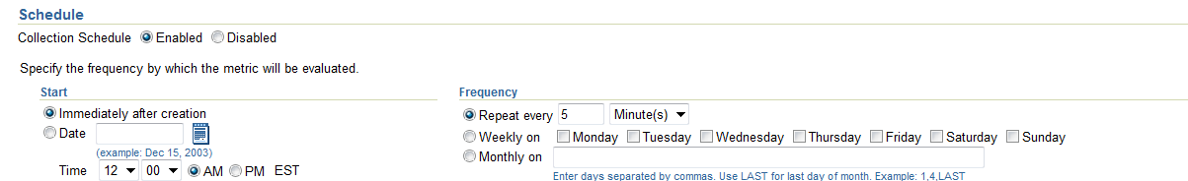
Figure 3: UDM for collecting "Force Logging" mode information on production DB
The actual monitoring is implemented as a different SQL UDM against the OEM repository:
select
count( member_target_guid )
from
mgmt$group_derived_memberships o ,
mgmt$target t
where
o.composite_target_name = ‘PROD'
and o. member_target_guid = t.target_guid
and ( t.target_type ='rac_database'
or
(t.target_type ='oracle_database'
and t.type_qualifier3 != 'RACINST‘
)
)
and not exists (
select
*
from
mgmt$metric_current i
where
i.target_guid = o.member_target_guid
and metric_name = 'SQLUDM'
and column_label = 'ForcedLogging'
and Metric_Column = 'StrValue'
and collection_timestamp > sysdate - 20/1440
and value = 'YES‘
)
With this setup, every production database must have Force Logging status ON and a local UDM in place in order not to trigger the OEM repository UDM. This framework allows great flexibility as well. If we would like to exempt a production database from the Force Logging policy, we can create an exempt UDM on that production DB (Error: Reference source not found).
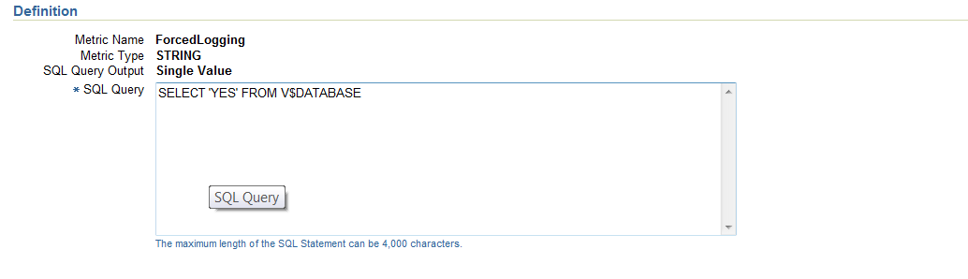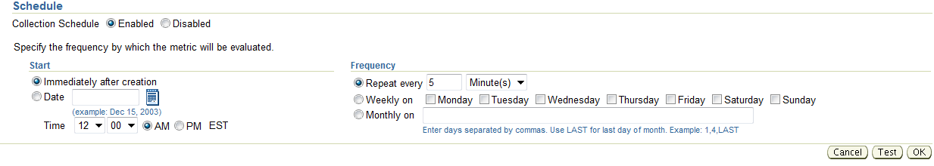
Figure 4: UDM for exempting a DB from the "Force Logging" policy
The flexibility can go even further - we can allow only certain tablespaces to be exempted from the Force Logging policy, while making sure that all other tablespaces have the setting (Error: Reference source not found).
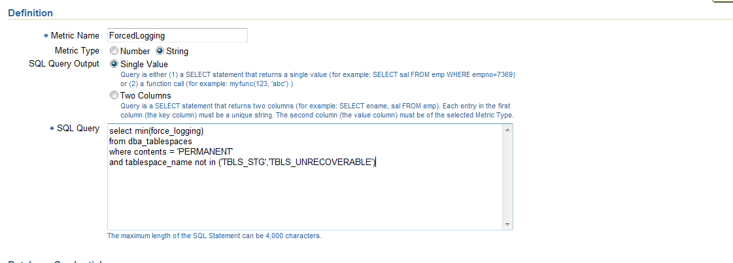
Figure 5 : UDM for exempting tablespaces from the "Force Logging" policy
One of the advantages of working directly with the OEM repository is that we can easily connect it with other sources of valuable database performance data that are also stored in Oracle. AWR/ASH is one such suitable candidate – we can effectively run any query against any table/view in any of the two repositories. That option tremendously increases our ability to prove or revoke theories about performance problems.
Let’s investigate the variation in a single block read time on a database that sits on ASM. A single query based on ASH and OEM repository can enable us to check various relationships:
select
corr(db.time_waited , oem.value) , count(*)
from
(select
sample_time ,
time_waited
from
dba_hist_active_sess_history@prod_db
where
event = 'db file sequential read'
and session_state = 'WAITING'
and sample_time > sysdate - 1 ) db ,
( select
collection_timestamp ,
value
from
mgmt$metric_details
where
target_name = '+ASM_PROD'
and metric_name = 'Single_Instance_DiskGroup_Performance'
and metric_column = ‘<ASM Metric>' ) oem
where
oem.collection_timestamp between db.sample_time - 15/1440
and db.sample_time
The result of this analysis ( Table 1) contains many helpful leads. It shows that the volume of IO writes, rather than the volume of IO reads, is what influences the speed of a single read. We cannot expect high absolute correlation in this case because the frequencies of gathering in ASH and OEM repository ('Single_Instance_DiskGroup_Performance') respectively are very different.
Table 1 : Correlation between select ASM metrics and time of single block read (DB)
ASM Metric | Correlation
writes_ps | 0.04
reads_ps | -0.04
write_throughput | 0.04
read_throughput | 0.01

We can utilize the OEM repository to find out what caused a significant latency on the apply side of a Streams configuration. Some believe that the load on the IO system on the apply side causes the latency. Using CORR SQL function and the data in OEM, we can put that hypothesis to a test:
select
corr(streams_latency.value , IO_load.value)
from
( select *
from
mgmt$metric_details
where
target_name = 'STRDEST'
and metric_name = 'streams_latency_throughput'
and column_label = 'Latency' ) streams_latency ,
(select *
from
mgmt$metric_details
where
target_name = ‘STRDEST'
and metric_name = 'instance_throughput'
and column_label = 'I/O Megabytes (per second)') IO_load
where
streams_latency.collection_timestamp between IO_load.collection_timestamp
and IO_load.collection_timestamp + 5/(60*24)
and streams_latency.collection_timestamp > sysdate – 1

-0.001043436634863007975354458994748444098631
It seems that this is not a viable lead. Is it possible that the latency is linked to the amount of redo generated on the capture database? A single query can check that idea as well:
select corr(streams_latency.value , redo_source_1.value + redo_source_2.value)
from
( select *
from
mgmt$metric_details
where
target_name = 'STRDEST'
and metric_name = 'streams_latency_throughput'
and column_label = 'Latency' ) streams_latency ,
(select *
from
mgmt$metric_details
where
target_name = 'STRSRC_STRSRC 1'
and metric_name = 'instance_throughput'
and column_label = 'Redo Generated (per second)' ) redo_source_1 ,
(select *
from
mgmt$metric_details
where
target_name = 'STRSRC_STRSRC 2'
and metric_name = 'instance_throughput'
and column_label = 'Redo Generated (per second)' ) redo_source_2
where
streams_latency.collection_timestamp between redo_source_1.collection_timestamp and redo_source_1.collection_timestamp + 5/(60*24)
and streams_latency.collection_timestamp between redo_source_2.collection_timestamp
and redo_source_2.collection_timestamp + 5/(60*24)
and streams_latency.collection_timestamp > sysdate – 1

0.7641297491294021289799243642319279128629
Here, the verdict is clear – the redo size on the capture database correlates heavily with the Streams latency on the target database and is most likely the root cause of this problem.
OEM reports are another way to tap into the value of the data stored in the OEM repository. There are a few built-in reports, but most of them accept few parameters. Those restrictions can be overcome with using custom OEM reports. In fact, this has been my preferred way of delivery for most of the complex projects that I have worked on.
I typically use custom OEM reports with a SQL select statement, an option that provides simplicity and versatility for the report users. That choice presents a little bit of a challenge because it limits the ability to use intermediary tables in the underlying logic. Moreover, the programming choices are affected because some built-in PL/SQL functions that require a table column as an argument, such as DBMS_STAT_FUNCS, cannot be used. One way to get over those issues is to use pipelined functions and autonomous transactions.

Advanced Forecasting Example
To illustrate the potential of directly using OEM repository data, we’ll go though the development of enterprise-wide disk space forecasting utility for Oracle databases. The model behind the utility is linear regression. It assumes that tablespace size (tbls) is a linear function of time (t):
tbls(t) = tbls0 + incr*t
Parameter tbls0 is called intercept; incr is named slope. The first task is to find an estimate of tbls0 and incr based on the historical information about tablespace size that is kept in the OEM repository. Oracle built-in linear regression functions (prefixed REGR) are a convenient way not only to get the intercept and the slope, but also to get many other useful linear regression parameters.
select
regr_intercept (average , rollup_timestamp - sysdate ) ,
regr_slope (average , rollup_timestamp - sysdate ),
regr_r2 (average , rollup_timestamp - sysdate ),
regr_count (average ,rollup_timestamp - sysdate ),
regr_avgx (average ,rollup_timestamp - sysdate ),
regr_sxx (average ,rollup_timestamp - sysdate ) ,
regr_syy (average ,rollup_timestamp - sysdate ),
regr_sxy (average ,rollup_timestamp - sysdate )
into
…..
from
raw_data
where raw_data table gets populated with the following query

insert into raw_data
select
m.rollup_timestamp ,
m.average
from
mgmt$metric_daily m ,
mgmt$target_type t
where
(t.target_type ='rac_database'
or (t.target_type ='oracle_database'
and t.type_qualifiers3 != 'RACINST'))
and m.target_guid =p_target_guid (Database)
and m.target_guid = t.target_guid
and m.metric_guid =t.metric_guid
and t.metric_name ='tbspAllocation‘
and t.metric_column = 'spaceUsed'
and m.rollup_timestamp >= sysdate - p_period_hist
and m.rollup_timestamp <= sysdate
and m.key_value = p_tablespace_name;
Some tablespaces grow in a straight and orderly fashion, while others have significant variations and hard to identify trends. Newly created tablespaces have little historical data to base our predictions on. Those concerns bring us to the next challenge – how to find a range for the forecasted tablespace size? The formula can be found in statistics textbooks; below is its implementation in PL/SQL:
l_ci:=sqrt ( 1/ l_cnt
+
power((p_period_forecast - l_avgx),2)
/
l_sxx
);
l_sigma:= sqrt(
abs(
(l_syy
-
(power(l_sxy,2)/l_sxx)
)
)
/(l_cnt-2)
) ;
p_out_estimate_95_range:=(l_ci
*
f_forecast_t_dist(l_cnt-2,0.95)
*
l_sigma) ;

The p_period_forcast is the time we are making the forecast for, in number of days. The f_forecast_t_dist is a custom function that accepts degrees of freedom and confidence level and returns the t-distribution statistic. The rest of the parameters are from the linear regression query in the previous paragraph. These estimates should be used for forecasting values that are “near” the historical data. For instance, forecasting 3 years ahead based on 3 months of history would probably not produce reliable results.
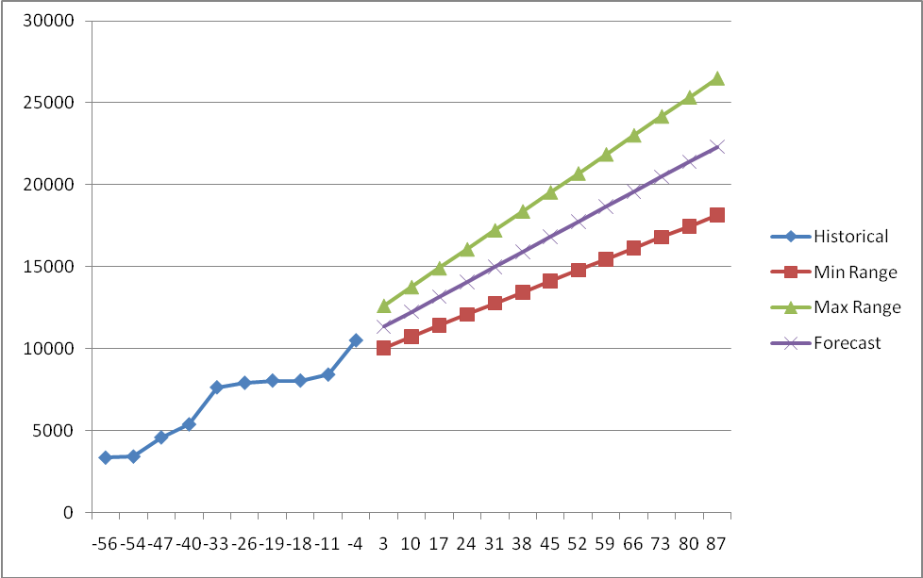
Time (days)
Size
Figure 6 : Linear regression with 95% prediction interval

Error: Reference source not found provides a graphical illustration of this method. We can see how the forecasted values follow the historic trend. We can also observe that the further in the future we forecast, the wider the range becomes.
An important part of forecasting is to find out if your data is suitable for the model -in our case linear regression. Normal distribution, lack of autocorrelation of residual errors and lack of heteroscedasticity are the prerequisites for linear regression. The better that our data set conforms to those prerequisites, the more reliable the forecasted range would be.
The forecasting utility is implemented with PL/SQL functions in a package that resides in the OEM repository.
PACKAGE FORECAST AS
FUNCTION EST_PROD_DBS ( p_lookback NUMBER , p_lookforward NUMBER …) RETURN forecast_compact_type PIPELINED ;
FUNCTION EST_DB ( p_target_guid VARCHAR2 , p_lookback NUMBER ……) RETURN forecast_compact_type PIPELINED ;
FUNCTION EST_TABLESPACE ( p_target_guid VARCHAR2 , p_tablespace_name VARCHAR2 …………) RETURN NUMBER ;
END FORECAST;

EST_DB and EST_PROD_DBS functions generate forecast reports for a database and all production databases respectively. Those functions call EST_TABLESPACE, which performs most of the statistics computations. Error: Reference source not found shows how the custom OEM report for this project is defined.
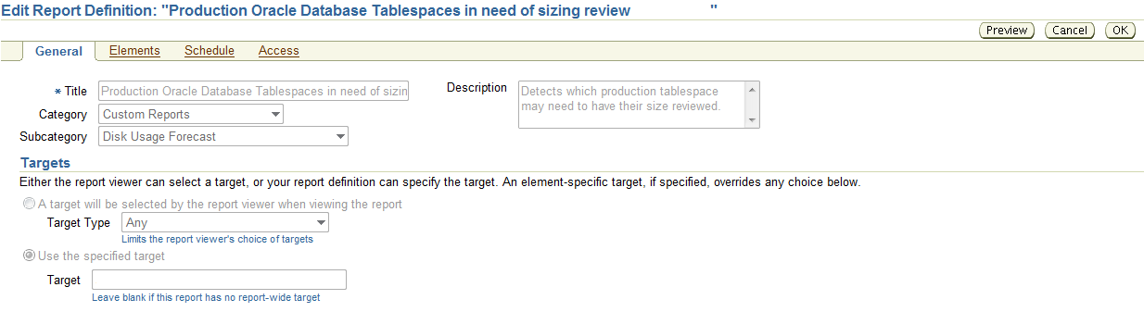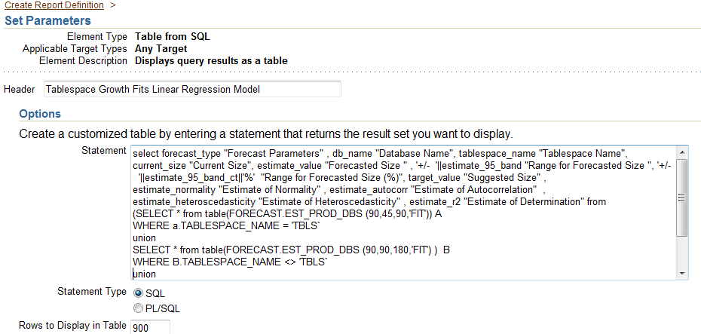
Figure 7: Custom OEM forecast report definition
The final report (Error: Reference source not found) provides lots of valuable information to users who are in charge of disk allocation decisions. The first column [Forecast Parameters] shows the parameters used for the specific forecast. In this case we look for the most recent 90 days worth of data, and based on that we generate a forecast for 90 days in the future [Forecasted Size] as well as 180 days in the future [Suggested Size]. In addition to forecasting the tablespace sizes, we compute the range for those estimates, as an absolute value [Range for Est. Forecast] and as a percentage [Range for Est. Forecast (%)], as well as number of other regression variables. If the forecasted size is larger than the current size, then we show the tablespace in the report. If the linear regression variables are reasonable, then the tablespace goes to the “Fits Linear Regression” portion of the report. Otherwise, it goes to the “does not Fit Linear Regression” portion. Flexibility is a key to this technique – everything from forecast and look back periods to the definition of “reasonable” regression variables can be changed with little effort.
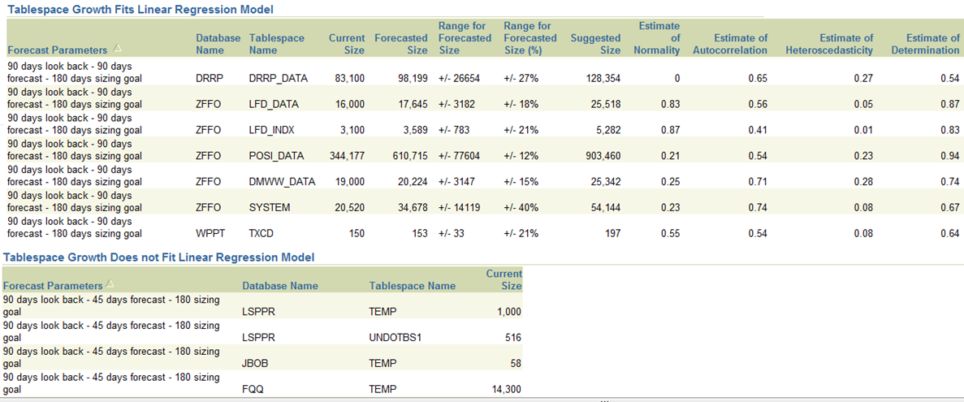
Figure 8: Sample output of forecasting report

Conclusion
Troubleshooting performance problems and analyzing resource usage could be a challenging job. We need all the reliable information we can get to be effective in those endeavors. OEM repository data is centrally stored, readily available, and easy to use, making it a valuable data source for a variety of purposes.
Even though OEM comes with considerable functionality to report on the vast amounts of data it collects, we can benefit greatly by working directly with the underlying tables and views. We can utilize the OEM repository not only to support operational DBA activities, but also to build advanced resource management utilities.

Oracle Automatic Workload Repository (AWR) is a separately licensed feature
Iordan K. Iotzov is a Senior Database Administrator at News America Marketing (NewsCorp).

