CS-273 Final

Emergency room simulator

Requirement specification:

The program simulates a hospital with a number of doctors and nurses that are inputted by the user. It simulates the amount of patients treated over the span of a week, based on a patient arrival rate that the user also enters. The program will display a menu after it has run through the simulation that allows the user to display all of the patients that had been treated over the week or search for a specific patient by name. After the user has made their choice and the information has been displayed they can either make another choice about searching or close the simulation.

Use Cases:

|  |  |  |
| --- | --- | --- |
| Steps | User’s Actions | System Response |
| 1 |  | Prompts the user to enter data about the number of nurses and doctors as well as the arrival rate for the patients. |
| 2 | Enters information about the number of doctors and nurses as well as the arrival rate of the patients. |  |
| 3 |  | System sets the enter data to their respective variables. The system then runs through the simulation with the given information. |
| 4 |  | The system prompts the user if they would like to display a table of the patients or search for a specific patient |
| 5 | The user enters their choice |  |
| 6 |  | The system searches and displays the information based on the user’s input |
| 7 |  | The system prompts the user if they would like to search for somebody else or close the simulation |
| 8 | The user enters their choice |  |
| 9 |  | The system will either close or go back to step 4 |

UML Diagram:

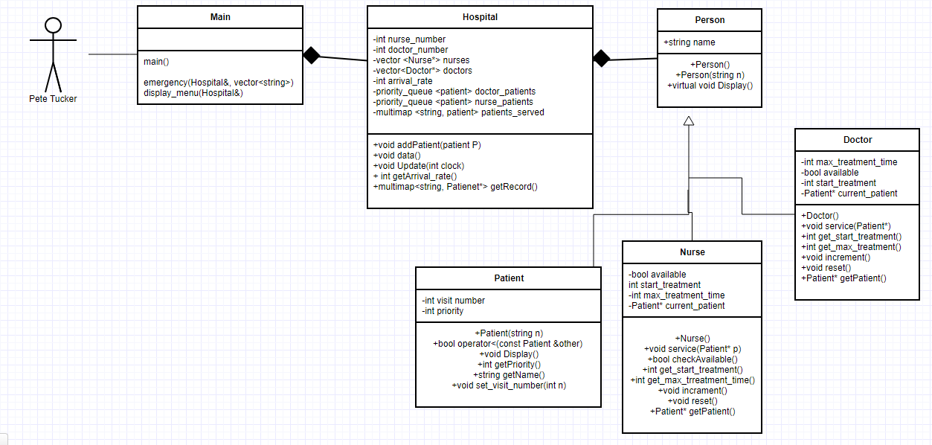

Pseudo Code:

Main(){

Open file with first names

Open file with last names

If(first name doesn’t open)

Close

If(last name doesn’t open)

Close

While(not at the end of lastname)

{

Set the current line of first name to a string

Set the current line of last name to a string

Combine the two strings into one

Push the name into a vector of strings

}

Close last name

Open last name file again (this will reset the current line)

While(not at the end of first name)

{

Set the current line of first name to a string

Set the current line of last name to a string

Combine the two strings

Push the name onto the vector of names

}

Prompt the user to input data about the simulation

For(clock that will tick every “minute” and update other functions)

{

If(it is time to add a patient)

{

Call emergency function to make a new patient and push them to the proper queue

}

Update the other queues by passing them the current clock tick

}

Display the menu for the user to navigate and search

Close first name

Close last name

}