GEOG 678

K. Roenspie

Week 2 Lab

Web App Link

<https://tamu.maps.arcgis.com/apps/instant/basic/index.html?appid=6e92d0370ada40e5885580e262be55a6>

Screenshot of web collector App.  
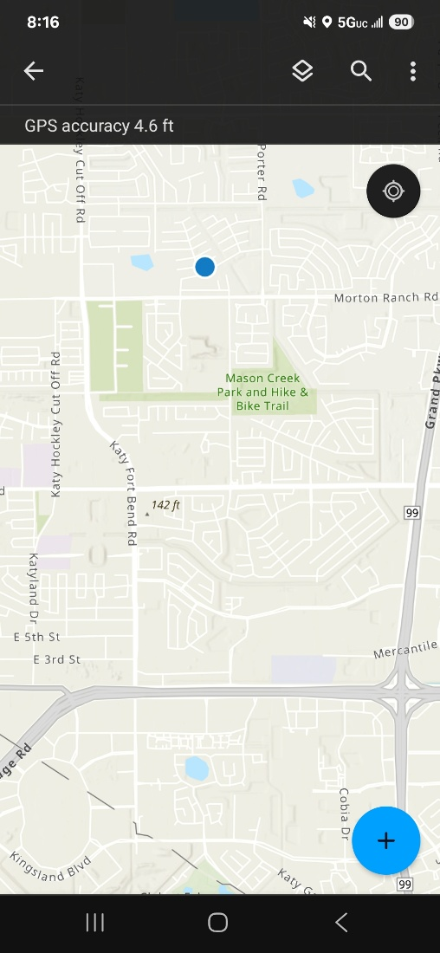

Hawaiian Volcano Analysis WebMap

<https://experience.arcgis.com/experience/9698b725609c41f082a693646bb55d92/>  
