1. **FxSpliter**

This is an application to split image, so that you can make 2 disk images.

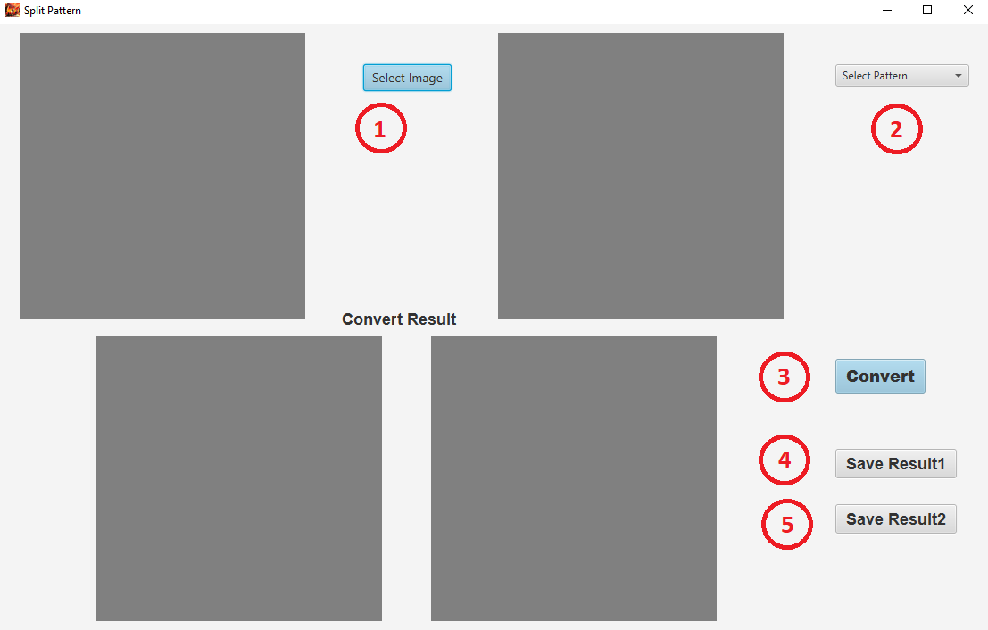

① Select image

This image is an image to split to 2 disk images.

Size should be more than 320 x 320 pixels.

② Select Pattern

Pattern is to split selected image to 2 disk images.

It is better to use more clear resolution patterns.

③ Convert

If you click “Convert” button, the selected image will be split to 2 disk images from based on the selected pattern.

And the split 2 disk images will be showed on 2 screens.

④ Save Result1

This is to save the first disk image which is split.

⑤ Save Result2

This is to save the second disk image which is split.

**Example:**

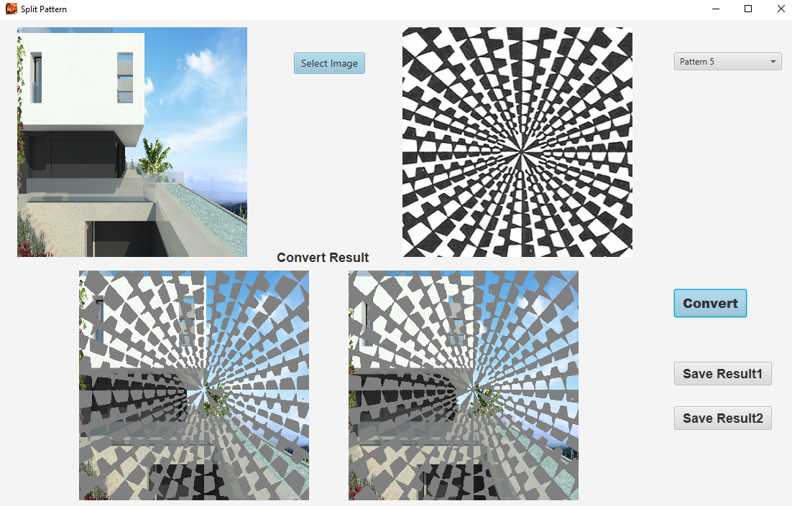

1. **DiskRing**

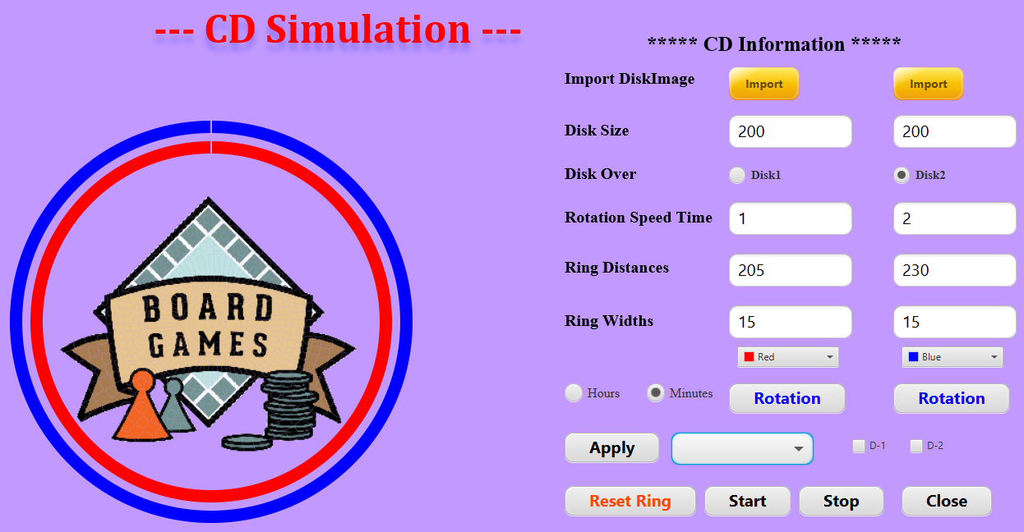

* Import Disk Image

This is to import first disk and second disk.

* Disk Size

This is to manage disk size which are imported.

You will be able to input number of radius of disk images in the fields.

Unit of radius is pixel (Pixel is unit on screen).

* Disk Over

This is to manage the layers of disks.

If you check Disk1 radio button, first disk will be over second disk.

If you check Disk2 radio button, second disk will be over first disk.

* Rotation Speed Time

This is to manage the speed of ration.

This is related with Hours option and Minutes option.

* When you select Minutes option:

If you input number 1 in the first input box like the screenshot, the rotation time that first disk rotate one time will be 1 minute.

Also, if you input number 2 in the second input box like the screenshot, the rotation time what second disk rotate one time will be 2 minutes.

* When you select Hours option:

If you input number 1 in the first input box like the screenshot, the rotation time that first disk rotate one time will be 1 hour.

Also, if you input number 2 in the second input box like the screenshot, the rotation time what second disk rotate one time will be 2 hours.

* Hours option
* Minutes option
* Ring Distances

This is to manage the distance of rings from the center of circle.

In the screenshot, the distance of first ring from center of circle is 205 pixels, the distance of second ring from center of circle is 230 pixel.

* Ring Widths

This is to manage the thin of rings.

In the screenshot, the thin of first ring is 15 pixel, the thin of second ring is 15 pixel.

* First color panel

This is to manage the color of first ring.

* Second color panel

This is to manage the color of second ring.

* Rotation (first button)

This is to rotate the first ring and first disk only.

* Rotation (second button)

This is to rotate the second ring and second disk only.

* Apply

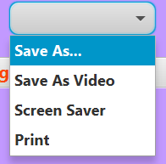

This button to apply the dropdown menu features.

* Save As…

This is related with D-1 checkbox and D-2 checkbox.

If you click “Apply” button with selected D-1 only, you will be able to save the first disk to image only.

If you click “Apply” button with selected D-2 only, will be able to save second disk to image only.

If you click “Apply” button with selected D-1 and D-2 both all, will be able to save integrated first disk and second disk to image.

* Save As Video

This is to save a video.

In this case, the video will be made with the entered information (imported disks, Disk Size, Disk Over, Rotation Speed, Ring Distance, Ring Widths, Ring colors).

* Screen Save

This is to make screensaver configuration.

The result will be configuration file and 2 disk images.

This configuration file and 2 disks will be used on Screensaver Program.

* Print

This is to print Disks

* D-1 checkbox
* D-2 checkbox
* Reset Ring button

This is to reset the position of rings.

* Start button

This button is to rotate all disks with the entered information.

* Stop button

This button is to stop the rotation of disks.

* Close button

This button is to close the program.