1. Making API for Google Authenticate Part on MISP.

* Change login URL

MISP/app/Controller/AppController.php

335th line disable

Add new line $this->redirect('https://dev.ecrimelabs.net:7000');

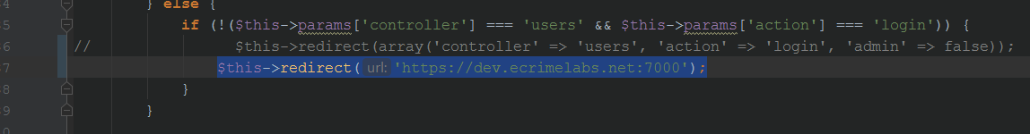

* Change logout URL

MISP/app/Lib/cakephp/lib/Cake/Controller/Component/AuthComponent.php

653rd line disable

Add new line

return Router::normalize('https://dev.ecrimelabs.net:7000/misp/login');

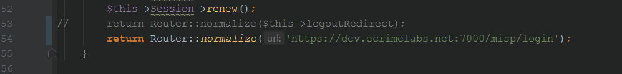

* Add View

MISP/app/View/Layouts/default.ctp

Add after of 118th line (the end of script)

<script>

window.addEventListener('message', function(event) {

// IMPORTANT: Check the origin of the data!

if (~event.origin.indexOf(https://dev.ecrimelabs.net:7000')) {

if (event.data == 'message') {

var key = $('input[name=data\\[_Token\\]\\[key\\]]').val();

console.log(key);

parent.postMessage(key, '*');

}

} else {

return;

}

});

</script>

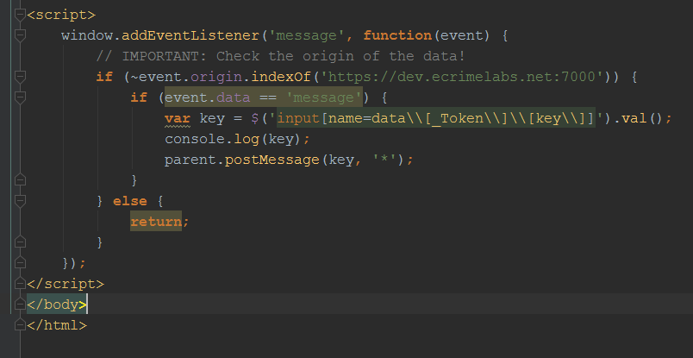

1. Set Database for Google Authenticate.

Add one field on users Table of database for google 2FA

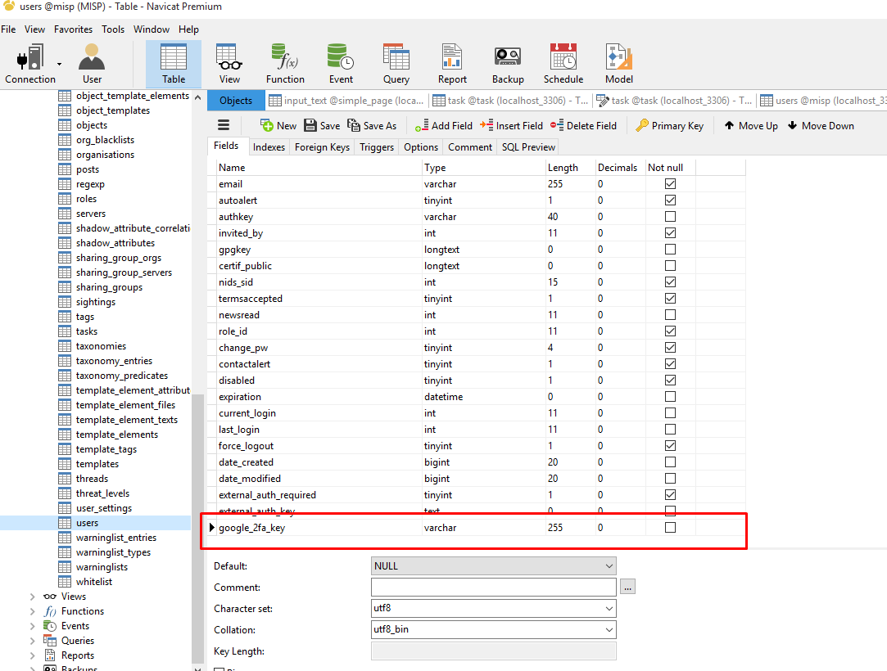

1. Install Custom Module.

* Upload source on server
* NewMISP.zip
* unzip NewMISP.zip -d destination folder
* npm install
* set config file

NewMISP/config/index.js

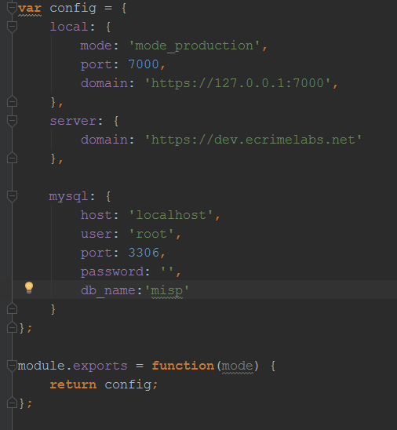

On here, you have to focus the server domain and mysql login information.

* sudo apt-get install pm2
* …/NewMISP folder
* pm2 start server.js

1. Set google Authenticate on Admin page

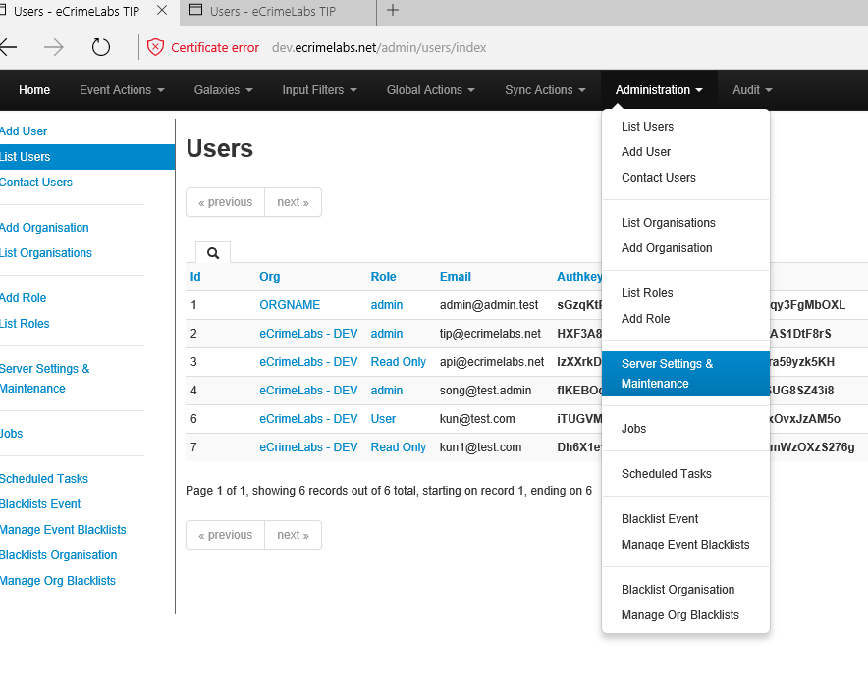

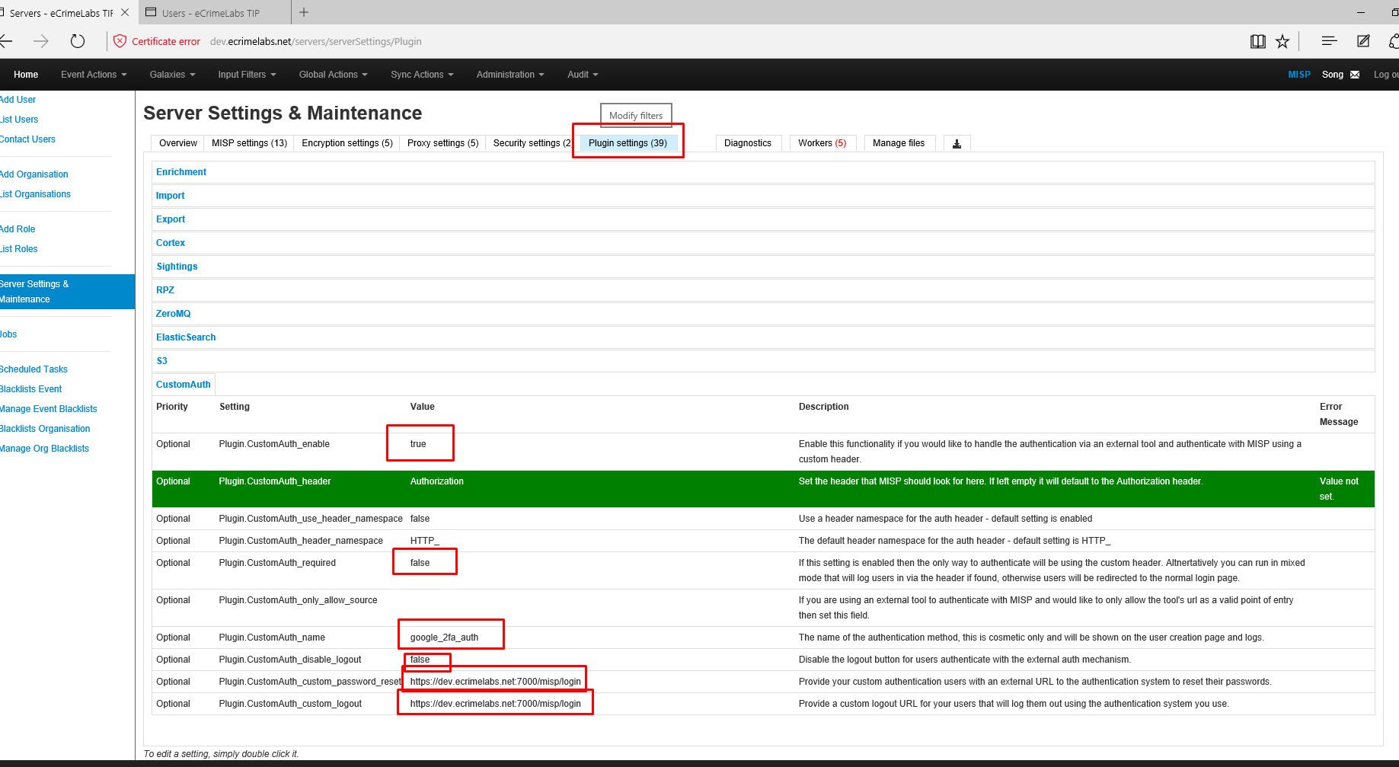

1. Add user

* First, set password and submit

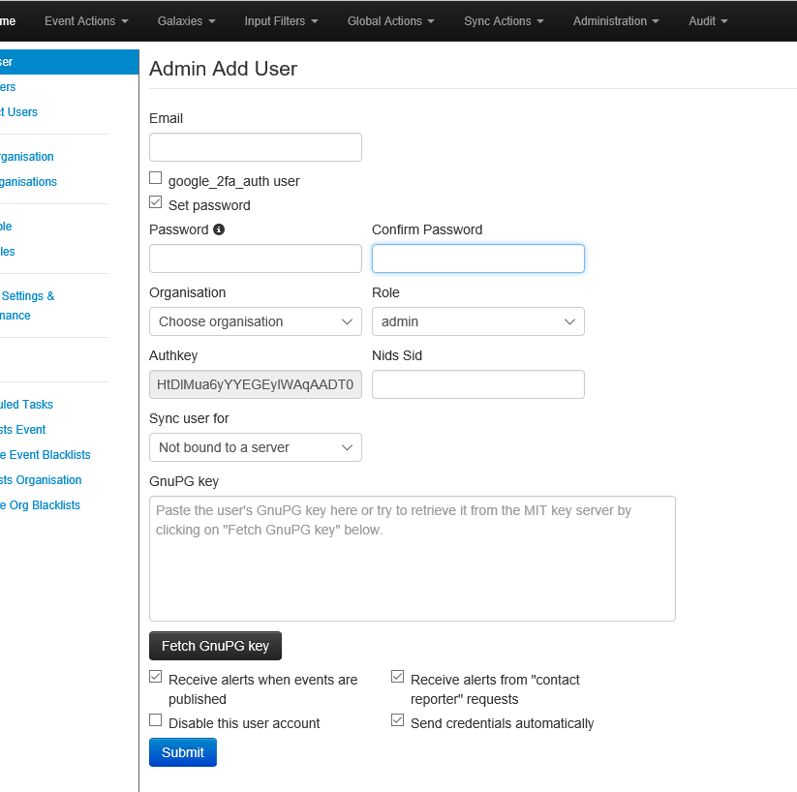

* Edit to google authenticate, check google_2fa_auth user

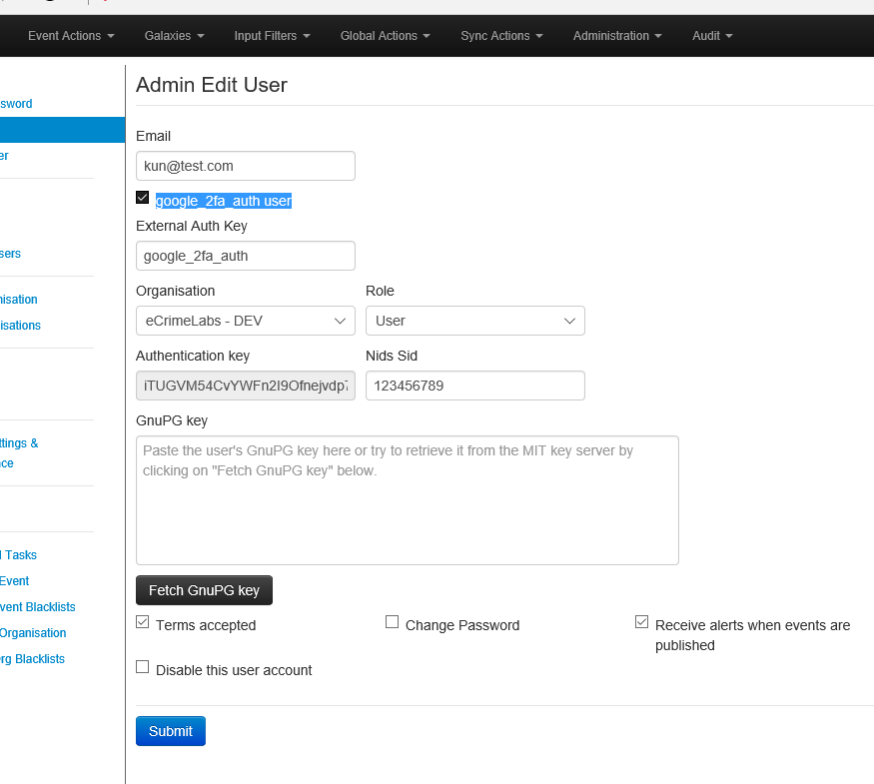

Done.

Note:

You should https credentials, therefore, you have to add server.pem and server.key files on NewMISP/sslcert

NewMISP/server.js

var privateKey = fs.readFileSync('sslcert/server.key', 'utf8');

var certificate = fs.readFileSync('sslcert/server.pem', 'utf8');

