Workflow –

A customer opens the android or iOS app or website. They browse the inventory displayed or search for a specific product. When they find what they’d like to buy, they’ll add it to the cart by clicking the + icon next to it. when they’ve selected all the items they’d like to purchase, the customer proceeds to checkout by selecting the shopping cart. In order to qualify for delivery, the admin will set a minimum total that the customer has to have in the cart, otherwise the customer will be prompted to add items to fulfil the business requirement. If the minimum is met, the customer can proceed to checkout by clicking the checkout option. At this point, the customer will be prompted to register if they aren’t already registered. Registration will be completed by entering the customer’s local phone number. The mobile payment API takes a phone number and returns the customer’s records on file which make up the customer’s profile. If registration is successful, the customer’s information is saved in the DB and the customer will be asked for delivery details and prompted for payment with mobile money to complete the order. We need an interface to collect the payment from mobile money. If all the information and payment is provided, the order is placed with us and the customer will be shown an order confirmation with an approximate delivery window and we’ll also send a confirmation with an approximate delivery window to the phone number provided.

Website:

Landing page – simple clean layout displaying products without any borders.

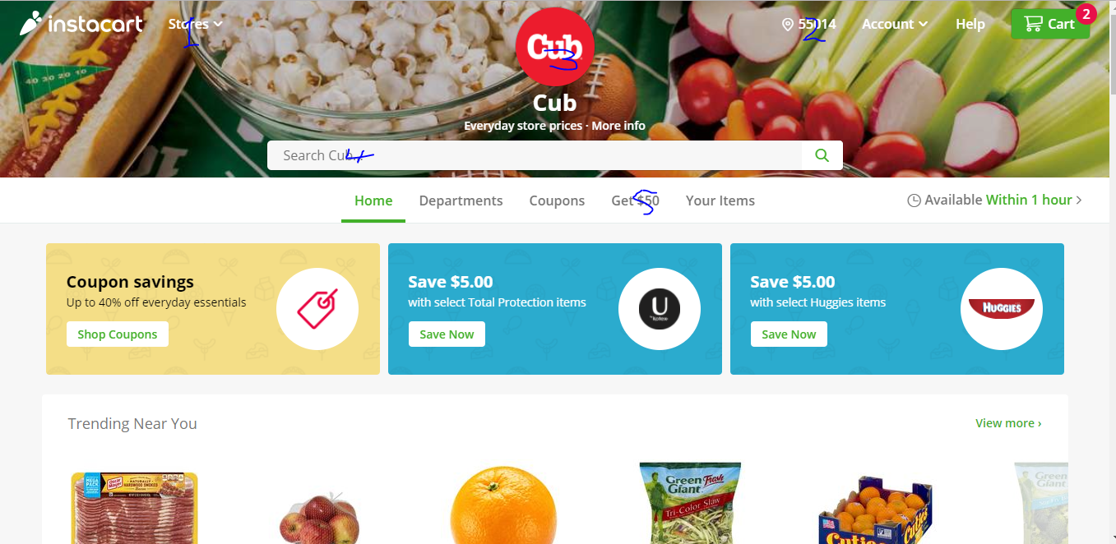

1. We don’t need to display a list of stores, so this functionality will not be included in our app.
2. Instead of zip code, we’d like to display the user’s current location (city) if they aren’t registered or their recorded delivery location (city).
3. Our company logo and slogan will be displayed in the middle of the page, not the left corner of the app.
4. Customers should be able to search for products, wording in the search box could say.. Search inventory
5. Product pages will include: Home, Departments, Coupons, Promotions, Your items – displaying the customers list of purchased from the past (purchase history). The next delivery availability window (admin will control the deliver windows/time slots) will be also be displayed depending on the time of the day.
6. When the page is scrolled up, the banner will be hidden but the top section including departments will still be shown while our logo will now be displayed on the far left corner.

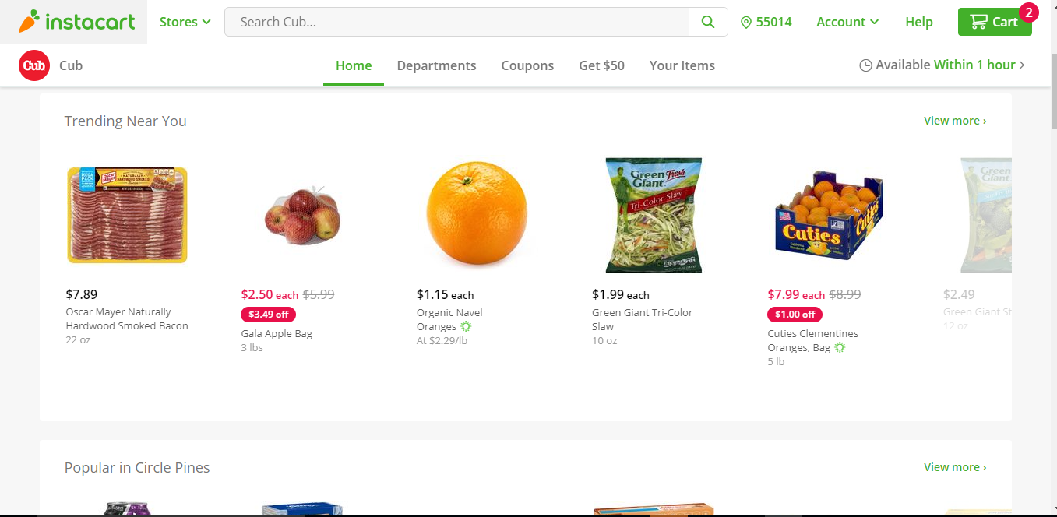

1. Customers have a quick add option to add items to the shopping cart by clicking the + (displayed with a mouse over the item) next to the item. Items selected/added to the cart are shown in line with the number of items next to the selected item.

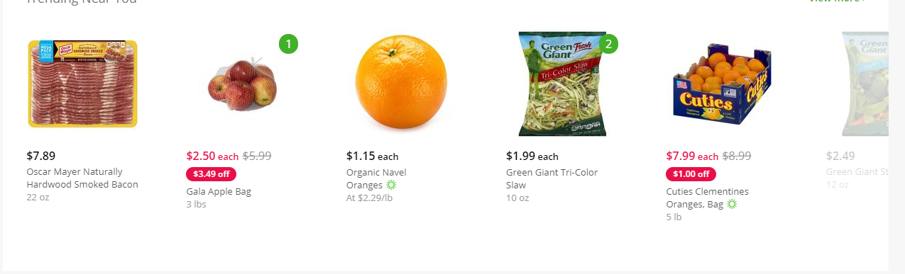

1. Product detail page shows the product, it’s details – name, size, amount, number in cart and also suggests related items below it.

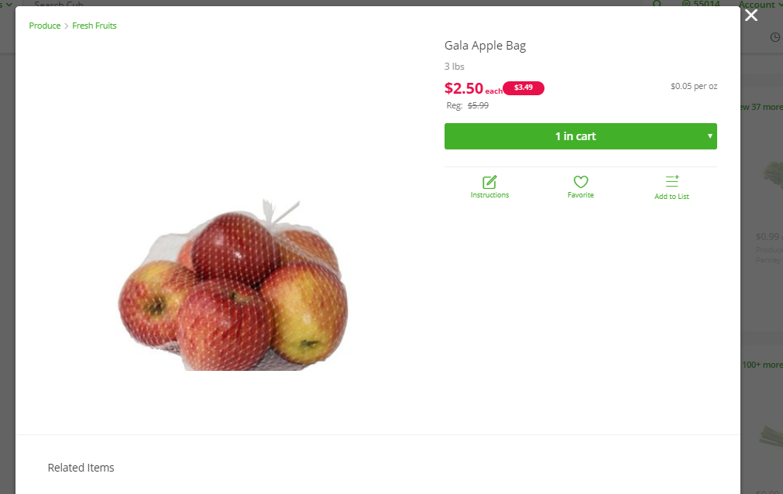

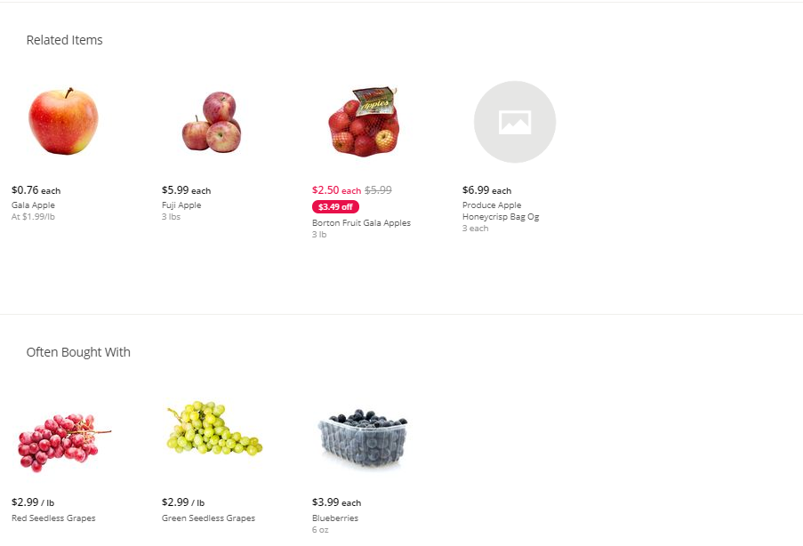

1. The shopping cart should display the following information.
   1. The labels at the top: Personal cart, delivery location/user’s location, close option.
   2. Our logo will be displayed on the far left where the Cub logo is. Total will be displayed on the far right and at the bottom as shown in the screen shot.
   3. Delivery window will be displayed in the cart as shown below.
   4. Product details for every item will be displayed as shown below.
   5. Unregistered users will be prompted to register when they attempt to submit an order. User will be notified of order minimum to qualify for delivery.

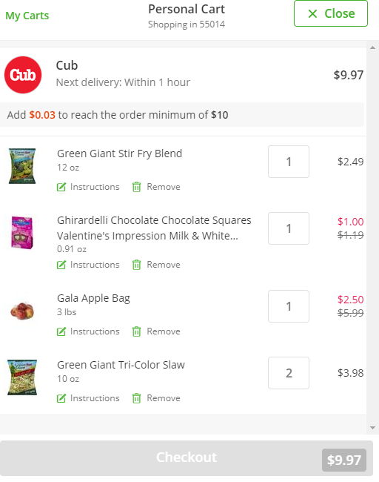

Mobile applications: