1)

Module2 Fix’s:

* app1\static\dc\ipfinder\new-field.xlsx Excel can not upload if deleted and re uploaded it. (pip install xlrd==1.2.0)
* app1\static\dc\ipfinder\new-field.xlsx Excel need subnetmask support.
* Syntax fixes RED on DB_README-v2 file.
* Add Exclude VRF on “SHOW IP INT VRF ALL”

• new field to Exclude “clientname routes” on “ SHOW IP ROUTE VRF ALL”

The exclude list should able to have “direct”, “hsrp”, “local”, “static”…etc

* Below is not showing “PDC DCS PRD DSW2 CONNECTED” which have same matching /24 subnet.

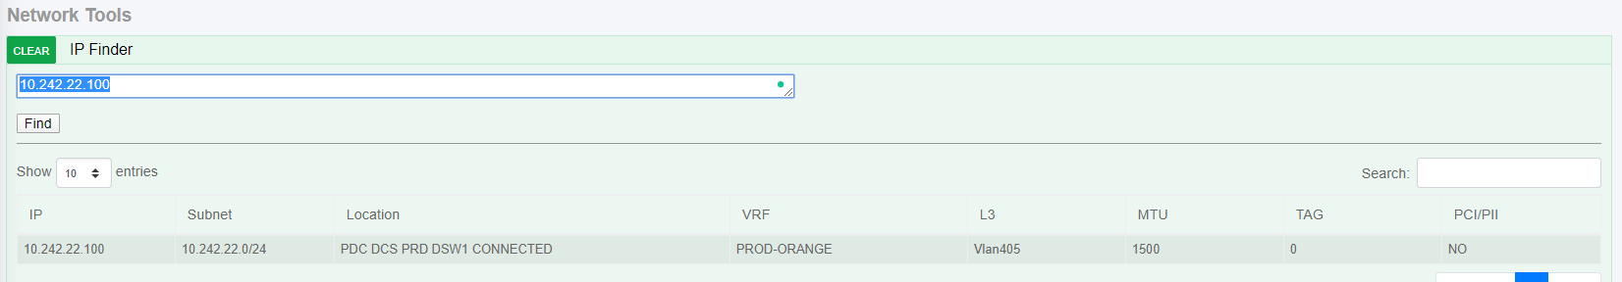

* Search UVN.xml as last resort.
* 0.0.0.0/0 should only show on these

'DFW_DCW_BSW01', 'DFW_DCW_BSW02', 'DFW_DCW_BSW03', 'DFW_DCW_BSW04'

'PHX_DCW_DSW1', 'PHX_DCW_DSW2'

'PDC_DCW_DSW1', 'PDC_DCW_DSW2'

'CDC_DCW_DSW1', 'CDC_DCW_DSW2'

* Even though the highlighted fields are in exclude list it still makes it to the database.

app1\static\dc\ipfinder\pdc\dcs\prd\DSW1.xml -> PDC_DCS_PRD_DSW1

default

management

dxc_oob

10.234.125.141

10.234.125.150

10.234.125.26

10.234.125.153

10.234.125.101

10.234.125.110

10.234.125.22

10.234.125.113

10.234.125.81

10.234.125.90

10.234.125.181

10.234.125.190

10.234.125.30

10.234.125.193

10.234.125.1

10.234.125.10

10.234.125.245

10.234.125.254

10.234.125.93

10.234.125.242

10.245.140.30, 10.245.140.31 = ANYCAST-INFOBLOX

10.234.125.214 = EBRS SWITCH

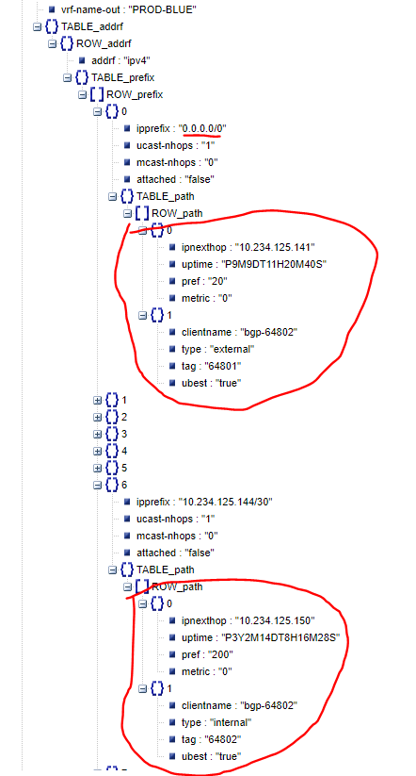

* In the same example database.

10.244.1.0/24 and others L3 field shows N/A it should be “static” and tag

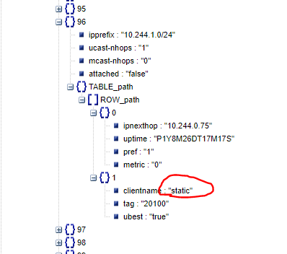

• In the same example database.

10.77.128.0/23 and others L3 field shows N/A it should be “bgp-64802” and tag

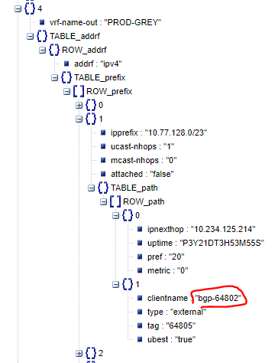

• In the same example database.

10.58.134.5/32 and others L3 field shows Vlan406 it should be “Vlan406 static”

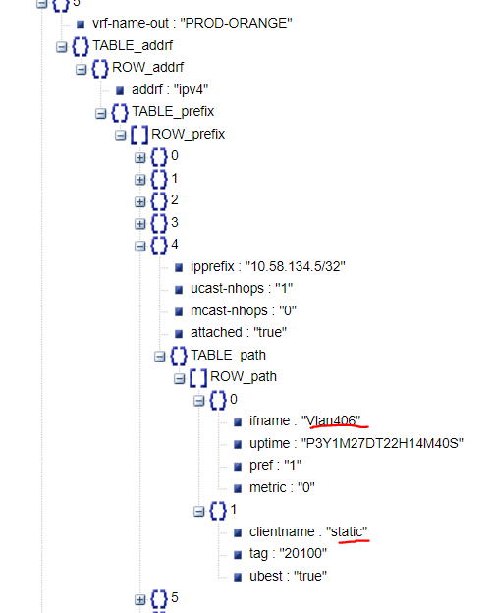

• CLI Way of doing things

2)

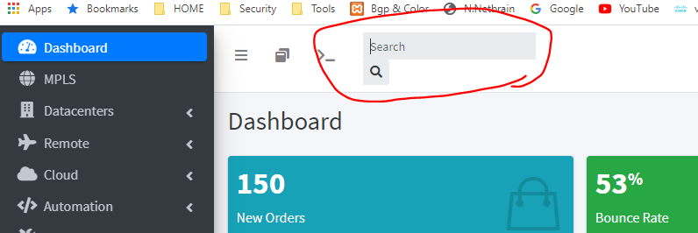

Fix the search format and it should give site wide search results.

3)

* The text should be organized with paragraphs and url links.

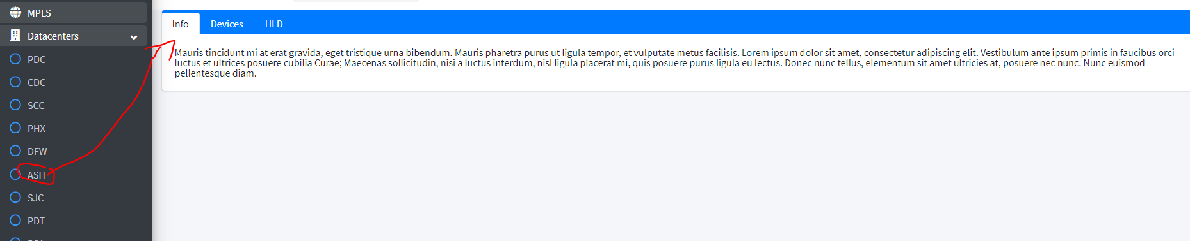

* This should look nice with row’s so I can add items like first line later to other row’s

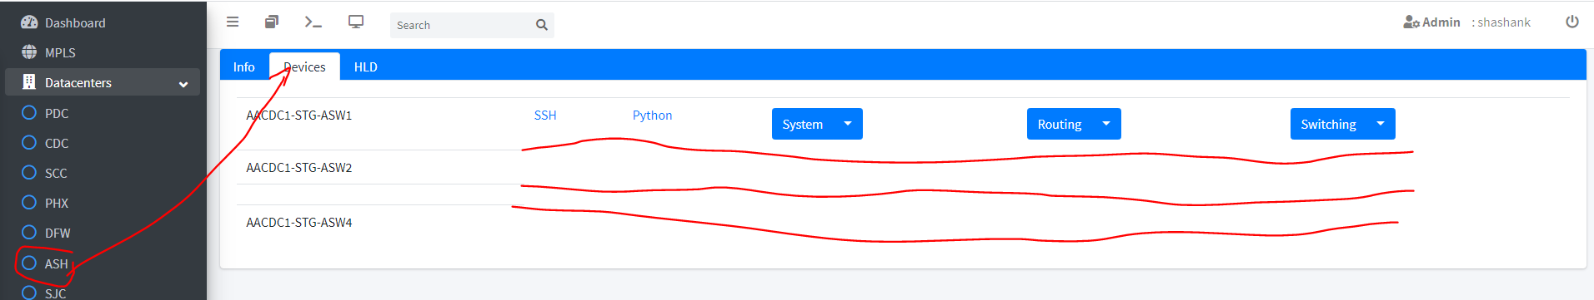

* So the SVG should be displayed perfectly on screen and should have scrolling zoom feature.

By clicking on that red object it should display modal as below on ash.html code

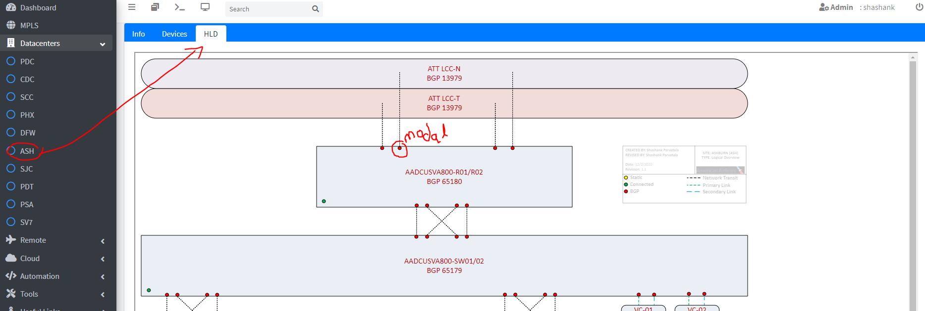

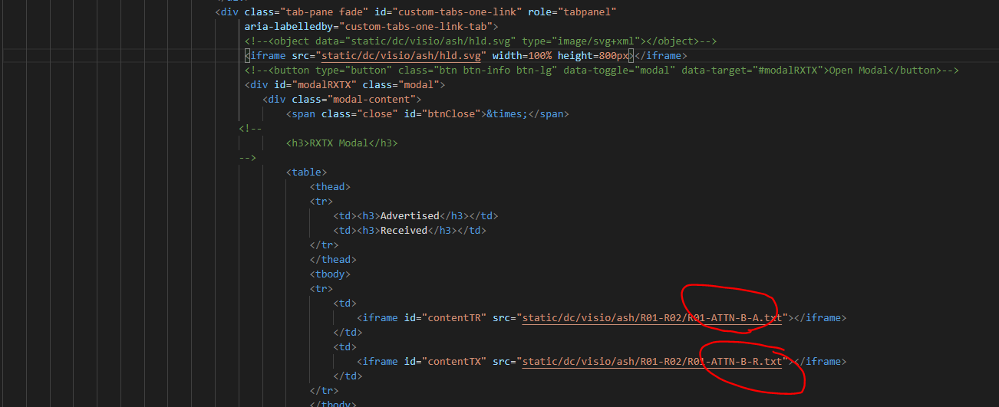

Idea is by clicking all red/green/yellow circles it displays the configs saved as text files.

**Any idea to scale this better way is appreciated as there will be lot of modal’s in that SVG.**

4)

Netmikoconfig.html and netmikoresult.html should be displayed with in the workspace.

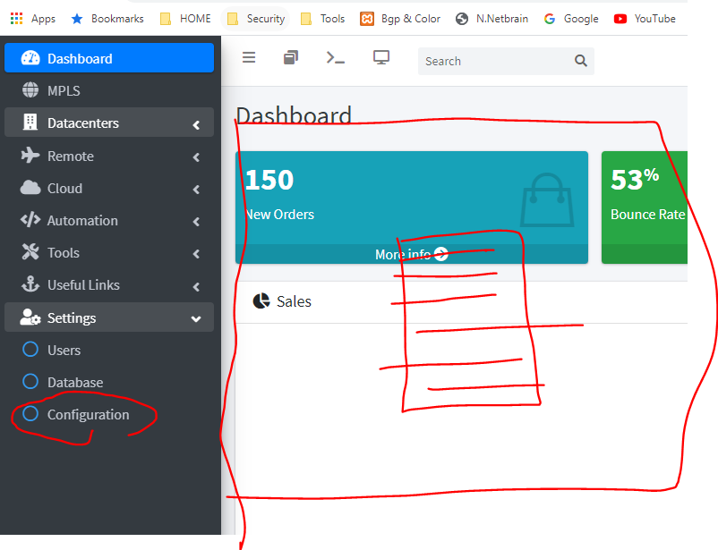

5)

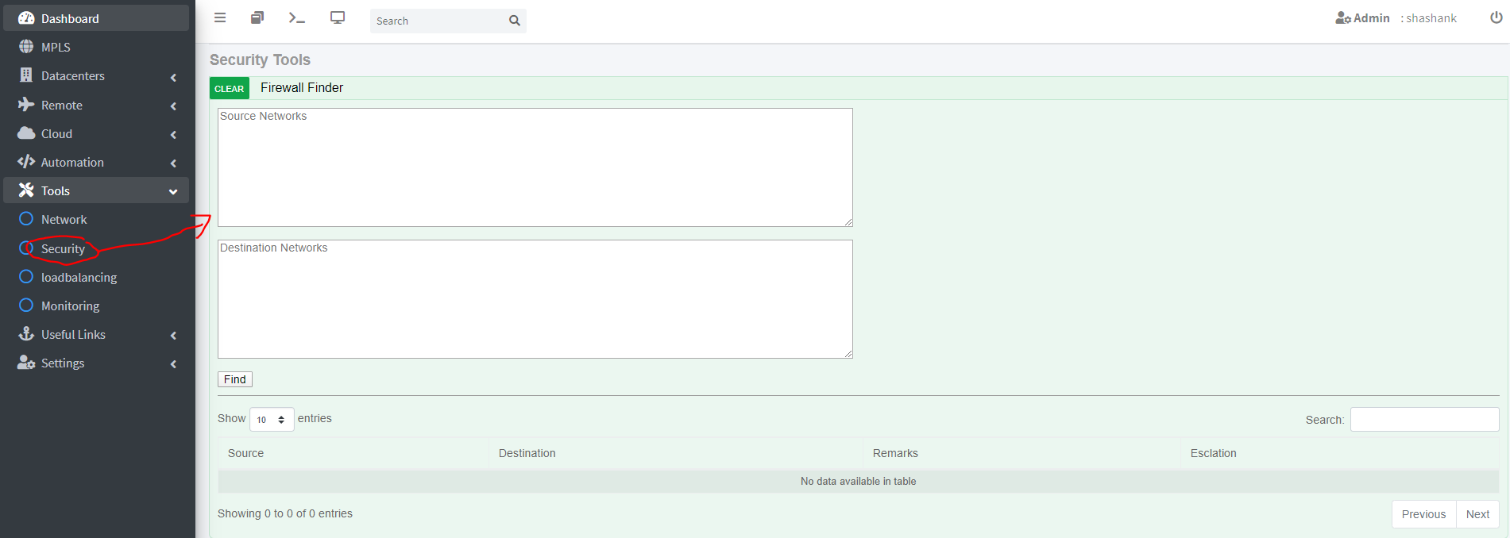

The Source and Destinations are subnets not IP’s. For example

dbs = ['DC_PCI’,

‘PDC_DCS_PRD_DSW1', 'PDC_DCS_PRD_DSW2', 'PDC_DCS_STG_DSW1', 'PDC_DCS_STG_DSW2',

'CDC_DCS_PRD_DSW1', 'CDC_DCS_PRD_DSW2', 'CDC_DCS_STG_DSW1', 'CDC_DCS_STG_DSW2'

]

Case:

**PDC to PDC**

Condition:PDC_DCS_PRD_DSW1 or PDC_DCS_PRD_DSW2 TO PDC_DCS_PRD_DSW1 or PDC_DCS_PRD_DSW2

SRC: 10.242.193.0/25

DST: 10.242.130.0/26

Remark: PDC-DCS-FW(SRC-VRF TO DST-VRF)

Escalation:

Yes for below and DB on “DC_PCI” else No

(PRD-GREY TO PRD-BLUE)

(PRD-BLUE TO PRD-GREY)

(PRD-GREY TO PRD-GREEN)

(PRD-GREEN TO PRD-GREY)

(PRD-RED TO PRD-BLUE)

(PRD-BLUE TO PRD-RED)

EXAMPLE: PDC-DCS-FW(PRD-GREY TO PRD-BLUE) and YES for Escalation

Condition:PDC_DCS_PRD_DSW1 or PDC_DCS_PRD_DSW2 TO PDC_DCS_STG_DSW1 or PDC_DCS_STG_DSW2

SRC: INPUT

DST: INPUT

Remark: PDC-DCS-FW(SRC-VRF TO DST-VRF)

Escalation:

Yes for below and DB on “DC_PCI” else No

(PRD-RED TO STG-BLUE)

(PRD-BLUE TO STG-RED)

Condition:PDC_DCS_STG_DSW1 or PDC_DCS_STG_DSW2 TO PDC_DCS_STG_DSW1 or PDC_DCS_STG_DSW2

SRC: INPUT

DST: INPUT

Remark: PDC-DCS-FW(SRC-VRF TO DST-VRF)

Escalation:

Yes for below and DB on “DC_PCI” else No

(STG-GREY TO STG-BLUE)

(STG-BLUE TO STG-GREY)

(STG-GREY TO STG-GREEN)

(STG-GREEN TO STG-GREY)

(STG-RED TO STG-BLUE)

(STG-BLUE TO STG-RED)

Condition:PDC_DCS_STG_DSW1 or PDC_DCS_STG_DSW2 TO PDC_DCS_PRD_DSW1 or PDC_DCS_PRD_DSW2

SRC: INPUT

DST: INPUT

Remark: PDC-DCS-FW(SRC-VRF TO DST-VRF)

Escalation:

Yes for below and DB on “DC_PCI” else No

(STG-ANY TO PRD-ANY)

(STG-RED TO STG-BLUE)

(STG-BLUE TO STG-RED)

**PDC to CDC**

Condition:PDC_DCS_PRD_DSW1 or PDC_DCS_PRD_DSW2 TO CDC_DCS_PRD_DSW1 or CDC_DCS_PRD_DSW2

SRC: INPUT

DST: INPUT

Remark: PDC-DCS-FW(SRC-VRF TO OUTSIDE)<-> CDC-DCS-FW(OUTSIDE TO DST-VRF)

Escalation:

Yes for below and DB on “DC_PCI” else No

(PRD-GREY TO PRD-BLUE)

(PRD-BLUE TO PRD-GREY)

(PRD-GREY TO PRD-GREEN)

(PRD-GREEN TO PRD-GREY)

(PRD-RED TO PRD-BLUE)

(PRD-BLUE TO PRD-RED)

Condition:PDC_DCS_PRD_DSW1 or PDC_DCS_PRD_DSW2 TO CDC_DCS_STG_DSW1 or CDC_DCS_STG_DSW2

SRC: INPUT

DST: INPUT

Remark: PDC-DCS-FW(SRC-VRF TO OUTSIDE)<-> CDC-DCS-FW(OUTSIDE TO DST-VRF)

Escalation:

Yes for below and DB on “DC_PCI” else No

(PRD-RED TO STG-BLUE)

(PRD-BLUE TO STG-RED)

Condition:PDC_DCS_STG_DSW1 or PDC_DCS_STG_DSW2 TO CDC_DCS_STG_DSW1 or CDC_DCS_STG_DSW2

SRC: INPUT

DST: INPUT

Remark: PDC-DCS-FW(SRC-VRF TO OUTSIDE)<-> CDC-DCS-FW(OUTSIDE TO DST-VRF)

Escalation:

Yes for below and DB on “DC_PCI” else No

(STG-GREY TO STG-BLUE)

(STG-BLUE TO STG-GREY)

(STG-GREY TO STG-GREEN)

(STG-GREEN TO STG-GREY)

(STG-RED TO STG-BLUE)

(STG-BLUE TO STG-RED)

Condition:PDC_DCS_STG_DSW1 or PDC_DCS_STG_DSW2 TO CDC_DCS_PRD_DSW1 or CDC_DCS_PRD_DSW2

SRC: INPUT

DST: INPUT

Remark: PDC-DCS-FW(SRC-VRF TO OUTSIDE)<-> CDC-DCS-FW(OUTSIDE TO DST-VRF)

Escalation:

Yes for below and DB on “DC_PCI” else No

(STG-ANY TO PRD-ANY)

(STG-RED TO STG-BLUE)

(STG-BLUE TO STG-RED)

**PDC to OTHER**

Condition:PDC_DCS_PRD_DSW1 or PDC_DCS_ PRD_DSW2 TO OTHER

SRC: INPUT

DST: INPUT

Remark: PDC-DCS-FW(SRC-VRF TO OUTSIDE)

Escalation:

Yes for below and DB on “DC_PCI” else No

(PRD-BLUE)

Condition:PDC_DCS_STG_DSW1 or PDC_DCS_ STG_DSW2 TO OTHER

SRC: INPUT

DST: INPUT

Remark: PDC-DCS-FW(SRC-VRF TO OUTSIDE)

Escalation:

Yes for below and DB on “DC_PCI” else No

(STG-BLUE)

**PDC to SPECIFIC**

Condition:PDC_DCS_PRD_DSW1 or PDC_DCS_ PRD_DSW2 TO SPECIFIC

SRC: INPUT

DST: (ONLY 134.70.8.0/21,134.70.16.0/22,134.70.24.0/21,134.70.32.0/22)

Remark: PDC-DCS-FW(SRC-VRF TO OUTSIDE) <-> OCI-FW(OUTSIDE TO INSIDE)

Escalation:

Yes for below and DB on “DC_PCI” else No

(PRD-BLUE)

Condition:PDC_DCS_STG_DSW1 or PDC_DCS_ STG_DSW2 TO SPECIFIC

SRC: INPUT

DST: (ONLY 134.70.8.0/21,134.70.16.0/22,134.70.24.0/21,134.70.32.0/22)

Remark: PDC-DCS-FW(SRC-VRF TO OUTSIDE) <-> OCI-FW(OUTSIDE TO INSIDE)

Escalation:

Yes for below and DB on “DC_PCI” else No

(STG-BLUE)

Same as above in opposite direction for below two cases.

**CDC to CDC**

**CDC to PDC**

**CDC to OTHER**

**CDC to SPECIFIC**

6) Add web page to MPLS (Ill provide page later)

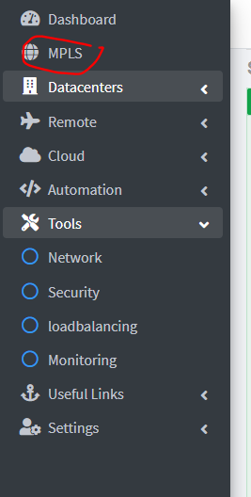

Should display this on right with the ip address search function.

