Starting page should have this on center(fullscreen)

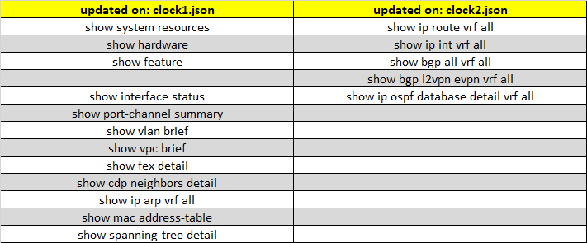

SSH

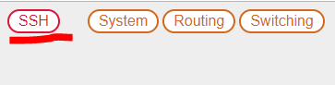

When I click SSH it should match hostname and use url from mapping_ssh.json

Mapping_<X> should be separate for all functions.

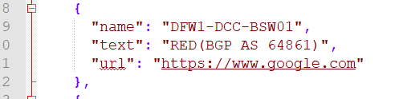

*************************************************************************************

System->Info on center(fullscreen)

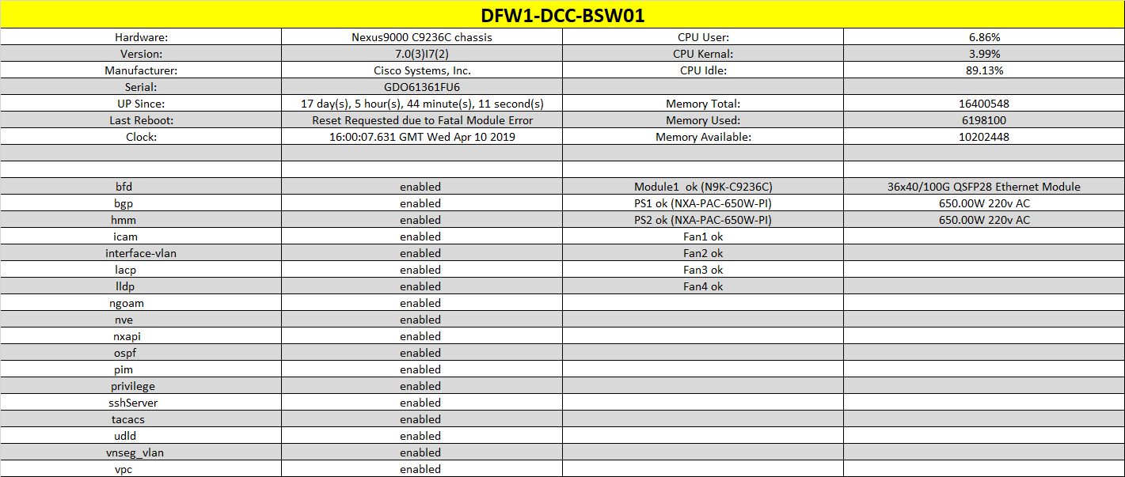

System->config on center(fullscreen)

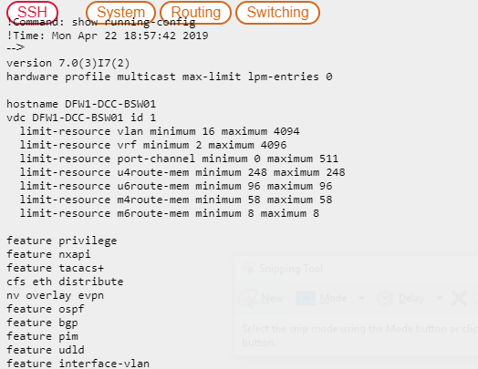

System->log

