Name:
Lab 2
This is a problem from our textbook. The following figure is our population of 100 rectangles.
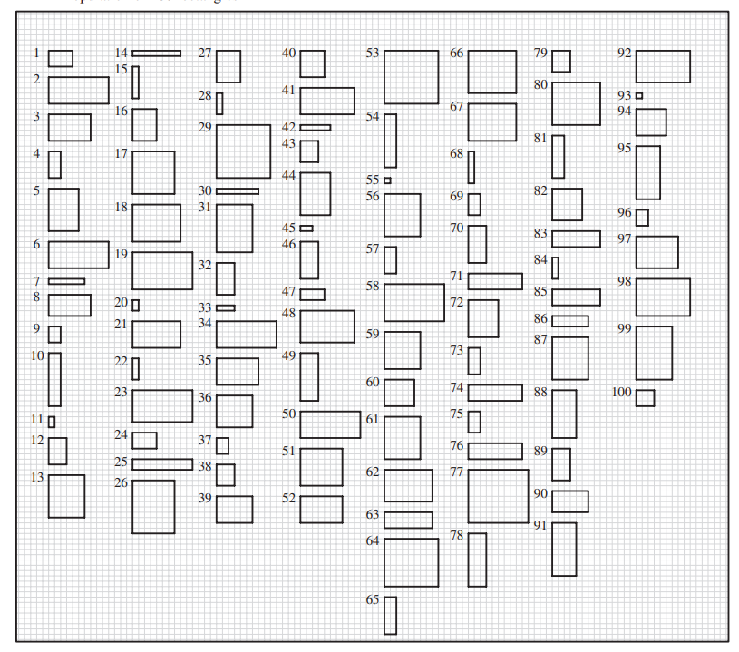

- Select a purposive sample (not an SRS) of 10 rectangles that you think will be representative of the population of 100 rectangles. Record the area (number of small squares) for each rectangle in your sample. Use your sample to estimate the total area. How did you choose the rectangles for your sample?
Sample selection, every nth observation where nth=10th observation.
So sample is rectangles 10,20,30,40,50,60,70,80,90 and 100.
Area for those rectangles is:
Area 10=20
Area 20= 4
Area 30= 7
Area 40= 20
Area 50= 50
Area 60= 25
Area 70= 21
Area 80= 64
Area 90= 24
Area 100= 9

Total area for sample= 244/10=24.4
Using the sample as an indicator total area for all rectangles is 2440.

- Find the sample variance for your purposive sample of 10 rectangles from part (1), and use
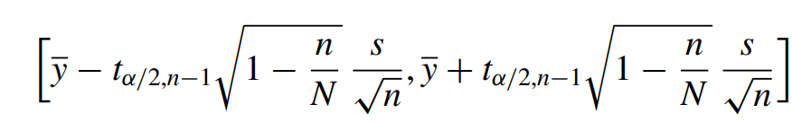
to form an interval estimate for the total area t.
Sample Variance= 358.933
The CI for the total area t= (1084.72,3795.28)

- Now take an SRS of 10 rectangles. Use your SRS to estimate the total area of all 100 rectangles, and find a 95% CI for the total area.
SRS for rectangles:
Area 19: 70
Area 99: 60
Area 90: 24
Area 14: 8
Area 93: 1
Area 67: 8
Area 4: 10
Area 77: 100
Area 78: 30
Area 39: 30
Ybar= 34.1

CI for total area t= (2054.72,4765.282)

- Go to the Lab 2 CIs discussion on D2L and post your CIs from part (2) and part (3). Compare your intervals with those of other students in the class. What percentage of the intervals from part (2) include the true total area of 3079? What about the CIs from part (3)?

At the time of posting in the discussion post 66% of the post had an interval that contained 3079, and for part 2 100% of the post contained the interval

