Kent Roller
Stat 4307

Chapter 6 Lab

- Consider a pps sample of faculty. The 27 academic units range in size from 2 to 92. Lahiri’s method was used to choose 10 psus with probabilities proportional to size and with replacement, and an SRS of four (or fewer, if Mi < 4) members from each psu was taken. (Note that academic unit 14 appears three times in the sample; each time it appears, a different subsample was collected.) Find the estimated total number of publications, along with its standard error.

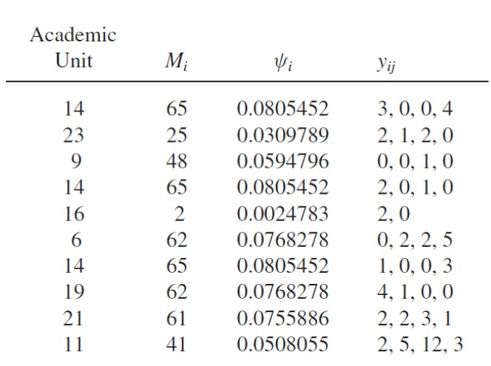

y_bar(i) | t_hat(i) | t_hat/psi(i)
3+4/4=1.75 | 65*1.75=113.75 | 113.75/0.0805452=1412.25
2+1+2/4=1.25 | 25*1.25=31.25 | 31.25/0.0309789=1008.75
¼=0.25 | 48*.25=12 | 12/0.0594796=201.75
¾=0.75 | 65*.75=48.75 | 48.75/0.0805452=605.25
2/4=0.50 | 2*.50=1 | 1/0.0024783=403.502
2+2+5/4=2.25 | 2.25*62=139.5 | 139.5/0.0768278=1815.75
1+3/4=1 | 1*65=65 | 65/0.0805452=807
4+1/4=1.25 | 1.25*62=77.5 | 77.5/0.0768278=1008.75
2+2+3+1/4=2 | 2*61=122 | 122/0.0755886=1614
2+5+12+3/4=5.5 | 5.5*41=225.5 | 225.5/0.0508055=4428.65

t_hat_psi= sum(t_hat/psi(i))/10
sum t_hat/psi:13305.7
13305.7/10=1330.57

SE: sqrt(1/n*(sum(t_hat/psi(i)-t_hat_psi)^2/n-1)

1/sqrt(10)*sqrt((1412.25-1330.57)^2+(1008.75-1330.57)^2+(201.75-1330.57)^2…)/9
=380.957
The estimated total number of publications is 1331 publications with a standard error of 380.957.

- The file statepps.dat lists the number of counties, land area, and 1992 population for the 50 states plus the District of Columbia.
  - Use the cumulative-size method to draw a sample of size 10 with replacement, with probabilities proportional to land area. What is !i for each state in your sample?
  - Use the cumulative-size method to draw a sample of size 10 with replacement, with probabilities proportional to population. What is !i for each state in your sample?
  - How do the two samples differ? Which states tend to be in each sample?
  - Use your sample of states drawn with probability proportional to population for this problem. Using the sample, estimate the total number of counties in the United States, and find the standard error of your estimate. How does your estimate compare with the true value of total number of counties (which you can calculate, since the file statepps.dat contains the data for the whole population)?
  - Now suppose that your friend Harry finds the ten values of numbers of counties in your sample but does not know that you selected these states with probabilities proportional to population. Harry then estimates the total number of counties using formulas for an SRS. What values for the estimated total and its standard error are calculated by Harry? How do these values differ from yours? Is Harry’s estimator unbiased for the population total?

Answers and work for part 2 will be submitted via rmd and pdf in dropbox

