IST 652 Homework 1
Kent Roller

Introduction
Data science and data analysis are powerful tools that can be leveraged by a wide array of industries in order to gain insight into their operations and increase efficiency. From industrial processes, to customer service optimization, many facets of any business can analyzed to gain this insight. One such example can include non-profits or other volunteer organizations that rely on donations to fund operations. By examining the pool of people making donations to the organization, advertising and other direct marketing campaigns can utilize this insight to have maximum impact. In this case, maximum impact, forgoing c-suite speak, means reaching out to those who are most likely to donate and those most likely to donate in the largest amounts, thereby maximizing the among of donations received for every dollar spent in advertising. Performing this method of selection for markets to advertise to, in the long run, equates to a higher amount of funding for the organization which means they can more effectively perform whatever function it is that they perform. In order to perform this analysis, a dataset was provided which contains a variety of information about the donors to the organization, which will be explored in the next section.

Data and Analysis
Data
The data set provided initially consisted of 24 columns of data. The first seven rows were deemed unnecessary for the analysis being performed, as they consisted of duplicated row id numbers, and a variable named zip_convert which is assumed to be the zip code for each donor in a particular region. Additionally, several rows were stored in an inappropriate datatype for the analysis to be performed.
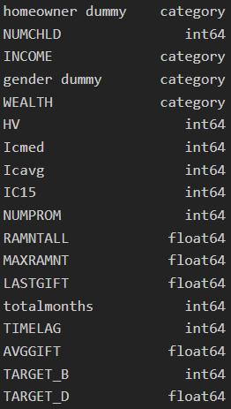
Figure 1.1

Figure 1.1 shows the modified table after converting the required variables to categorical data types instead of integer data types(All category data types listed in the dataset were converted from int64). A brief description of each of the variables is listed below:
- NUMCHLD: The number of children the donor has, stored as an INT

- INCOME: A categorical representation of income brackets for each donor, stored as categorical variable.

- Gender Dummy: A dummy variable representing the gender of the donor, stored as categorical variable.

- Wealth: A categorical representation of wealth brackets for each donor, stored as categorical variable.

- HV: The homevalue of the donor in assumed 100’s of dollars, however this is not defined in the dictionary. Stored as an INT.

- HV_fact: The homevalue of the donor expressed as a category, stored as a categorical variable.

- Icmed: The median income for the donor, stored as an INT.

- Icavg: The average income for the donor, stored as an INT.

- IC15: Undefined variable not used in the analysis

- NUMPROM: The number of promotions the organization has run for each donor

- RAMNTALL: The Lifetime value of all gifts made by the donor, stored as a Float.

- MAXRAMNT: The maximum value of gift ever made by the donor, stored as a Float.

- LASTGIFT: The value of the last gift made by the donor, stored as a Float.

- Total Months: The number of months since the last donation was made, stored as an INT.

- TIMELAG: The timelag in the series for use with Time Series Analysis, stored as an INT.

- AVGGIFT: The average gift amount made for each donor stored as an INT.

- Target_B: The target group for advertising

- Target_D: The target amount of donation desired from each group, stored as a Float.

After the data conversion and removal of unneeded variables, need to make sure that there are no NA or NULL values in the dataset.
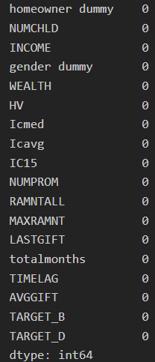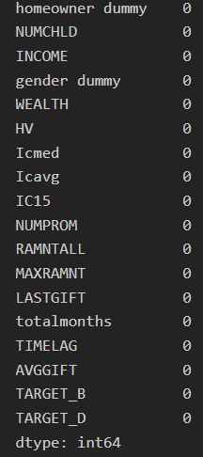
Figure 1.12 Figure 1.13
Figure 1.12 displays the NA count for the dataset in all columns, while figure 1.13 displays all of the NULL values in the columns of the dataset. As can be seen in the figures, there are no NA or NULL values so the next step can begin. Often in linear modeling and other applications it is useful to look at a scatter matrix of all variables to see what kind of distribution the variables have as well as indications of what correlation may exist between variables.
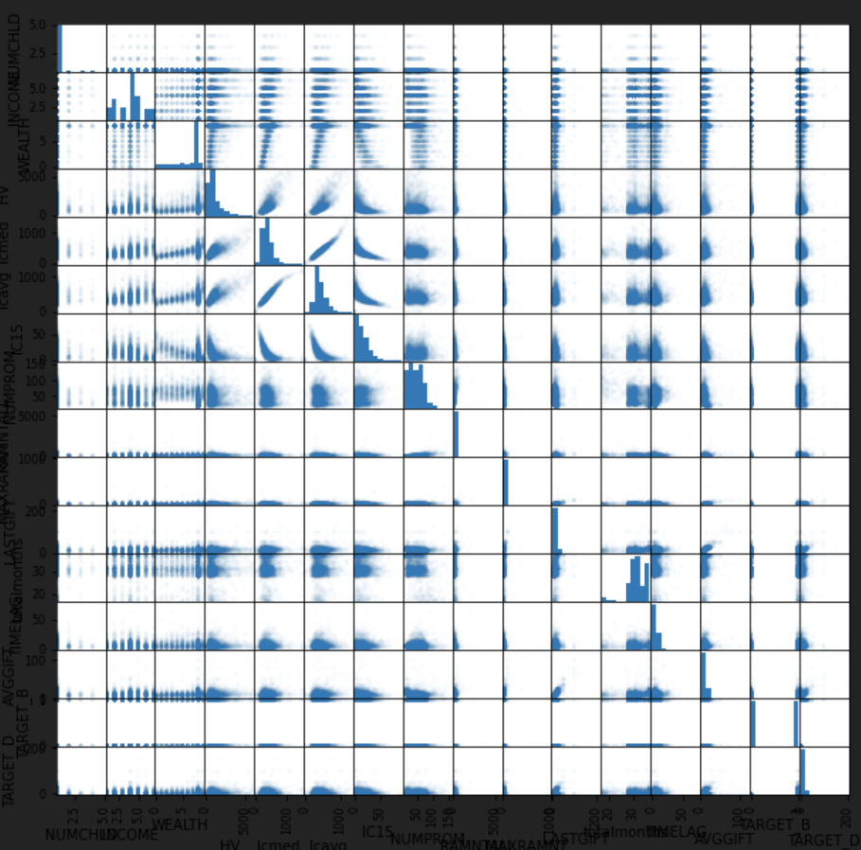
Figure 1.14
Figure 1.14 displays the scatter_matrix for all of the variables. There is some expected correlation between variables such as the income averages and median measures, but this is to be expected as those to measures are very similar and should have a high correlation with one another. Outside of the expected relationships, many of the variables do not seem to share a strong correlation with one another, though some of the distributions may be skewed, and a closer look should be taken.

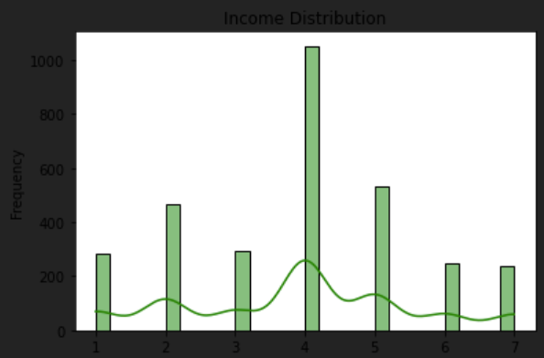
Figure 1.15
In figure 1.15 the distribution of the Income brackets can be seen. Here the data is somewhat normal, though the data point in the first quartile may cause a second peak and cause the distribution not to be true normal. The mean is around income bracket 4, which seems to be roughly the halfway point in the data, the median likewise should be close based on the distribution and the lack of a severe skew in the data.

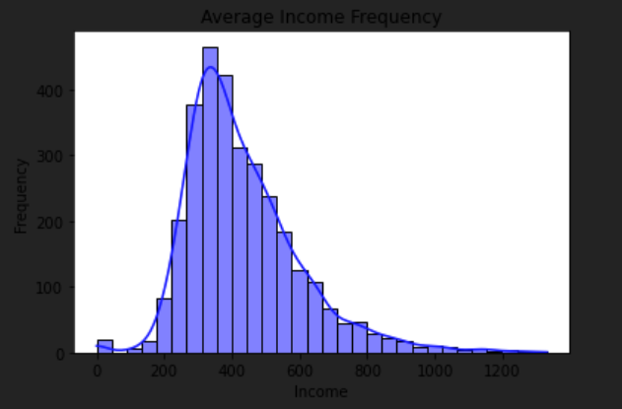
Figure 1.16
Figure 1.16 shows the distribution of the income as an integer instead of as a category. Here the data contains a rightward skew, and does not follow a normal distribution. If linear modeling is to be applied to this then the data should be log transformed in order to bring the distribution of the data closer to normal.

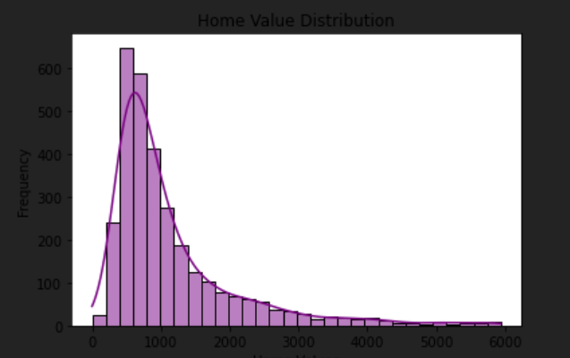
Figure 1.17
The homevalue distribution for the donors can be seen in Figure 1.17. A similar rightward skew can be seen in the data as with the income data, once again suggesting that if this variable is to be used in any type of regression a transformation should be performed first.

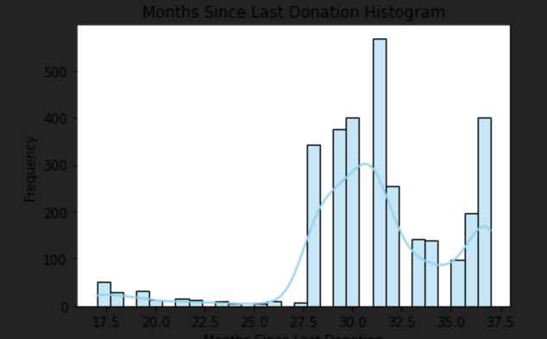
Figure 1.18
Figure 1.18 displays the months since last donation for the donors data set. Viewing the plot, the reason for analysis becomes clear, there were several waves of high value donations but those all occurred over 24 months ago. Since the operation depends in some part on donations for continued existence, the issue is clear. How to bring in more donations and replicate the cycles that occurred 27 to 37 months prior to the current date.

Analysis
To begin the analysis a closer examination of the data present in the dataset is made. Questions about the data need to be posed to better understand which donor groups are making donations and when they are making them. A first step is examining the relationship between the number of children and the last donation made.
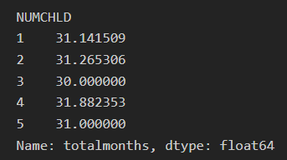
Figure 2.1
This data is displayed in Figure 2.1, where the number of children can be seen on the right and the number of months since the last donation can be seen on the right. Unfortunately, not much insight is gained here, as the average number of months since the last donation does not seem to vary greatly based on the number of children the donor has. That being said, it does appear that something occurred ~30 months ago that caused all households with children to donate. Perhaps the organization had kid-friendly aspects to its operation that it no longer focuses on, but, without additional context, this is speculation.

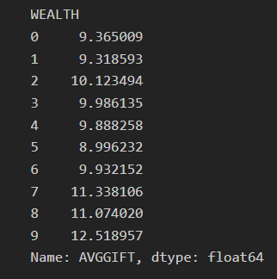
Figure 2.2
Figure 2.2 displays the average amount of donation for each wealth category. As can be observed in the figure, the wealth category makes a minimal difference in the lower categories and only produces a notable difference in the last 3 tiers.

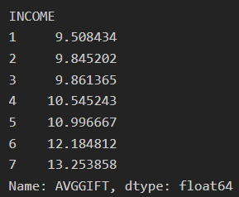
Figure 2.3
Figure 2.3 allows for comparison between the donation amounts for the Income and Wealth categories. Interestingly, the number of tiers needed for a notable difference to occur are less for the income measure than they are for the wealth measure, as by income tier 4 there is a noticeable increase in the donation amount made. Where as in the wealth measure it wasn’t until the last 3 tiers that a noticeable uptick in donation amount occurred.
So if a relationship exist between income/wealth and the donation amount, does this also mean that there exist a relationship between the home value of the donor and the donation amount?
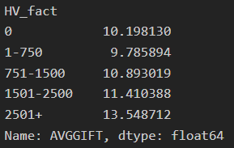
Figure 2.4
Figure 2.4 displays the average donation amount for each home value bracket. Once more, the home values displayed are assumed to be in hundreds of dollars, however this is not clarified in the dictionary so it can not be said with any degree of certainty. However, what can be observed is a slight dip in donations between 0 and 751-1500. However, once above 1500 in home values the donations continue to increase with each subsequent bracket. A comparison can additionally be made between wealth and home values to try and draw parallels between the two.
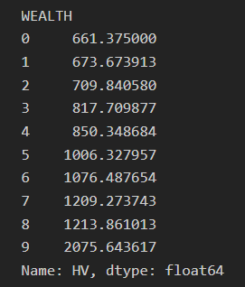
Figure 2.5
The average home values for each wealth category can be seen in figure 2.5. Parallels between the two groups are apparent, as the home values don’t cross the 1500 value until the last tier of wealth, reflecting what was observed in figures 2.2 and 2.4. Likewise, it is not until tier 7 where the home values begin to approach the 1500 mark, which was were a notable increase occurred after the dip donations in figure 2.4.

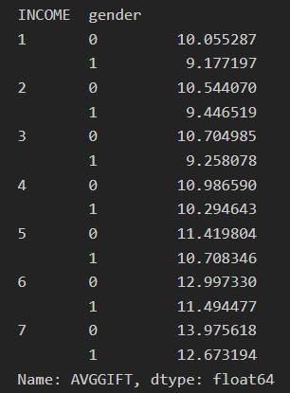
Figure 2.6
Factoring in gender with income, insight can be gained on if differences exist between genders for each income bracket, as shown in figure 2.6. The first three tiers show gender 0 slightly outpacing gender 1 in the amount of donations made. Then in bracket 4 the genders equal out roughly, before returning to the same pattern for the remaining brackets. Given this information, little time would be spent in catering to one gender over another in marketing materials.
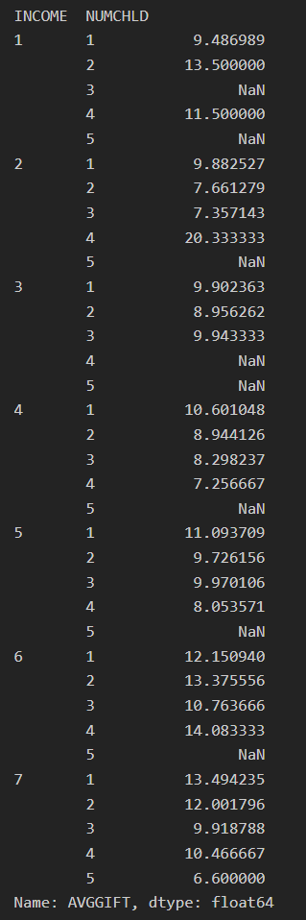
Figure 2.7
Figure 2.7 displays the donations made broken down by child count within each income group. Interestingly, the lower income brackets seem to increase the dollar amount of donations as child count increase, up to income bracket 4 where a change occurs and households with one child tend to donate more than house holds with multiple children.

Conclusions
Data science and analysis are powerful tools. They can be used in a variety of industries including the non-profit sector. This can include any such entity in the space, as such as, one that operates in part or completely due to donations. These can be local, national, or international, they can be focused on a whole selection of topics and functions such as animal rescue, politically based, or any number of other organizations that perform some sort of service or product at a low cost. But, because the donations funding them are paramount to the continuation of their activities, finding ways to maximize the number of donors and the donation amount made by each donor is a key to success.
To this end, the data set was analyzed in order to determine what donors would best maximize per dollar spent advertising and marketing campaigns. As the organization depends to some extent on donor funding, the advertising budget is likely to be very small. Even a large non-profit organization will be dwarfed in the amount of capital a for profit company has to work with, as such it is of fundamental importance to stretch every dollar for the non-profit. The conclusions that can be drawn from the analysis performed give some insight into the donor’s behavior.
From this analysis it can be concluded that the ideal marketing campaign would appeal to both genders, as there was not a significant amount in donation amount between the genders. Likewise, we would want to appeal to households that are in neighborhoods where the average home value is 1500 or higher, as this is predominately where the highest value donations originated from. In the same vein, we would want to advertise to households in these neighborhoods that were single child homes, unless their income was greater than 5 or equal to 2. Additionally, most of the donations that summed to the highest values for the organization seemed to be based around some event in which children were the primary focus, as such, the context for this event should be discerned and replicated if possible.
It should be noted that this is general analysis and as such no findings presented here are to be taken as statistically significant. In other words, these recommendations should be treated as general suggestions and not as concrete evidence. In following analysis, the proper variables would be transformed and a multi-variate linear regression could be used to determine what variables are the most significant in contributing to donators donating, statistically speaking.

