AAPL — Stock & News Analysis Report

Apple Inc. (AAPL) Performance Analysis Report

Timeframe: March 10, 2025 – March 10, 2026

Summary of Price Performance
Apple's stock price increased from $220.09 at the start of the period to $259.89 at the end, representing a total return of approximately 18.1% over the year. The estimated annualized return stands at 24.4%, with an annualized volatility of 31.99%, indicating moderate risk relative to return. The stock experienced a maximum drawdown of -22.99%, reflecting a significant but not extreme decline during the period (see Figure 1: Closing Price Trend, Figure 2: Daily Returns, and Figure 3: Drawdown).

Volatility and Risk
Daily volatility averaged 2.02%, which is consistent with a technology sector stock exhibiting moderate fluctuations. The maximum drawdown suggests some vulnerability to market corrections but remains within a manageable range for long-term investors.

Sentiment Analysis
The sentiment summary from 10 recent articles shows a predominantly neutral stance with 9 neutral articles and 1 negative article, resulting in an average sentiment score of -0.1. No positive articles were identified in this period. This neutral to slightly negative sentiment reflects cautious market views but no strong bearish outlook.

Notable Articles
- [Citi reiterates a Buy rating and a $315 price target on Apple stock][4] highlights continued analyst confidence in Apple's growth potential.
- [Apple Latest Move Is a Brilliant One, and It Could Be a Game Changer for the Stock][5] discusses strategic initiatives that may enhance Apple's competitive position.
- [Is Apple Stock a Buy Now? | The Motley Fool][2] provides a balanced perspective on valuation and growth prospects.
- [FinancialContent - Technical Breakdown: S&P 500 Breaches 100-Day Moving Average as Slow-Motion Decline Eyes 6500][10] reflects broader market caution which may impact Apple indirectly.

Conclusion and Recommendation
Apple has demonstrated solid price appreciation with a healthy return profile despite moderate volatility and a notable drawdown. The neutral to slightly negative sentiment suggests investors are cautious but not pessimistic. Analyst coverage remains positive with buy ratings and optimistic price targets.

**Recommendation:** BUY

**Confidence:** Medium

The recommendation to BUY is based on strong historical returns, positive analyst outlooks, and strategic company moves. However, the moderate volatility and cautious market sentiment warrant a medium confidence level.

---

_Not financial advice._

Sources
[1] https://www.sharecast.com/news/market-report-us-close/us-close-stocks-rebound-after-trump-suggests-iran-war-is-very-complete--21982280.html
[2] https://www.fool.com/investing/2026/03/09/is-apple-stock-a-buy-now/?source=iedfolrf0000001
[3] https://www.fool.com.au/2026/03/10/have-asx-technology-shares-finally-hit-rock-bottom/
[4] https://macdailynews.com/2026/03/09/citi-reiterates-a-buy-rating-and-a-315-price-target-on-apple-stock/
[5] https://www.fool.com/investing/2026/03/09/apples-latest-move-is-a-brilliant-one-and-it-could/?source=iedfolrf0000001
[10] https://markets.financialcontent.com/stocks/article/marketminute-2026-3-9-technical-breakdown-s-and-p-500-breaches-100-day-moving-average-as-slow-motion-decline-eyes-6500

Figures
Figure 1: AAPL_close.png
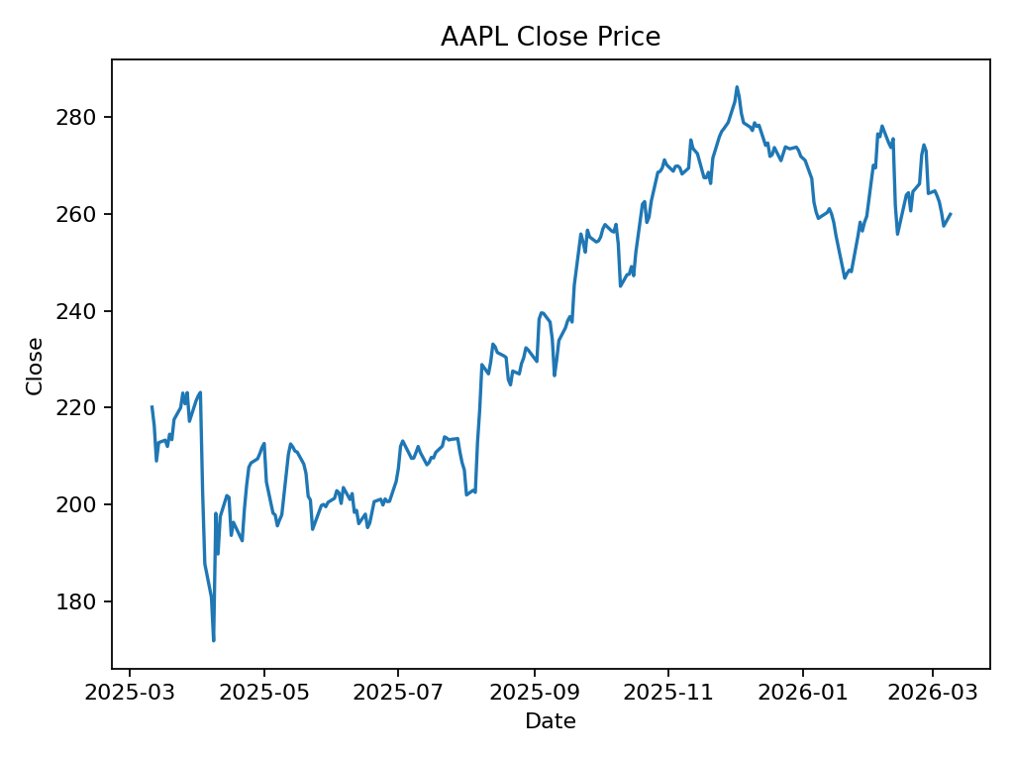
Figure 2: AAPL_daily_returns.png
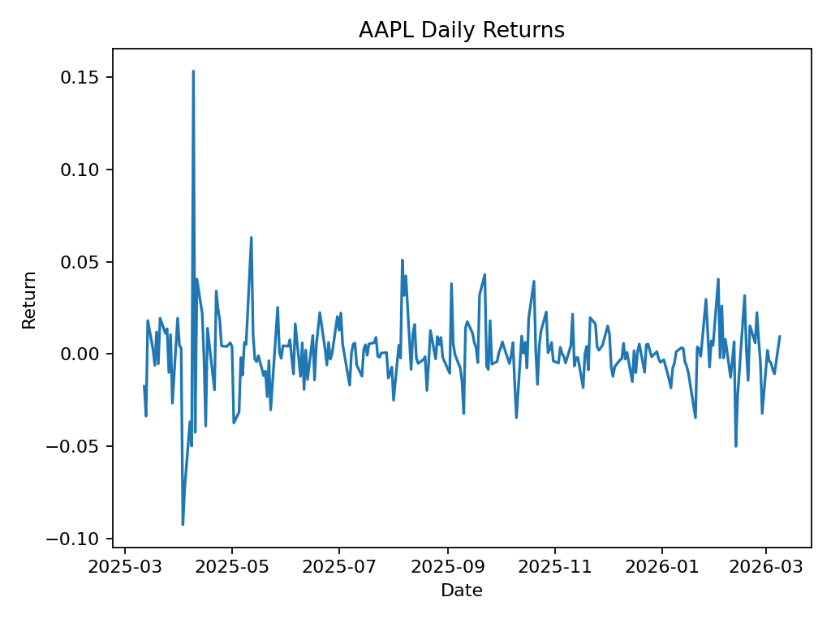
Figure 3: AAPL_drawdown.png
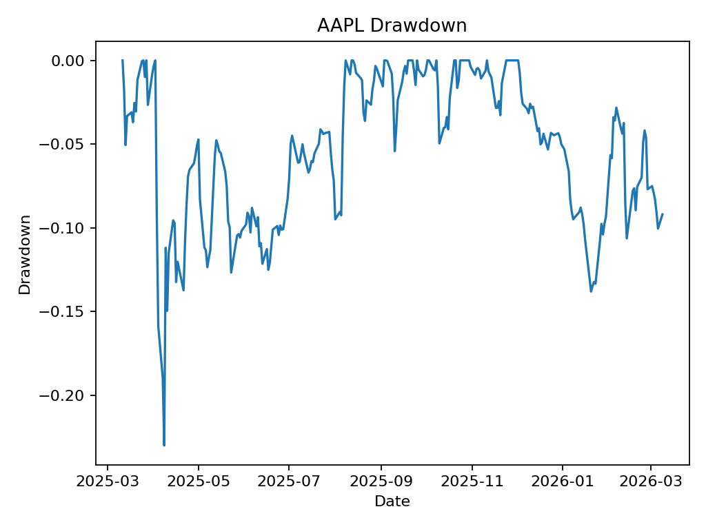

References
References (Article URLs)
[1] US close : Stocks rebound after Trump suggests Iran war is very complete — https://www.sharecast.com/news/market-report-us-close/us-close-stocks-rebound-after-trump-suggests-iran-war-is-very-complete--21982280.html
[2] Is Apple Stock a Buy Now ? | The Motley Fool — https://www.fool.com/investing/2026/03/09/is-apple-stock-a-buy-now/?source=iedfolrf0000001
[3] Have ASX technology shares finally hit rock bottom ? — https://www.fool.com.au/2026/03/10/have-asx-technology-shares-finally-hit-rock-bottom/
[4] Citi reiterates a Buy rating and a $315 price target on Apple stock — https://macdailynews.com/2026/03/09/citi-reiterates-a-buy-rating-and-a-315-price-target-on-apple-stock/
[5] Apple Latest Move Is a Brilliant One , and It Could Be a Game Changer for the Stock — https://www.fool.com/investing/2026/03/09/apples-latest-move-is-a-brilliant-one-and-it-could/?source=iedfolrf0000001
[6] 3 Unstoppable Tech Stocks to Buy Right Now for Less Than $1 , 000 — https://finance.yahoo.com/news/3-unstoppable-tech-stocks-buy-135000741.html
[7] Retirees Take Note : DGRO Yields 2 . 4 %, Has Raised Its Dividend Every Single Year for Over a Decade — https://finance.yahoo.com/news/retirees-note-dgro-yields-2-135422251.html
[8] FinancialContent - Fear Returns to Wall Street : VIX Soars to 23 . 57 as Risk - Off Sentiment Rattles Investors — https://markets.financialcontent.com/stocks/article/marketminute-2026-3-9-fear-returns-to-wall-street-vix-soars-to-2357-as-risk-off-sentiment-rattles-investors
[9] FinancialContent - $166 Billion Windfall : Supreme Court Ruling Triggers Massive Liquidity Injection for U . S . Corporates — https://markets.financialcontent.com/stocks/article/marketminute-2026-3-9-166-billion-windfall-supreme-court-ruling-triggers-massive-liquidity-injection-for-us-corporates
[10] FinancialContent - Technical Breakdown : S & P 500 Breaches 100 - Day Moving Average as Slow - Motion Decline Eyes 6500 — https://markets.financialcontent.com/stocks/article/marketminute-2026-3-9-technical-breakdown-s-and-p-500-breaches-100-day-moving-average-as-slow-motion-decline-eyes-6500

