Odd Semester (2021)



**BINUS UNIVERSITY**

**BINUS INTERNATIONAL**

**Assignment Cover Letter**

**(Individual Work****)**

|  |  |  |  |  |  |  |  |  |
| --- | --- | --- | --- | --- | --- | --- | --- | --- |
|  | | | | |  | |  | |
| **Student Information**: **Surname** | | | | | **Given Names**  **Farras** | | **Student ID Number**  **2101704584** | |
| 1. | | **Yamin** |  | |
|  |  |
| **Course Code** | **: COMP6502** |  |  | | **Course Name** | | **: Introduction to Programming** | |
| **Class** | **: L1AC** |  |  | | **Name of Lecturer(s)** | | **:** 1. Ida Bagus Kerthyayana | |
|  |  |  |  | |  | | 2. Tri Asih Budiono | |
| **Major** | **: CS** |  |  | |  | |  | |
| **Title of Assignment**  (if any) | : Pong Game | |  |  | |  | |  | |
| **Type of Assignment**    **Submission Pattern** | **: Final Project** |  |  | |  | |  | |
| **Due Date** | **: 7-11-2017** |  |  | | **Submission Date** | | **:** | |

The assignment should meet the below requirements.

1. Assignment (hard copy) is required to be submitted on clean paper, and (soft copy) as per lecturer’s instructions.
2. Soft copy assignment also requires the signed (hardcopy) submission of this form, which automatically validates the softcopy submission.
3. The above information is complete and legible.
4. Compiled pages are firmly stapled.
5. Assignment has been copied (soft copy and hard copy) for each student ahead of the submission.

**Pong Game**

Introduction

This program is about a ball that bounce from one side to the other and if it passes the bar then the score will plus one. The purposes are to entertain people and to fulfill my final project.

Flow Chart

Multi

Single

No

Yes

End

Retry,

Yes or No

Play against friend

Play against bot

Single

or

Multi

Start

Explanation

**1. main.py**

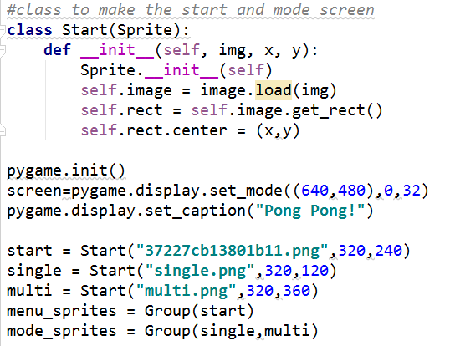

Class Start used to make the start, single, and multi buttons. pygame.init used for   
initialize all imported pygame modules.

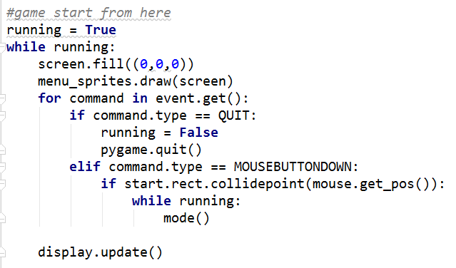

When we run the program, we start with the black screen and the start button will appear. It’ll wait for our input, so if we click the X button (exit), the game will close but, if we click the start button then we’ll go to the mode function.

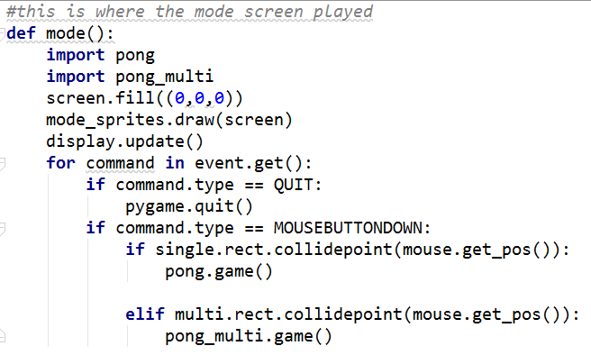

Mode function is where you can choose if you want to play against bot or play with your friend. It’ll wait for your input (mouse click) and after you choose/click, the game will play.

**2. pong.py**

If you choose to play against bot, this module will run. First, there are some variables for the background, the bars, and the circle (the ball).

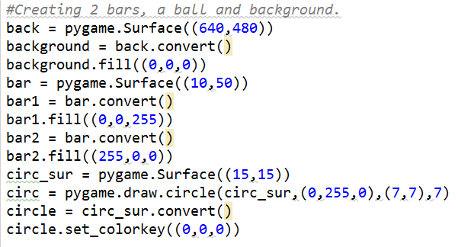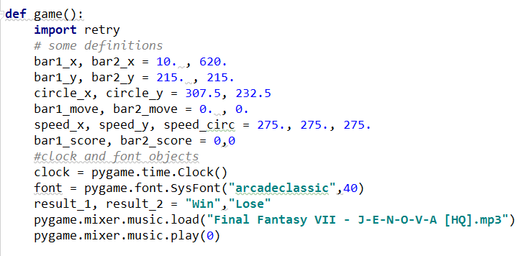

There is a game function, with some variables as well. We define the position for the bars (x,y) and the movement speed. Clock used for create an object to help track time and font used for create a Font object from the system fonts. The background music will play at the moment.

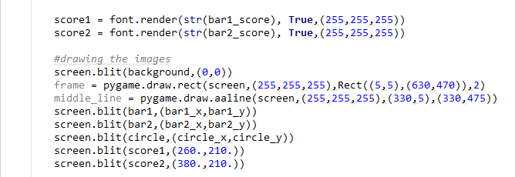

This code will draw the scores, the frame (white square line), the white middle line, the bars and its position, and the circle and its position.

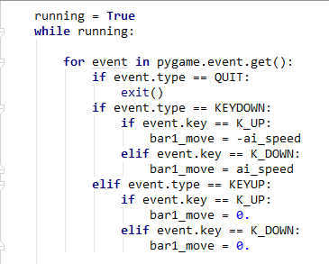

Here is how we moved our bars in game. If our input is we press the up arrow, the bar will go up, vice versa and if we don’t press the button, the bar will stay in its position because the speed is 0.

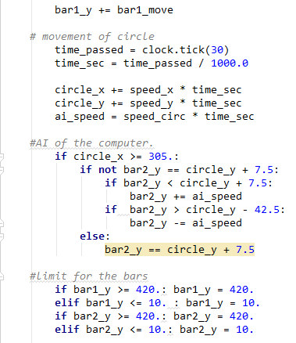

This is how everything move. There are the formulas, yet I don’t know how to explain it on words. For the limit, it’ll limit the bars so it won’t go over the screen if the bars position (x,y) reached the limit.

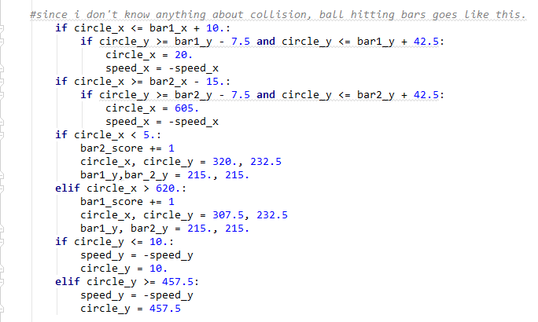

The score will increase for us if the circle’s x is under 620 px and will increase for bot if the circle’s x is under 5 px. After that, the position for the bars will reset and the circle will go again from the center. The score limit is 10.

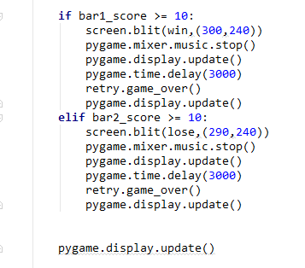

If you win the game, the “WIN” text will appear but if you lose, the “LOSE” text will appear, the background music will stop and it’ll delay about 3 seconds before it goes to the game over screen.

**3. pong_multi.py**

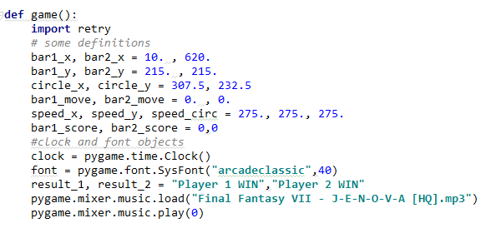

So if you choose to play multiplayer, the pong_multi.py module will run. The beginning of this module is almost the same as pong.py module, there are some variables for the background, the bars, and the circle.

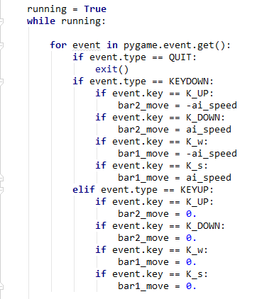

Because it’s multiplayer, so for the first player uses W button to go up and S button to go down, for the second player uses arrow up to go up and arrow down to go down.

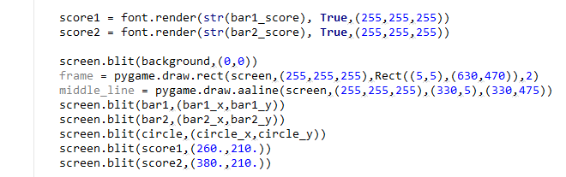

This code will draw the scores, the frame (white square line), the white middle line, the bars and its position, and the circle and its position.

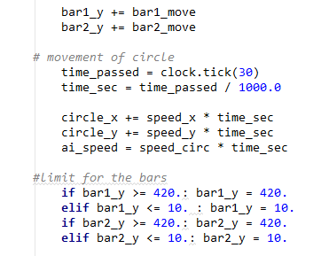

Since we play with our friend, we can remove the AI code. For the limit, it’ll limit the bars so it won’t go over the screen if the bars position (x,y) reached the limit.

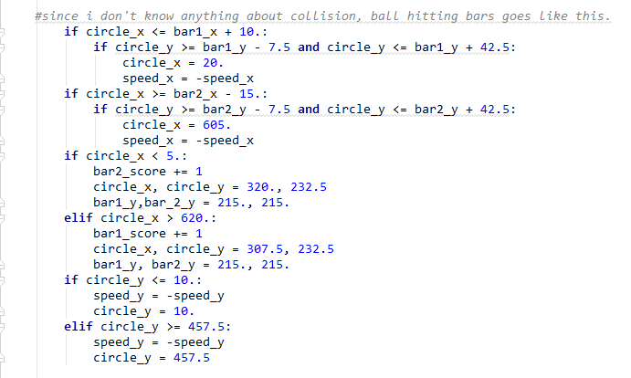

The score will increase for us if the circle’s x is under 620 px and will increase for bot if the circle’s x is under 5 px. After that, the position for the bars will reset and the circle will go again from the center. The score limit is 10.

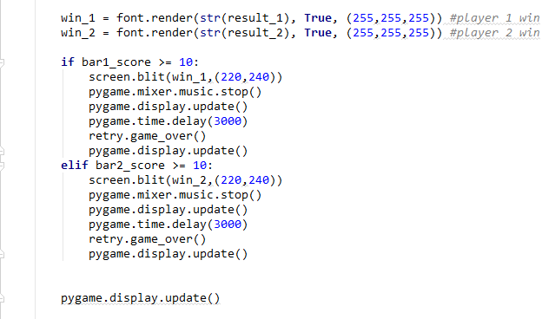

If the left bar wins the game, the “Player 1 WIN” text will appear but if the right bar wins, the “Player 2 WIN” text will appear, the background music will stop and it’ll delay about 3 seconds before it goes to the game over screen.

**4. retry.py**

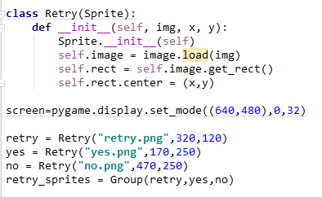

Class Retry used to make the retry image, yes, and no buttons.

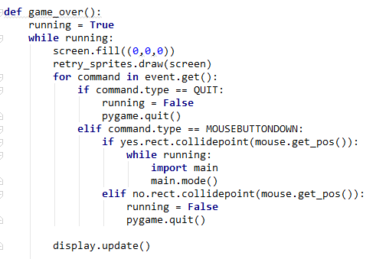

Game over function used after you finish the game, either you lose or win. It’ll draw a retry text, a yes and a no button. It’ll detect your input. If you choose/click no, you’ll quit the game. Else, if you choose/click yes, you can play again.

In game picture

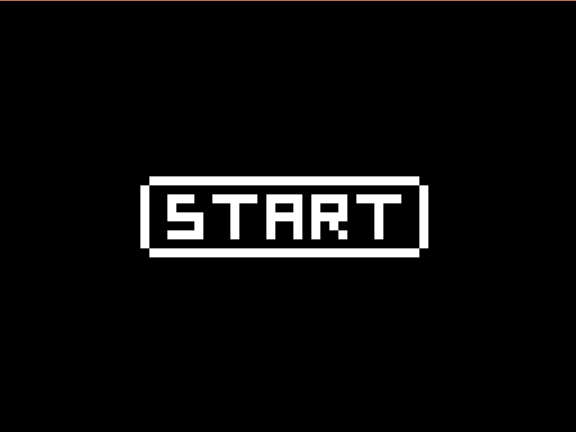

*The start screen.*

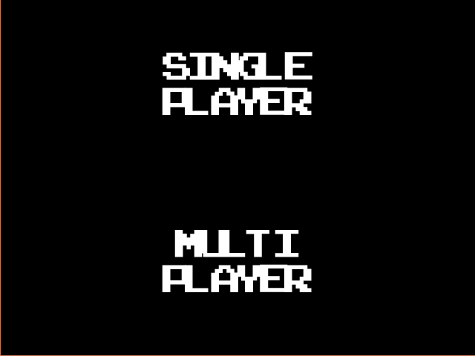

*Choose which one you want to play.*

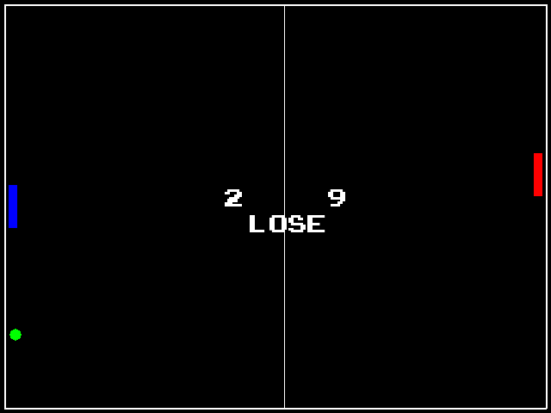

*When you lose in a single player game.*

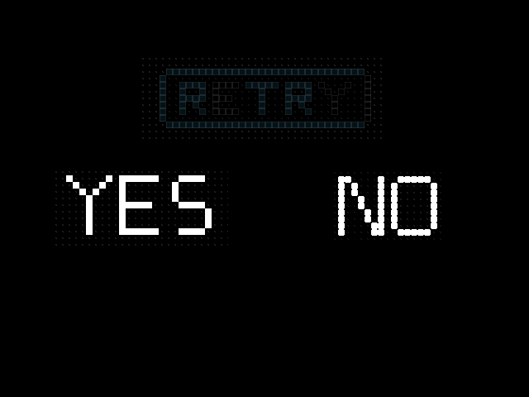

*Retry screen, if you want choose yes, otherwise choose no.*

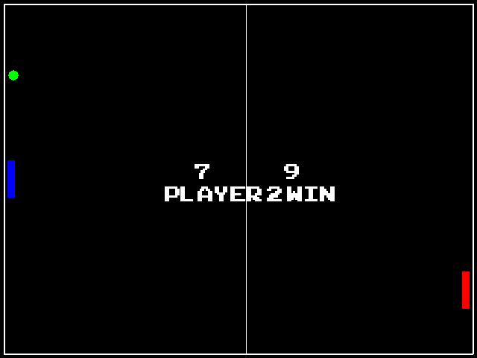

*Multiplayer.*

Disclaimer:

This code is not fully my own work. I copy the main code from the link below and change, add some codes. I fully understand about what I did and take full responsibility of it. The music for my background music “J-E-N-O-V-A” is the original soundtrack of Final Fantasy VII.

Source : http://www.pygame.org/project-Very+simple+Pong+game-816-.html