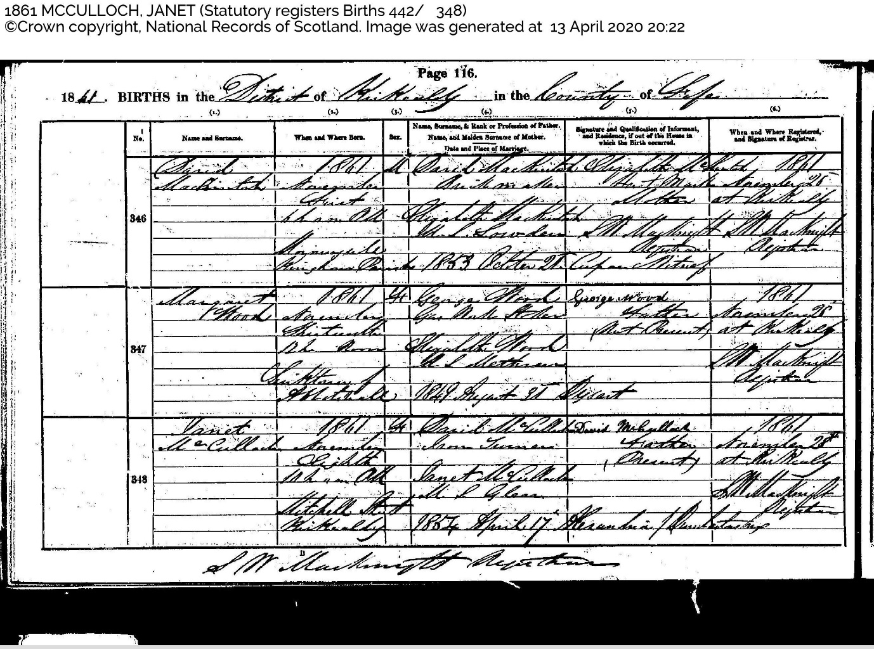
Name and Surname: Janet McCulloch
When and where born: 1861 ? Eighth ? Mitchell Street Kirkaldy
Name, Surname & Rank or Profession of Father: David McCulloch, Iron Turner
Name, and Maiden Surname of Mother: Janet McCulloch, Nee Glenn
Date and Place of Marriage: 1854 April 17th ? / ?

