THE WRECKED EXPRESS
DETAILS AND INCIDENTS OF THE DISASTER
No element of horror was lacking the in awful accident by which at least ten persons were killed on the railway at Thirsk yesterday morning, and which was reported in last night’s Evening Post. Some of the victims doubtless passed from sleep to death almost instantaneously; others, it is feared, may have escaped that happier fate only to perish in the flames which illuminated for hours the scene of one of the most painful catastrophes in the record of railway disaster. The picture even to the imagination is sufficiently appalling.
The train sped on at the rate of fifty miles an hour, and in a moment, even before the driver had realised that the line was obstructed, the crash came, startling the night to such an unmistakable purpose that the noise impelled a signalman a mile and a half distant to telegraph at once for help. Fore soon followed the shock and dissipated the darkness. To exaggerate the horror, the confusion that reigned now and later was indicated to the outside world by the vague, contradictory, but always alarming rumours which travelled from the scene of the disaster. The train in collision was the second portion of the East Coast express from Edinburgh to York and London.
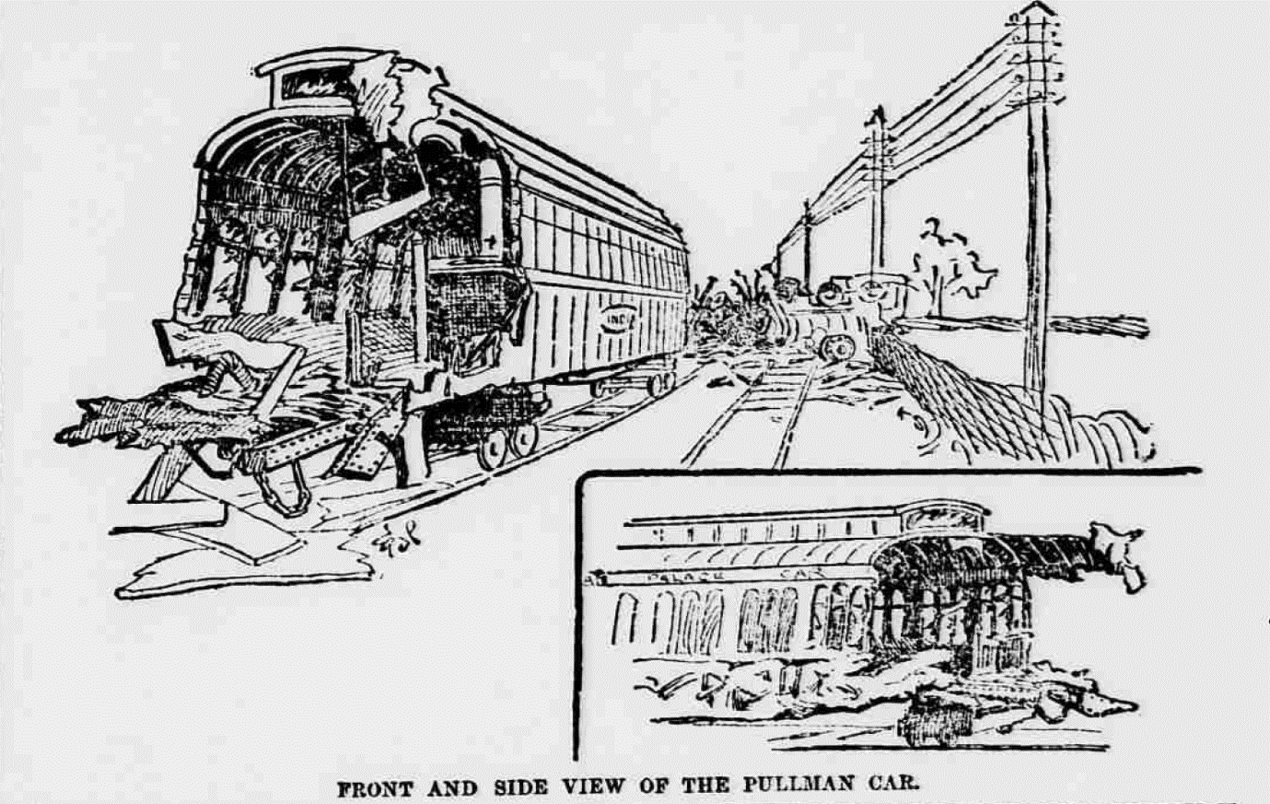
The following are a few of the most striking incidents associated with this dreadful disaster. Further and later details will be found elsewhere.
CHARRED REMAINS
The scene of the collision was visited by some hundreds of spectators, who drove out in traps from Northallerton and other places to witness the ghastly spectacle. The clearing gang diligently pursued their work of trying to get the fire under, and rescuing the bodies. One of those recovered was in such a charred condition that it had to be gathered into a sack and removed to Thirsk. In one particular place there was sad and shocking evidence of the spot in which lay the remains of at least one of the missing bodies, for on a mass of burning debris were visible human remains, and the olfactory nerves conveyed sickening proof of the fact that portion were being consumed by the fire.
TALKING ABOUT THE TAY BRIDGE DISASTER
Mrs J Johnson, who lives near the scene of the disaster, says:- I heard the crash of the collision. The noise awoke me, and I said to my husband, “Whatever is that? It is like the house end falling in.” He replied, “I heard something; but it will very likely be the bumping of some trains shunting.” Soon there was a loud knock at the door. On looking out we were informed that a passenger train was off the line. I lighted a fire whilst my husband went out to see what assistance he could render. I assised three or four out of one of the carriages, a boy about fifteen years of age, and, I think, three young ladies. They told me afterwards that just before the accident occurred they had been talking about the Tay Bridge disaster.
A TOUCHING CASE
A very touching case was that of Mr and Mrs Mackenzie. They were on their way from Edinburgh to London, where the husband, who is a tailor’s cutter, had obtained a situation in Conduit Street, With them they carried their savings, a sum of £20. After the collision Mackenzie found himself under a pile of debris. It was all darkness for a time. A quarter of an hour passed and then a light came. “I looked for my wife,” he say, “and saw her lying with a beam across her chest and her hands help up. I spoke to her, and she gave me no answer. Her name is among the list of the dead.”
DEATH PREFERRED TO MAIMING
Mr Mackenzie says:- The cries of the women and children from fright or injury were something dreadful. The tears come into my eyes when I think of it. I was asleep at the time, and when I realised that a collision had taken place I said to myself that I would rather be killed outright than be seriously maimed.
PUT YOUR LEGS ON THE SEAT
Mr Hodgson, who is at the Station Hotel in York, say:- Everything seemed to be all right until there was a sudden crash, and I saw the sides of the carriage “caving in” tent fashion. I instantly realised the danger and exclaimed to two ladies who were in the third class compartment in which I was, “For God’s sake, put your legs on the seat.” We had hardly done so before the seats crashed together. The doors of the carriages being locked, I crawled out through the window, and lifted out the two ladies. I then assisted to lift out some of the other passengers – about 15 more, I should think – and place them at the side of the line.
LOST THEIR HEADS
Most of the passengers who were not seriously injured (says Mr Hodgson) “lost their heads,” and husbands and wives were crying piteously after their dear ones.
THE MARQUESS WITHOUT BOOTS
The Marquess of Tweeddale had taken off his boots before going to sleep, and when he awoke was unable to find them. He had, therefore, to walk in his stocking feet along the line and across a corner of a grass field, in order to reach the labourers’ cottages, where he and his unfortunate fellow-travellers who were able to go thither found both refreshments as well as shelter.
LOTTIE HAMILTON’S FATE
The McCulloch’s, one of whom was killed and the other injured, were members of a family about to embark for Australia. Their niece, Lottie Hamilton, live for some time after the accident. Her case was an extremely painful one. For a long time her screams were heard before she could be extricated; and not only was it evident that she was badly bruised, but she was suffering frightful agony from contact with the flames. She was tenderly carried towards Thirsk, but on the way she expired.
THE POOR GIRL’S DOLL
Mr McCulloch, of Alexandria, N. B., says :- I went to sleep, and was awoke by a sudden and sharp knock on the head. The next thing I remember was finding myself among a lot of debris. Close by I heard someone moaning, and I scrambled as well as I could to the spot from when the sound came. There I came across the driver of the express. He was suffering very badly, but owing to my own injuries and the cold – I was without hat or shoes – I could not do much to assist him. I spoke to the driver, asking him what had happened. He said, “It’s a terrible accident.” I then inquired, “Were you going hard?” and he replied, “I was going at the rate of 60 miles an hour.” He also said that the express had run into a goods train, and that the signals were in his favour.
HOW LOTTIE HAMILTON WAS IDENTIFIED
Mr McCulloch continued:- Presently I heard a man shout for water to pour on a portion of the wrecked and burning train, and what appeared to be a little bundle was brought out of the wreckage. It as the charred body of my little niece, who was only five years of age, and whose name was Lottie Hamilton. She was burnt beyond recognition. Just before we left Scotland my mother gave her a threepenny piece with a hole in it, and it was through this gift, which was worn round the neck, that I was able to identify the child.
A DISTINGUISHED STUDENT AMONG THE PASSENGERS
Two of the injured are now detained at Thirsk at the Lambert Memorial Hospital. These are the driver of the express – Rowland Ewart, who belongs to Gateshead – and James Buchanan, a Fellow of Peterhouse College, Cambridge, who is a native of Cardross, near Dumbarton, on the Clyde. The injuries of Mr Buchanan, too, are serious, that gentleman being badly cut about the face and head. The authorities at the hospital at once communicated with Mr Buchanan’s father at Cardross, and likewise with Cambridge University, intimating the seriousness of the injuries that gentleman had sustained, and shortly afterwards a reply came from Mr Buchanan’s father that he had set out for Thirsk. Mr Buchanan was a distinguished mathematical student of Glasgow University, from which he proceeded to Cambridge, where he obtained a high place in the mathematical tripos.
MR BUCHANAN’S NARRATIVE
Of the accident Mr Buchanan says:- “Of the actual state of things, when the collision occurred I have absolutely no recollection. I remember absolutely nothing until I was brought to my senses by the cold nipping of my wounds. I was then lying in a field, into which I had been thrown by the force of the collision.”
THE ENGINE-DRIVER AND FIREMANDS EXPERIENCE
The experience of the engine-driver and fireman of the mail was most extraordinary. The were not aware of any danger, and no attempt had therefore been made to pull up the train; and such was the force of the collision that they were both shot from their engine into the air and propelled forward at least 20 yards, into an adjoining field. The engineman had a thigh broken and was otherwise injured; but singularly enough the fireman escaped with nothing more than the shock.
THE ENGINE DRIVER’S HEROISM
The drive himself, as stated, was hurled from his engine a distance of 20 or 30 years into a field adjoining the line. On assistance being tendered to him when found he was a noble-hearted enough to exclaim, “Oh, don’t mind me; look after the passengers!”

