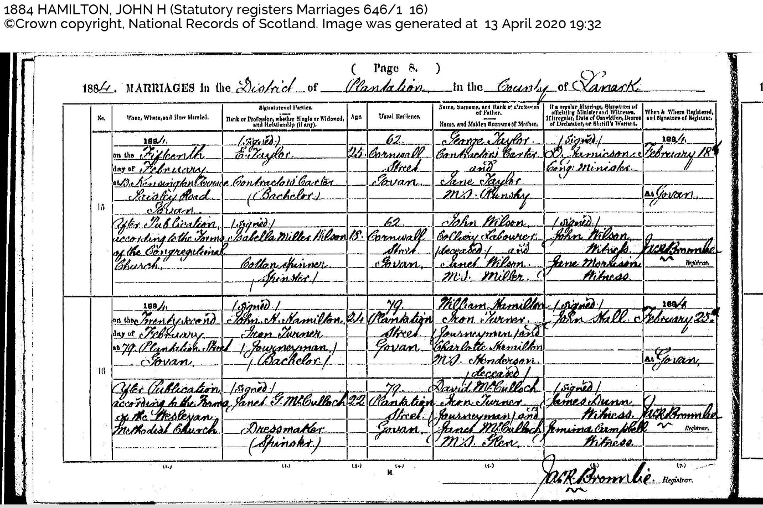
When, Where and How Married: 1884 on the twenty second day of February at 79 Plantation Street Govan. After publication according to the Forms of the Wesleyan Methodist Church
Signature of Parties, Rank or Profession, whether single of widowed and relationship (if any): | Signed | John H Hamilton Iron Turner (Journeyman) (Bachelor) |signed | Janet G McCulloch, Dressmaker (Spinster)
Age: 24 (John), 22 (Janet)
Usual Residence: 79 Plantation Street Govan (both?)
Name, Surname, Rank or Profession of Father. Name and Maiden Surname of Mother: William Hamilton, Iron Turner (Journeyman) and Charlotte Hamilton nee Henderson (deceased). David McCulloch, Iron Turner (Journeyman) and Janet McCulloch nee Glenn
If a regular marriage Signature of officiating minister and Witnesses. If irregular, Date of Conviction, Decree of Declarator, or Sheriff’s Warrant: | signed | John Hall | signed | James Dunn (witness) Jemima Campbell (witness)
When and where registered, and signature of registrar: 1884 February 25th at Govan. Jack Bromlie

