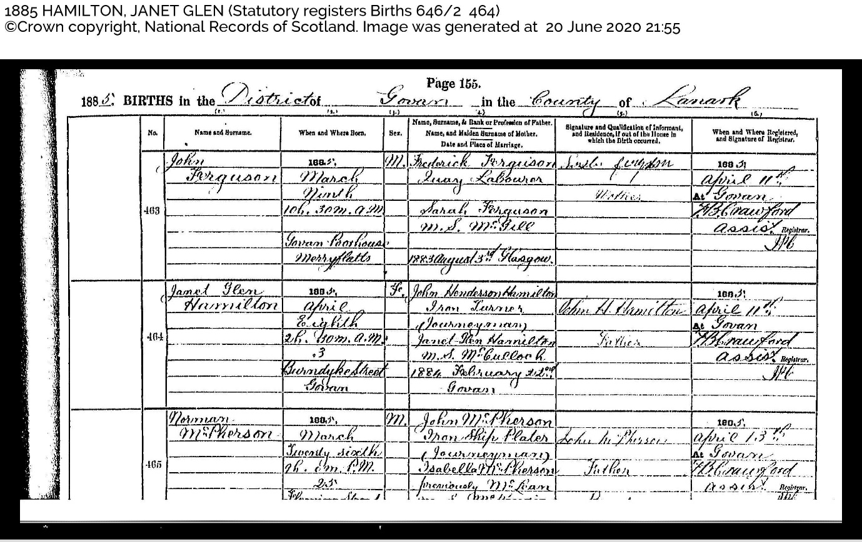
Name and Surname: Janet Glen Hamilton
When and Where Born: 1885 April Eighth 2h 30m am Burndyke Street Govan
Name, Rank or Profession of Father: John Henderson Hamilton, Iron Turner (Journeyman)
Name, and Maiden Surname of Mother: Janet Glen Hamilton nee McCulloch
Date and Place of Marriage: 1884 February 22nd Govan
Signature and Qualification of Informant, and Residence if out of the House in which the birth occurred: John H Hamilton, Father
When and where registered, and signature of registrar: 1885 April 11th at Govan. FB Crawford

