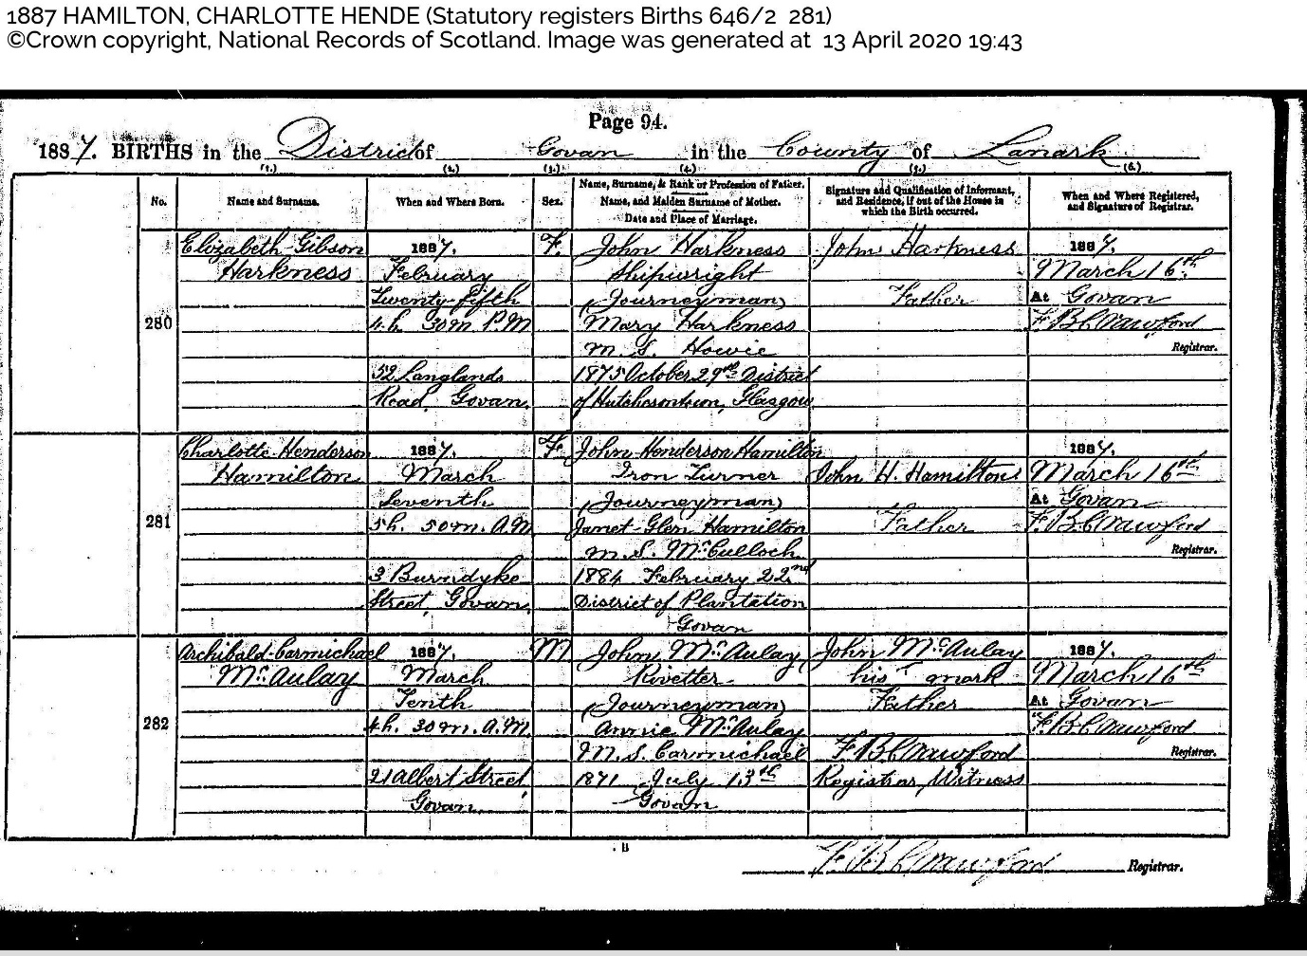
Name and Surname: Charlotte Henderson Hamilton
When and Where Born: 1887 March Seventh 5h 50m am. 3 Burndyke Street Govan
Name, Rank or Profession of Father: John Henderson Hamilton, Iron Turner (Journeyman)
Name, and Maiden Surname of Mother: Janet Glenn Hamilton nee McCulloch
Date and Place of Marriage: 1884 February 22nd District of Plantation, Govan
Signature and Qualification of Informant, and Residence if out of the House in which the birth occurred: John H Hamilton, Father
When and where registered, and signature of registrar: 1884 March 16th at Govan. FB Crawford

