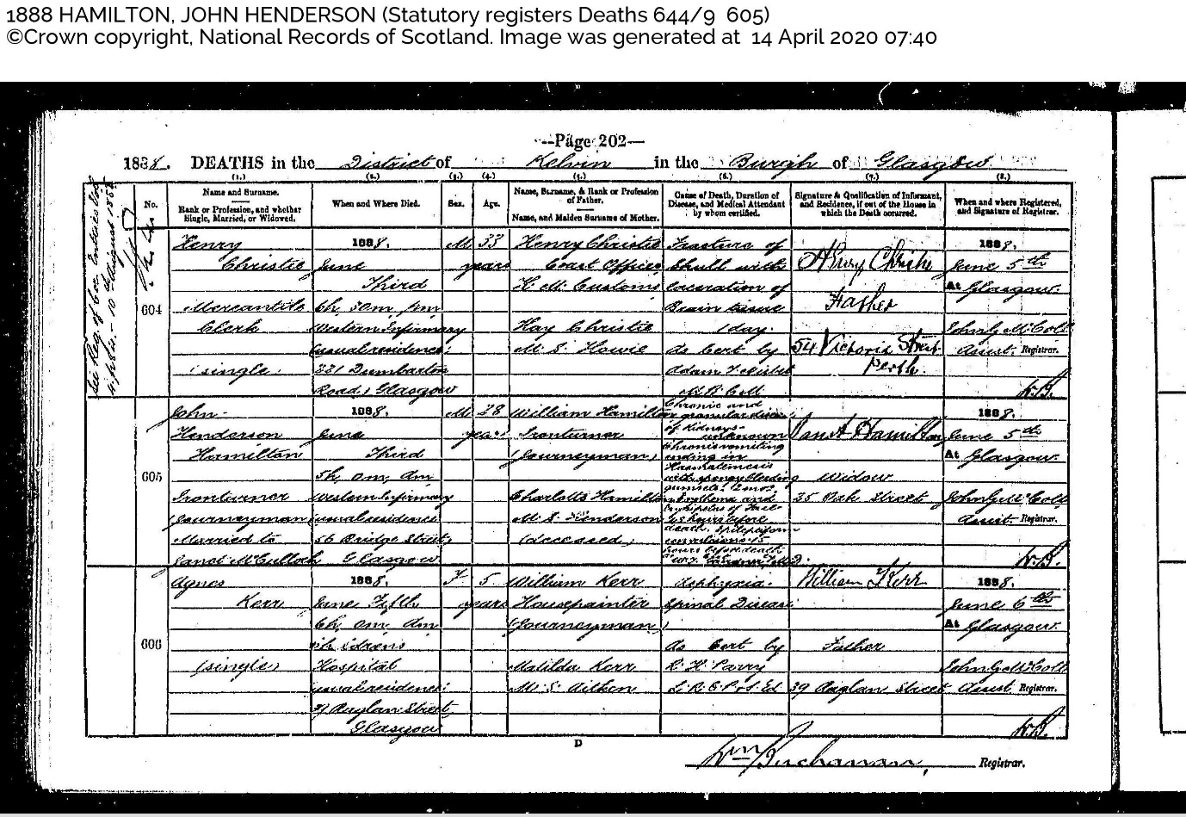
Name and Surname = John Henderson Hamilton
Rank or Profession, and whether single, married or widowed = Iron turner (journeyman). Married to Janet McCulloch
When and where died = 1888 June Third 5h 0m am Western Infirmary (usual residence 56 Bridge Street Glasgow)
Sex = M
Age = 28 years
Name, Surname & Rank of Profession of Father = William Hamilton, Iron turner (journeyman)
Name, and Maiden Surname of Mother = Charlotte Hamilton Nee Henderson (deceased)
Cause of Death, Duration of Disease, and Medical Attendant by whom certified = Chronic and granular disease of kidneys- unknown chronic vomiting ending in Haematemesis with ? bleeding gums etc! ? Erythema and Erysipelas of face 48 hours before death. ? convulsions 15 hours before death. ? ? ? ?

Haematemesis = vomiting blood
Erythema = (from the Greek erythros, meaning red) is redness of the skin or mucous membranes, caused by hyperemia (increased blood flow) in superficial capillaries.
Erysipelas = also known as St. Anthony's fire, is a relatively common bacterial infection of the superficial layer of the skin (upper dermis), extending to the superficial lymphatic vessels within the skin, characterized by a raised, well-defined, tender, bright red rash typically on the face or legs, but can occur anywhere in skin. It is a form of cellulitis and is potentially serious.
Signature & Qualification of Informant, and Residence, if out of the House in which the Death occurred = Janet Hamilton, Widower, 35 Dake(?) Street

