1891 Scotland Census Data
Name | Janet Hamilton | Janet McCulloch
Age | 29 | 60
Estimated birth year | Abt 1862 | Abt 1831
Relationship | Head | Head
Gender | Female | Female
Where born | Kircaldy, Fifeshire | Old Kilpatrick, Dumbartonshire
Registration Number | 493 | 493
Registration district | Bonhill | Bonhill
Civil parish | Bonhill | Bonhill
County | Dumbartonshire | Dumbartonshire
Address | 25 Main Street | 106 Main Street
Occupation | Dressmaker | Housewife
ED | 7 | 5
Household schedule number | 81 | 61
Line | 17 | 7
Roll | CSSCT1891_157 | CSSCT1891_157
Household Members | Janet Hamilton (29)  Janet Hamilton (5)  Charles Hamilton (4) | Janet McCulloch (60)  Eliza McCulloch (23)  Annie McCulloch (21)  William McCulloch (17)

Streetview image of 25 Main Street:
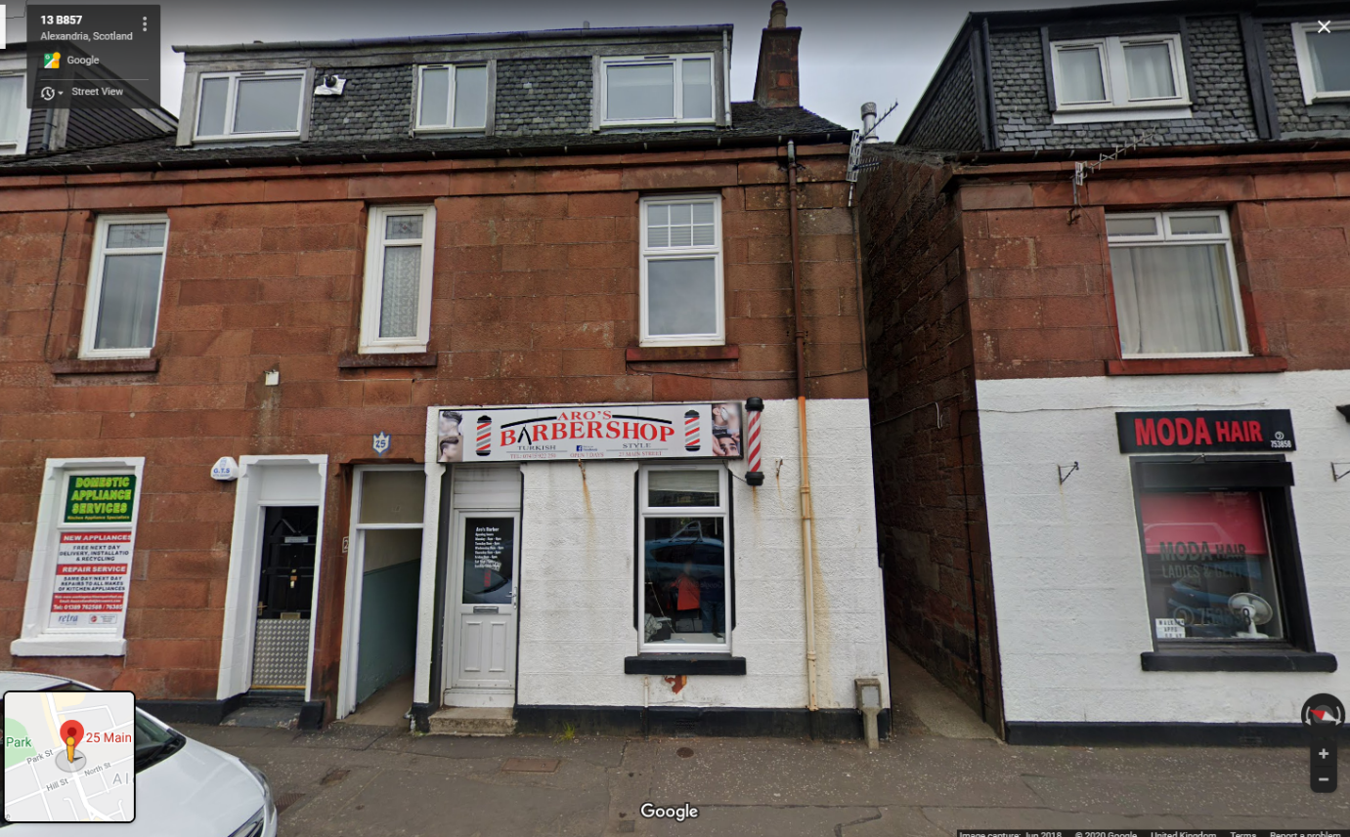

At the same address (searched for Bonhill in registration district and 25 Main St in address) are 16 other people listed in 4 other households (single room each?)
Family of 6:

Name Age
John Smith 37
Jeanie Smith 40
James Smith 10
John Smith 9
Andrew Smith 4
Robert Smith 3

Family of 3:
Archel Logan 62
Isabella C Logan 33
Mary M Logan 27

Family (?) of 3:
Helen Edmond 73
Jessie Edmond 33
Robert Campbell 44

Family(?) of 4:
John McAuslane 22
Sarah McAuslane 17
Susan McAuslane 3 Mo
Malcolm M D Gregor 21

According to mouseprice this building is now split in 3 flats:
25/3 Main Street G83 2 bed worth £57,000 internal area 61m2
25/2 Main Street G83 ? bed worth £59,000 internal area ?
25/1 Main Street G83 3 bed worth £59,000 internal area ?

