1.(a) The Species class inherits from the parent class Genus.

1.(b)The Specimen class has a variable that is a Species object.

1.(c)

|  |
| --- |
| Species |
| -String speciesName |
| +getSpeciesName() : String  +setSpeciesName(s : String ) : void  +toString():String |

1.(d)

Avoids repeating code because it inherits the properties of the parent class.

The code becomes easier to test because the parent class’s functionality does not need to be re tested.

1.(e)(i) It refers to the method defined within the Species class. Since the human is an instance of the Species class, it is able to invoke the toString() method within that class.

1.(e)(ii) Overriding

2.(a) Encapsulation is the practice of hiding data within a class and being able to access and manage that data by using methods.

2.(b)One advantage of encapsulation is that it allows the hiding and security of data. Another is that it allows the programmer to reuse the code again and again.

2.(c) The getName() method within the Specimen class.

2.(d) The name variable within the Specimen class.

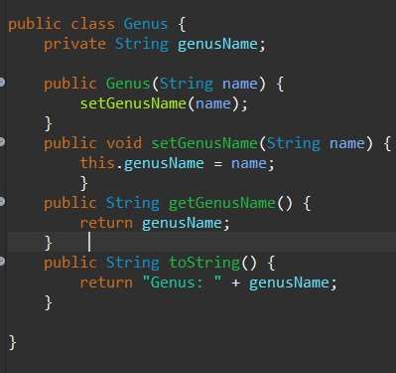2.(e)

2.(f) One advantage is that the Specimen object would continue to inherit the properties of the Species class and one disadvantage of this is that the data may take up more memory.

3.(a) A new markings instance variable within the Specimen class can be added, purposeful getter and setter methods should also be added and the toString() method should now contain the description for the markings.

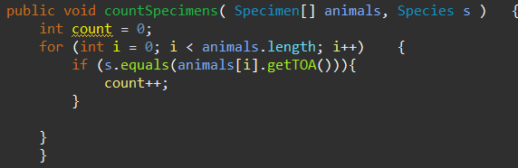3.(b)

3.(c)

4.(a) An abstract data type is one that has no implementation details

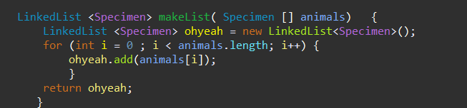4.(b)

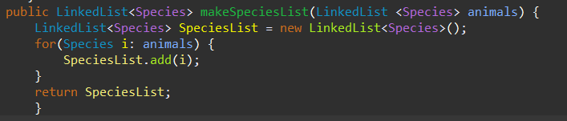4.(c)

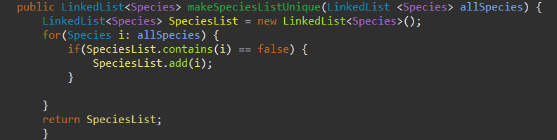4.(d)