|  |  |
| --- | --- |
|  | Data Analytics |

Energy Consumption in France:

Data Analysis and Predictive Modeling

Adel Chahed

March, 2023

## Table des matières

Table des matières 2

Introduction 4

Plan 5

Data and data sources 6

Energy Consumption and Production 6

Holidays 8

Weather 8

Data collection 9

Data cleaning and Exploratory data analysis 10

Fixing the Datetime Type 10

Creating New Features 10

Dropping & Creating Columns 10

Dropping & Creating Rows 10

NaN Handling 11

Outliers 11

SQL connection 11

EDA with Python 13

SQL or NoSQL 18

ERM 19

MySQL Queries 21

Conclusion 27

Annexe 28

Project plan 28

Github 28

## 

## 

## Introduction

Energy consumption is a critical topic in today's society and economy, with implications for climate change, energy transition, and energy sovereignty. Climate change has become an urgent and pressing issue, with the increase in global temperature posing a significant threat to the planet's ecosystem. Therefore, it's important to examine how we consume energy and understand how we can reduce our carbon footprint.

This report focuses on energy consumption in France, which is essential for understanding the country's energy usage but also for gaining insights into how we can predict the consumption in the future. The interest in this topic stems from the recent energy crisis caused by the geopolitical tensions between Russia and Ukraine, which have highlighted the importance of energy security. Given my deep interest in the challenges related to climate change and energy transition, it was clear to me that I should focus my final project on this topic.

To gather data on energy consumption, production, and weather, I used an open data platform called ODRE, which provides access to various energy-related datasets. Additionally, I discovered a dashboard on RTE France’s website that displays real-time energy consumption metrics in France, which I found fascinating. It inspired me to extract the data and perform further analysis. I also extracted a dataset about public holidays in France to see if it’s an important feature for energy consumption.

The goal of this project is to develop a time series model that predicts energy consumption in France based on historical data and identifies the key features that drive energy consumption. The aim of this report is to enhance our understanding of this crucial topic as citizens, and to assist energy management decisions in making more informed choices regarding energy consumption and production.

## Plan

1. Data collection: Obtain data from the appropriate sources
2. Data Cleaning: Load CSVs into Python and clean it
3. Create a Database in MySQL
4. Export clean data to MySQL for processing
5. Join datasets into one
6. Data Description Analytics with Python
7. Process data to use appropriate metrics
8. Times Series Model: prediction of the energy consumption
9. Feature Selection and Engineering
10. Prediction of the energy consumption based on appropriate features

## Data and data sources

For this project, I am going to use three datasets to analyze the energy consumption in France over time: “Energy Consumption and Production”, “Weather” and “Holidays".

### Energy Consumption and Production

This dataset provides real-time data on electricity consumption and production in France, refreshed every hour. The data includes actual consumption, forecasted consumption, production from different energy sources, consumption by pumps in energy transfer stations, physical exchanges at borders, and estimated carbon emissions generated by electricity production in France. The dataset also includes information on the breakdown of production by technology and energy source. The data is provided at a quarter-hourly interval and includes a historical depth of January 2012 to May 2022 (around 400k rows).

The dataset is produced by RTE (French electricity transmission system operator) and is available for free via the éCO2mix tool, which is designed to help consumers better understand and consume electricity.

|  |  |
| --- | --- |
| **Column Name** | **Description** |
| Périmètre | The geographic scope of the data, which covers the entire territory of France |
| Nature | The type of data, which includes consolidated and final data |
| Date | The date of the data point |
| Heure | The hour of the data point |
| Date et Heure | The date and time of the data point |
| Consommation (MW) | Actual electricity consumption in megawatts (MW) |
| Prévision J-1 (MW) | Forecasted electricity consumption for the previous day in MW |
| Prévision J (MW) | Forecasted electricity consumption for the current day in MW |
| Fioul (MW) | Production from oil in MW |
| Charbon (MW) | Production from coal in MW |
| Gaz (MW) | Production from gas in MW |
| Nucléaire (MW) | Production from nuclear power plants in MW |
| Eolien (MW) | Production from wind turbines in MW |
| Solaire (MW) | Production from solar power in MW |
| Hydraulique (MW) | Production from hydroelectric power in MW |
| Pompage (MW) | Consumption by pumps in energy transfer stations in MW |
| Bioénergies (MW) | Production from bioenergy sources in MW |
| Ech. physiques (MW) | Physical exchanges with neighboring countries in MW |
| Taux de CO2 (g/kWh) | Estimated carbon emissions generated by electricity production in France in grams per kilowatt-hour (g/kWh) |
| Ech. comm. Angleterre (MW) | Commercial exchanges with England in MW |
| Ech. comm. Espagne (MW) | Commercial exchanges with Spain in MW |
| Ech. comm. Italie (MW) | Commercial exchanges with Italy in MW |
| Ech. comm. Suisse (MW) | Commercial exchanges with Switzerland in MW |
| Ech. comm. Allemagne-Belgique (MW) | Commercial exchanges with Germany and Belgium in MW |
| Fioul - TAC (MW) | Production from oil in cogeneration units in MW |
| Fioul - Cogénération (MW) | Production from oil in thermal power plants with cogeneration in MW |
| Fioul - Autres (MW) | Production from other oil sources in MW |
| Gaz - TAC (MW) | Production from gas in cogeneration units in MW |
| Gaz - Cogénération (MW) | Production from gas in thermal power plants with cogeneration in MW |
| Gaz - CCG (MW) | Production from combined cycle gas turbines in MW |
| Gaz - Autres (MW) | Production from other gas sources in MW |
| Hydraulique - Fil de l'eau + éclusée (MW) | Production from hydroelectric power using water flows and lock systems in MW |
| Hydraulique - Lacs (MW) | Production from hydroelectric power using lakes in MW |
| Hydraulique - STEP turbinage (MW) | Production from hydroelectric power using pumped storage in MW |
| Bioénergies - Déchets (MW) | Production from bioenergy sources using waste in MW |
| Bioénergies - Biomasse (MW) | Production from bioenergy sources using biomass in MW |
| Bioénergies - Biogaz (MW) | Production from bioenergy sources using biogas in MW |

### Holidays

This dataset, "Jours fériés en France", provides information on French public holidays as defined by the labor code. The data includes the date of the holiday, the year it occurred, the geographic area it applies to (such as mainland France), and the name of the holiday. The dataset covers holidays for up to 20 years in the past and 5 years in the future from the current year. The data is provided in CSV format and extracted from the Government’s open data platform.

|  |  |
| --- | --- |
| **Column Name** | **Description** |
| date | Date of the holiday |
| annee | Year of the holiday |
| zone | Geographic area the holiday applies to (e.g., "Métropole" for mainland France) |
| nom_jour_ferie | Name of the holiday |

### 

### Weather

The weather dataset includes daily historical data on maximum power (in GW) required to cover the peaks of French gross consumption. It also includes values of reference and average temperatures. The dataset is provided by RTE and Météo-France, updated monthly, and covers the entire territory of France. The temporal granularity is daily, and the depth of history ranges from 2012 to M-1 (previous month). The dataset is licensed under the Open License v2.0 (Etalab) and the data source is available on the ODRE platform. The dataset is related to electricity energy and the networks of distribution and transport.

|  |  |
| --- | --- |
| **Column Name** | **Description** |
| Date | Date of the day for which the data is recorded |
| Pic journalier consommation (MW) | Maximum power (in MW) required to cover the peaks of French gross consumption on that particular day |
| Température moyenne (°C) | Average temperature (in °C) on that particular day |
| Température référence (°C) | Reference temperature (in °C) on that particular day |

## Data collection

The above data was collected by exporting the CSVs respectively from each platform. Then the data was parsed properly as shown in the next section, using Python.

## Data cleaning and Exploratory data analysis

### Fixing the Datetime Type

In the three datasets, I had to fix some data types. The most important feature to fix was the datetime and date columns.  


### Creating New Features

For all the dataset I have created more features about time to be able to match the rows in SQL. We have a datetime column in the Energy Consumption and Production dataset and each row of the table corresponds to an hour of a day. But in the other datasets, each row corresponds to a day, so we have a lot more rows in the first dataset.

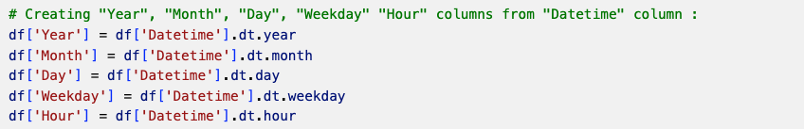

### Dropping & Creating Columns

I dropped many low variance columns, with unique values. For example, columns regarding the geographical area (which is only France) or the kind of data (consolidated or final data). I also dropped very specific columns useless for our analysis in order to simplify our datasets. This includes columns regarding very specific kind of technologies of different energy sources and the name of each public holiday. Moreover, I have created a calculated field “Temperature Deviation (°C)” in the Weather dataset which is the difference between the average temperature and the reference temperature.

### Dropping & Creating Rows

In our main dataset, the temporal granularity is quarter-hourly to half-hourly. But the quarter-hourly rows were empty so I dropped them. So, the temporal granularity became half-hourly. In the other datasets, I had to drop rows to match the time range of our main dataset. In the Holidays dataset there was only public holidays, so I have created a flag feature with 1 value for holidays. So, I had to create new rows of “normal” days (that are not holidays) with the flag feature equal to 0 between the holidays inside the time range.

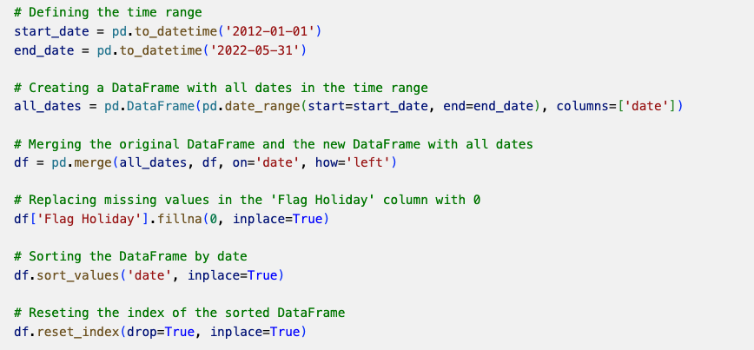

### NaN Handling

In the main dataset, I got around 700 rows ​ with missing values out of 180,000 records. I replaced the null values with the median values of the columns.

### Outliers

I tried to analyze the dataset in order to detect outliers, but I wasn't really convinced by the idea of removing them and probably corrupting the data. The outliers seem to occur exclusively in winter, probably because of cold waves. I preferred to keep these data in order to study the evolution of the number of days with extreme temperature deviation and to see if climate change can play a role in the evolution of energy consumption.

### SQL connection

After the cleaning of the data, I was able to go ahead and insert the tables into MySQL. The reasons for that choice are explained in the next section. I connect the Python file with the MySQL database that I already established using PyMySQL, and SQLalchemy. Thus, I end up with 3 tables in MySQL, one for each of ‘holidays’, ‘energy_consumption_in_france’, ‘weather’. Once the data has been added and cleaned successfully, the subsequent chapter will involve analysis using SQL. However, at present, we will shift our attention back to EDA with Python.

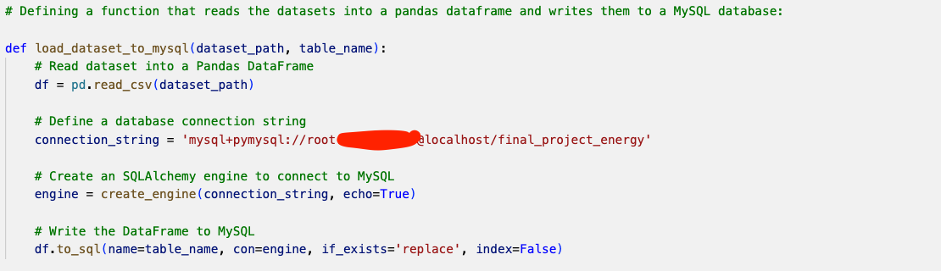

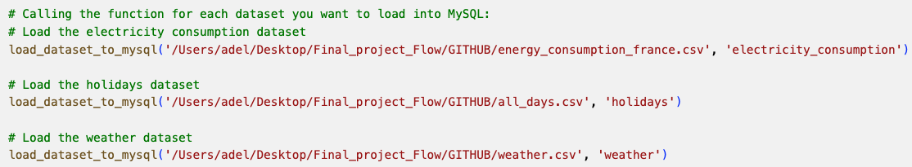

### 

### EDA with Python

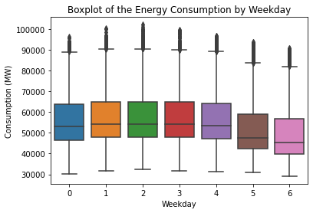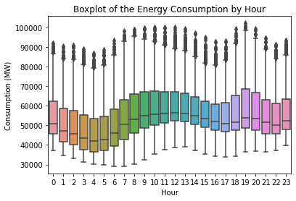

These boxplots allow us to visualize the evolution of the average energy consumption over time: per year, per month, per hour of the day and per day of the week (Monday is 0).

We observe that the energy consumption remains relatively stable over the years, with slight variations, especially in 2020 with the lockdown.

Some years seem to have a large number of outliers, this is mainly due to cold waves in winter (2012 is the most affected year).

We notice a seasonal pattern for the months, this was to be expected. In France, we observe that the consumption peaks are in winter (some hot countries may have the opposite pattern because of air conditioning). The boxplot of the months confirms that it is indeed in winter that the vast majority of outliers are found.

The boxplots on the hour and weekdays illustrate that we consume more energy on days and hours when we are working. Indeed, we observe a decrease in consumption on weekends and nights.

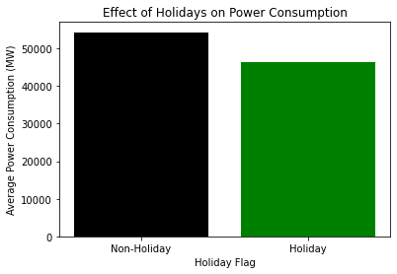

We consume less energy on public holidays.

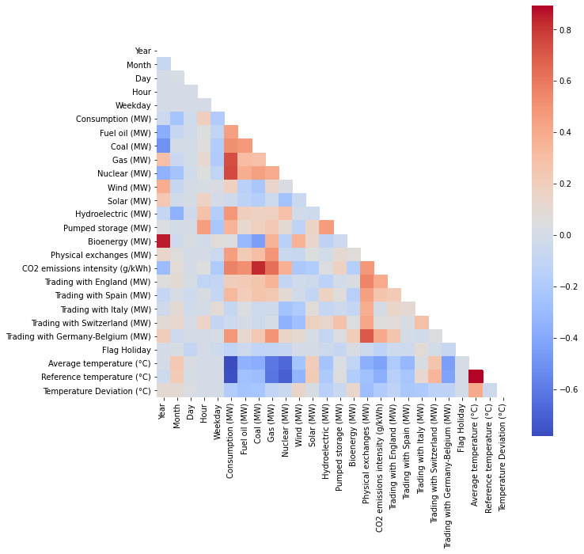

In this heat map the column "Consumption (MW)" is correlated with energy sources, which is logical, but mostly with gas and nuclear. This may indicate that these are probably important sources in the energy mix. The consumption is also correlated with the CO2 emission intensity. We also observe that there is a strong negative correlation between average and reference temperature and consumption. This means that we consume more energy when it is cold, which is in agreement with the previous charts.

Apart from that, we can also observe that there is a strong correlation between CO2 emissions and fuel oil, coal and gas.

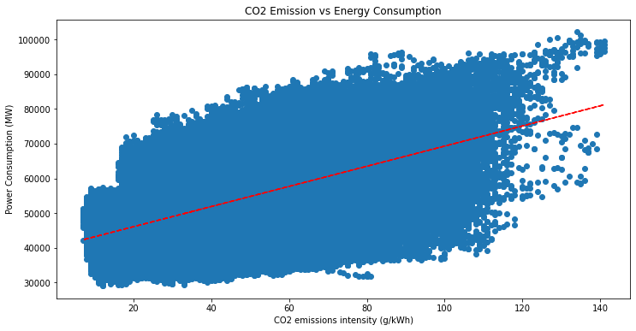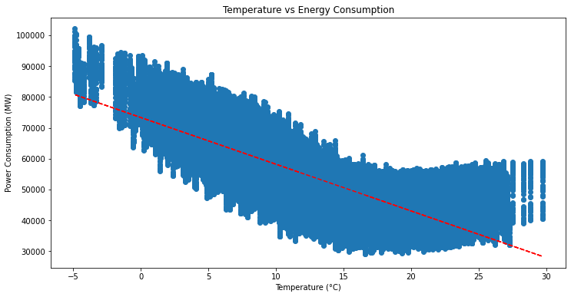

Indeed, energy consumption is correlated with temperature (it increases with the cold in France) and CO2 emissions.

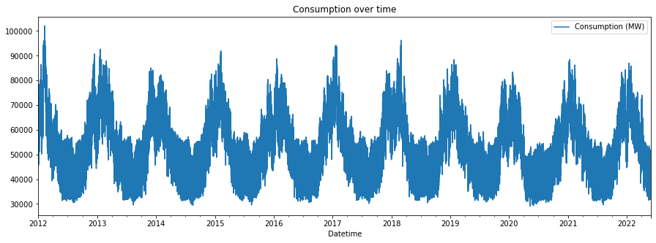

The chart representing energy consumption over time reaffirms our previous observation from the boxplots and provides a clearer illustration of the seasonal pattern.

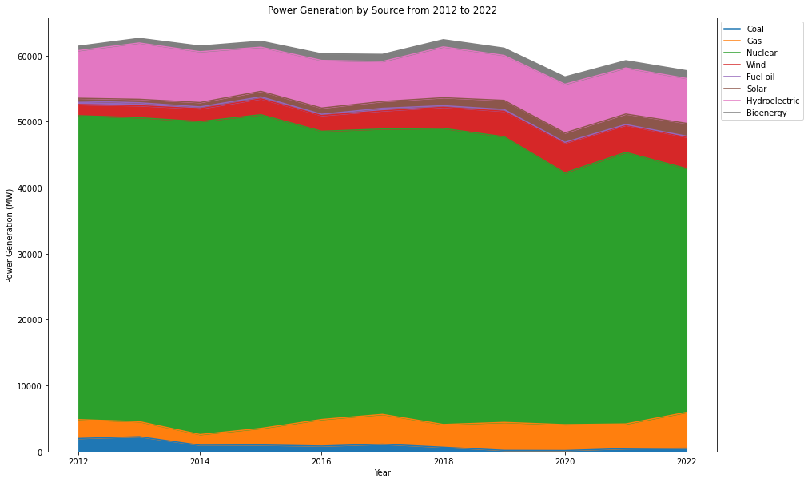

This area chart of the share of the types of energy sources in France shows us that nuclear is the main source of energy, and its share in the energy mix seems to be decreasing in recent years. Then comes hydroelectricity whose share seems to be stable in the mix. Wind power is our third source of energy and we observe a growth in its share in the mix during the last decade, this is also the case for solar energy. The share of gas seems to be increasing since 2014.

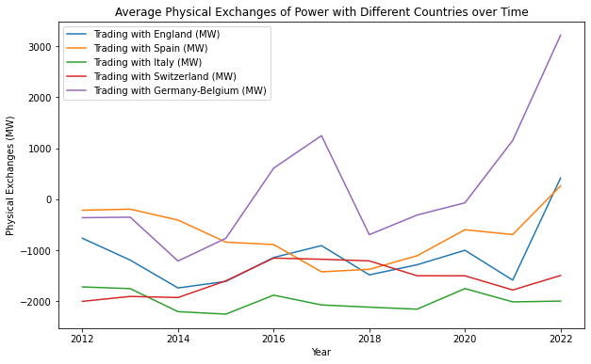

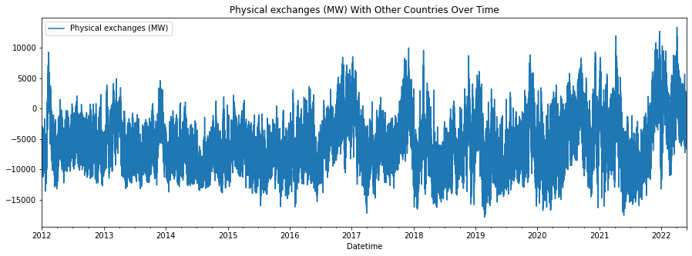

The two charts above illustrate the evolution of energy exchanges with neighboring countries. When the values are negative, France is exporting energy and when they are positive, it is importing electricity. We observe that France was an exporter on average during this decade but we can observe a trend towards imports. The production capacity seems to be increasingly overwhelmed in the winters. Imports mainly from Germany and Belgium, this may leave us that the French regions bordering these countries do not have close or efficient production capacity.

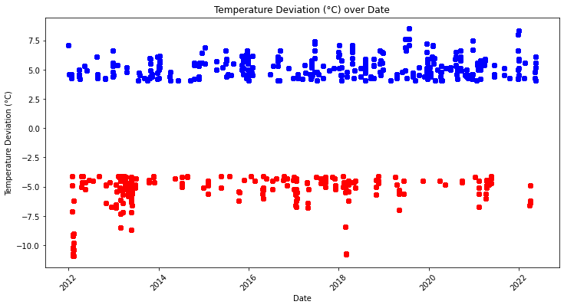

This scatter plot illustrates the number of days when the Temperature Deviation was significant (+4°C or -4°C). We observe that indeed 2012 was a year with strong waves of exceptional cold. But there is a slight tendency towards more extreme values in heat and less in cold.

## SQL or NoSQL

After conducting a thorough examination of the differences, benefits, and drawbacks of each database type, the primary distinctions can be summarized as follows:

* SQL databases are relational and rely on structured query language and predefined schemas. In contrast, NoSQL databases are non-relational and have dynamic schemas designed for unstructured data.
* SQL databases are vertically scalable, while NoSQL databases are horizontally scalable.
* SQL databases use a table-based model, whereas NoSQL databases are available in various forms, including document, key-value, graph, or wide-column stores.
* SQL databases are ideal for multi-row transactions, while NoSQL databases are better suited for handling unstructured data such as documents or JSON.

Given that structured tables with predefined schemas are used in our case, it seems appropriate to use SQL. Additionally, if we anticipate adding more data or sources in the future, SQL would be preferable due to its vertical scalability and ability to perform multi-row transactions.

## 

## 

## ERM

The diagram for our entity relation model can be seen as follows:

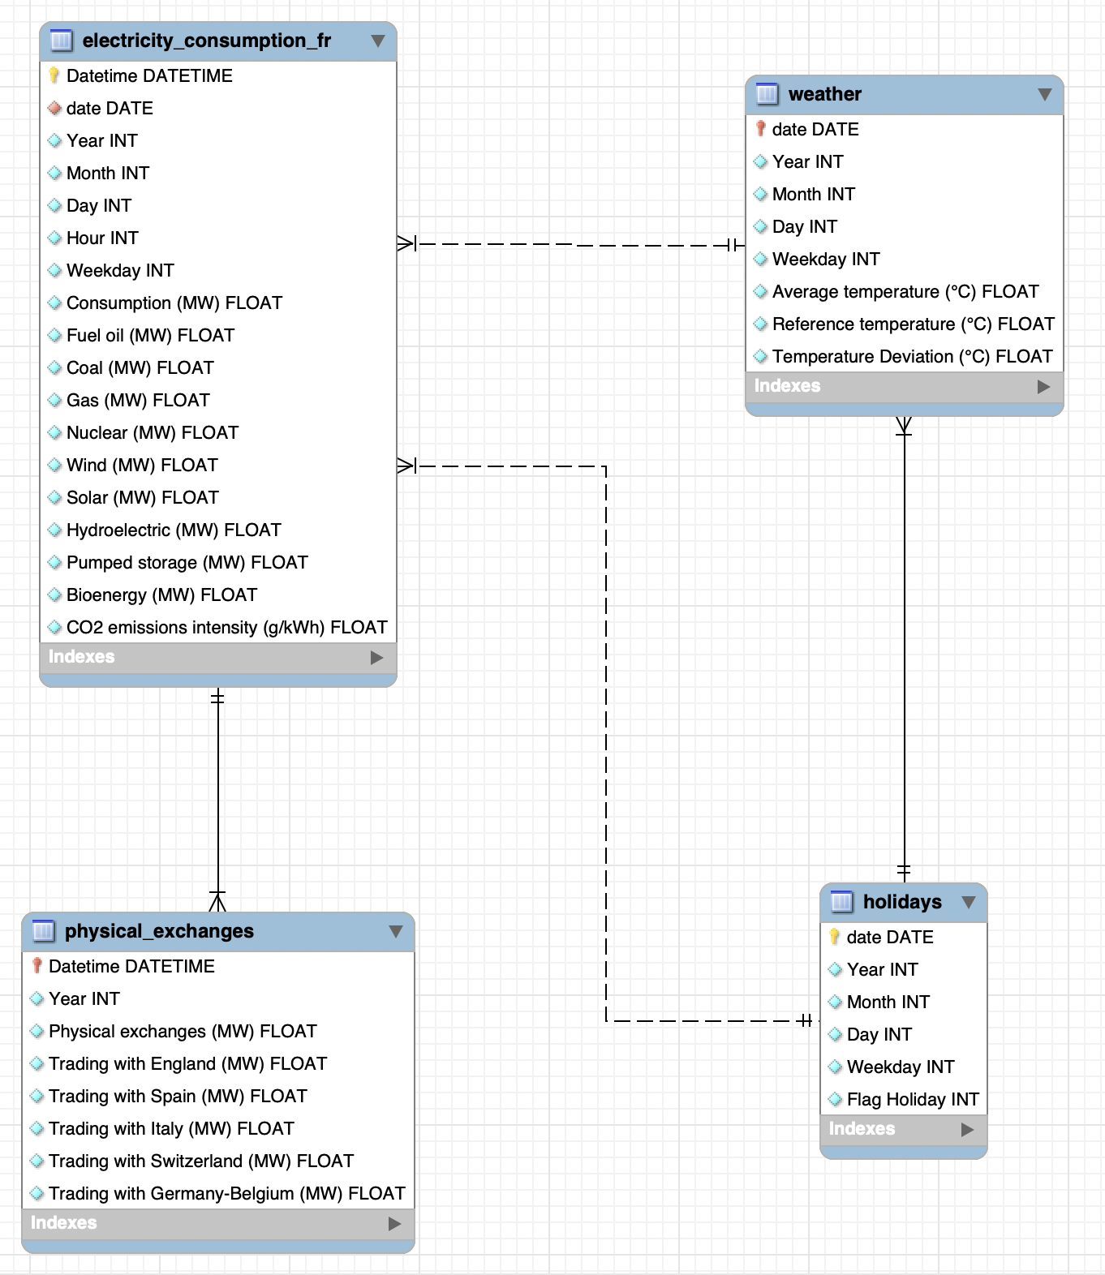

The database consists of four tables: "electricity_consumption_fr", "physical_exchanges", "weather" and "holidays."

The "electricity_consumption_fr" table includes fields for date and time, year, month, day, hour, weekday, and various energy sources' consumption in France, including fuel oil, coal, gas, nuclear, wind, solar, hydroelectric, pumped storage, bioenergy, and CO2 emissions intensity.

The "physical_exchanges" table includes fields for date and time, year, and physical exchanges of electricity between France and other countries, including England, Spain, Italy, Switzerland, and Germany-Belgium.

The "weather" table contains information on the weather conditions in France, including the average temperature, reference temperature, and temperature deviation.

The "holidays" table includes fields for date, year, month, day, weekday, and a flag indicating whether the day is a holiday or not.

## 

## MySQL Queries

The MySQL code used to create the database prior to pushing in the tables:



After I imported the datasets with PyMySQL, I had to clean the tables: Fixing the data types of the columns, adding primary and foreign keys, and creating a new column ‘date’ for the energy consumption table. I divided the main table into two separate tables, namely electricity_consumption_fr and physical_exchanges.

Examples of data cleaning query:

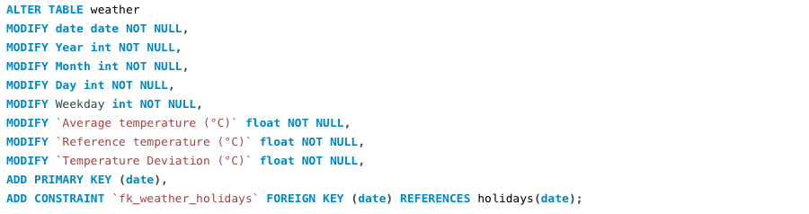

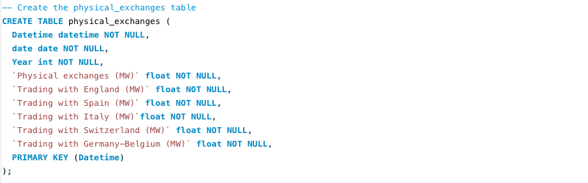

The average electricity consumption by sources of energy:

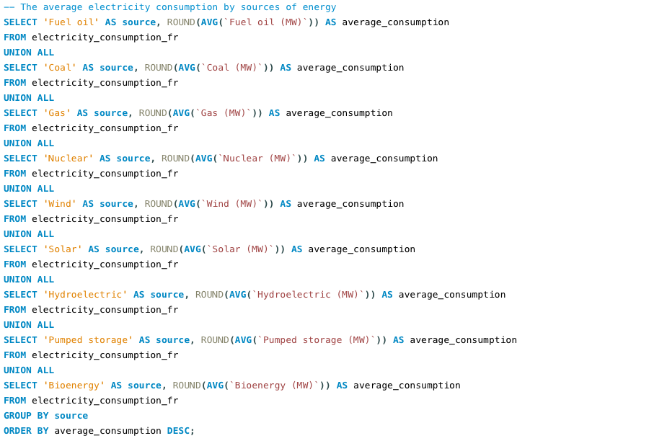

|  |  |
| --- | --- |
| **source** | **average_consumption** |
| Nuclear | 43862 |
| Hydroelectric | 7204 |
| Gas | 3402 |
| Wind | 2945 |
| Solar | 1039 |
| Bioenergy | 968 |
| Coal | 936 |
| Fuel oil | 281 |
| Pumped storage | -787 |

The average production of pumped storage is negative probably because more energy is used to pump water uphill than is generated by releasing it downhill.

The average trading (MW) exchanges with other countries:

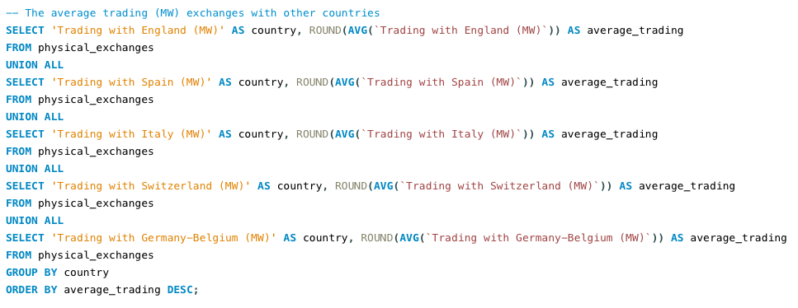

|  |  |
| --- | --- |
| **country** | **average_trading** |
| Trading with Germany-Belgium (MW) | 55 |
| Trading with Spain (MW) | -733 |
| Trading with England (MW) | -1204 |
| Trading with Switzerland (MW) | -1572 |
| Trading with Italy (MW) | -1992 |

The average physical exchanges by Year:

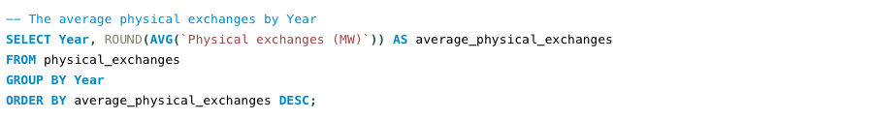

|  |  |
| --- | --- |
| **Year** | **average_physical_exchanges** |
| 2022 | 88 |
| 2017 | -4678 |
| 2016 | -4811 |
| 2021 | -5207 |
| 2020 | -5210 |
| 2012 | -5254 |
| 2013 | -5607 |
| 2019 | -6676 |
| 2018 | -7275 |
| 2015 | -7373 |
| 2014 | -7748 |

The Average temperature (°C) and the date of the top 10 days with the higher average Consumption (MW):

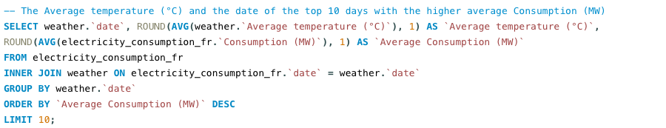

|  |  |  |
| --- | --- | --- |
| **date** | **Average temperature (°C)** | **Average Consumption (MW)** |
| 08/02/2012 | -4.9 | 94096.7 |
| 09/02/2012 | -3.8 | 92868.1 |
| 07/02/2012 | -4.8 | 91176.3 |
| 10/02/2012 | -2.9 | 90262.6 |
| 28/02/2018 | -3.5 | 89600.1 |
| 03/02/2012 | -4.6 | 89247.9 |
| 06/02/2012 | -3.3 | 88151.9 |
| 11/02/2012 | -4.8 | 87951.2 |
| 02/02/2012 | -3.5 | 87524 |
| 27/02/2018 | -3.7 | 87012.2 |

The average energy consumption (MW) and average CO2 emission (g/kWh) by flag holiday:

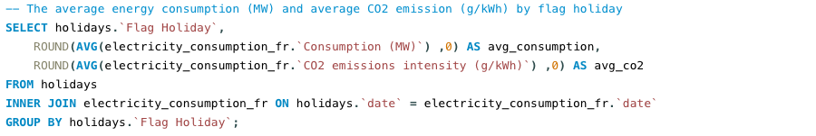

|  |  |  |
| --- | --- | --- |
| **Flag Holiday** | **avg_consumption** | **avg_co2** |
| 1 | 46372 | 32 |
| 0 | 54350 | 48 |

Creating a temporary table that merges all the tables in order extract it for the next steps of the project:

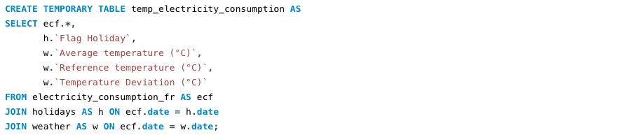

## Conclusion

This report has provided a comprehensive analysis of energy consumption in France, including factors such as holidays and weather, using various data sources and analytical methods. Through exploratory data analysis with Python, we have been able to identify patterns in energy consumption and production over time, including seasonal variations and the impact of public holidays and the temperature. Additionally, we have discovered that despite the decreasing share of nuclear energy in the energy mix in recent years, it remains the dominant source of energy in France, while wind and solar energy are increasing in their share.

The findings from this report can provide useful insights for us as consumers and citizens. By using the historical data and identifying the key features that drive energy consumption, it is possible to be more informed and aware about energy consumption and production in the future. Furthermore, the report highlights the importance of energy security, sovereignty and the need to transition to more sustainable and renewable energy sources to reduce carbon emissions and mitigate the effects of climate change.

In conclusion, this report has contributed to the body of knowledge on energy consumption in France and provided valuable insights for people and energy management professionals. With the use of open data platforms and analytical tools, it is possible to gain a deeper understanding of energy consumption and production patterns, which can help in making informed decisions about energy management and production.

The next steps in this project are to develop a time series model that predicts energy consumption in France based on historical data.

## Annexe

### Project plan

The project plan was created in Jira and can be accessed [here](https://kaci213.atlassian.net/jira/software/projects/FPIAC/boards/4).

### Github

The Github repository of the project can be accessed [here](https://github.com/kronodel/Final-Project---IronHack-Paris.git).