MASTERTOOLS APPLICATION

INTRODUCTION
The main aim of the project is the management of the database of a tool shop.
This project is insight into the design and implementation of a Tools Management System.
This is done by creating a database of the available tools in the shop.
The primary aim of tools management system is to improve accuracy and enhance safety and efficiency in the tools store. The aim of this project is to develop software for the effective management for a new tool store that shows the list of employees, all tools with their available stock.
Implemented options:
- Login or Cancel buttons (cancel for closing the application);
- Back button on each page - allows you to go back to the previous accessed page;
- Logout Button - implemented on all pages for allowing you to sign out in every moment;
- JTable - reads from MySQL DB and it's wrapped in a JScrollPanel which implements horizontal and vertical scroll features;
- Pages for different tools categories that allows you to add / edit / delete any record.
All the pictures used in this application were taken from a free website (e.g. pixabay.com).

Tools used for MasterTools application:
Eclipse IDE
Swing JFrame
MySQL DB

Features:
- Login Page for admin / user - this page allow you to log into the system pressing "Enter" or pressing the button "Login" :
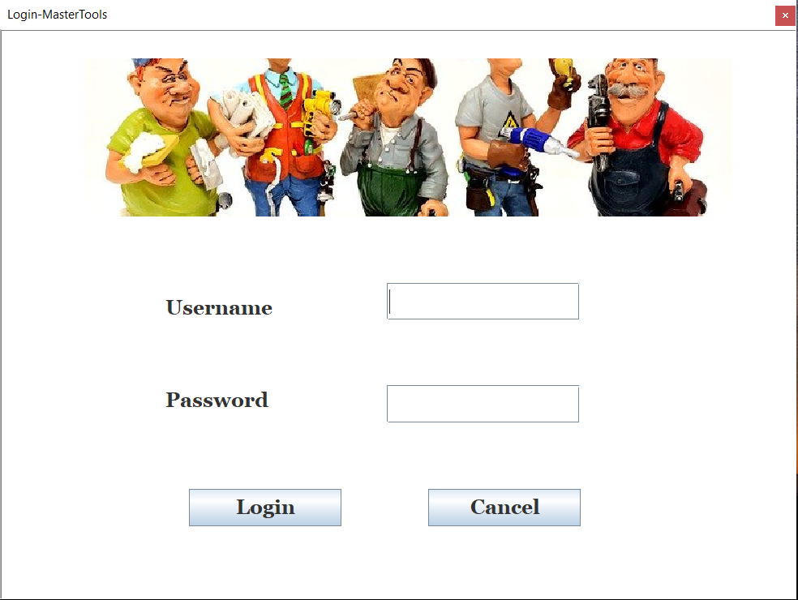
a. Login Page
- Main Menu that contains:
- Administration
- Suppliers
- Cordless Tools
- Power Tools
- Woodworking
- Outdoor Tools
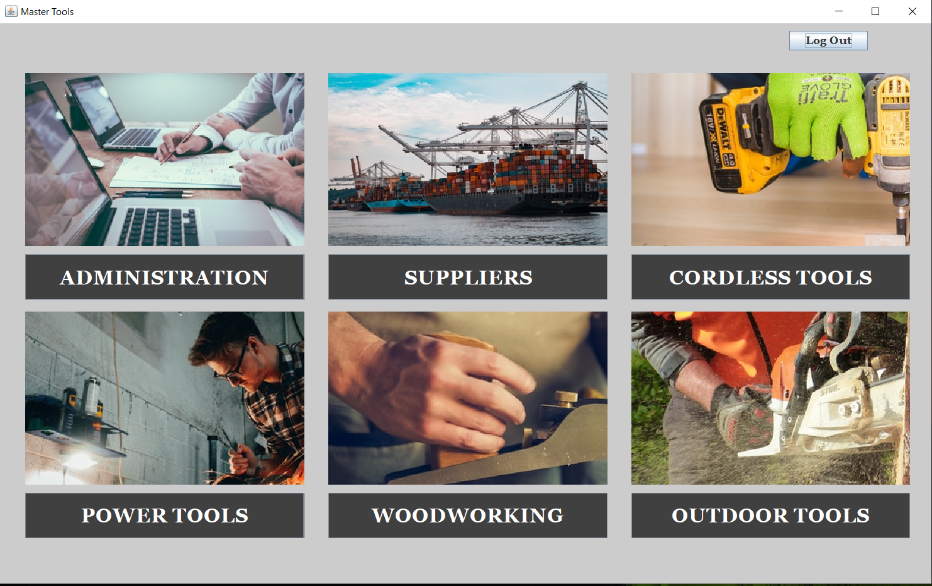
b. Main Menu
1. Administration
This page contains two buttons with function: New User and Employee DB. It helps to add a new employee in your DB or to check your current employees:
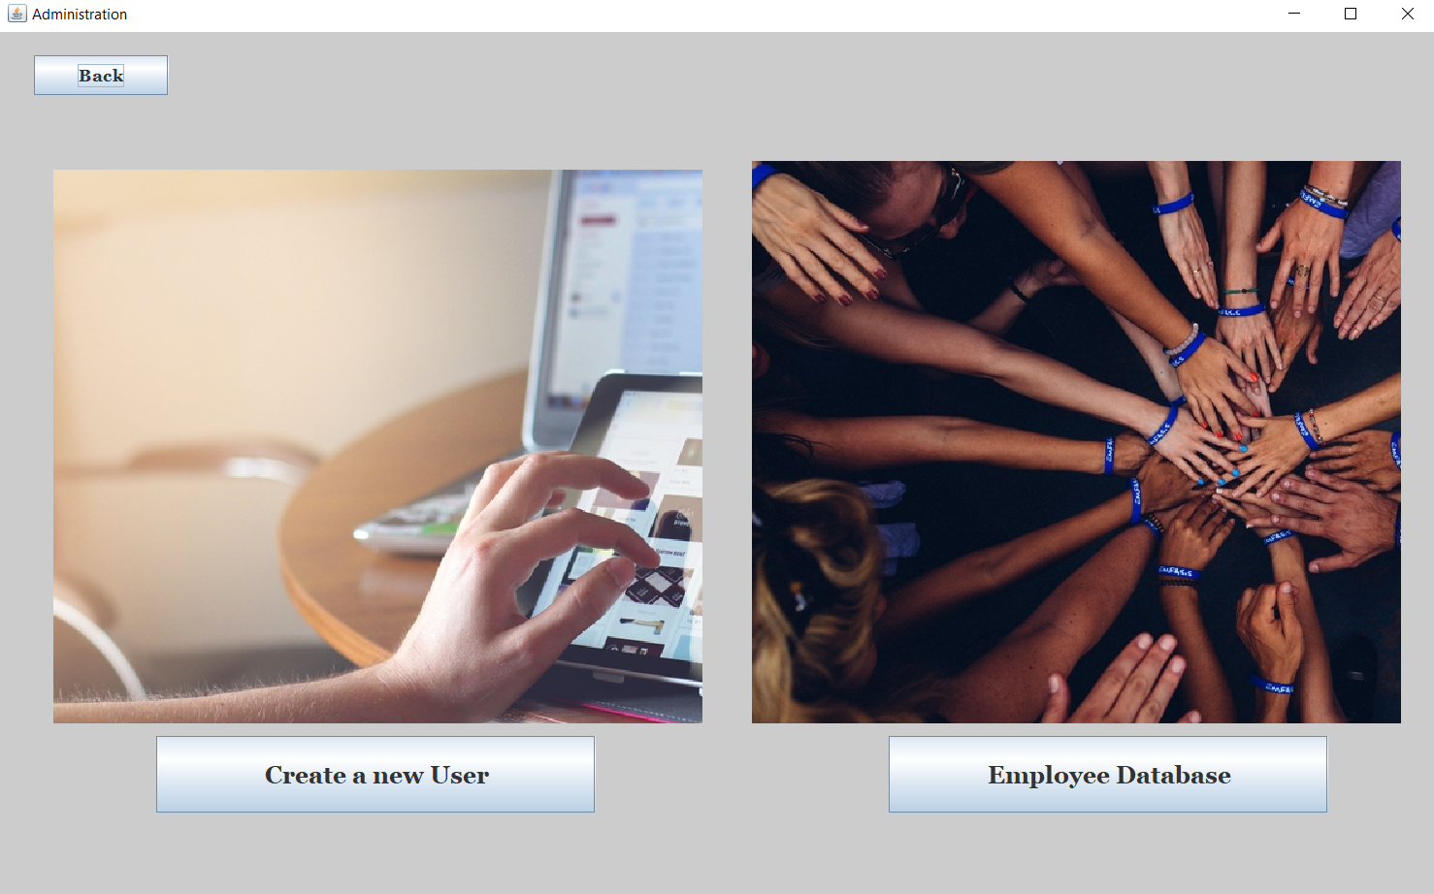
c. Administration
2. Suppliers - page created with the list of available suppliers for different tools and allows you to add / edit / remove suppliers with details like: Country / E-mail address and phone number:
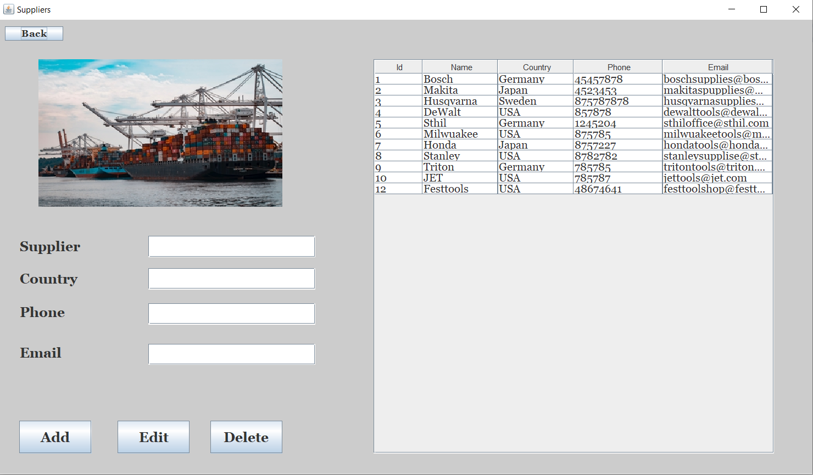
d. Suppliers page
3. Cordless tools - this page contains different cordless tools that are available in this moment.
It allows you as well to add / delete cordless tool:
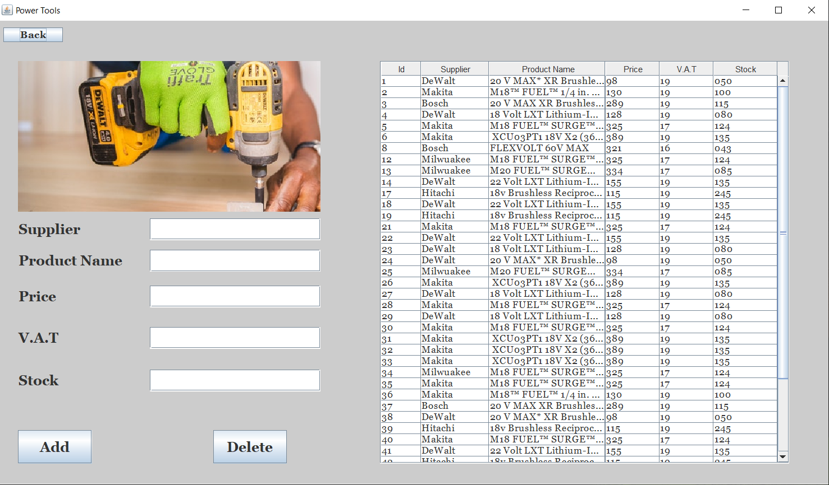
e. Cordless tools
4. Power Tools - page with different available power tools that allow you also to see the supplier / product name / price / V.A.T :
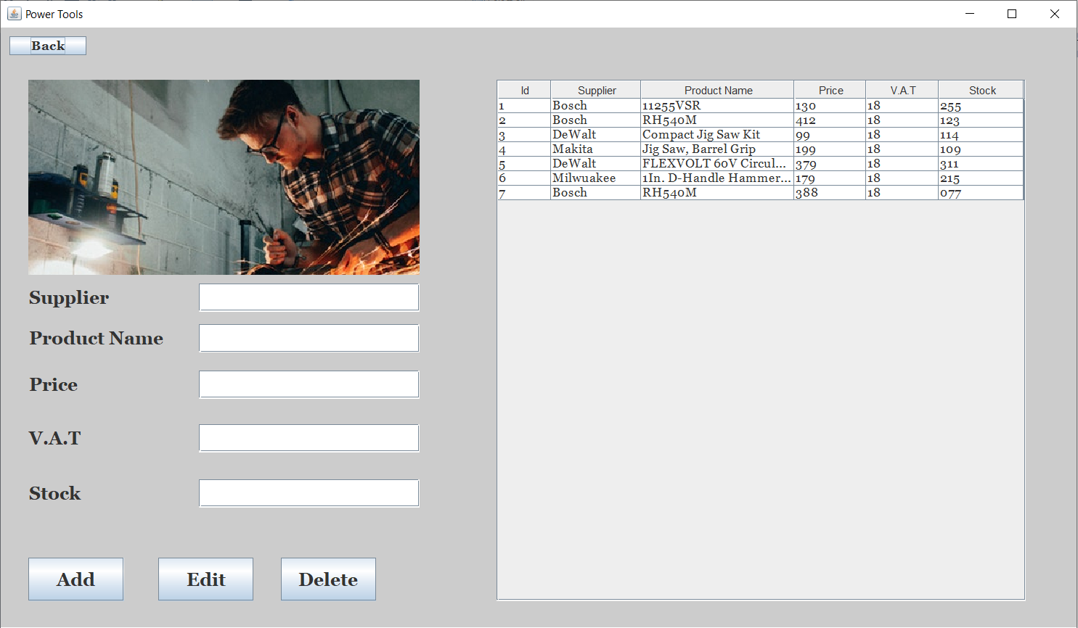
f.Power tools
5. Woodworking tools - page with specific tools for wood industry that allows you to add / edit / delete and you can see the available stock for it:
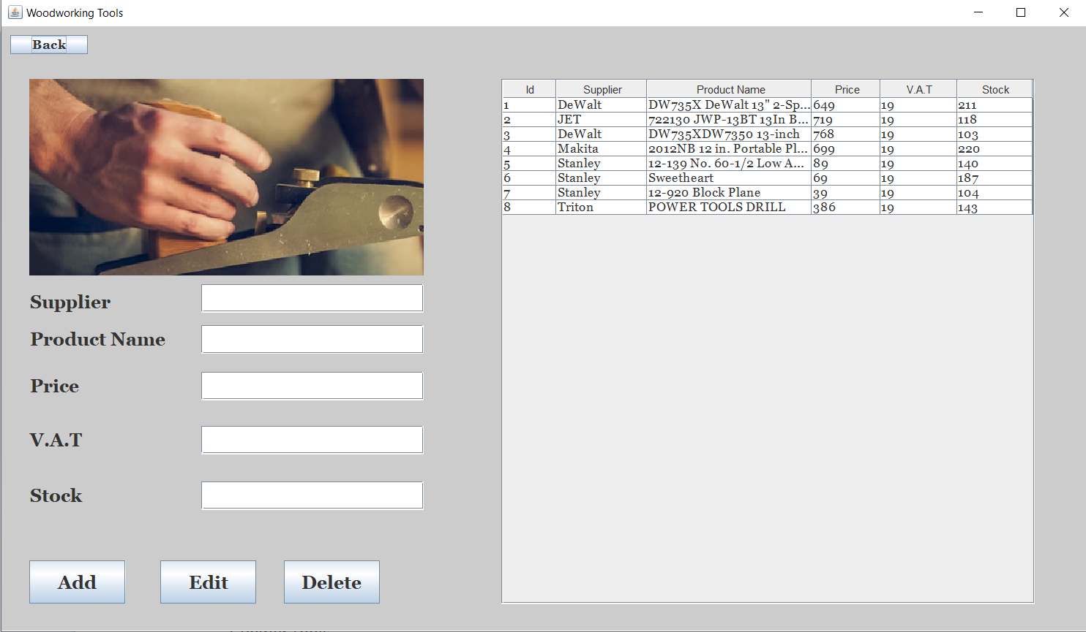
g. Woodworking tools

6. Outdoor tools - page created with different tools that can be used outside like : Propelled Mower or Chainsaw Kit. All the options available in the pages already described previously are implemented here as well:
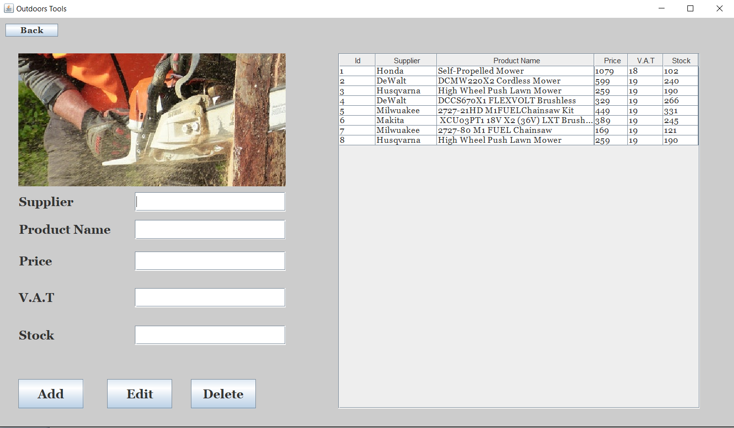
h. Outdoor Tools

Enjoy the application and let me know if you find some bugs in order to imrpove it!

