TMA01-32J-Solutions

# Question 1

a)

1. Code

/**

* SafeState Class - SafeState Managers the State of Class Safe

* Enabling Users to Set/Get the current State of a Safe

* Object

*

* @author Joel Manning

* @version 23-10-2023

*/

public class SafeState

{

1. CodeRunner ResultsA blue and white striped background

   Description automatically generated

b)

1. Code

/**

* @brief part(b) private instance fields for SafeState

*/

private String userCode, masterCode, display;

private boolean open;

1. CodeRunner Results

c)

1. Code

/**

* @brief Constructor for objects of class SafeState

*/

public SafeState()

{

//(c) Initialise fields to default values

this.userCode = null;

this.masterCode = "9999";

this.display = "WELCOME";

this.open = true;

}

1. CodeRunner Results

d)

1. Code

/**

* @brief (d)(part i)Method for retrieving display field value

*/

public String getDisplay()

{

return this.display;

}

1. CodeRunner Results

e)

1. Code

/**

* @brief part(e) Method for opening the safe

*/

public boolean open(String aCode)

{

if( this.open == true )

{

this.display = "ALREADY OPEN";

}

else if( this.open == false )

{

if( aCode == this.userCode || aCode == this.masterCode )

{

this.open = true;

this.display = "OPEN";

this.userCode = null;

}

else

{

this.display = "INVALID CODE";

}

}

// Will return state of open field

return this.open;

}

1. CodeRunner Results

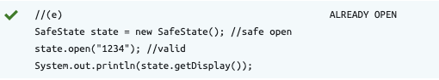

f)

1. Code

/**

* @brief part(f) Method for checking a valid code for new user code

* @param String aCode

*/

public boolean isValidUserCode(String aCode)

{

/**

* Immutable code length as spec states constant

*/

final int codeLength = 4;

if(aCode.length() != codeLength){

return false;

}

/**

* for loop using i as index and charAt method to isolate

* char for validation check

*/

for(int i = 0; i < aCode.length(); i++){

if(aCode.charAt(i) != '0' &&

aCode.charAt(i) != '1' &&

aCode.charAt(i) != '2' &&

aCode.charAt(i) != '3' &&

aCode.charAt(i) != '4' &&

aCode.charAt(i) != '5' &&

aCode.charAt(i) != '6' &&

aCode.charAt(i) != '7' &&

aCode.charAt(i) != '8' &&

aCode.charAt(i) != '9')

{

return false;

}

}

return true;

}

1. CodeRunner Results

g)

1. Code

/**

* @brief part(g) Method to lock the Safe Providing Correct String has been entered

* @param String aCode

*/

public boolean lock (String aCode)

{

boolean lockedState = false;

/**

* part(g)(part i) Check if Safe is Locked

*/

if(this.open == false)

{

lockedState = false;

this.display = "ALREADY LOCKED";

}

else

{

/**

* part (g)(part ii) using internal isValidUserCode method determine

* is passed code is valid

*/

if(isValidUserCode(aCode) == true)

{

this.open = false;

this.display = "LOCKED";

this.userCode = aCode;

lockedState = true;

}

/**

* part (g)(part iii) Set display to `INVALID CODE` if code is invalid

*/

else

{

this.display = "INVALID CODE";

}

}

return lockedState;

}

1. CodeRunner Results

h)

1. Code

**

* @brief part (h) Display the current status of the Safe

*/

public String about()

{

return "Safe " + this.display;

}

1. CodeRunner Results

# Question 2

a)

1. Code

/**

* @brief Java Library Imports

*/

import java.util.ArrayList;

import java.util.Iterator;

/**

* Class 'Safe' for containing a number of limited items to be safely stored

*

* @author Joel Manning

* @version 31-10-2023

*/

public class Safe

{

1. CodeRunner Results

b)

1. Code

/**

* @brief part(b) importing external class state and

* declaring maxItems and contents of safe

*/

private SafeState state;

private int maxItems;

public ArrayList<String> contents;

1. CodeRunner Results

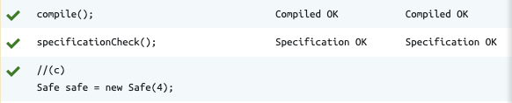

c)

1. Code

/**

* @brief part(c)(i,ii,iii)

* @param number of maximum items used

*/

public Safe(int aMaxItems)

{

this.state = new SafeState();

this.contents = new ArrayList<String>();

this.maxItems = aMaxItems;

}

1. CodeRunner Results



d)

1. Code

/**

* part(d) Attempt to add contents

* @param item to add to the safe ArrayList

*/

public void addToContents(String item)

{

if(this.contents.size() < this.maxItems)

{

contents.add(item);

}

}

1. CodeRunner Results

e)

1. Code

/**

* @brief part(e) remove an item from contents

* @param stored item for removal

*/

public void removeFromContents(String item)

{

boolean found = false;

// index used to enable removal of item using java String remove(index)

for(int i = 0; i < this.contents.size(); i++)

{

if(contents.get(i) == item)

{

found = true;

this.contents.remove(i);

}

}

if(found)

{

System.out.println("Removed " + item);

}

else

{

System.out.println("Item " + item + " not in safe");

}

}

1. CodeRunner Results

f)

1. Code

/**

* @brief part(f) Display all item contents

*/

public void display()

{

/**

* Display all items in contents

*/

for(String item : this.contents) // Capture and Display using for_each

{

System.out.println(item);

}

}

1. CodeRunner Results

g)

1. Code

**

* @brief part(g) Empty method to clear the array list

*/

public void empty()

{

/**

* Carry out operation only if is not empty

*/

if(!this.contents.isEmpty()){

/**

* Iterator to run through arraylist contents

*/

int index = 0;

Iterator<String> contentIter = this.contents.iterator();

/**

* Iterater will run through and remove all items in contents

*/

while(contentIter.hasNext()) {

System.out.println("Removed " + contentIter.next());

contentIter.remove();

}

}

}

1. CodeRunner Results

h)

1. Code

/**

* @brief part(h) Attempt to open the safe

* @param Code to open the safe must be valid code or master code

* @return boolean value indicating the open status of the safe

*/

public boolean open(String aCode)

{

boolean SafeOpen = false;

if(this.state.isOpen() == true)

{

SafeOpen = true;

}

else

{

SafeOpen = this.state.open(aCode);

}

return SafeOpen;

}

1. CodeRunner Results

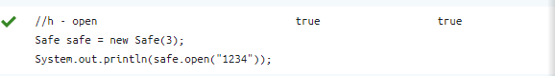

i)

1. Code

/**

* @brief part(i) Lock the Safe using field state object

* @param Code passed to lock the safe(String)

* @return boolean indicating the locked status of the safe true | false

*/

public boolean lock(String aCode)

{

boolean isLocked = false;

if(this.state.isOpen() == false)

{

isLocked = false;

}

else

{

isLocked = this.state.lock(aCode);

}

return isLocked;

}

1. CodeRunner Results

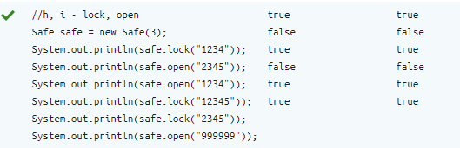

# References

oracle (2019). ArrayList (Java Platform SE 8 ). [online] Oracle.com. Available at: <https://docs.oracle.com/javase/8/docs/api/java/util/ArrayList.html>.

docs.oracle.com. (n.d.). Iterator (Java Platform SE 8 ). [online] Available at: <https://docs.oracle.com/javase/8/docs/api/java/util/Iterator.html>.