Name_____________________ School_____________________

**TAMS Tournament 2013**

**Chemistry Test**

Instructions:

You have 50 minutes to complete 35 multiple-choice and 5 free-response questions.

Each free-response question is worth three times as much as a multiple-choice question.

Only correct answers will be counted for both the multiple-choice portion and the free-response portion; there will be no partial credit.

There is no penalty for guessing.

You may use a non-programmable calculator and the periodic table given.

You may write on the test.

Good Luck!

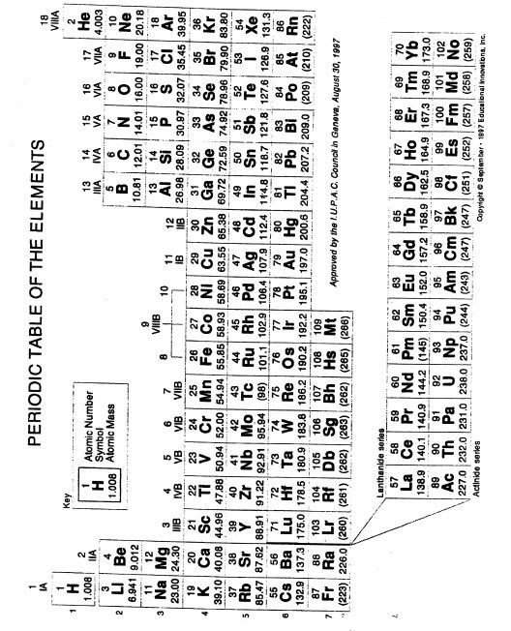

TAMS Tournament 2013- Chemistry

Multiple-Choice (35 questions)

1. To confirm the identity of a metal ion in solution, a flame test was performed. The result was a violet flame. Which of the following metal ions is indicated?
2. Na
3. K
4. Ca
5. Ba
6. 6 mg/ cm2 = ______ ng/ µm2
7. 6 x 10-3
8. 6 x 10-2
9. 6 x 103
10. 6 x 102
11. The name of the compound with the condensed structural formula, CHF2CH2CH2CH2C(O) OH, is
12. 4,4- difluorobutanoic acid
13. 5,5- difluorobutanoic acid
14. 1,1- difluorobutanoic acid
15. 5,5- difluoro-1-pentanoic acid
16. What is the final concentration of Pb2+ ions when 100. mL of 0.20 M Pb(NO3)2 solution is mixed with 100. mL of 0.30 NaCl solution?

(A) 0.010 M

(B) 0.015 M

(C) 0.020 M

(D) 0.025 M

1. Which of the following are possible for a process in which the internal energy does not change? Circle all answer(s) that apply.
2. Heat>0, Work>0
3. Heat<0, Work >0
4. Heat>0, Work<0
5. Heat<0, Work<0
6. 100 mL of 0.5 M HNO3 (aq) is added to 200mL of 0.5 M NaOH (aq), releasing 3.1 kJ of heat and forming water and another product. What is the ΔH required to form one mole of the product?
7. 62 kJ
8. -62kJ
9. 31kJ
10. -31kJ
11. Which two substances react spontaneously?
12. Zn2+ and Pb
13. Zn2+ and Pb2+
14. Zn and Pb
15. Zn and Pb2+
16. Which of the following when placed into water will test as an acid solution?
17. HCl(g) + H2O
18. Excess H3O+ + H2O
19. CuSO4 + H2O
20. I only
21. I and II only
22. II and III only
23. I, II, and III
24. Of the atoms listed, which has the largest second ionization energy?

(A) Na

(B) F

(C) Mg

(D) K

1. The Fourth Ionization Energy of an atom is ΔE for the process:
2. X4+ 🡪 X5+ + e-
3. X3+ 🡪 X4+ +e-
4. X4+ +e- 🡪 X3+
5. X 🡪 X3+ +3e-
6. How many moles of water are produced by the complete combustion of 20.0 g of heptane?

(A) 0.400

(B) 0.800

(C) 1.60

(D) 3.20

1. Zn(s) | Zn2+(aq) || Cu2+(aq) | Cu(s)

For the voltaic cell represented above, which change will increase the voltage?

(A) increasing the size of the Zn electrode

(B) increasing the [Zn2+]

(C) increasing the size of the Cu electrode

(D) increasing the [Cu2+]

1. The salt bridge for an electrochemical cell is filled with a saturated solution of KNO3. Processes that occur at the salt bridge include which of the following? Circle all that apply.
2. K+ moves into the anode half-cell.
3. K+ moves into the cathode half-cell.
4. NO3- moves into the anode half-cell.
5. NO3- moves into the cathode half-cell.
6. Which aqueous solution freezes at the highest temperature?
7. 0.50 *m* C3H7OH
8. 0.15 *m* KNO3
9. 0.10 *m* FeCl3
10. 0.20 *m* CaBr2
11. CsCl has what kind of cubic unit cell structure?
12. Face-centered
13. Body-centered
14. Simple
15. Corner-centered
16. When added to 3 L of 0.40 M HNO3, which one of the following would form a buffer?
17. 2. L of 0.50 M NaOH
18. 4. L of 0.30 M LiNO3
19. 3. L of 0.50 M Na3PO4
20. 5. L of 0.30 M LiOH
21. What volume of 0.225 M Ba(OH)2 is required to titrate to the equivalence point 60.0 mL of a 0.150 M solution of a monoprotic weak acid that’s 40% ionized?
22. 20.0 mL
23. 8.00 mL
24. 40.0 mL
25. 16.0 mL
26. What is the molar solubility of CaF2 in water? (Ksp for CaF2= 4.0 x 10-11)
27. 6.3 x 10-6 M
28. 3.2 x 10-6 M
29. 3.4 x 10-4 M
30. 2.2 x 10-4 M

A <---> B + C ΔH= -150 kJ/mol

The value of Kc can be increased by which of the following:

1. Decreasing the temperature
2. Increasing the temperature
3. Decreasing the pressure
4. Increasing the pressure
5. You are given equimolar solutions of each of the following. Which has the lowest pH?
6. NH4Cl
7. NaCl
8. K3PO4
9. Na2CO3
10. Which of the following gases behave least ideally?
11. SO2
12. CH4
13. CO2
14. H2
15. The melting point of MgS is higher than that of KCl. Which of the following observations can explain this?
16. Mg2+ has a greater positive charge than K+
17. S2- has a greater negative charge than Cl-
18. S2- has a smaller radius than Cl-
19. I and II
20. I and III
21. II and III
22. None of the above
23. Which of the following can be used to predict the paramagnetism of certain elements?
24. Heisenberg Uncertainty Principle
25. Shrondinger equation
26. Hund’s Rule
27. Photoelectric Effect
28. Which of the following electron configurations is incorrectly paired with its ground-state element?
29. 1s22s22p63s23p64s13d10- Copper
30. 1s22s22p63s23p64s23d104p6 5s14d9- Palladium
31. 1s22s22p63s23p64s23d104p6 5s14d5- Molybdenum
32. 1s22s22p63s23p64s23d104p6 5s24d105p66s14f145p9- Platinum
33. Consider the second order reaction, A --> Products. The rate constant for this reaction is 0.03 M-1s-1. The initial concentration of A is 0.80 M.

What is the half-life for this reaction?

1. 13.3 s
2. 23.1 s
3. 41.7 s
4. 26.6 s
5. In which species is the central atom NOT described as having sp3d hybridization?
6. PF3
7. XeF2
8. IF3
9. SeF4
10. Which of the following does not describe any of the molecules below:

CCl4, CO2, PCl3, PCl5, SF6

1. Linear
2. Tetrahedral
3. Trigonal pyramidal
4. Square planar
5. An unknown gas has a density of 3.78 g/L at a pressure of 1140 torr and a temperature of 7°C. What is the identity of this gas?
6. Methane
7. Ethane
8. Propane
9. Butane
10. How would you increase the solubility of a gas in a solvent?
11. Increase temperature, Increase pressure
12. Increase temperature, Decrease pressure
13. Decrease temperature, Increase pressure
14. Decrease temperature, Decrease pressure
15. How many electrons are transferred when a solution of potassium permanganate is added to a solution of ferrous chloride in a basic solution?
16. 1e-
17. 3e-
18. 4e-
19. 6e-
20. What is the basic formula for an aromatic compound?
21. CnH2n+2
22. CnH2n+1
23. CnH2n-2
24. CnH2n-6
25. Oxidation occurs when a hot copper wire is inserted into an alcohol. What is the product of this oxidation?
26. aldehyde
27. organic acid
28. ketone
29. ether
30. Which of the following correctly describes what happens to the mass that is lost when a nucleus forms?
31. It is emitted as an alpha particle.
32. It is emitted as a beta particle.
33. It is emitted as a positron.
34. None of the above
35. Alloys are present everywhere in our day-to-day lives. One reason why they are so prevalent is that alloys, a mixture of two or more metals, are stronger and more durable than the individual original metals.

What alloy is comprised of mainly copper and zinc?

1. Bronze
2. Brass
3. Steel
4. Pig Iron
5. The energy absorbed when dry ice sublimes is required to overcome what attractive forces?
6. H-bonds
7. Dipole-dipole forces
8. London-dispersion forces
9. Covalent bonds

Free-Response (5 questions)

1. Write the balanced net-ionic equation for the following reaction:

A concentrated solution of ammonia is added to a solution of cupric nitrate

1. A buffer solution of 0.050 M NH3 and 0.050 M NH4Cl, volume 50 mL was used. Calculate the pH of the ammonia-ammonium chloride buffer after 3.0 mL of 0.20 M NaOH is added. (Kb for ammonia= 1.8 x 10-5)
2. The longest wavelength of light with enough energy to break the Cl-Cl bond in Cl2 is 495 nm.

Calculate the minimum energy of the Cl-Cl bond in kJ/mol.

1. Draw the Lewis structure of ICl4+ and then name what geometric shape is formed by the atoms.
2. Determine the mass of copper that can be plated on a paper clip if a current of 10.0 amps is passed for 30.0 minutes through a solution of cupric sulfate.