Gloabal Terrorism Output

#Read the data  
  
dat<- read.csv("globalterrorismdb_0617dist.csv")  
  
#Printing the names of the columns in dataset  
names(dat)

## [1] "eventid" "iyear" "imonth"   
## [4] "iday" "approxdate" "extended"   
## [7] "resolution" "country" "country_txt"   
## [10] "region" "region_txt" "provstate"   
## [13] "city" "latitude" "longitude"   
## [16] "specificity" "vicinity" "location"   
## [19] "summary" "crit1" "crit2"   
## [22] "crit3" "doubtterr" "alternative"   
## [25] "alternative_txt" "multiple" "success"   
## [28] "suicide" "attacktype1" "attacktype1_txt"   
## [31] "attacktype2" "attacktype2_txt" "attacktype3"   
## [34] "attacktype3_txt" "targtype1" "targtype1_txt"   
## [37] "targsubtype1" "targsubtype1_txt" "corp1"   
## [40] "target1" "natlty1" "natlty1_txt"   
## [43] "targtype2" "targtype2_txt" "targsubtype2"   
## [46] "targsubtype2_txt" "corp2" "target2"   
## [49] "natlty2" "natlty2_txt" "targtype3"   
## [52] "targtype3_txt" "targsubtype3" "targsubtype3_txt"   
## [55] "corp3" "target3" "natlty3"   
## [58] "natlty3_txt" "gname" "gsubname"   
## [61] "gname2" "gsubname2" "gname3"   
## [64] "gsubname3" "motive" "guncertain1"   
## [67] "guncertain2" "guncertain3" "individual"   
## [70] "nperps" "nperpcap" "claimed"   
## [73] "claimmode" "claimmode_txt" "claim2"   
## [76] "claimmode2" "claimmode2_txt" "claim3"   
## [79] "claimmode3" "claimmode3_txt" "compclaim"   
## [82] "weaptype1" "weaptype1_txt" "weapsubtype1"   
## [85] "weapsubtype1_txt" "weaptype2" "weaptype2_txt"   
## [88] "weapsubtype2" "weapsubtype2_txt" "weaptype3"   
## [91] "weaptype3_txt" "weapsubtype3" "weapsubtype3_txt"   
## [94] "weaptype4" "weaptype4_txt" "weapsubtype4"   
## [97] "weapsubtype4_txt" "weapdetail" "nkill"   
## [100] "nkillus" "nkillter" "nwound"   
## [103] "nwoundus" "nwoundte" "property"   
## [106] "propextent" "propextent_txt" "propvalue"   
## [109] "propcomment" "ishostkid" "nhostkid"   
## [112] "nhostkidus" "nhours" "ndays"   
## [115] "divert" "kidhijcountry" "ransom"   
## [118] "ransomamt" "ransomamtus" "ransompaid"   
## [121] "ransompaidus" "ransomnote" "hostkidoutcome"   
## [124] "hostkidoutcome_txt" "nreleased" "addnotes"   
## [127] "scite1" "scite2" "scite3"   
## [130] "dbsource" "INT_LOG" "INT_IDEO"   
## [133] "INT_MISC" "INT_ANY" "related"

#Summary of the dataset  
The dataset has 170350 data points with 136 variables which included the exact date of terrorist attack, what kind of attack, how many people were killed, what kind of weapons used, whether ransom was demanded and many more.

#Classification of Attacks  
attacktype <- ifelse (dat$nkill > 10, "Major",  
 ifelse (dat$nkill > 3 |dat$nkill < 10, "Small", "Minor")  
)  
dat$attacktype= attacktype

With the above syntax, an attribute is created with casualties greater than 10 are classified as major attacks, with casualties between 3 and 10, the attack type is classified as small attacks and will less than 3, classified as minor.

#---------------------------Scatter Plots------------------------------------#Major Attacks  
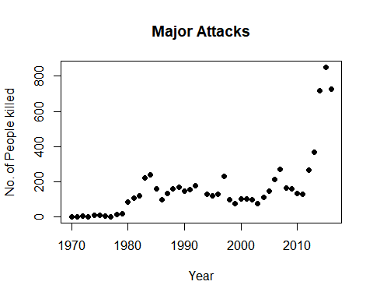

#Small Attacks  
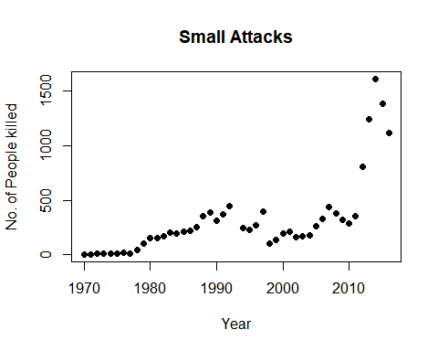

#Minor Attacks  
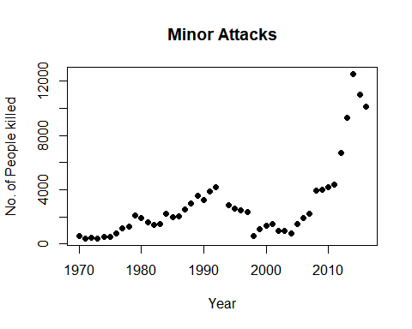

*From the plot we observe that the no. of attacks during 1970s were less but increased during 1980s and then again the attacks were in smaller nos. during 2000s but since latter half of 2000s and early 2010s the attacks have been increasing exponentially for all the major, small and minor types of attack.*

#------------------Linear Regression Model-----------------------------------  
#------------------For Major Attacks-----------------------------------------  
## Residuals:  
## Min 1Q Median 3Q Max   
## -186.49 -93.93 -2.66 34.23 500.56   
##   
## Coefficients:  
## Estimate Std. Error t value Pr(>|t|)   
## (Intercept) -16750.567 2985.443 -5.611 1.26e-06 ***  
## iyear 8.486 1.498 5.665 1.04e-06 ***  
## ---  
## Signif. codes: 0 '***' 0.001 '**' 0.01 '*' 0.05 '.' 0.1 ' ' 1  
##   
## Residual standard error: 139.3 on 44 degrees of freedom  
## Multiple R-squared: 0.4218, Adjusted R-squared: 0.4086   
## F-statistic: 32.1 on 1 and 44 DF, p-value: 1.045e-06

From the output of linear regression we see that R-squared value is 0.4218 which means that the data points do not regression line very well as we can see from the scatter plot itself that with time the no. of attacks is increasing exponentially and thus the error values are high during later part of the plot.

#------------------For Small Attacks-----------------------------------------## Residuals:  
## Min 1Q Median 3Q Max   
## -337.19 -214.78 29.57 72.19 919.91   
##   
## Coefficients:  
## Estimate Std. Error t value Pr(>|t|)   
## (Intercept) -35510.53 5620.12 -6.318 1.15e-07 ***  
## iyear 17.98 2.82 6.375 9.49e-08 ***  
## ---  
## Signif. codes: 0 '***' 0.001 '**' 0.01 '*' 0.05 '.' 0.1 ' ' 1  
##   
## Residual standard error: 262.2 on 44 degrees of freedom  
## Multiple R-squared: 0.4801, Adjusted R-squared: 0.4683   
## F-statistic: 40.64 on 1 and 44 DF, p-value: 9.488e-08

This regression line too does not fit properly with R-squared value as 0.4801.

#------------------For Minor Attacks-----------------------------------------## Residuals:  
## Min 1Q Median 3Q Max   
## -3541.1 -938.2 199.5 814.7 6906.5   
##   
## Coefficients:  
## Estimate Std. Error t value Pr(>|t|)   
## (Intercept) -262715.73 46542.79 -5.645 1.12e-06 ***  
## iyear 133.24 23.35 5.706 9.12e-07 ***  
## ---  
## Signif. codes: 0 '***' 0.001 '**' 0.01 '*' 0.05 '.' 0.1 ' ' 1  
##   
## Residual standard error: 2172 on 44 degrees of freedom  
## Multiple R-squared: 0.4252, Adjusted R-squared: 0.4122   
## F-statistic: 32.55 on 1 and 44 DF, p-value: 9.121e-07

From the output of linear regression of minor attacks too, we see that R-squared value is 0.4252 which means that the data points do not regression line very well as we can see from the scatter plot itself that with time the no. of attacks is increasing exponentially and thus the error values are high during later part of the plot.

#Adding Regression line to the Scatterplots  
#Major Attacks  
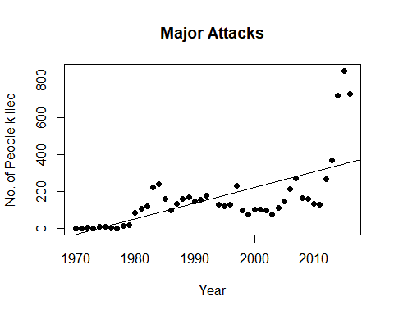

#Small Attacks  
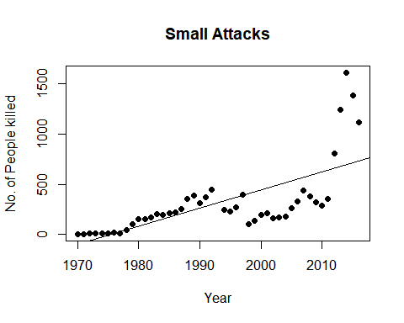

#Minor Attacks  
