DOC-ANALOG-002

- Formulation of the Physical Model of the Plant with Parasites

To obtain a numerically exact small-signal transfer function from control input to output G_{vd}(s) it is essential to abandon the assumptions of ideal components. In high-precision analog systems, the DC resistance of the inductor (DCR) and the equivalent series resistance of the output capacitor (ESR) significantly affect the damping factor, DC gain, and the location of the cutoff frequencies.

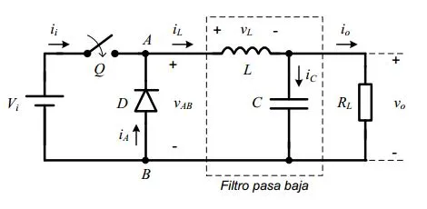
Nominal System Parameters (CCM Operating Point)

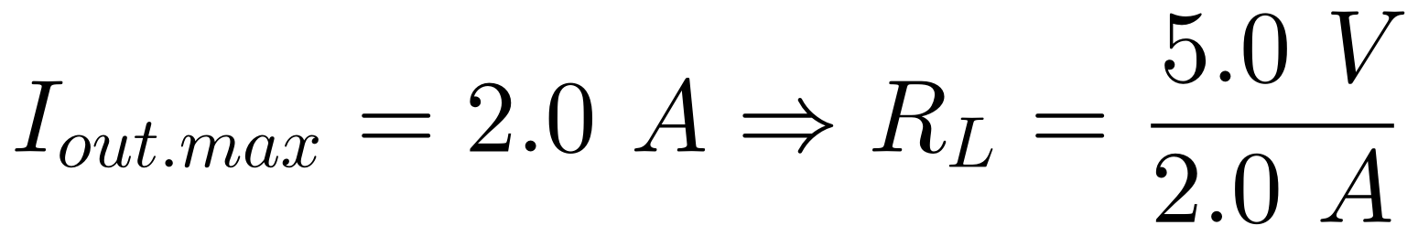  Parasitic Element / Parameter | Symbol | Physical Value | Origin / Physical Criteria
Input Voltage | V_{in} | 24.0 V | Nominal Power Bus
Load Resistance | R_{L} | 2.5 Ω
Output Inductance | L | 68.0 μH | Rated power inductance
DC Resistance of Inductance | R_{L} (DCR) | 25.0 mΩ | Losses due to copper wires in the winding
Output Capacity | C_{out} | 220.0 μF | Output Bank Capacity
Equivalent Series Resistance | R_{C} (ESR) | 25.0 mΩ | Losses in the dielectric/terminals of C_{out}

- Formal Derivation of the Transfer Function G_{vd}(s)

Using the state-space averaging method in Continuous Conduction Mode (CCM), the switching node is replaced by an equivalent voltage source with a small-signal average value v_{sw}(s) = V_{in} · d̂(s).

Step 1: Impedance of the Parasitic Capacitive Block Z_{C}(s)

The impedance of the output capacitor branch with its ESR in series is:

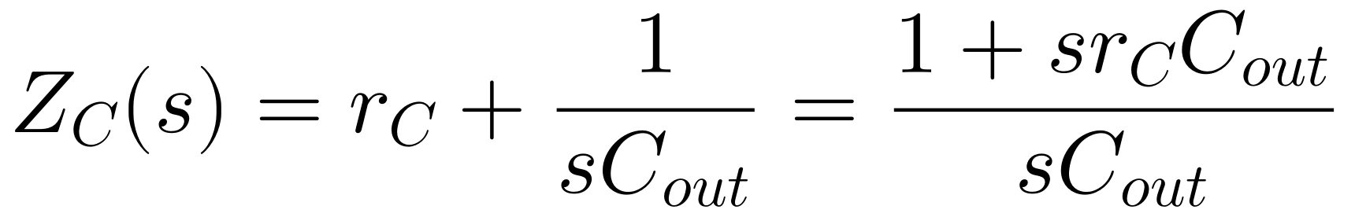
Step 2: Equivalent Load Impedance Z_{P}(s)

By connecting the capacitive branch Z_{C}(s) in parallel with the load resistor R_{L}:

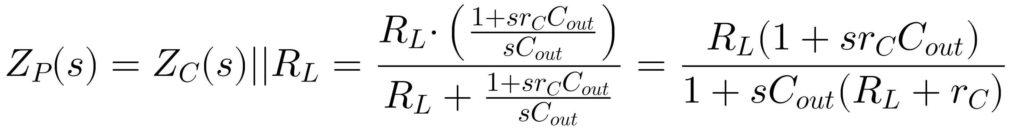

Step 3: Voltage Divider Used in the Plant

The output voltage v̂_{out}(s) is obtained using the voltage divider between Z_{P}(s) and the series inductive branch (sL + r_{L}):

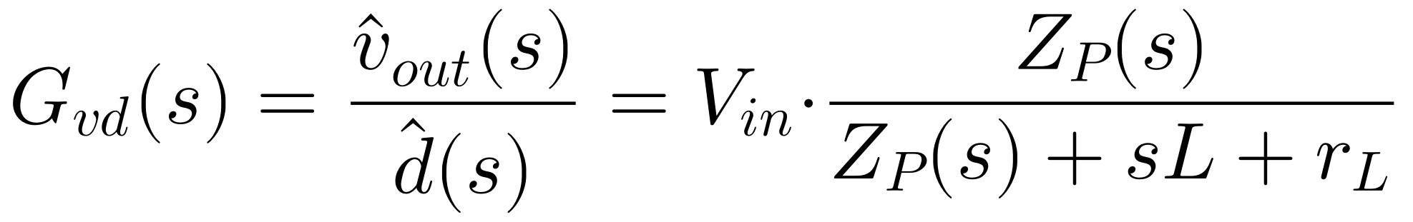
Substituting the expression for Z_{P}(s):

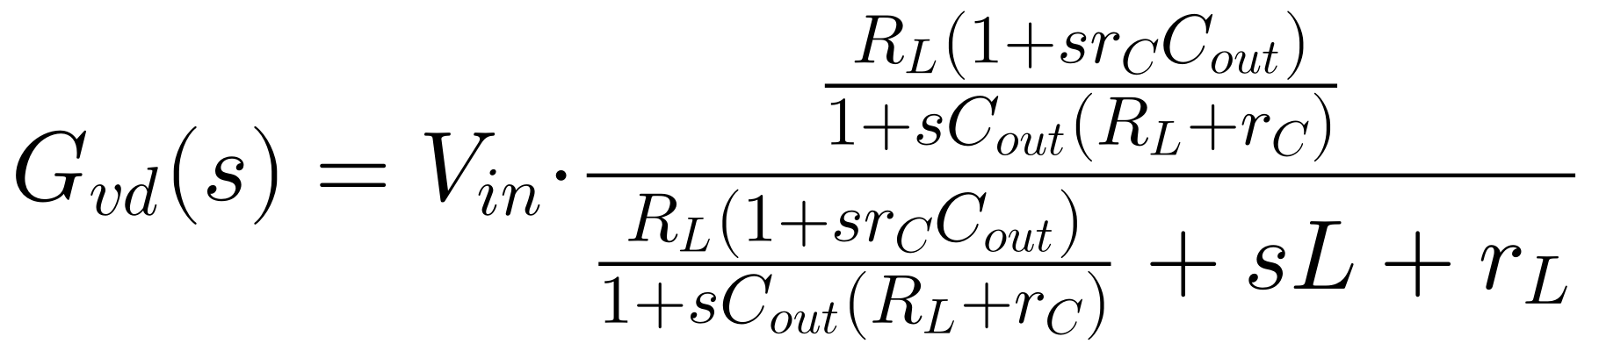
By multiplying the numerator and denominator by [1 + sC_{out} (R_{L} + r_{C})]:

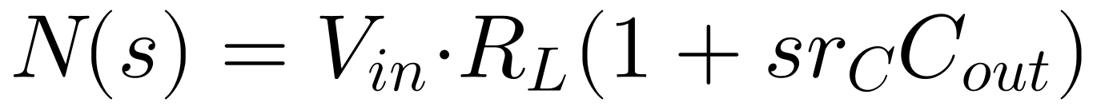

Expanding the terms in the denominator D(s):

Grouping terms by powers of the complex variable s:

Factoring (R_{L} + r_{L}) to obtain the normalized canonical polynomial form:

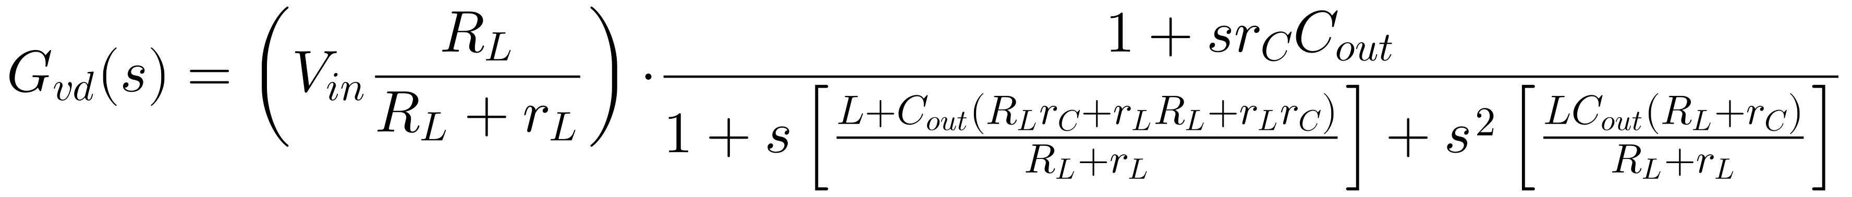

- Second-Order Canonical Form and Numerical Analysis

Expressing G_{vd}(s) in its standard canonical representation in control theory:

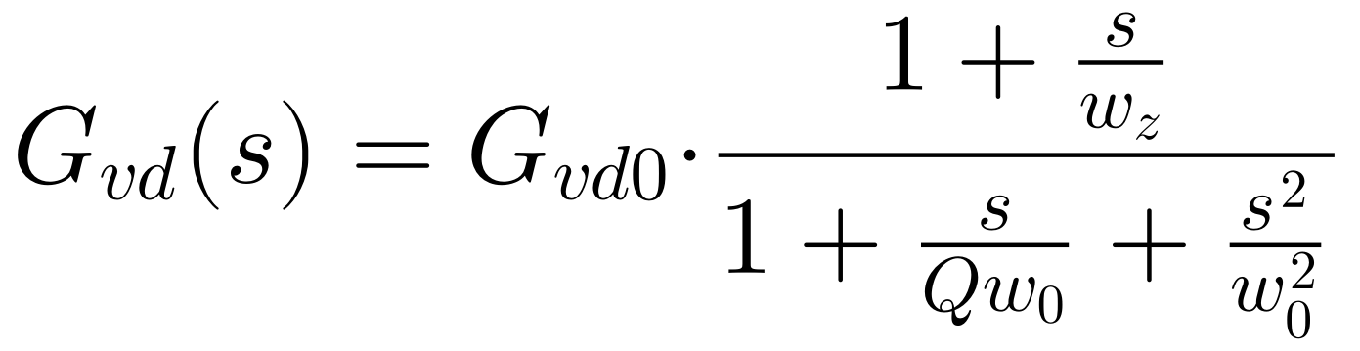

  - Direct Current Gain G_{vd0}(s)

Due to the voltage drop attenuated by the resistive divider consisting of the DCR (r_{L}) and the load (R_{L}):

On a logarithmic magnitude scale:

  - Zero Introduced by the Capacitor's ESR (w_{z}, f_{z})

The output capacitor's ESR (r_{C}) introduces a real zero in the left half-plane that stops the gain roll-off at high frequencies and injects a phase lead of +90º:

  - Resonant Frequency of the Double Pole (w₀, f₀)

The quadratic term in the denominator defines the natural resonance frequency of the damped LC filter:

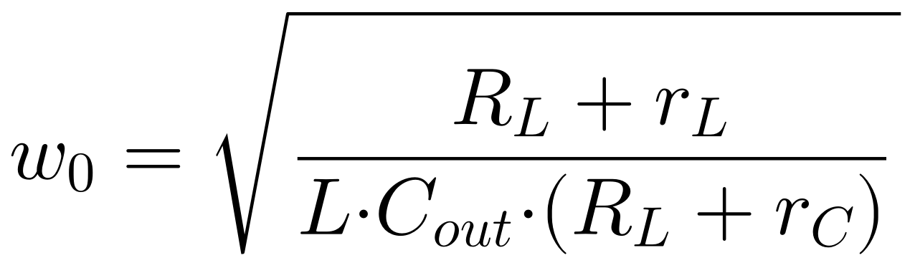

Substituting the values from the system:

- Numerator: R_{L} + r_{L} = 2.5 + 0.025 = 2.525 Ω
- Denominator: LC_{out}(R_{L} + r_{C}) = (68 x 10⁻⁶) · (220 x 10⁻⁶) · (2.5 + 0.025) = 1.496 x 10⁻⁸ · 2.525 = 3.7774 x 10⁻⁸ s² · Ω

Calculating the fundamental frequency in Hertz (Hz):

  - Resonant Quality Factor (Q) and Damping (ζ)

The coefficient of the linear term s in the denominator satisfies the relation 1 / Qw₀ = b₁:

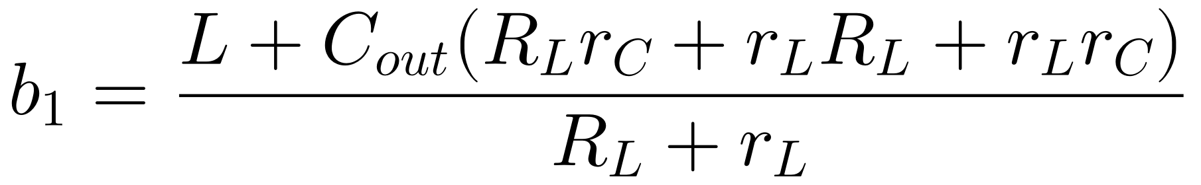

Evaluating the combined parasitic terms:

- R_{L}r_{C} = 2.5 · 0.025 = 0.0625 Ω²
- r_{L}R_{L} = 0.025 · 2.5 = 0.0625 Ω²
- r_{L}r_{C} = 0.025 · 0.025 = 0.000625 Ω²
- Sum of Terms R_{comb} = 0.125625 Ω²

Numerator of b₁:

Dividing by (R_{L} + r_{L}) = 2.525 Ω:

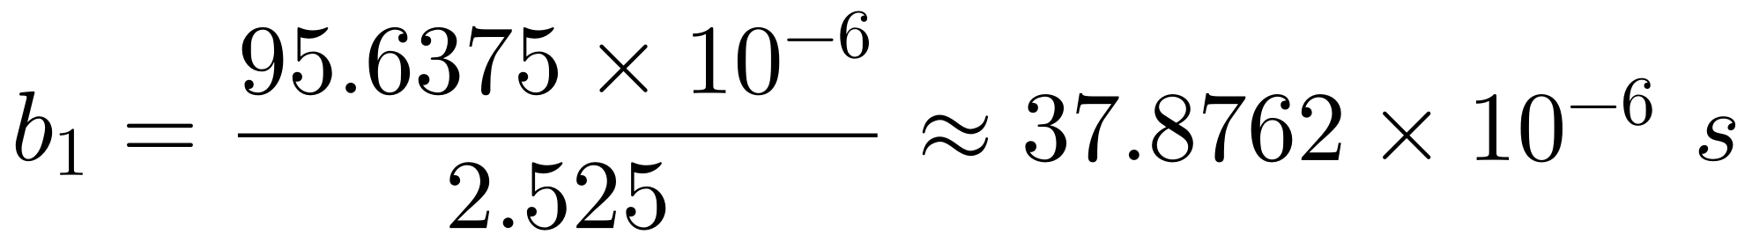

Therefore, the Quality Factor Q is:

The dimensionless damping factor ζ is given by:

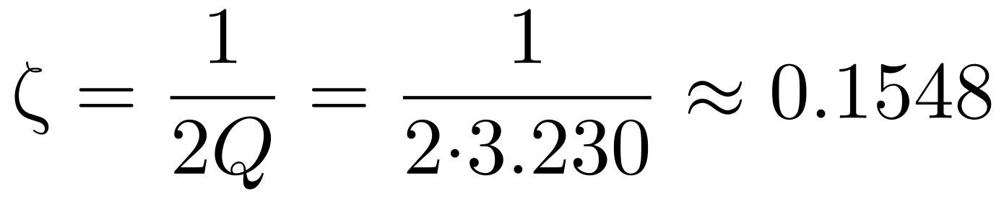

Interpretation of Resonant Overdrive (Peaking)

Since Q = 3.230 > 0.707, the system exhibits severe underdamping near f₀ = 1.301 kHz. The peak magnitude relative to the DC gain is:

- Summary Table of Plant Dynamics (Open-Loop)

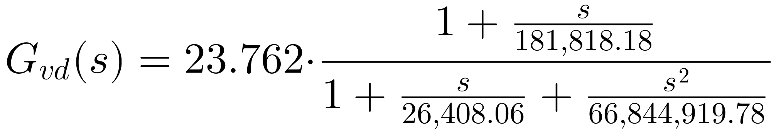

Dynamic Parameter | Notation | Calculated Exact Value | Physical and Circuit Analysis
Gain in DC | G_{vd0} | 23.762 V (27.52 dB) | Mitigated by DCR (r_{L} = 25 mΩ)
LC Resonant Frequency | f₀ | 1,31.23 Hz (1.301 kHz) | Location of the filter's dual pole
Magnitude Resonance Peak | |G_{vd}(f₀)|_{max} | +37.70 dB (+10.18 dB vs DC) | Characteristic underdamping ( ζ = 0.155)
Resonant Phase Drop | ∕G_{vd}(f₀) | -90º (abrupt transition to -180º) | Requires compensation by adv. network
Zero per ESR of C_{out} | f_{z} | 28,952.42 Hz (28.95 kHz) | Flatten the slope of -40 to -20 dB/dec

- Physical Implications for the Design of Type II/III Compensators

- Severe Phase Delay: Between 1.0 kHz and 2.0 kHz, the phase collapses from 0º to nearly -180º. If the desired crossover frequency (f_{c}) is set to 10 kHz (f_{sw} / 10), the analog compensator must provide a phase boost of approximately +70º to +80º using zeros located below f_{c}.
- Impact of the ESR (r_{C}): The zero at f_{z} ≈ 28.95 kHz helps restore +90º of phase above 29 kHz. However, in modern polymer capacitors with ESR < 10 mΩ, this zero shifts to much higher frequencies (>75 kHz), forcing the op-amp-based compensator to autonomously provide all compensation using a Type III topology (two zeros and two poles).

