DOC-ANALOG-001

- Summary and Architectural Philosophy

The fundamental purpose of this project is to revive the purity of continuous analog computing as applied to real-time power control, emulating the philosophy of aerospace guidance and dynamic simulation computers.

Unlike modern digital controllers based on microcontrollers or DSPs, which are inherently limited by:
- Sampling Latency: Conversion times of analog-to-digital converters (ADCs).
- Sampling and Quantization Jitter: Phase Noise and Finite Resolution in the Error Signal.
- Computational delay: Lags caused by interrupt service routines (ISR) and digital PWM refresh rates.

A pure analog control loop processes the error signal using the flow of electrons in the continuous domain. The response speed is limited only by the gain-bandwidth product (GBW) and the slew rate of the selected precision operational amplifiers.

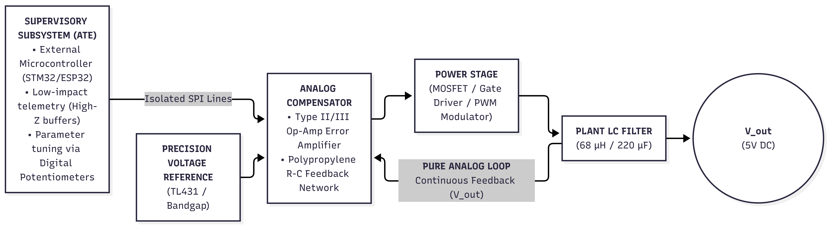
- Mathematical Modeling and Plant Sizing

The physical design consists of a step-down (Buck) DC-DC converter operating in Continuous Conduction Mode (CCM). Its function is to step down a nominal 24V industrial bus voltage to a stabilized 5V output voltage, supplying up to 2.0A of direct current to the load.

  - Nominal Operating Conditions

Parameter | Symbol | Nominal Value | Tolerance/Physical Criteria
Input Voltage | V_{in} | 24.0 V | DC bus with typical ripple ±10 %
Output Voltage | V_{out} | 5.0 V | Static tolerance < ±0.5 %
Maximum Load Current | I_{out_max} | 2.0 A | Rated Design Current
Minimum Load Current | I_{out_min} | 291 mA | Critical threshold for preventing DCM
Switching Frequency | f_{sw} | 100 kHz | Period T_{sw} = 10 μs
Relative Current Ripple | γ | 30 % | ΔI_{L} = 0.30 * I_{out} = 0.60 A
Output Voltage Ripple | ΔV_{out} | ≤ 20 mV_{p-p} | < 0.4 % de V_{out}

  - Calculation of Power Inductance

Under steady-state conditions and assuming ideal components, the duty cycle D is defined as:

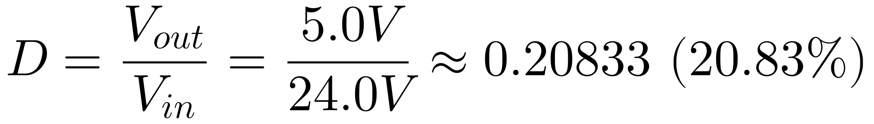
During the main switch's conduction interval (t_{on} = D · T_{sw} = 2.0833 μs), the voltage applied to the inductor is V_{L} = V_{in –} V_{out} = 19.0 V. Applying Faraday-Lenz's Law to the volt-second relationship:

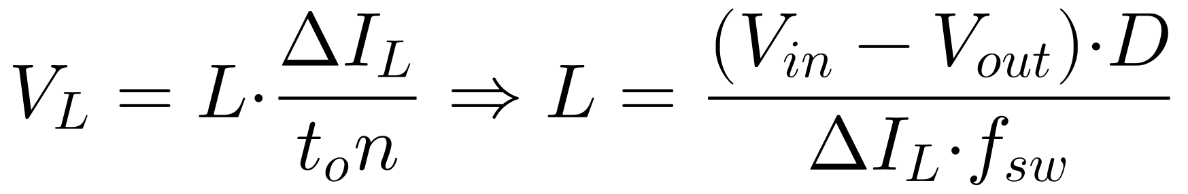
Substituting the target values:

Seleccionamos el valor comercial estandarizado superior: L = 68 μH.

Recalculation of Dynamic Parameters Using L = 68 μH:

- Real Current Ripple (ΔI_{L}):

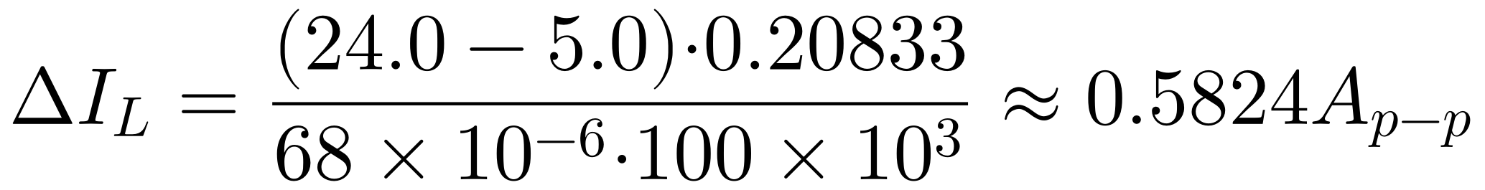
- Peak Current in Inductance (I_{L_peak}):

- Magnetic Saturation Margin (I_{sat}):

To prevent a catastrophic drop in inductance caused by saturation of the ferrite core during load transients, the selected physical component must meet the following requirements:

- Threshold for Transition to Intermittent Driving Mode (DCM):

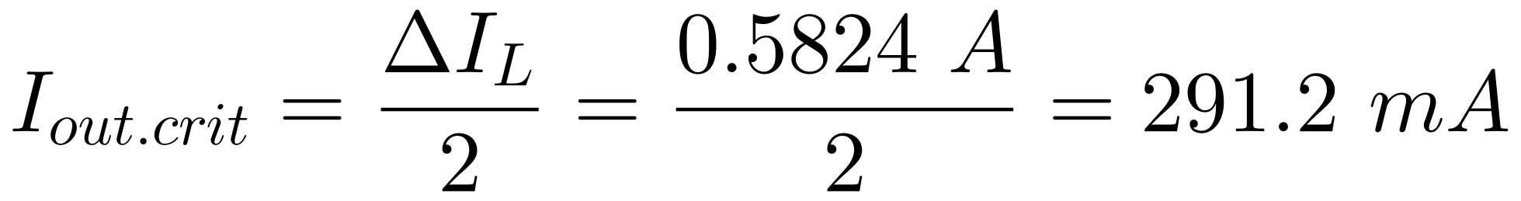
Design Note: If I_{out} < 291.2 mA, the plant transitions from a second-order system to a first-order system dependent on load resistance R_{L}, by changing the position of the loop's ends.

  - Calculation of the Output Capacitor and ESR Budget

The total voltage ripple at the output node ΔV_{out} is the vector sum/superposition of the pure capacitive component (ΔV_{C}) and the resistive drop across the Equivalent Series Resistance (ΔV_{ESR}):

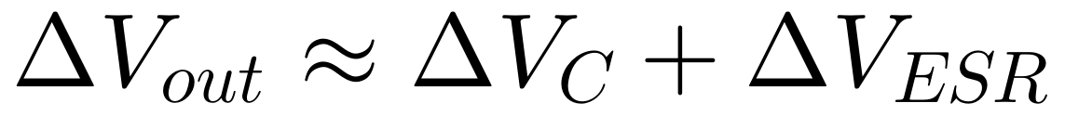
To meet the requirement for high analog purity (ΔV_{out} ≤ 20 mV_{p-p}), we break down the switching noise budget as follows:
- Capacitive Budget (ΔV_{C}): ≤ 5.0 mV
- ESR by Budget (ΔV_{ESR}): ≤ 15.0 mV

- Minimum Capacity (C_{out_min}):

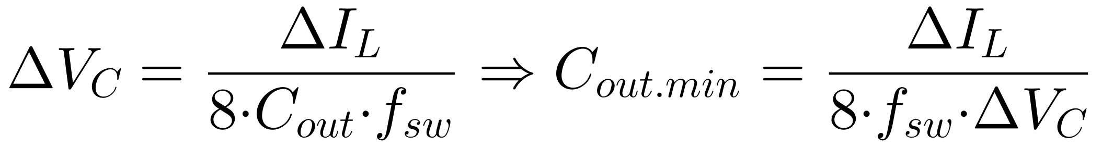
We select a market value of C_{out} = 220 μF (Ultra-low ESR aluminum polymer electrolytic capacitor in parallel with a ceramic capacitor 10 μF X7R/C0G to attenuate high-frequency spikes).

- Maximum Equivalent Series Resistance (ESR_{max}):

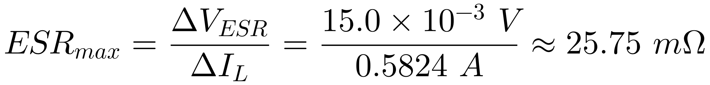

It is a strict rule that the capacitive output network must ensure an ESR ≤ 25.0 mΩ.

Recalculation of the Expected Total Stress Curvature:

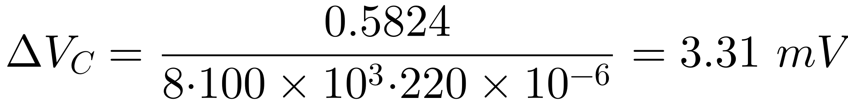

- Plant Transfer Function

Using the State-Space Averaging (SSA) method developed by R. D. Middlebrook and S. Ćuk, the small-signal transfer function between the duty cycle d(s) and the output voltage v_{out}(s) is given by:

Since R_{L} = V_{out} / I_{out_max} = 5 V / 2 A = 2.5 Ω >> ESR = 25 mΩ, the equation simplifies to the canonical second-order form:

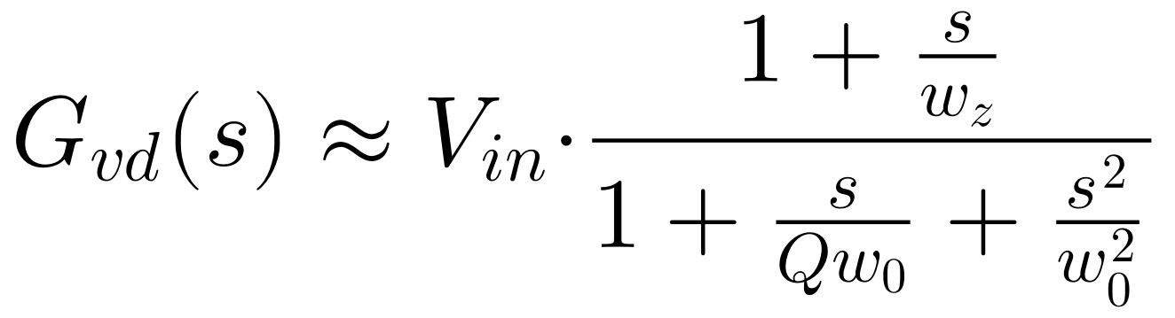

  - Location of Poles and Zeros in an Open-Loop System

- Natural Resonance Frequency of the LC Filter (f₀):

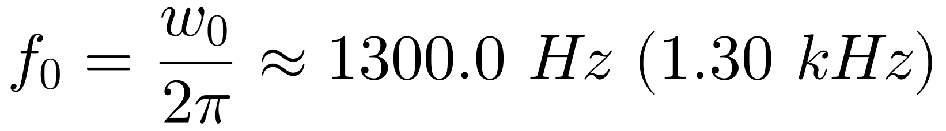

- Zero Introduced by the Capacitor's ESR (f_{z}):

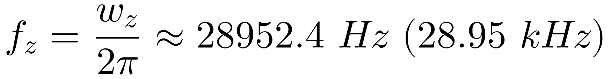

- Resonance Quality Factor (Q):

Physical Interpretation of Control: At a frequency of 1.30 kHz, the LC filter introduces a double pole that causes an abrupt drop in gain at a rate of -40 dB/decade and a critical phase drop of -180º. The analog compensator must provide a substantial phase boost near the crossover frequency to prevent unstable oscillation of the converter.

- Physics of Discrete Components and Non-idealities

High-level design of an analog circuit requires modeling real-world imperfections before physical assembly.

  - Capacitors and Dielectric Soakage

In the integrator nodes and feedback networks of the compensator, the use of high-dielectric-constant ceramic capacitors (X7R/Y5V type) is strictly prohibited due to their high DC voltage coefficient and high dielectric loss.

- Effect of Dielectric Absorption: The molecules in the dielectric retain a residual charge that they slowly release after a rapid discharge, causing integration drift and memory errors in the PID loop.
- Approved Components: Only polypropylene (PP) or polystyrene film capacitors for the op-amp's R-C networks, and C0G/NP0 ceramic capacitors for small capacitance values (< 10 nF).

  - Magnetic Cores and Hysteresis

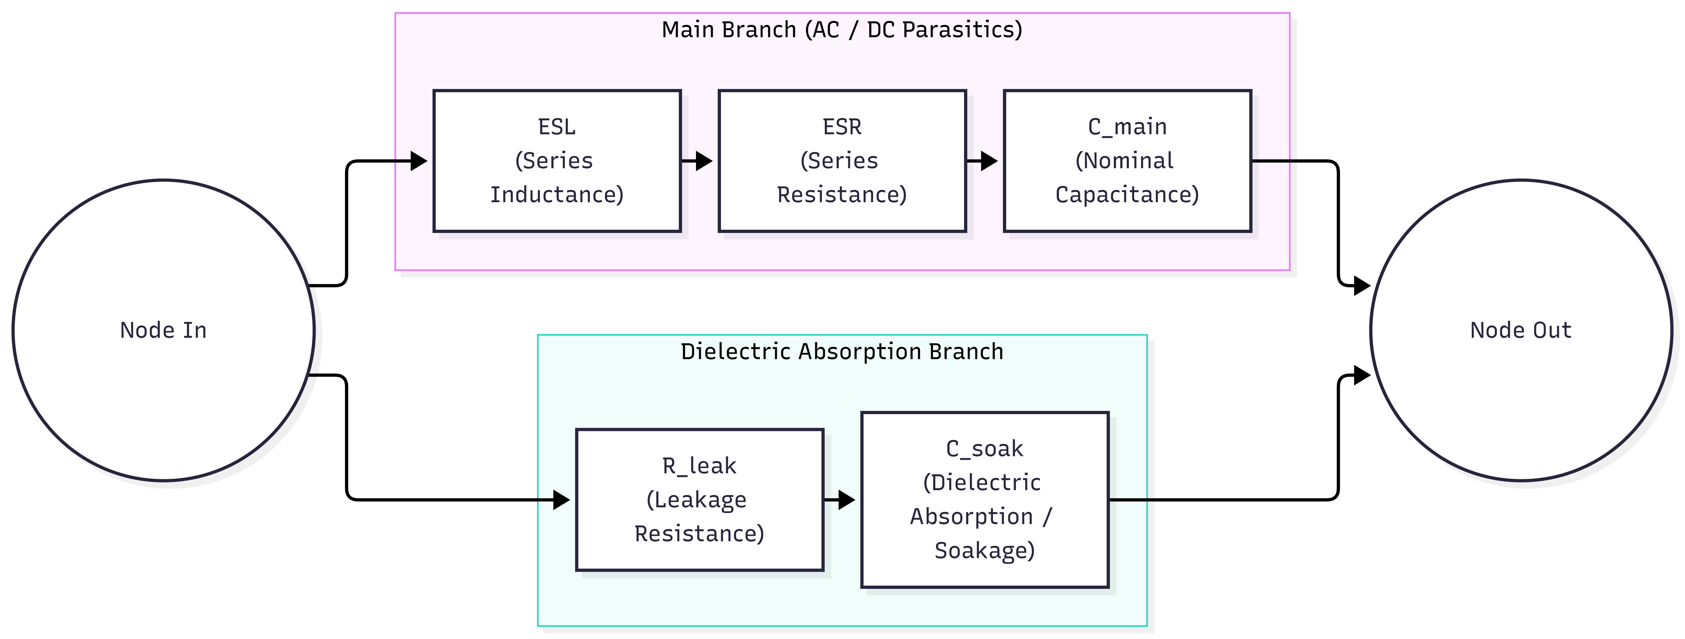
The power inductance L exhibits three nonlinear phenomena:

- Losses in the Core (Steinmetz Equation): P_{core} = k · f^{α} · B^{β}. At 100 kHz, the flux density ΔB must be limited to prevent thermal runaway in the core.
- Skin Effect and Proximity Effect: At 100 kHz, the depth of current penetration in copper is δ ≈ 0.21 mm. Multifilament yarn is required (Litz) or flat windings to minimize AC resistance (R_{AC}).

  - Error Operational Amplifier: Input Imperfections

The op-amp for the analog compensator should be selected by evaluating:

- Input Bias Current (I_{b}): A current I_{b} > 100 pA when continuously injected into the high-impedance summing node, it will charge the integration capacitor C_{f}, causing the output to drift toward saturation of the power rails.
  - Requirement: I_{b} > 10 pA (JFET or ultra-low-leakage CMOS technology, e.g., OPA140 or LMC662).

- Product-Bandwidth Product (GBW):
  - Requirement: GBW ≥ 100 x f_{sw} = 10 Mhz to ensure that the open-loop gain A_{OL} the op-amp's phase response does not degrade at the desired crossover frequency (10 kHz).

- Pre-Layout Simulation Strategy in Ltspice

The verification process in LTspice is divided into two distinct stages:

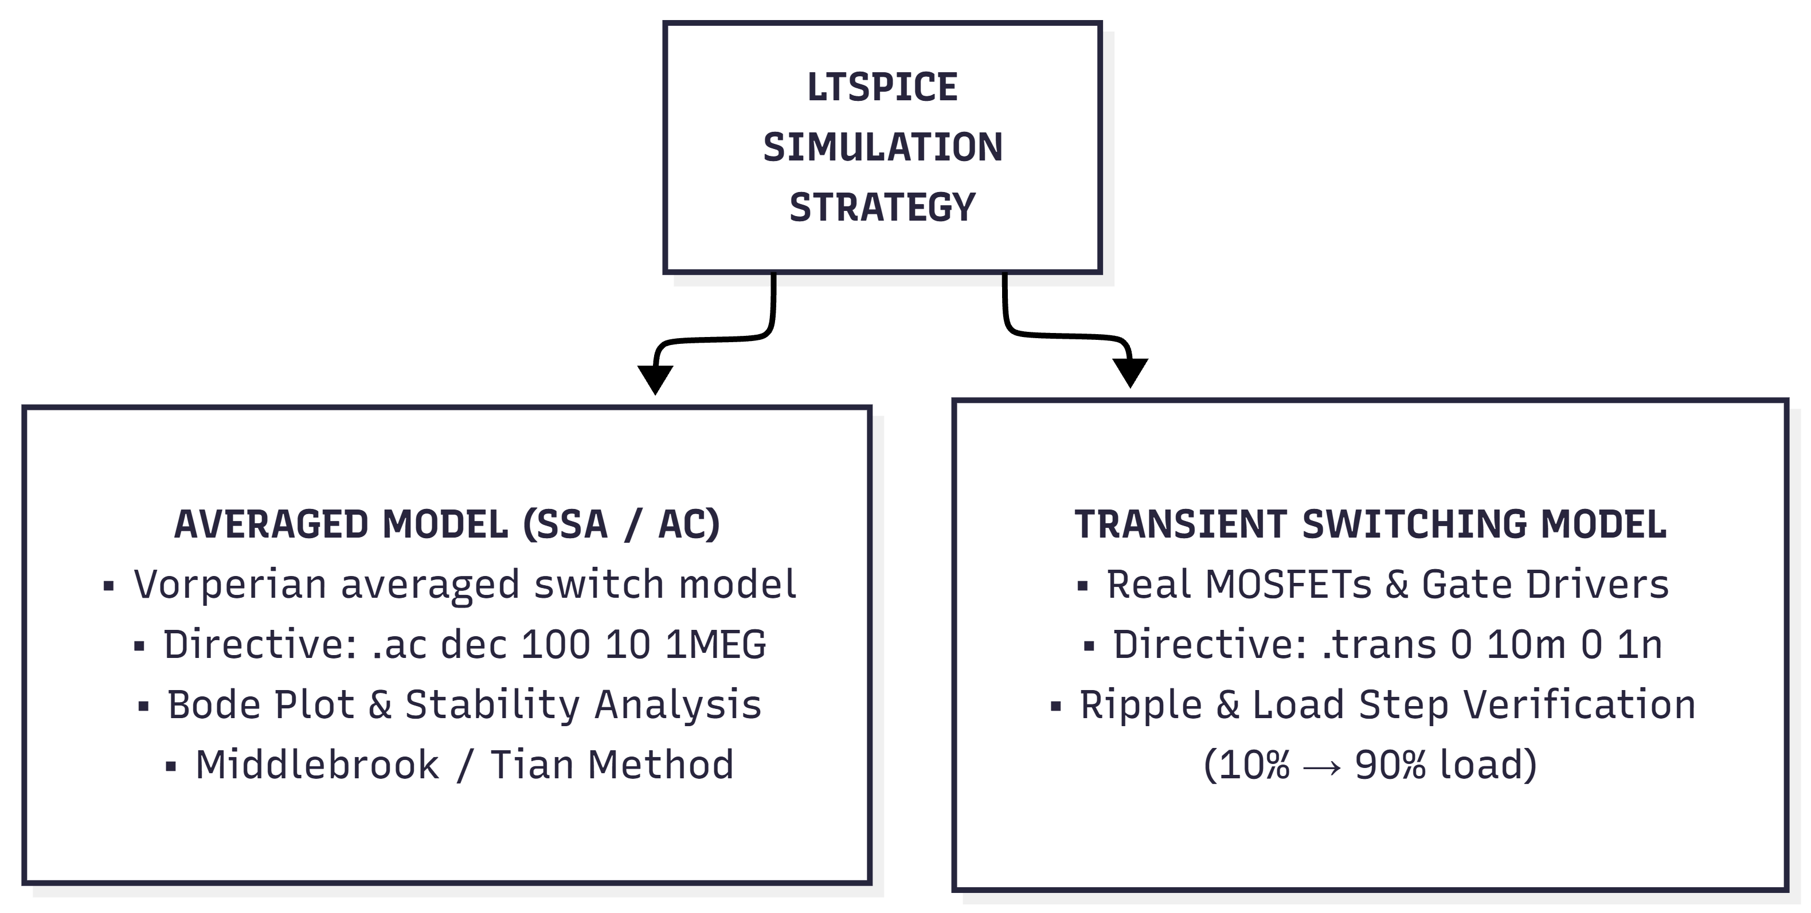
  - Signal Injection Protocol (Tian/Middlebrook Method)

To measure closed-loop gain T(s) = A(s) · β(s) Without disrupting the DC operating point of the analog loop, a test AC voltage source is inserted (V_{test}) in series with the feedback network.

Margen de Fase (Φ_{m}) = 180º + ∕T(jw_{crossover}) ≥ 60º

Margen de Ganancia (A_{m}) = -20 log₁₀ |T(jw_{-180º})| ≥ 10 dB

- Rules for Electromagnetic Tracing

The most common failure in analog power controllers is contamination of the high-impedance summing node by radiated (dv/dt) and conducted (di/dt) noise from the power stage.

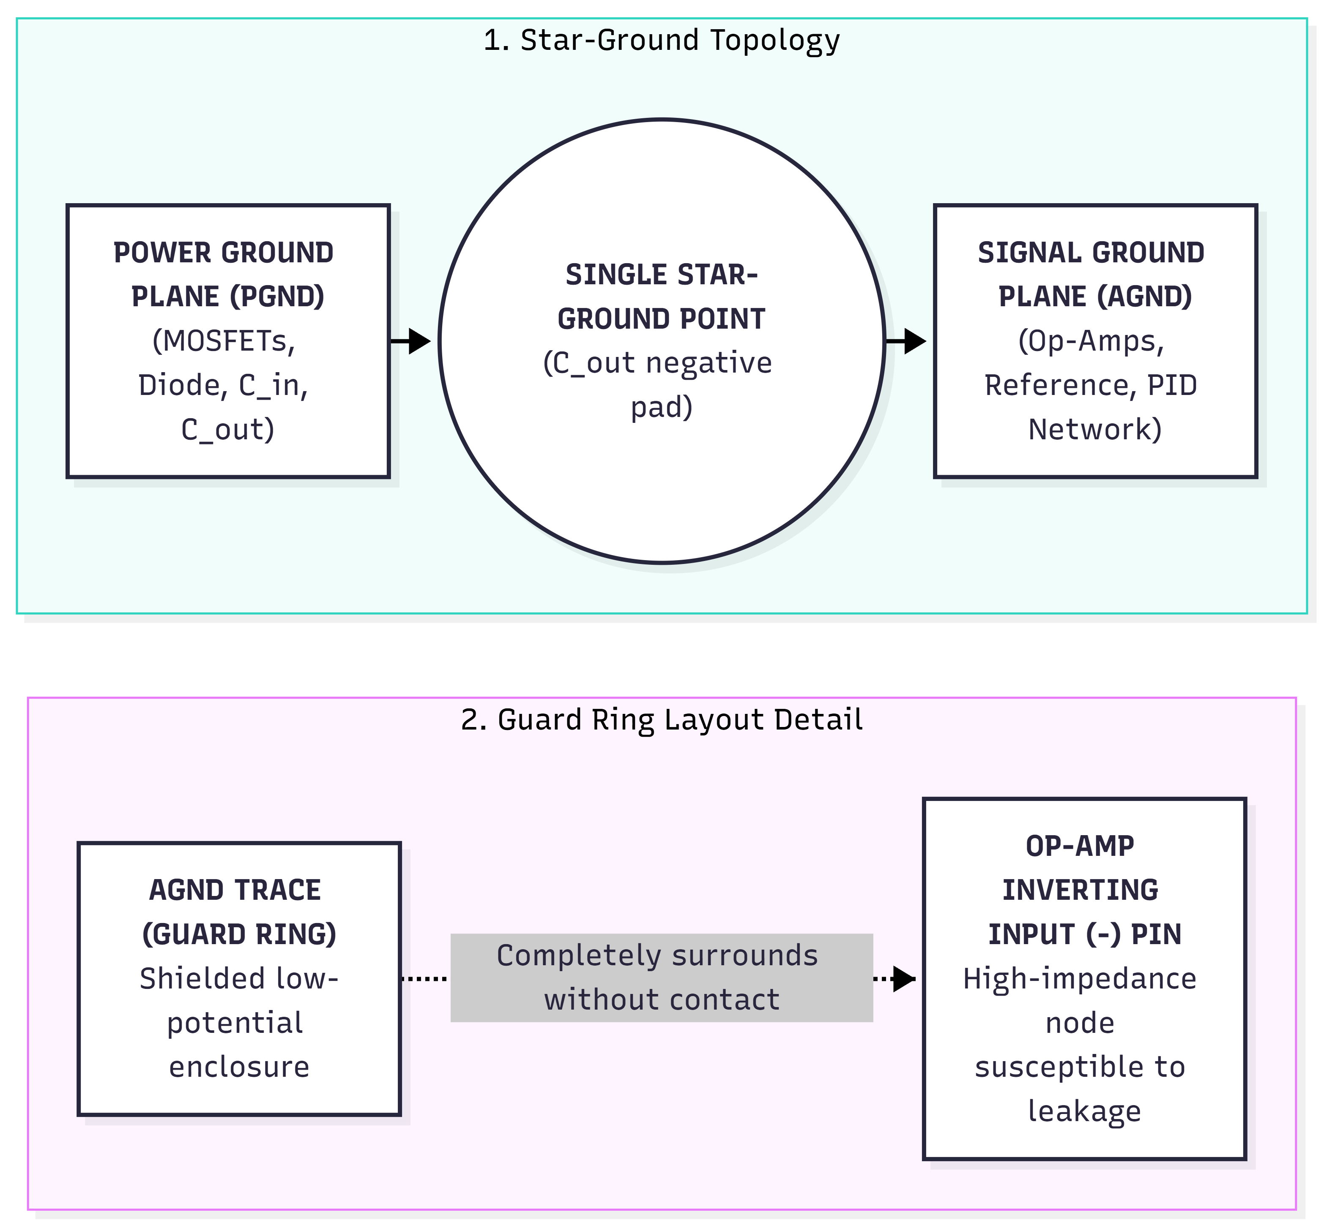

  - Signal Injection Protocol (Tian/Middlebrook Method)

- Ground Separation: The Power Ground (PGND) and Analog Ground (AGND) planes are completely separated on the PCB and are connected strictly at a single star point located beneath the negative terminal of the output capacitor C_{out}.
- Guard Rings: Trace the analog ground (AGND) signal around the inverting input pins (V₋) of the error op-amps to drain surface leakage currents from the PCB caused by moisture or flux residue.
- Reducing the Switching Node (SW) Area: The copper in the node that connects the MOSFETs to the inductor L generates intense electric fields (E-field; dv/dt ≈ 10 V/ns). Its area must be minimized and must never cross layers adjacent to the analog compensator traces.
- Bipolar Symmetrical Power Supply: The op-amps in the control loop will be powered by dedicated ±12 V regulated rails derived from ultra-low-noise LDO regulators (VRMS < 10 μV), independent of the 24 V input line.

- References and Sources of Contrast

To verify and explore in greater depth the mathematical and physical concepts presented in this document, the following sources of technical reference literature are cited:

- Middlebrook, R. D., & Ćuk, S. (1976). A General Unified Approach to Modeling Switching-Converter Power Stages. IEEE Power Electronics Specialists Conference (PESC).
(A fundamental reference for the state-space averaging method).

- Erickson, R. W., & Maksimović, D. (2001). Fundamentals of Power Electronics (2nd ed.). Springer Science & Business Media.
(Chapters 7 and 8: Formal derivation of Gvd(s) and design of Type II/III compensators).

- Basso, C. (2012). Designing Control Loops for Linear and Switching Power Supplies: A Tutorial Guide. Artech House.
(A practical guide to pole-zero placement and stability margins).

- Analog Devices / Linear Technology. Application Note 19: LTspice IV Circuit Notes - Middlebrook Loop Gain Measurement.
(Signal Injection Methodology in SPICE Simulations).

- Texas Instruments. SLOA020A: Precision Op-Amp Single-Supply Design Techniques (Analysis of bias currents Ib, offset, and guard ring design).

- National Aeronautics and Space Administration (NASA). NASA SP-8018: Spacecraft Gravitational Torques—Analog Flight Computers Reference.
(Fundamentals of Drift Mitigation in Pure Analog Integrators).

