Министерство образования Республики Беларусь

Учреждение образования

«Брестский государственный технический университет»

Кафедра ИИТ

Лабораторная работа №4

По дисциплине: «МиАПР»

Тема: «Нелинейные ИНС в задачах прогнозирования.»

Выполнил:

Студент 2 курса

Группы ПО-7(2)

Панкратов Р.С.

Проверил:

Крощенко А.А.

2021

Вариант 3

**Цель работы:**

Изучить обучение и функционирование нелинейной ИНС при решении задач распознавания образов.

**Задание:**

Спрогнозировать нелинейный временной ряд, применяя параметры лабораторной работы №3. При этом необходимо использовать алгоритм обучения многослойной ИНС с адаптивным шагом.

**Код программы:**

from typing import Tuple, Callable, Any  
from functools import partial  
  
import numpy as np  
from numpy.typing import NDArray  
  
LEARNING_SPEED = 0.1  
  
WeightsType = NDArray[NDArray[np.float64]]  
TType = NDArray[np.float64]  
  
  
def func(a: float, b: float, c: float, d: float, x) -> float:  
 return a * np.cos(b * x) + c * np.sin(d * x)  
  
  
def sigmoid(s):  
 return 1 / (1 + np.exp(-s))  
  
  
def d_sigmoid(y):  
 return y * (1 - y)  
  
  
def lin(s):  
 return s  
  
  
def d_lin(_):  
 return 1.0  
  
  
def generate_dataset(  
 start: int, stop: int, count: int, func: Callable[[Any], float], step: float  
) -> Tuple[NDArray[NDArray[np.float64]], NDArray[NDArray[np.float64]]]:  
 inputs, outputs = [], []  
 for i in range(start, stop):  
 inputs_sample = func(np.arange(i, count + i) * step)  
 outputs_sample = np.array([func((count + i) * step)])  
  
 inputs.append(inputs_sample)  
 outputs.append(outputs_sample)  
  
 return np.array(inputs), np.array(outputs)  
  
  
def calc_error(  
 outputs: NDArray[NDArray[np.float64]], ideal_outputs: NDArray[NDArray[np.float64]]  
) -> NDArray[np.float64]:  
 errors = (outputs - ideal_outputs) ** 2  
 return errors.sum(axis=0) / len(ideal_outputs)  
  
  
def calc_percent(  
 outputs: NDArray[NDArray[np.float64]], ideal_outputs: NDArray[NDArray[np.float64]]  
) -> NDArray[np.float64]:  
 percents = (outputs * 100) / ideal_outputs  
 return percents.sum(axis=0) / len(ideal_outputs)  
  
  
def training(  
 inputs: NDArray[np.float64],  
 outputs: NDArray[np.float64],  
 w_output: WeightsType,  
 w_hidden: WeightsType,  
 T_output: TType,  
 T_hidden: TType,  
 is_adaptive_learning_speed: bool = False,  
) -> None:  
 hidden_outputs = sigmoid(np.dot(w_hidden, inputs) - T_hidden)  
 output_outputs = lin(np.dot(w_output, hidden_outputs) - T_output)  
  
 error_output = output_outputs - outputs  
 error_hidden = error_output * d_sigmoid(hidden_outputs) * w_output  
  
 learning_speed_output = LEARNING_SPEED  
 learning_speed_hidden = LEARNING_SPEED  
 if is_adaptive_learning_speed:  
 ls_output_numerator = (np.square(error_output) * d_lin(hidden_outputs)).sum()  
 ls_output_denominator = 1 + np.square(error_output * d_lin(hidden_outputs)).sum()  
 learning_speed_output = ls_output_numerator / ls_output_denominator  
  
 ls_hidden_numerator = 4 * (np.square(error_hidden) * d_sigmoid(hidden_outputs)).sum()  
 ls_hidden_denominator = (1 + np.square(output_outputs).sum()) * np.square(error_hidden * d_sigmoid(hidden_outputs)).sum()  
 learning_speed_hidden = ls_hidden_numerator / ls_hidden_denominator  
  
 w_output -= learning_speed_output * np.dot(error_output.reshape(-1, 1), hidden_outputs.reshape(1, -1))  
 T_output += learning_speed_output * error_output.reshape(-1)  
  
 w_hidden -= learning_speed_hidden * np.dot(error_hidden.reshape(-1, 1), inputs.reshape(1, -1))  
 T_hidden += learning_speed_hidden * error_hidden.reshape(-1)  
  
  
def learn(  
 inputs: NDArray[NDArray[np.float64]],  
 ideal_outputs: NDArray[NDArray[np.float64]],  
 w_output: WeightsType,  
 w_hidden: WeightsType,  
 T_output: TType,  
 T_hidden: TType,  
 epochs: int = 1000,  
 is_print_intermediate_result: bool = True,  
 is_adaptive_learning_speed: bool = False  
):  
 for epoch in range(epochs + 1):  
 for input, output in zip(inputs, ideal_outputs):  
 training(input, output, w_output, w_hidden, T_output, T_hidden, is_adaptive_learning_speed)  
  
 if is_print_intermediate_result and not epoch % (epochs // 10):  
 outputs = v_predict(inputs, w_hidden, w_output, T_hidden, T_output)  
 errors = calc_error(outputs, ideal_outputs)  
 percents = calc_percent(outputs, ideal_outputs)  
 print(f"{epoch} error: {errors}, percent: {percents}")  
  
 return w_output, w_hidden, T_output, T_hidden  
  
  
def predict(  
 inputs: NDArray[np.float64], w_hidden: WeightsType, w_output: WeightsType, T_hidden: TType, T_output: TType  
) -> NDArray[np.float64]:  
 hidden_outputs = sigmoid(np.dot(w_hidden, inputs) - T_hidden)  
 return lin(np.dot(w_output, hidden_outputs) - T_output)  
  
  
def print_results(epochs, inputs, ideal_outputs, w_output, w_hidden, T_output, T_hidden):  
 outputs = v_predict(inputs, w_hidden, w_output, T_hidden, T_output)  
 difference = ideal_outputs - outputs  
  
 error = calc_error(outputs, ideal_outputs)  
 percent = calc_percent(outputs, ideal_outputs)  
 print(f"Epochs: {epochs}")  
 print(f"Error: {error[0]}")  
 print(f"Percent: {percent[0]}")  
 print("Prediction:")  
 print(" Ideal output: Output: Difference:")  
 for i in range(len(difference)):  
 print(f"{ideal_outputs[i][0]: 22}{outputs[i][0]: 25}{difference[i][0]: 25}")  
  
  
VPredictType = Callable[  
 [NDArray[NDArray[np.float64]], WeightsType, WeightsType, TType, TType], NDArray[NDArray[np.float64]]  
]  
v_predict: VPredictType = np.vectorize(predict, signature="(n)->(m)", excluded=[1, 2, 3, 4])  
  
  
def main():  
 EPOCHS = 10_000  
  
 A, B, C, D = 0.3, 0.3, 0.07, 0.3  
 STEP = 0.1  
  
 nn_inputs = 10  
 nn_hidden = 4  
 nn_output = 1  
  
 training_values, testing_values = 30, 15  
  
 wrapped_func = partial(func, A, B, C, D)  
 inputs, ideal_outputs = generate_dataset(0, training_values, nn_inputs, wrapped_func, STEP)  
 test_inputs, test_ideal_outputs = generate_dataset(  
 training_values, training_values + testing_values, nn_inputs, wrapped_func, STEP  
 )  
  
 w_hidden: WeightsType = np.random.normal(-1, 1, (nn_hidden, nn_inputs))  
 w_output: WeightsType = np.random.normal(-1, 1, (nn_output, nn_hidden))  
 T_hidden: TType = np.random.normal(-1, 1, nn_hidden)  
 T_output: TType = np.random.normal(-1, 1, nn_output)  
  
 not_adaptive_result = learn(  
 inputs, ideal_outputs, w_output.copy(), w_hidden.copy(), T_output.copy(), T_hidden.copy(), EPOCHS, False, False  
 )  
 print("No adaptive learning speed result:")  
 print("Learning dataset:")  
 print_results(EPOCHS, inputs, ideal_outputs, *not_adaptive_result)  
 print()  
 print("Testing dataset:")  
 print_results(EPOCHS, test_inputs, test_ideal_outputs, *not_adaptive_result)  
  
 adaptive_result = learn(  
 inputs, ideal_outputs, w_output.copy(), w_hidden.copy(), T_output.copy(), T_hidden.copy(), EPOCHS, False, True  
 )  
 print()  
 print("Adaptive learning speed result:")  
 print("Learning dataset:")  
 print_results(EPOCHS, inputs, ideal_outputs, *adaptive_result)  
 print()  
 print("Testing dataset:")  
 print_results(EPOCHS, test_inputs, test_ideal_outputs, *adaptive_result)  
  
  
if __name__ == "__main__":  
 main()

**Результат:**

Результаты без адаптивного шага обучения:

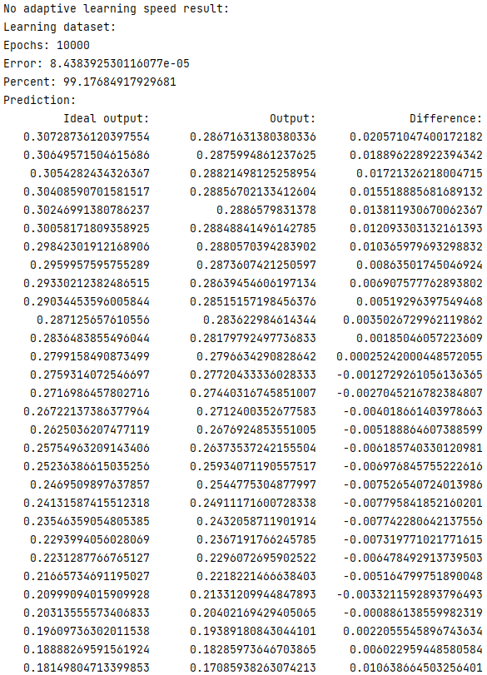

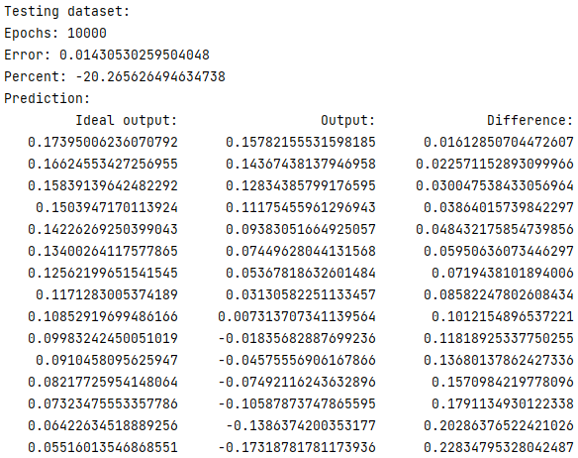

Результаты c адаптивным шагом обучения:

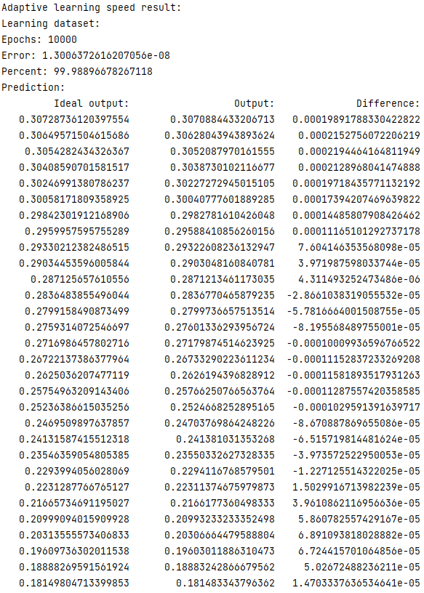

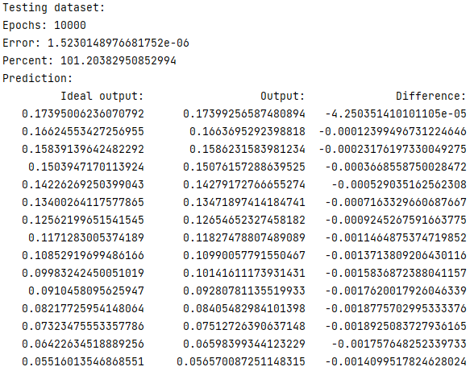

**Вывод:**

Нн с адаптивным шагом обучения обучается горазда эффективнее нн без адаптивного шага обучения.