Министерство образования Республики Беларусь

Учреждения образования
«Брестский государственный технический университет

Факультет электронно-информационных систем

Кафедра интеллектуальных информационных технологий

Отчет по лабораторной работе №5

Специальность ПО-12

Выполнил
К. В. Ковалюк,
студент группы ПО-12
Проверил
А. Д. Кулик,
преп. стаж. кафедры ИИТ,
« » 2026 г.

Брест 2026

Цель работы: Приобрести практические навыки разработки API и баз данных.

Вариант: №7
Общее задание
1. Реализовать базу данных из не менее 5 таблиц на заданную тематику. При реализации продумать типизацию полей и внешние ключи в таблицах;
2. Визуализировать разработанную БД с помощью схемы, на которой отображены все таблицы и связи между ними (пример, схема на рис. 1);
3. На языке Python с использованием SQLAlchemy реализовать подключение к БД;
4. Реализовать основные операции с данными (выборку, добавление, удаление, модификацию);
5. Для каждой реализованной операции с использованием FastAPI реализовать отдельный эндпойнт; Базу данные можно реализовать в любой СУБД (MySQL, PostgreSQL, SQLite и др.)
7) База данных Компьютерная лаборатория

Выполнение:
Код программы:
create_db.py:
from database import engine, Base, SessionLocal
from crud import create_client, create_manufacturer, create_product, create_computer
from datetime import date

Base.metadata.drop_all(bind=engine)
Base.metadata.create_all(bind=engine)

db = SessionLocal()

client1 = create_client(db, "Иван", "Петров", "M", "ivan_p", "+7(123)456-78-90", "ivan@mail.ru")
client2 = create_client(db, "Мария", "Сидорова", "F", "masha_s", "+7(098)765-43-21", "maria@mail.ru")
client3 = create_client(db, "Алексей", "Иванов", "M", None, "+7(555)123-45-67", "alex@mail.ru")

man1 = create_manufacturer(db, "Intel Corporation", date(1968, 7, 18))
man2 = create_manufacturer(db, "AMD", date(1969, 5, 1))
man3 = create_manufacturer(db, "NVIDIA", date(1993, 4, 5))
man4 = create_manufacturer(db, "ASUS", date(1989, 4, 2))
man5 = create_manufacturer(db, "Kingston", date(1987, 10, 17))

product1 = create_product(db, "Процессор Intel Core i9-13900K", 58990.00, man1.man_id)
product2 = create_product(db, "Процессор AMD Ryzen 9 7950X", 54990.00, man2.man_id)
product3 = create_product(db, "Видеокарта NVIDIA RTX 4090", 189990.00, man3.man_id)
product4 = create_product(db, "Материнская плата ASUS ROG Maximus Z790", 45990.00, man4.man_id)
product5 = create_product(db, "Оперативная память Kingston FURY 32GB", 12990.00, man5.man_id)
product6 = create_product(db, "Видеокарта NVIDIA RTX 4080", 129990.00, man3.man_id)
product7 = create_product(db, "Процессор Intel Core i7-13700K", 38990.00, man1.man_id)

computer1 = create_computer(db, "SN001", "Gaming PC Ultra", "Intel Core i9-13900K", 32, 1000, product1.pr_id, "available")
computer2 = create_computer(db, "SN002", "Workstation Pro", "AMD Ryzen 9 7950X", 64, 2000, product2.pr_id, "available")
computer3 = create_computer(db, "SN003", "Gaming PC RTX", "Intel Core i7-13700K", 32, 1000, product6.pr_id, "rented")
computer4 = create_computer(db, "SN004", "Design Station", "AMD Ryzen 9 7950X", 128, 4000, product3.pr_id, "maintenance")

print("База данных успешно создана и заполнена тестовыми данными!")
print(f"Добавлено клиентов: 3")
print(f"Добавлено производителей: 5")
print(f"Добавлено продуктов: 7")
print(f"Добавлено компьютеров: 4")

db.close()

crud.py:
from sqlalchemy.orm import Session
from datetime import date
from database import Client, Manufacturer, Product, Order, OrdersSummary, Computer

def create_client(db: Session, first_name, last_name, sex, nick_name=None, phone=None, email=None):
client = Client(
first_name=first_name,
last_name=last_name,
sex=sex,
nick_name=nick_name,
phone=phone,
email=email
)
db.add(client)
db.commit()
db.refresh(client)
return client

def get_clients(db: Session, skip=0, limit=100):
return db.query(Client).offset(skip).limit(limit).all()

def get_client(db: Session, client_id):
return db.query(Client).filter(Client.d_id == client_id).first()

def update_client(db: Session, client_id, **kwargs):
client = db.query(Client).filter(Client.d_id == client_id).first()
if client:
for key, value in kwargs.items():
if hasattr(client, key):
setattr(client, key, value)
db.commit()
db.refresh(client)
return client

def delete_client(db: Session, client_id):
client = db.query(Client).filter(Client.d_id == client_id).first()
if client:
db.delete(client)
db.commit()
return True
return False

def create_product(db: Session, name, price, man_id):
product = Product(name=name, price=price, man_id=man_id)
db.add(product)
db.commit()
db.refresh(product)
return product

def get_products(db: Session, skip=0, limit=100):
return db.query(Product).offset(skip).limit(limit).all()

def get_product(db: Session, product_id):
return db.query(Product).filter(Product.pr_id == product_id).first()

def update_product(db: Session, product_id, **kwargs):
product = db.query(Product).filter(Product.pr_id == product_id).first()
if product:
for key, value in kwargs.items():
if hasattr(product, key):
setattr(product, key, value)
db.commit()
db.refresh(product)
return product

def delete_product(db: Session, product_id):
product = db.query(Product).filter(Product.pr_id == product_id).first()
if product:
db.delete(product)
db.commit()
return True
return False

def create_order(db: Session, d_id, items):
order = Order(d_id=d_id, date_of_order=date.today(), total_sum=0.00)
db.add(order)
db.flush()

total = 0
for item in items:
product = db.query(Product).filter(Product.pr_id == item["pr_id"]).first()
if product:
order_item = OrdersSummary(
ord_id=order.ord_id,
pr_id=item["pr_id"],
count=item["count"]
)
db.add(order_item)
total += float(product.price) * item["count"]

order.total_sum = total
db.commit()
db.refresh(order)
return order

def get_orders(db: Session, skip=0, limit=100):
return db.query(Order).offset(skip).limit(limit).all()

def get_order(db: Session, order_id):
return db.query(Order).filter(Order.ord_id == order_id).first()

def update_order(db: Session, order_id, **kwargs):
order = db.query(Order).filter(Order.ord_id == order_id).first()
if order:
for key, value in kwargs.items():
if hasattr(order, key):
setattr(order, key, value)
db.commit()
db.refresh(order)
return order

def delete_order(db: Session, order_id):
order = db.query(Order).filter(Order.ord_id == order_id).first()
if order:
db.query(OrdersSummary).filter(OrdersSummary.ord_id == order_id).delete()
db.delete(order)
db.commit()
return True
return False

def create_manufacturer(db: Session, name, establish_date):
manufacturer = Manufacturer(name=name, establish_date=establish_date)
db.add(manufacturer)
db.commit()
db.refresh(manufacturer)
return manufacturer

def get_manufacturers(db: Session, skip=0, limit=100):
return db.query(Manufacturer).offset(skip).limit(limit).all()

def get_manufacturer(db: Session, man_id):
return db.query(Manufacturer).filter(Manufacturer.man_id == man_id).first()

def update_manufacturer(db: Session, man_id, **kwargs):
manufacturer = db.query(Manufacturer).filter(Manufacturer.man_id == man_id).first()
if manufacturer:
for key, value in kwargs.items():
if hasattr(manufacturer, key):
setattr(manufacturer, key, value)
db.commit()
db.refresh(manufacturer)
return manufacturer

def delete_manufacturer(db: Session, man_id):
manufacturer = db.query(Manufacturer).filter(Manufacturer.man_id == man_id).first()
if manufacturer:
db.delete(manufacturer)
db.commit()
return True
return False

def get_order_details(db: Session, order_id):
result = db.query(
Order.ord_id,
Client.first_name,
Client.last_name,
Order.date_of_order,
Order.total_sum,
Product.name,
OrdersSummary.count,
(Product.price * OrdersSummary.count).label("subtotal")
).join(Client, Order.d_id == Client.d_id)\
.join(OrdersSummary, Order.ord_id == OrdersSummary.ord_id)\
.join(Product, OrdersSummary.pr_id == Product.pr_id)\
.filter(Order.ord_id == order_id).all()
return result

def create_computer(db: Session, serial_number, model, processor, ram_gb, storage_gb, pr_id, status="available"):
computer = Computer(
serial_number=serial_number,
model=model,
processor=processor,
ram_gb=ram_gb,
storage_gb=storage_gb,
status=status,
pr_id=pr_id
)
db.add(computer)
db.commit()
db.refresh(computer)
return computer

def get_computers(db: Session, skip=0, limit=100):
return db.query(Computer).offset(skip).limit(limit).all()

def get_computer(db: Session, comp_id):
return db.query(Computer).filter(Computer.comp_id == comp_id).first()

def update_computer(db: Session, comp_id, **kwargs):
computer = db.query(Computer).filter(Computer.comp_id == comp_id).first()
if computer:
for key, value in kwargs.items():
if hasattr(computer, key):
setattr(computer, key, value)
db.commit()
db.refresh(computer)
return computer

def delete_computer(db: Session, comp_id):
computer = db.query(Computer).filter(Computer.comp_id == comp_id).first()
if computer:
db.delete(computer)
db.commit()
return True
return False

database.py:
from sqlalchemy import create_engine, Column, Integer, String, DECIMAL, Date, ForeignKey
from sqlalchemy.ext.declarative import declarative_base
from sqlalchemy.orm import sessionmaker, relationship

Base = declarative_base()

class Client(Base):
__tablename__ = "clients"

d_id = Column(Integer, primary_key=True)
first_name = Column(String(50), nullable=False)
last_name = Column(String(50), nullable=False)
sex = Column(String(1), nullable=False)
nick_name = Column(String(50))
phone = Column(String(20))
email = Column(String(30))

orders = relationship("Order", back_populates="client")

class Manufacturer(Base):
__tablename__ = "manufacturers"

man_id = Column(Integer, primary_key=True)
name = Column(String(100), nullable=False)
establish_date = Column(Date, nullable=False)

products = relationship("Product", back_populates="manufacturer")

class Product(Base):
__tablename__ = "products"

pr_id = Column(Integer, primary_key=True)
name = Column(String(100), nullable=False)
price = Column(DECIMAL(15, 2), nullable=False)
man_id = Column(Integer, ForeignKey("manufacturers.man_id"), nullable=False)

manufacturer = relationship("Manufacturer", back_populates="products")
order_items = relationship("OrdersSummary", back_populates="product")

class Order(Base):
__tablename__ = "orders"

ord_id = Column(Integer, primary_key=True)
d_id = Column(Integer, ForeignKey("clients.d_id"), nullable=False)
date_of_order = Column(Date, nullable=False)
total_sum = Column(DECIMAL(15, 2), default=0.00)

client = relationship("Client", back_populates="orders")
items = relationship("OrdersSummary", back_populates="order")

class OrdersSummary(Base):
__tablename__ = "orders_summary"

ord_s_id = Column(Integer, primary_key=True)
ord_id = Column(Integer, ForeignKey("orders.ord_id"), nullable=False)
pr_id = Column(Integer, ForeignKey("products.pr_id"), nullable=False)
count = Column(Integer, nullable=False)

order = relationship("Order", back_populates="items")
product = relationship("Product", back_populates="order_items")

class Computer(Base):
__tablename__ = "computers"

comp_id = Column(Integer, primary_key=True)
serial_number = Column(String(50), nullable=False, unique=True)
model = Column(String(100), nullable=False)
processor = Column(String(100))
ram_gb = Column(Integer)
storage_gb = Column(Integer)
status = Column(String(20), default="available")
pr_id = Column(Integer, ForeignKey("products.pr_id"), nullable=False)

product = relationship("Product")

engine = create_engine("sqlite:///computer_lab.db", echo=True)
SessionLocal = sessionmaker(bind=engine)

def get_db():
db = SessionLocal()
try:
yield db
finally:
db.close()

main.py:
from fastapi import FastAPI, Depends, HTTPException
from sqlalchemy.orm import Session
from typing import List, Optional
from pydantic import BaseModel
from datetime import date

from database import get_db, engine, Base
import crud

app = FastAPI(title="Computer Laboratory API")

Base.metadata.create_all(bind=engine)

class ClientCreate(BaseModel):
first_name: str
last_name: str
sex: str
nick_name: Optional[str] = None
phone: Optional[str] = None
email: Optional[str] = None

class ClientResponse(BaseModel):
d_id: int
first_name: str
last_name: str
sex: str
nick_name: Optional[str] = None
phone: Optional[str] = None
email: Optional[str] = None

class ProductCreate(BaseModel):
name: str
price: float
man_id: int

class ProductResponse(BaseModel):
pr_id: int
name: str
price: float
man_id: int

class OrderItem(BaseModel):
pr_id: int
count: int

class OrderCreate(BaseModel):
d_id: int
items: List[OrderItem]

class OrderResponse(BaseModel):
ord_id: int
d_id: int
date_of_order: date
total_sum: float

class ManufacturerCreate(BaseModel):
name: str
establish_date: date

class ManufacturerResponse(BaseModel):
man_id: int
name: str
establish_date: date

class ComputerCreate(BaseModel):
serial_number: str
model: str
processor: Optional[str] = None
ram_gb: Optional[int] = None
storage_gb: Optional[int] = None
pr_id: int
status: Optional[str] = "available"

class ComputerResponse(BaseModel):
comp_id: int
serial_number: str
model: str
processor: Optional[str] = None
ram_gb: Optional[int] = None
storage_gb: Optional[int] = None
status: str
pr_id: int

@app.get("/")
def read_root():
return {"message": "Computer Laboratory API"}

@app.post("/clients/", response_model=ClientResponse)
def create_client(client: ClientCreate, db: Session = Depends(get_db)):
return crud.create_client(
db=db,
first_name=client.first_name,
last_name=client.last_name,
sex=client.sex,
nick_name=client.nick_name,
phone=client.phone,
email=client.email
)

@app.get("/clients/", response_model=List[ClientResponse])
def read_clients(skip: int = 0, limit: int = 100, db: Session = Depends(get_db)):
clients = crud.get_clients(db, skip=skip, limit=limit)
return clients

@app.get("/clients/{client_id}", response_model=ClientResponse)
def read_client(client_id: int, db: Session = Depends(get_db)):
client = crud.get_client(db, client_id)
if client is None:
raise HTTPException(status_code=404, detail="Client not found")
return client

@app.put("/clients/{client_id}", response_model=ClientResponse)
def update_client(client_id: int, client: ClientCreate, db: Session = Depends(get_db)):
updated = crud.update_client(
db=db,
client_id=client_id,
first_name=client.first_name,
last_name=client.last_name,
sex=client.sex,
nick_name=client.nick_name,
phone=client.phone,
email=client.email
)
if updated is None:
raise HTTPException(status_code=404, detail="Client not found")
return updated

@app.delete("/clients/{client_id}")
def delete_client(client_id: int, db: Session = Depends(get_db)):
success = crud.delete_client(db, client_id)
if not success:
raise HTTPException(status_code=404, detail="Client not found")
return {"message": "Client deleted successfully"}

@app.post("/products/", response_model=ProductResponse)
def create_product(product: ProductCreate, db: Session = Depends(get_db)):
return crud.create_product(db=db, name=product.name, price=product.price, man_id=product.man_id)

@app.get("/products/", response_model=List[ProductResponse])
def read_products(skip: int = 0, limit: int = 100, db: Session = Depends(get_db)):
products = crud.get_products(db, skip=skip, limit=limit)
return products

@app.get("/products/{product_id}", response_model=ProductResponse)
def read_product(product_id: int, db: Session = Depends(get_db)):
product = crud.get_product(db, product_id)
if product is None:
raise HTTPException(status_code=404, detail="Product not found")
return product

@app.put("/products/{product_id}", response_model=ProductResponse)
def update_product(product_id: int, product: ProductCreate, db: Session = Depends(get_db)):
updated = crud.update_product(
db=db,
product_id=product_id,
name=product.name,
price=product.price,
man_id=product.man_id
)
if updated is None:
raise HTTPException(status_code=404, detail="Product not found")
return updated

@app.delete("/products/{product_id}")
def delete_product(product_id: int, db: Session = Depends(get_db)):
success = crud.delete_product(db, product_id)
if not success:
raise HTTPException(status_code=404, detail="Product not found")
return {"message": "Product deleted successfully"}

@app.post("/orders/", response_model=OrderResponse)
def create_order(order: OrderCreate, db: Session = Depends(get_db)):
items = [{"pr_id": item.pr_id, "count": item.count} for item in order.items]
return crud.create_order(db=db, d_id=order.d_id, items=items)

@app.get("/orders/", response_model=List[OrderResponse])
def read_orders(skip: int = 0, limit: int = 100, db: Session = Depends(get_db)):
orders = crud.get_orders(db, skip=skip, limit=limit)
return orders

@app.get("/orders/{order_id}", response_model=OrderResponse)
def read_order(order_id: int, db: Session = Depends(get_db)):
order = crud.get_order(db, order_id)
if order is None:
raise HTTPException(status_code=404, detail="Order not found")
return order

@app.delete("/orders/{order_id}")
def delete_order(order_id: int, db: Session = Depends(get_db)):
success = crud.delete_order(db, order_id)
if not success:
raise HTTPException(status_code=404, detail="Order not found")
return {"message": "Order deleted successfully"}

@app.post("/manufacturers/", response_model=ManufacturerResponse)
def create_manufacturer(manufacturer: ManufacturerCreate, db: Session = Depends(get_db)):
return crud.create_manufacturer(db=db, name=manufacturer.name, establish_date=manufacturer.establish_date)

@app.get("/manufacturers/", response_model=List[ManufacturerResponse])
def read_manufacturers(skip: int = 0, limit: int = 100, db: Session = Depends(get_db)):
manufacturers = crud.get_manufacturers(db, skip=skip, limit=limit)
return manufacturers

@app.get("/manufacturers/{man_id}", response_model=ManufacturerResponse)
def read_manufacturer(man_id: int, db: Session = Depends(get_db)):
manufacturer = crud.get_manufacturer(db, man_id)
if manufacturer is None:
raise HTTPException(status_code=404, detail="Manufacturer not found")
return manufacturer

@app.put("/manufacturers/{man_id}", response_model=ManufacturerResponse)
def update_manufacturer(man_id: int, manufacturer: ManufacturerCreate, db: Session = Depends(get_db)):
updated = crud.update_manufacturer(
db=db,
man_id=man_id,
name=manufacturer.name,
establish_date=manufacturer.establish_date
)
if updated is None:
raise HTTPException(status_code=404, detail="Manufacturer not found")
return updated

@app.delete("/manufacturers/{man_id}")
def delete_manufacturer(man_id: int, db: Session = Depends(get_db)):
success = crud.delete_manufacturer(db, man_id)
if not success:
raise HTTPException(status_code=404, detail="Manufacturer not found")
return {"message": "Manufacturer deleted successfully"}

@app.get("/orders/{order_id}/details")
def get_order_details(order_id: int, db: Session = Depends(get_db)):
details = crud.get_order_details(db, order_id)
if not details:
raise HTTPException(status_code=404, detail="Order not found")
return details

@app.post("/computers/", response_model=ComputerResponse)
def create_computer(computer: ComputerCreate, db: Session = Depends(get_db)):
return crud.create_computer(
db=db,
serial_number=computer.serial_number,
model=computer.model,
processor=computer.processor,
ram_gb=computer.ram_gb,
storage_gb=computer.storage_gb,
pr_id=computer.pr_id,
status=computer.status
)

@app.get("/computers/", response_model=List[ComputerResponse])
def read_computers(skip: int = 0, limit: int = 100, db: Session = Depends(get_db)):
computers = crud.get_computers(db, skip=skip, limit=limit)
return computers

@app.get("/computers/{comp_id}", response_model=ComputerResponse)
def read_computer(comp_id: int, db: Session = Depends(get_db)):
computer = crud.get_computer(db, comp_id)
if computer is None:
raise HTTPException(status_code=404, detail="Computer not found")
return computer

@app.put("/computers/{comp_id}", response_model=ComputerResponse)
def update_computer(comp_id: int, computer: ComputerCreate, db: Session = Depends(get_db)):
updated = crud.update_computer(
db=db,
comp_id=comp_id,
serial_number=computer.serial_number,
model=computer.model,
processor=computer.processor,
ram_gb=computer.ram_gb,
storage_gb=computer.storage_gb,
pr_id=computer.pr_id,
status=computer.status
)
if updated is None:
raise HTTPException(status_code=404, detail="Computer not found")
return updated

@app.delete("/computers/{comp_id}")
def delete_computer(comp_id: int, db: Session = Depends(get_db)):
success = crud.delete_computer(db, comp_id)
if not success:
raise HTTPException(status_code=404, detail="Computer not found")
return {"message": "Computer deleted successfully"}

run.py:
import uvicorn
if __name__ == "__main__":
uvicorn.run("main:app", host="127.0.0.1", port=8000, reload=True)

requirements.txt
fastapi==0.115.0
uvicorn==0.30.0
sqlalchemy==2.0.35

Результат работы программы:
PS C:\DZ\3Kurs2Part\SPP\spp_po12\reports\Kovaluk_K_V\Lab5\src> python run.py
INFO: Will watch for changes in these directories: ['C:\\DZ\\3Kurs2Part\\SPP\\spp_po12\\reports\\Kovaluk_K_V\\Lab5\\src']
INFO: Uvicorn running on http://127.0.0.1:8000 (Press CTRL+C to quit)
INFO: Started reloader process [26956] using StatReload
2026-04-13 10:58:37,389 INFO sqlalchemy.engine.Engine BEGIN (implicit)
2026-04-13 10:58:37,390 INFO sqlalchemy.engine.Engine PRAGMA main.table_info("clients")
2026-04-13 10:58:37,390 INFO sqlalchemy.engine.Engine [raw sql] ()
2026-04-13 10:58:37,392 INFO sqlalchemy.engine.Engine PRAGMA main.table_info("manufacturers")
2026-04-13 10:58:37,393 INFO sqlalchemy.engine.Engine [raw sql] ()
2026-04-13 10:58:37,394 INFO sqlalchemy.engine.Engine PRAGMA main.table_info("products")
2026-04-13 10:58:37,394 INFO sqlalchemy.engine.Engine [raw sql] ()
2026-04-13 10:58:37,395 INFO sqlalchemy.engine.Engine PRAGMA main.table_info("orders")
2026-04-13 10:58:37,395 INFO sqlalchemy.engine.Engine [raw sql] ()
2026-04-13 10:58:37,396 INFO sqlalchemy.engine.Engine PRAGMA main.table_info("orders_summary")
2026-04-13 10:58:37,397 INFO sqlalchemy.engine.Engine [raw sql] ()
2026-04-13 10:58:37,398 INFO sqlalchemy.engine.Engine PRAGMA main.table_info("computers")
2026-04-13 10:58:37,398 INFO sqlalchemy.engine.Engine [raw sql] ()
2026-04-13 10:58:37,399 INFO sqlalchemy.engine.Engine COMMIT
INFO: Started server process [23408]
INFO: Waiting for application startup.
INFO: Application startup complete.
INFO: 127.0.0.1:56664 - "GET /docs HTTP/1.1" 200 OK
INFO: 127.0.0.1:56664 - "GET /openapi.json HTTP/1.1" 200 OK

Рисунок с результатом работы программы:

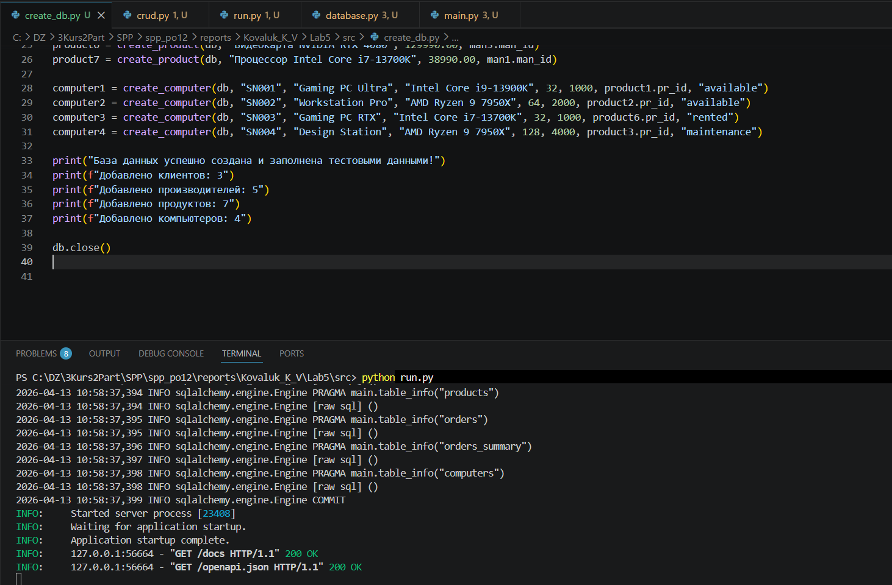

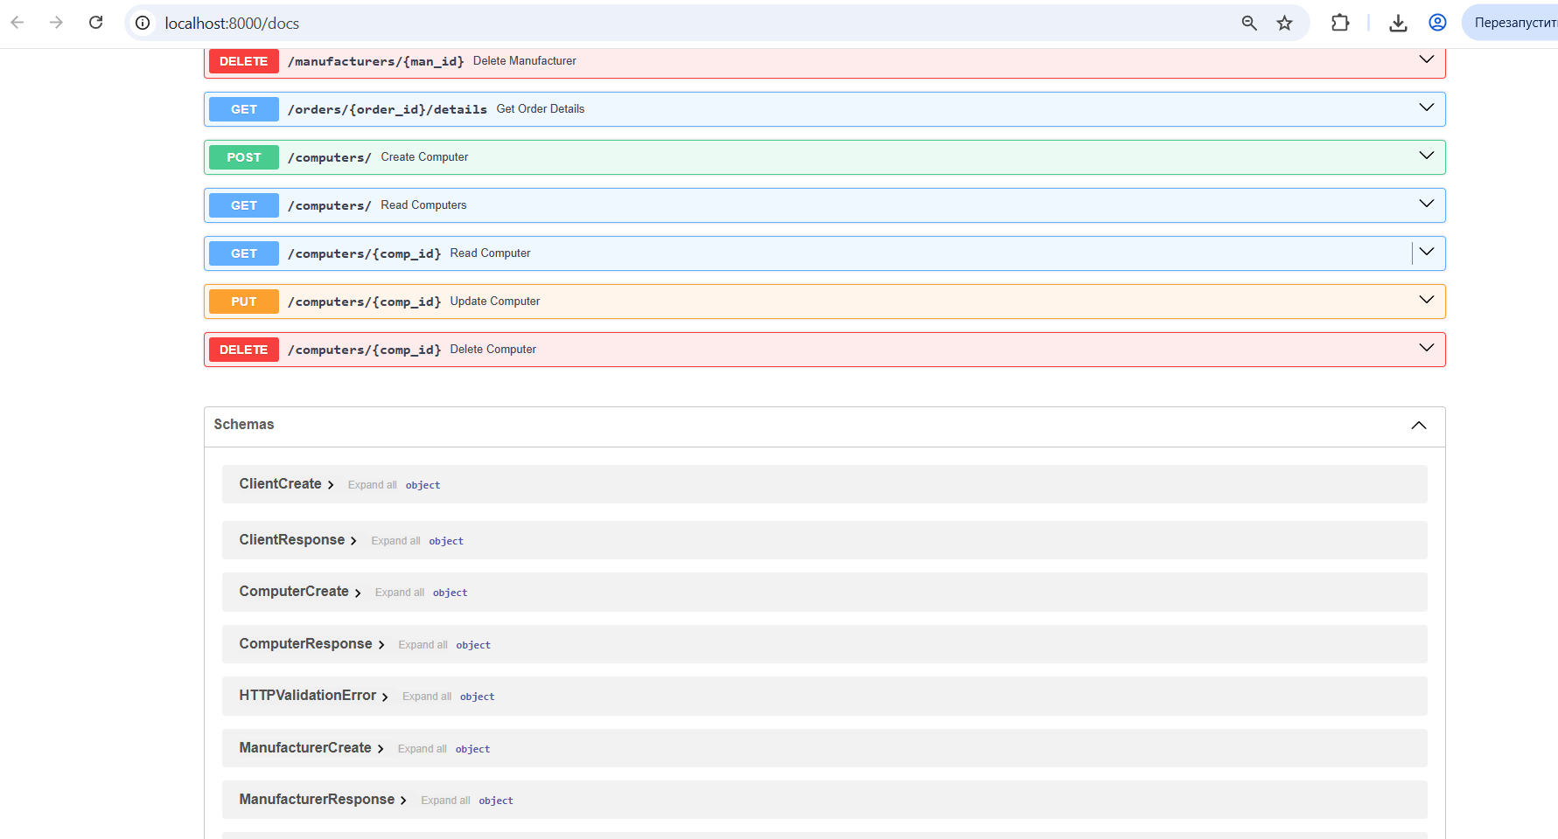

Вывод: В ходе работы я приобрел практические навыки разработки API и баз данных.

