МИНИСТЕРСТВО ОБРАЗОВАНИЯ РЕСПУБЛИКИ БЕЛАРУСЬ

УЧРЕЖДЕНИЕ ОБРАЗОВАНИЯ

 «БРЕСТСКИЙ ГОСУДАРСТВЕННЫЙ ТЕХНИЧЕСКИЙ УНИВЕРСИТЕТ»

Кафедра ИИТ

ЛАБОРАТОРНАЯ РАБОТА №12

По дисциплине: «Современные платформы программирования»

Выполнил:

Студент ФЭИС

3-го курса, группы ПО-5

Лозейко П. А.

Проверил:

Крощенко А. А.

Брест 2022

Разработать клиент-серверное оконное приложение на Java с использованием сокетов и JavaFX. Можно сделать одну программу с сочетанием функций клиента и сервера либо две отдельных (клиентская часть и серверная часть). Продемонстрировать работу разработанной программы в сети либо локально (127.0.0.1). Лабораторную работу разрешается выполнять в команде из 2-х человек.

Игра «Крестики-нолики». Классическая игра для двух игроков на поле 3х3.

Код программы:

**Клиент:**

**Common:**

package com.company;  
  
import java.io.IOException;  
import java.io.BufferedReader;  
import java.io.BufferedWriter;  
import java.io.InputStreamReader;  
import java.io.OutputStreamWriter;  
  
public class Common {  
 public static String readBytes(java.io.InputStream stream) {  
 try {  
 BufferedReader reader = new BufferedReader(new InputStreamReader(stream));  
 int length = reader.read();  
  
 String string = "";  
 for (int i = 0; i < length; ++i) {  
 string += (char)reader.read();  
 }  
  
 return string;  
 }  
 catch (IOException ex) {  
 System.*out*.println("I/O Error!");  
 }  
 return null;  
 }  
  
 public static void writeBytes(java.io.OutputStream stream, String string) {  
 try {  
 BufferedWriter writer = new BufferedWriter(new OutputStreamWriter(stream));  
 writer.write(string.length());  
 writer.write(string);  
 writer.flush();  
 }  
 catch (IOException ex) {  
 System.*out*.println("I/O Error!");  
 }  
 }  
}

**GameButton:**

package com.company;  
  
import java.io.OutputStream;  
  
import javax.swing.*;  
import java.awt.event.ActionEvent;  
import java.awt.event.ActionListener;  
  
import com.google.gson.Gson;  
  
public class GameButton extends JButton {  
 public GameButton(int x, int y, OutputStream socketOut) {  
 super("");  
 m_x = x;  
 m_y = y;  
 m_socketOut = socketOut;  
  
 addActionListener(new MoveActionListener());  
 }  
  
 public class MoveActionListener implements ActionListener {  
 public void actionPerformed(ActionEvent e) {  
 Gson gson = new Gson();  
  
 Messages.Move moveMessage = new Messages.Move();  
 moveMessage.x = m_x;  
 moveMessage.y = m_y;  
  
 Common.writeBytes(m_socketOut, gson.toJson(moveMessage));  
 }  
 }  
  
 private int m_x, m_y;  
 private OutputStream m_socketOut;  
}

**GameWindow:**

package com.company;  
  
import java.awt.Dimension;  
import java.io.OutputStream;  
import java.awt.*;  
import javax.swing.*;  
  
public class GameWindow extends JFrame {  
 public GameWindow(OutputStream socketOut) {  
 super("Game Window");  
 createGUI(socketOut);  
 }  
  
 private void createGUI(OutputStream socketOut) {  
 setDefaultCloseOperation(JFrame.*EXIT_ON_CLOSE*);  
  
 JPanel mainPanel = new JPanel(new BorderLayout());  
 add(mainPanel);  
  
 JPanel gridPanel = new JPanel(new GridLayout(Size, Size, 2, 2));  
 gridPanel.setBackground(Color.*orange*);  
  
 m_message = new JLabel("Ожидайте подключения противника...");  
 m_message.setPreferredSize(new Dimension(600, 40));  
 m_message.setMinimumSize(new Dimension(100, 20));  
  
 gridPanel.setPreferredSize(new Dimension(600, 600));  
  
 mainPanel.add(m_message, BorderLayout.*NORTH*);  
 mainPanel.add(gridPanel, BorderLayout.*SOUTH*);  
  
 m_buttons = new GameButton[3][];  
 for (int i = 0; i < 3; i++) {  
 m_buttons[i] = new GameButton[3];  
 for (int j = 0; j < 3; j++) {  
 m_buttons[i][j] = new GameButton(i, j, socketOut);  
 m_buttons[i][j].setMargin(new Insets(0, 0, 0, 0));  
 m_buttons[i][j].setEnabled(false);  
  
 gridPanel.add(m_buttons[i][j]);  
 }  
 }  
 setSize(600, 600);  
 }  
  
 public void load(Messages.Board boardMessage) {  
 boolean isActive = boardMessage.move == boardMessage.your_type;  
  
 if (isActive == true) {  
 m_message.setText("Ваша фигура: " + boardMessage.your_type + ". Ваш ход");  
 }  
 else {  
 m_message.setText("Ваша фигура: " + boardMessage.your_type + ". Ждите. Ходит противник");  
 }  
  
 for (int i = 0; i < 3; i++) {  
 for (int j = 0; j < 3; j++) {  
 char c = boardMessage.gameboard.charAt(i*Size + j);  
 if (c == '_')  
 c = ' ';  
 m_buttons[i][j].setText("" + c);  
 m_buttons[i][j].setEnabled(isActive);  
 }  
 }  
  
 if (boardMessage.winner != '_') {  
 if (boardMessage.winner == boardMessage.your_type)  
 m_message.setText("Конец игры. Вы выиграли");  
 else {  
 m_message.setText("Конец игры. Вы проиграли");  
 }  
 return;  
 }  
 }  
  
 private GameButton[][] m_buttons;  
 private JLabel m_message;  
 public final int Size = 3;  
}

**Messages:**

package com.company;  
  
public class Messages {  
 public static class Move {  
 public int x, y;  
 }  
  
 public static class Board {  
 public String gameboard;  
 public char your_type;  
 public char move;  
 public char winner;  
 }  
}

**TcpClient:**

package com.company;  
  
import java.io.IOException;  
import java.io.InputStream;  
import java.io.OutputStream;  
import java.net.Socket;  
import java.net.UnknownHostException;  
import com.google.gson.*;  
  
public class TcpClient {  
 public static void main(String[] args) {  
 String host = *DEFAULT_HOST*;  
 int port = *DEFAULT_PORT*;  
 if (args.length > 0) {  
 host = args[0];  
 }  
 if (args.length > 1) {  
 port = Integer.*parseInt*(args[1]);  
 }  
  
 try {  
 Socket socket = new Socket(host, port);  
  
 System.*out*.println("connected.\n");  
  
 OutputStream out = socket.getOutputStream();  
 InputStream in = socket.getInputStream();  
  
 GameWindow gamewindow = new GameWindow(out);  
 gamewindow.pack();  
 gamewindow.setVisible(true);  
  
 while (true) {  
 String fromServer = Common.*readBytes*(in);  
 Gson gson = new Gson();  
  
 Messages.Board boardMessage = gson.fromJson(fromServer, Messages.Board.class);  
  
 if (boardMessage == null)  
 break;  
  
 gamewindow.load(boardMessage);  
  
 if (boardMessage.winner != '_')  
 break;  
 }  
 } catch (UnknownHostException e) {  
 System.*out*.println("Неизвестный хост: " + host);  
 System.*exit*(-1);  
 } catch (IOException e) {  
 System.*out*.println("Ошибка при подключении, сервер занят");  
 // e.printStackTrace();  
 System.*exit*(-1);  
 }  
 }  
  
 private static final String *DEFAULT_HOST* = "localhost";  
 private static final int *DEFAULT_PORT* = 11122;  
}

**Сервер:**

**Common:**

package com.company.tcp_server;  
  
import java.io.IOException;  
import java.io.BufferedReader;  
import java.io.BufferedWriter;  
import java.io.InputStreamReader;  
  
import java.io.OutputStreamWriter;  
  
public class Common {  
  
 public static String readBytes(java.io.InputStream stream) {  
 try {  
 BufferedReader reader = new BufferedReader(new InputStreamReader(stream));  
 int length = reader.read();  
  
 String string = "";  
 for (int i = 0; i < length; ++i) {  
 string += (char)reader.read();  
 }  
  
 return string;  
 }  
 catch (IOException ex) {  
 System.*out*.println("I/O Error!");  
 }  
 return null;  
 }  
  
 public static void writeBytes(java.io.OutputStream stream, String string) {  
 try {  
 BufferedWriter writer = new BufferedWriter(new OutputStreamWriter(stream));  
 writer.write(string.length());  
 writer.write(string);  
 writer.flush();  
 }  
 catch (IOException ex) {  
 System.*out*.println("I/O Error!");  
 }  
 }  
}

**GameBoard:**

package com.company.tcp_server;  
  
import java.io.IOException;  
import java.io.BufferedReader;  
import java.io.BufferedWriter;  
import java.io.InputStreamReader;  
  
import java.io.OutputStreamWriter;  
  
public class Common {  
  
 public static String readBytes(java.io.InputStream stream) {  
 try {  
 BufferedReader reader = new BufferedReader(new InputStreamReader(stream));  
 int length = reader.read();  
  
 String string = "";  
 for (int i = 0; i < length; ++i) {  
 string += (char)reader.read();  
 }  
  
 return string;  
 }  
 catch (IOException ex) {  
 System.*out*.println("I/O Error!");  
 }  
 return null;  
 }  
  
 public static void writeBytes(java.io.OutputStream stream, String string) {  
 try {  
 BufferedWriter writer = new BufferedWriter(new OutputStreamWriter(stream));  
 writer.write(string.length());  
 writer.write(string);  
 writer.flush();  
 }  
 catch (IOException ex) {  
 System.*out*.println("I/O Error!");  
 }  
 }  
}

**Messages:**

package com.company.tcp_server;  
  
public class Messages {  
 public static class Move {  
 public int x, y;  
 }  
  
 public static class Board {  
 public String gameboard;  
 public char your_type;  
 public char move;  
 public char winner;  
 }  
}

**Player:**

package com.company.tcp_server;  
  
import java.net.Socket;  
import com.google.gson.Gson;  
import java.net.ServerSocket;  
import java.io.IOException;  
import java.io.InputStream;  
import java.io.OutputStream;  
  
public class Player {  
 Player() {  
 m_clientSocket = null;  
 m_in = null;  
 m_out = null;  
 m_playerType = '_';  
 }  
  
 void waitConnection(ServerSocket serverSocket) throws IOException {  
 m_clientSocket = serverSocket.accept();  
 System.*out*.print("Connection accepted.\n");  
  
 m_in = m_clientSocket.getInputStream();  
 m_out = m_clientSocket.getOutputStream();  
 }  
  
 void send(GameBoard board) {  
 Gson gson = new Gson();  
  
 Messages.Board boardMessage = new Messages.Board();  
 boardMessage.gameboard = board.toString();  
  
 boardMessage.your_type = m_playerType;  
 boardMessage.move = board.currentMove();  
 boardMessage.winner = board.getWinner();  
  
 Common.*writeBytes*(m_out, gson.toJson(boardMessage));  
 }  
  
 void set_type(char type) {  
 m_playerType = type;  
 }  
  
 Messages.Move readMoveIfActive(char currentPlayerType) {  
 if (m_playerType != currentPlayerType)  
 return null;  
  
 String buffer = Common.*readBytes*(m_in);  
  
 Gson gson = new Gson();  
 return gson.fromJson(buffer, Messages.Move.class);  
 }  
  
 private OutputStream m_out;  
 private InputStream m_in;  
 private Socket m_clientSocket;  
 private char m_playerType;  
}

**TcpServer:**

package com.company.tcp_server;  
  
import java.io.IOException;  
import java.net.ServerSocket;  
import java.util.Random;  
  
public class TcpServer {  
  
 public static void main(String[] args) {  
  
 int port = *DEFAULT_PORT*;  
 if (args.length > 0) {  
 port = Integer.*parseInt*(args[0]);  
 }  
  
 ServerSocket serverSocket = null;  
 try {  
 serverSocket = new ServerSocket(port);  
 } catch (IOException e) {  
 System.*out*.println("Порт занят: " + port);  
 System.*exit*(-1);  
 }  
  
 try {  
 Player players[] = new Player[2];  
  
 for (int i = 0; i < 2; ++i) {  
 players[i] = new Player();  
 players[i].waitConnection(serverSocket);  
 }  
  
 System.*out*.println("Game started...\n");  
  
 GameBoard gameboard = new GameBoard();  
 *generateRandomTypes*(players);  
  
 while (true) {  
 System.*out*.println("Gameboard on server: " + gameboard.toString() + "\n");  
  
 for (int i = 0; i < 2; ++i) {  
 players[i].send(gameboard);  
 }  
  
 if (gameboard.getWinner() != '_')  
 break;  
  
 Messages.Move move = null;  
 for (int i = 0; i < 2; ++i) {  
 Messages.Move currentMove = players[i].readMoveIfActive(gameboard.currentMove());  
 if (currentMove == null)  
 continue;  
 move = currentMove;  
 }  
 gameboard.process(move);  
 }  
  
 } catch (IOException e) {  
 e.printStackTrace();  
 System.*exit*(-1);  
 }  
 }  
  
 static void generateRandomTypes(Player[] players) {  
 Random rnd = new Random();  
 int value = rnd.nextInt(1);  
  
 if (value == 0) {  
 players[0].set_type('x');  
 players[1].set_type('o');  
 }  
 else {  
 players[0].set_type('o');  
 players[1].set_type('x');  
 }  
 }  
  
 private static final int *DEFAULT_PORT* = 11122;  
}

**Результат выполнения программы:**

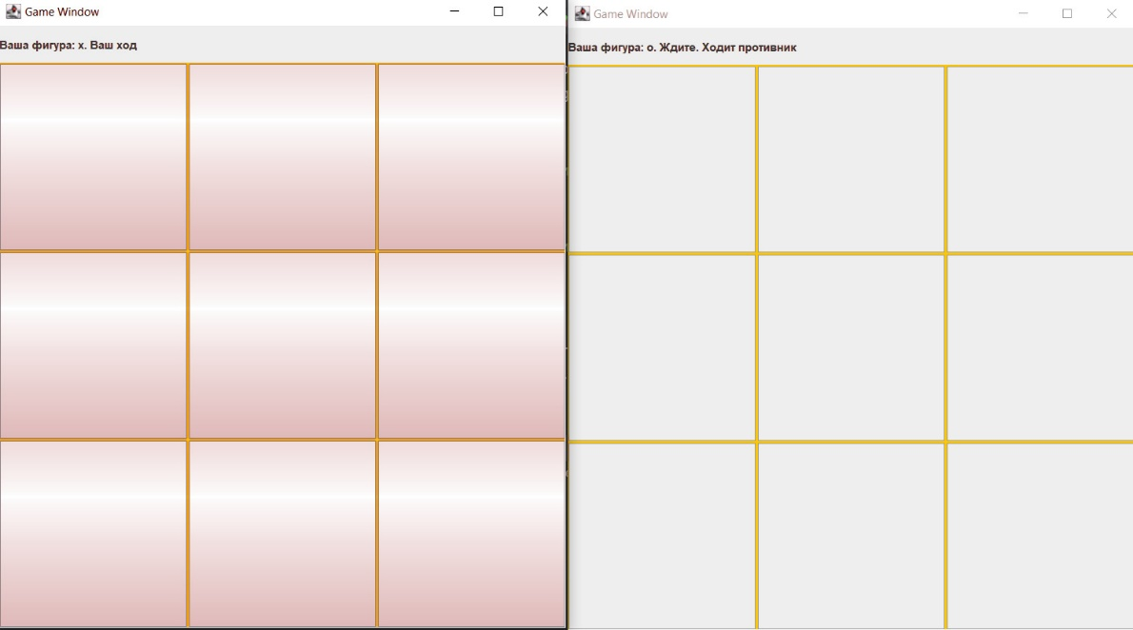

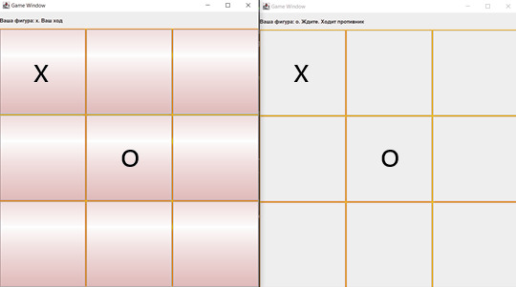

Вывод: Разработал клиент-серверное оконное приложение на Java с использованием сокетов и JavaFX.