МИНИСТЕРСТВО ОБРАЗОВАНИЯ РЕСПУБЛИКИ БЕЛАРУСЬ

УЧРЕЖДЕНИЕ ОБРАЗОВАНИЯ

«БРЕСТСКИЙ ГОСУДАРСТВЕННЫЙ ТЕХНИЧЕСКИЙ УНИВЕРСИТЕТ» ФАКУЛЬТЕТ ЭЛЕКТРОННО-ИНФОРМАЦИОННЫХ СИСТЕМ

Кафедра интеллектуальных информационных технологий

Отчет по лабораторной работе №12

Специальность ПО-5(о)

Выполнили

Прокопчик Егор,

Бриштен Дмитрий,

студенты группы ПО-5

Проверил

А. А. Крощенко

ст. преп. каф. ИИТ

Брест 2022

Цель работы: освоить приемы разработки оконных клиент-серверных приложений на Java с использованием сокетов.

Вариант 8

**Задание.** Игра «Крестики-нолики». Классическая игра для двух игроков на поле 3х3.

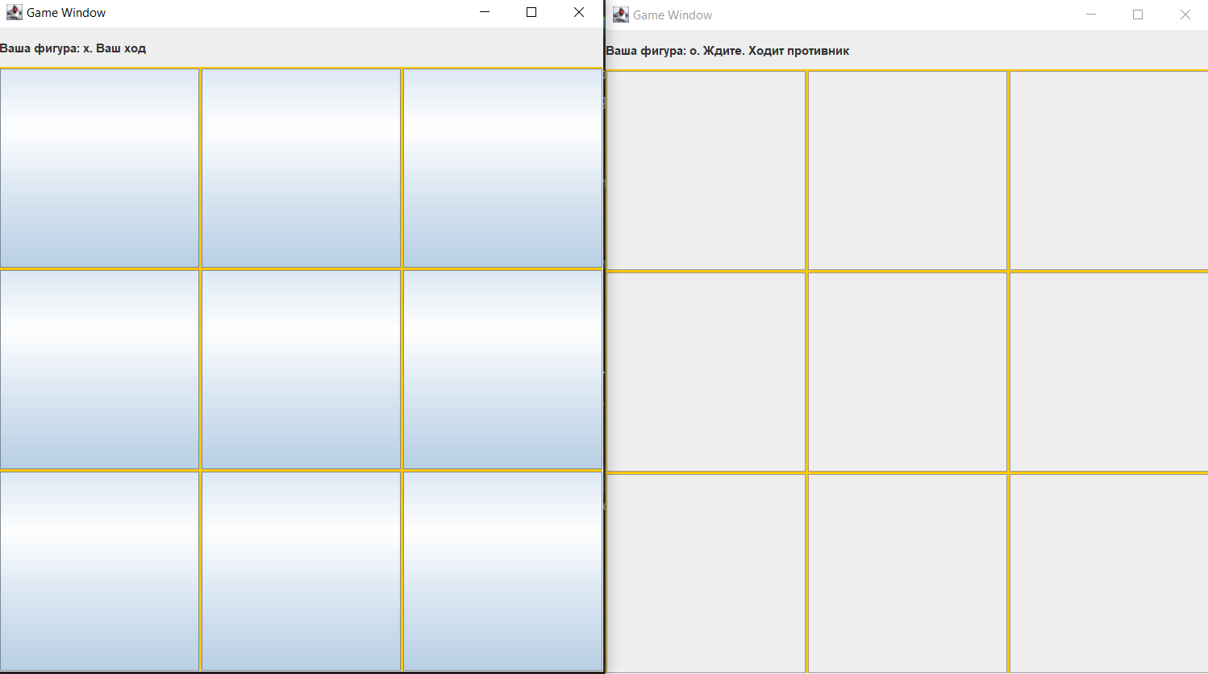

Рисунок 1 – Запуск игры

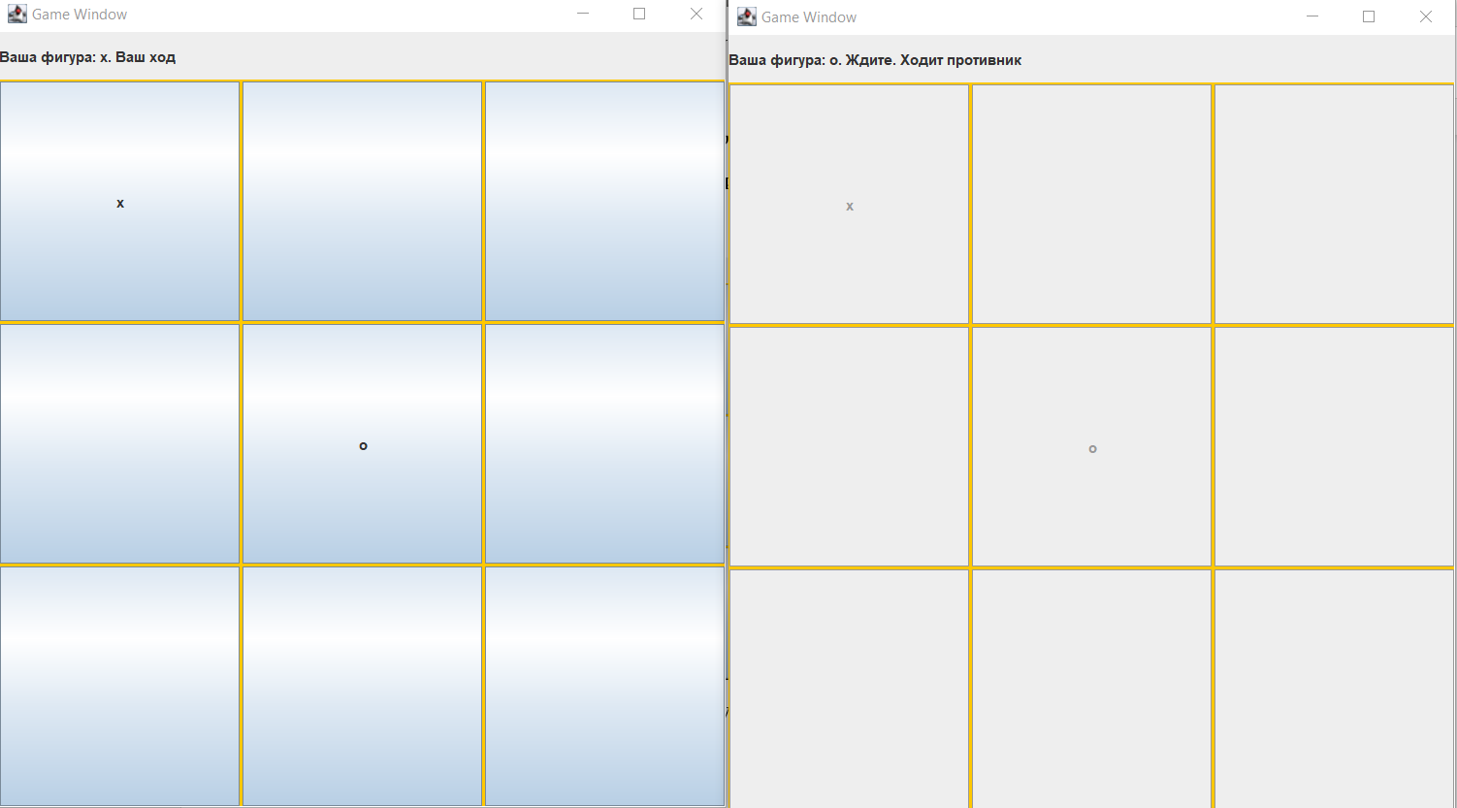

Рисунок 2 – Ходы игроков

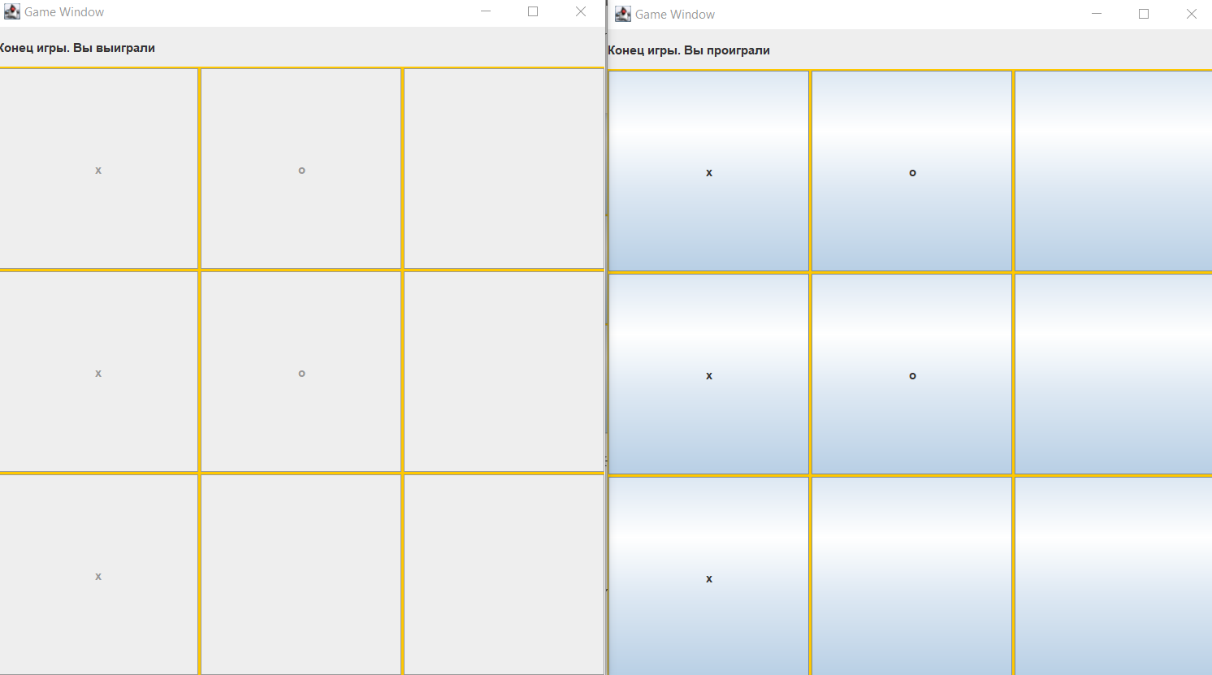

Рисунок 3 – Конец игры

**Код программы:**

**Сервер**

TcpServer.java

public class TcpServer {  
  
 public static void main(String[] args) {  
  
 int port = *DEFAULT_PORT*;  
 if (args.length > 0) {  
 port = Integer.*parseInt*(args[0]);  
 }  
  
 ServerSocket serverSocket = null;  
 try {  
 serverSocket = new ServerSocket(port);  
 } catch (IOException e) {  
 System.*out*.println("Порт занят: " + port);  
 System.*exit*(-1);  
 }  
  
 try {  
 Player players[] = new Player[2];  
  
 for (int i = 0; i < 2; ++i) {  
 players[i] = new Player();  
 players[i].waitConnection(serverSocket);  
 }  
  
 System.*out*.println("Game started...\n");  
  
 GameBoard gameboard = new GameBoard();  
 *generateRandomTypes*(players);  
  
 while (true) {  
 System.*out*.println("Gameboard on server: " + gameboard.toString() + "\n");  
  
 for (int i = 0; i < 2; ++i) {  
 players[i].send(gameboard);  
 }  
  
 if (gameboard.getWinner() != '_')  
 break;  
  
 Messages.Move move = null;  
 for (int i = 0; i < 2; ++i) {  
 Messages.Move currentMove = players[i].readMoveIfActive(gameboard.currentMove());  
 if (currentMove == null)  
 continue;  
 move = currentMove;  
 }  
 gameboard.process(move);  
 }  
  
 } catch (IOException e) {  
 e.printStackTrace();  
 System.*exit*(-1);  
 }  
 }  
  
 static void generateRandomTypes(Player[] players) {  
 Random rnd = new Random();  
 int value = rnd.nextInt(1);  
  
 if (value == 0) {  
 players[0].set_type('x');  
 players[1].set_type('o');  
 }  
 else {  
 players[0].set_type('o');  
 players[1].set_type('x');  
 }  
 }  
  
 private static final int *DEFAULT_PORT* = 11122;  
}

Player.java

public class Player {  
 Player() {  
 m_clientSocket = null;  
 m_in = null;  
 m_out = null;  
 m_playerType = '_';  
 }  
  
 void waitConnection(ServerSocket serverSocket) throws IOException {  
 m_clientSocket = serverSocket.accept();  
 System.*out*.print("Connection accepted.\n");  
  
 m_in = m_clientSocket.getInputStream();  
 m_out = m_clientSocket.getOutputStream();  
 }  
  
 void send(GameBoard board) {  
 Gson gson = new Gson();  
  
 Messages.Board boardMessage = new Messages.Board();  
 boardMessage.gameboard = board.toString();  
  
 boardMessage.your_type = m_playerType;  
 boardMessage.move = board.currentMove();  
 boardMessage.winner = board.getWinner();  
  
 Common.*writeBytes*(m_out, gson.toJson(boardMessage));  
 }  
  
 void set_type(char type) {  
 m_playerType = type;  
 }  
  
 Messages.Move readMoveIfActive(char currentPlayerType) {  
 if (m_playerType != currentPlayerType)  
 return null;  
  
 String buffer = Common.*readBytes*(m_in);  
  
 Gson gson = new Gson();  
 return gson.fromJson(buffer, Messages.Move.class);  
 }  
  
 private OutputStream m_out;  
 private InputStream m_in;  
 private Socket m_clientSocket;  
 private char m_playerType;  
}

Messages.java

public class Messages {  
 public static class Move {  
 public int x, y;  
 }  
  
 public static class Board {  
 public String gameboard;  
 public char your_type;  
 public char move;  
 public char winner;  
 }  
}

GameBoard.java

public class GameBoard {  
 GameBoard() {  
 m_board = new char[Size][Size];  
  
 for (int i = 0; i < Size; i++) {  
 for (int j = 0; j < Size; j++) {  
 m_board[i][j] = '_';  
 }  
 }  
  
 m_currentMove = 'x';  
 }  
  
 public String toString() {  
 String buffer = "";  
 for (int i = 0; i < Size; i++) {  
 for (int j = 0; j < Size; j++) {  
 buffer += m_board[i][j];  
 }  
 }  
 return buffer;  
 }  
  
 public char currentMove() {  
 return m_currentMove;  
 }  
  
 private void changeActivePlayer() {  
 if (m_currentMove == 'x')  
 m_currentMove = 'o';  
 else  
 m_currentMove = 'x';  
 }  
  
 public void process(Messages.Move move) {  
 if (m_board[move.x][move.y] != '_')  
 return;  
 m_board[move.x][move.y] = m_currentMove;  
 changeActivePlayer();  
 }  
  
 public char getWinner() {  
 for (int i = 0; i < Size; i++) {  
 for (int j = 0; j < Size; j++) {  
 if (checkFrom(i, j) == true)  
 return m_board[i][j];  
 }  
 }  
 return '_';  
 }  
  
 private boolean checkFrom(int x, int y) {  
 char player = m_board[x][y];  
 if (player == '_')  
 return false;  
  
 boolean xWin = true, yWin = true, xyWin = true;  
 for (int i = 0; i < 3; ++i) {  
 if (i + x >= Size || m_board[i+x][y] != player)  
 xWin = false;  
 if (i + y >= Size || m_board[x][i+y] != player)  
 yWin = false;  
 if (i + y >= Size || i + x >= Size || m_board[x+i][i+y] != player)  
 xyWin = false;  
 }  
  
 return xyWin || xWin || yWin;  
 }  
  
 private char[][] m_board;  
 private char m_currentMove;  
 public final int Size = 3;  
}

Common.java

public class Common {  
  
 public static String readBytes(java.io.InputStream stream) {  
 try {  
 BufferedReader reader = new BufferedReader(new InputStreamReader(stream));  
 int length = reader.read();  
  
 String string = "";  
 for (int i = 0; i < length; ++i) {  
 string += (char)reader.read();  
 }  
  
 return string;  
 }  
 catch (IOException ex) {  
 System.*out*.println("I/O Error!");  
 }  
 return null;  
 }  
  
 public static void writeBytes(java.io.OutputStream stream, String string) {  
 try {  
 BufferedWriter writer = new BufferedWriter(new OutputStreamWriter(stream));  
 writer.write(string.length());  
 writer.write(string);  
 writer.flush();  
 }  
 catch (IOException ex) {  
 System.*out*.println("I/O Error!");  
 }  
 }  
}

**Клиент**

TcpClient.java

public class TcpClient {

public static void main(String[] args) {

String host = DEFAULT_HOST;

int port = DEFAULT_PORT;

if (args.length > 0) {

host = args[0];

}

if (args.length > 1) {

port = Integer.parseInt(args[1]);

}

try {

Socket socket = new Socket(host, port);

System.out.println("connected.\n");

OutputStream out = socket.getOutputStream();

InputStream in = socket.getInputStream();

GameWindow gamewindow = new GameWindow(out);

gamewindow.pack();

gamewindow.setVisible(true);

while (true) {

String fromServer = Common.readBytes(in);

Gson gson = new Gson();

Messages.Board boardMessage = gson.fromJson(fromServer, Messages.Board.class);

if (boardMessage == null)

break;

gamewindow.load(boardMessage);

if (boardMessage.winner != '_')

break;

}

} catch (UnknownHostException e) {

System.out.println("Неизвестный хост: " + host);

System.exit(-1);

} catch (IOException e) {

e.printStackTrace();

System.exit(-1);

}

}

private static final String DEFAULT_HOST = "localhost";

private static final int DEFAULT_PORT = 11122;

}

Messages.java

public class Messages {  
 public static class Move {  
 public int x, y;  
 }  
  
 public static class Board {  
 public String gameboard;  
 public char your_type;  
 public char move;  
 public char winner;  
 }  
}

GameWindow.java

public class GameWindow extends JFrame {  
 public GameWindow(OutputStream socketOut) {  
 super("Game Window");  
 createGUI(socketOut);  
 }  
  
 private void createGUI(OutputStream socketOut) {  
 setDefaultCloseOperation(JFrame.*EXIT_ON_CLOSE*);  
  
 JPanel mainPanel = new JPanel(new BorderLayout());  
 add(mainPanel);  
  
 JPanel gridPanel = new JPanel(new GridLayout(Size, Size, 2, 2));  
 gridPanel.setBackground(Color.*orange*);  
  
 m_message = new JLabel("Ожидайте подключения противника...");  
 m_message.setPreferredSize(new Dimension(600, 40));  
 m_message.setMinimumSize(new Dimension(100, 20));  
  
 gridPanel.setPreferredSize(new Dimension(600, 600));  
  
 mainPanel.add(m_message, BorderLayout.*NORTH*);  
 mainPanel.add(gridPanel, BorderLayout.*SOUTH*);  
  
 m_buttons = new GameButton[3][];  
 for (int i = 0; i < 3; i++) {  
 m_buttons[i] = new GameButton[3];  
 for (int j = 0; j < 3; j++) {  
 m_buttons[i][j] = new GameButton(i, j, socketOut);  
 m_buttons[i][j].setMargin(new Insets(0, 0, 0, 0));  
 m_buttons[i][j].setEnabled(false);  
  
 gridPanel.add(m_buttons[i][j]);  
 }  
 }  
 setSize(600, 600);  
 }  
  
 public void load(Messages.Board boardMessage) {  
 boolean isActive = boardMessage.move == boardMessage.your_type;  
  
 if (isActive == true) {  
 m_message.setText("Ваша фигура: " + boardMessage.your_type + ". Ваш ход");  
 }  
 else {  
 m_message.setText("Ваша фигура: " + boardMessage.your_type + ". Ждите. Ходит противник");  
 }  
  
 for (int i = 0; i < 3; i++) {  
 for (int j = 0; j < 3; j++) {  
 char c = boardMessage.gameboard.charAt(i*Size + j);  
 if (c == '_')  
 c = ' ';  
 m_buttons[i][j].setText("" + c);  
 m_buttons[i][j].setEnabled(isActive);  
 }  
 }  
  
 if (boardMessage.winner != '_') {  
 if (boardMessage.winner == boardMessage.your_type)  
 m_message.setText("Конец игры. Вы выиграли");  
 else {  
 m_message.setText("Конец игры. Вы проиграли");  
 }  
 return;  
 }  
 }  
  
 private GameButton[][] m_buttons;  
 private JLabel m_message;  
 public final int Size = 3;  
}

GameButton.java

public class GameButton extends JButton {  
 public GameButton(int x, int y, OutputStream socketOut) {  
 super("");  
 m_x = x;  
 m_y = y;  
 m_socketOut = socketOut;  
  
 addActionListener(new MoveActionListener());  
 }  
  
 public class MoveActionListener implements ActionListener {  
 public void actionPerformed(ActionEvent e) {  
 Gson gson = new Gson();  
  
 Messages.Move moveMessage = new Messages.Move();  
 moveMessage.x = m_x;  
 moveMessage.y = m_y;  
  
 Common.*writeBytes*(m_socketOut, gson.toJson(moveMessage));  
 }  
 }  
  
 private int m_x, m_y;  
 private OutputStream m_socketOut;  
}

Common.java

public class Common {  
 public static String readBytes(java.io.InputStream stream) {  
 try {  
 BufferedReader reader = new BufferedReader(new InputStreamReader(stream));  
 int length = reader.read();  
  
 String string = "";  
 for (int i = 0; i < length; ++i) {  
 string += (char)reader.read();  
 }  
  
 return string;  
 }  
 catch (IOException ex) {  
 System.*out*.println("I/O Error!");  
 }  
 return null;  
 }  
  
 public static void writeBytes(java.io.OutputStream stream, String string) {  
 try {  
 BufferedWriter writer = new BufferedWriter(new OutputStreamWriter(stream));  
 writer.write(string.length());  
 writer.write(string);  
 writer.flush();  
 }  
 catch (IOException ex) {  
 System.*out*.println("I/O Error!");  
 }  
 }  
  
 public static String readString(java.io.InputStream stream) {  
 try {  
 BufferedReader br = new BufferedReader(new InputStreamReader(stream));  
 return br.readLine();  
 }  
 catch (IOException ex) {  
 System.*out*.println("I/O Error!");  
 }  
 return null;  
 }  
  
 public static void writeString(java.io.OutputStream stream, String string) {  
 try {  
 BufferedWriter writer = new BufferedWriter(new OutputStreamWriter(stream));  
 writer.write(string + "\n");  
 writer.flush();  
 }  
 catch (IOException ex) {  
 System.*out*.println("I/O Error!");  
 }  
 }  
}

Вывод: освоены приемы разработки оконных клиент-серверных приложений на Java с использованием сокетов.