МИНИСТЕРСТВО ОБРАЗОВАНИЯ РЕСПУБЛИКИ БЕЛАРУСЬ

УЧРЕЖДЕНИЕ ОБРАЗОВАНИЯ

 «БРЕСТСКИЙ ГОСУДАРСТВЕННЫЙ ТЕХНИЧЕСКИЙ УНИВЕРСИТЕТ»

Кафедра ИИТ

ЛАБОРАТОРНАЯ РАБОТА №9

По дисциплине: «Современные платформы программирования»

Выполнил:

Студент ФЭИС

3-го курса, группы ПО-5

Прокопчик Е.А.

Проверил:

Крощенко А.А.

Брест 2022

Цель работы: приобрести практические навыки разработки баз данных и начальной интеграции БД с кодом Java с помощью JDBC

Общее задание:

Реализовать базу данных из не менее 5 таблиц на заданную тематику. При реализации продумать типизацию полей и внешние ключи в таблицах. Визуализировать разработанную БД с помощью схемы, на которой отображены все таблицы и связи между ними (пример, схема на рис. 1). На языке Java с использованием JDBC реализовать подключение к БД и выполнить основные типы запросов, продемонстрировать результаты преподавателю и включить тексты составленных запросов в отчет. Основные типы запросов – 1. На выборку/на выборку с упорядочиванием (SELECT); 2. На добавление (INSERT INTO); 3. На удаление (DELETE FROM); 4. На модификацию (UPDATE). Базу данные можно реализовать в любой СУБД (MySQL, PostgreSQL, SQLite и др.)

12) База данных «Европейские футбольные чемпионаты»

**Код программы**

**DBWorker.java**

package com.spplab9.database;  
  
import java.sql.Connection;  
import java.sql.DriverManager;  
import java.sql.SQLException;  
  
public class DBWorker {  
 private final String URL = "jdbc:mysql://localhost:3306/lab9spp";  
 private final String USERNAME = "root";  
 private final String PASSWORD = "root";  
  
 private Connection connection;  
  
 public Connection getConnection() {return connection;}  
 public void setConnection(Connection connection) {this.connection = connection;}  
  
 public DBWorker(){  
  
 try{  
  
 connection = DriverManager.*getConnection*(URL, USERNAME, PASSWORD);  
 } catch (SQLException e) {  
 e.printStackTrace();  
 }  
 }  
}

**Team.java**

package com.spplab9.database;  
  
public class Team {  
  
 private int team_id;  
 private int league_id;  
 private String team_name;  
 private String country;  
  
 public Team() {  
 }  
  
 public Team(int league_id, String team_name, String country) {  
 this.league_id = league_id;  
 this.team_name = team_name;  
 this.country = country;  
 }  
  
 public Team(int team_id, int league_id, String team_name, String country) {  
 this.team_id = team_id;  
 this.league_id = league_id;  
 this.team_name = team_name;  
 this.country = country;  
 }  
  
 public int getTeam_id() {return team_id;}  
 public void setTeam_id(int team_id) {this.team_id = team_id;}  
  
 public int getLeague_id() {return league_id;}  
 public void setLeague_id(int league_id) {this.league_id = league_id;}  
  
 public String getTeam_name() {return team_name;}  
 public void setTeam_name(String team_name) {this.team_name = team_name;}  
  
 public String getCountry() {return country;}  
 public void setCountry(String country) {this.country = country;}  
  
 @Override  
 public String toString() {  
 return getClass().getSimpleName() + "{id: " + team_id  
 + ", league_id: " + league_id  
 + ", team_name: " + team_name  
 + ", country: " + country  
 + "}";  
 }  
}

**Match.java**

package com.spplab9.database;  
  
import java.sql.Date;  
  
public class Match {  
  
 private int match_id;  
 private String league_name;  
 private String stadium_name;  
 private String team1_name;  
 private String team2_name;  
 private Date match_date;  
  
 public Match(){  
  
 }  
  
 public Match(String league_name, String stadium_name, String team1_name, String team2_name, Date match_date){  
  
 this.league_name = league_name;  
 this.stadium_name = stadium_name;  
 this.team1_name = team1_name;  
 this.team2_name = team2_name;  
 this.match_date = match_date;  
 }  
  
 public Match(int match_id, String league_name, String stadium_name, String team1_name, String team2_name, Date match_date ){  
  
 this.match_id = match_id;  
 this.league_name = league_name;  
 this.stadium_name = stadium_name;  
 this.team1_name = team1_name;  
 this.team2_name = team2_name;  
 this.match_date = match_date;  
 }  
  
 public int getMatch_id() {return match_id;}  
 public void setMatch_id(int match_id) {this.match_id = match_id;}  
  
 public String getLeague_name() {return league_name;}  
 public void setLeague_name(String league_name) {this.league_name = league_name;}  
  
 public String getStadium_name() {return stadium_name;}  
 public void setStadium_name(String stadium_name) {this.stadium_name = stadium_name;}  
  
 public String getTeam1_name() {return team1_name;}  
 public void setTeam1_name(String team1_name) {this.team1_name = team1_name;}  
  
 public String getTeam2_name() {return team2_name;}  
 public void setTeam2_name(String team2_name) {this.team2_name = team2_name;}  
  
 public Date getMatch_date() {return match_date;}  
 public void setMatch_date(Date match_date) {this.match_date = match_date;}  
  
 @Override  
 public String toString() {  
 return getClass().getSimpleName() + "{id: " + match_id  
 + ", league_name: " + league_name  
 + ", stadium_name: " + stadium_name  
 + ", team1_name: " + team1_name  
 + ", team2_name: " + team2_name  
 + ", match_date: " + match_date  
 + "}";  
 }  
}

**Main.java**

package com.spplab9.database;  
  
import java.sql.ResultSet;  
import java.sql.SQLException;  
import java.sql.Statement;  
  
public class Main {  
  
 public static void main(String[] args) {  
 DBWorker worker = new DBWorker();  
  
 String querySSelect = "select * from teams";  
 try {  
 Statement statement = worker.getConnection().createStatement();  
 ResultSet resultSet = statement.executeQuery(querySSelect);  
  
 while(resultSet.next()) {  
 Team team = new Team();  
 team.setTeam_id(resultSet.getInt("team_id"));  
 team.setLeague_id(resultSet.getInt("league_id"));  
 team.setTeam_name(resultSet.getString("team_name"));  
 team.setCountry(resultSet.getString("country"));  
  
 System.*out*.println(team);  
 }  
 System.*out*.println("------------------------------------------------------------");  
  
 }catch (SQLException e) {  
 e.printStackTrace();  
 }  
  
 try {  
 Statement statement = worker.getConnection().createStatement();  
 statement.execute("INSERT INTO matches(league_name, stadium_name, team1_name, team2_name, match_date) VALUES('Belarusian Premier League', 'Barysaŭ-Arena', 'BATE', 'Dynamo Minsk', '2022.03.01')");  
 statement.execute("INSERT INTO matches(league_name, stadium_name, team1_name, team2_name, match_date) VALUES('Belarusian Premier League', 'Barysaŭ-Arena', 'BATE', 'Dynamo Minsk', '2018.01.01')");  
 }catch (SQLException e) {  
 e.printStackTrace();  
 }  
  
 String querySelectSort = "select * from matches order by match_date";  
 try {  
 Statement statement = worker.getConnection().createStatement();  
 ResultSet resultSet = statement.executeQuery(querySelectSort);  
  
 while(resultSet.next()) {  
 Match match = new Match();  
 match.setMatch_id(resultSet.getInt("match_id"));  
 match.setLeague_name(resultSet.getString("league_name"));  
 match.setStadium_name(resultSet.getString("stadium_name"));  
 match.setTeam1_name(resultSet.getString("team1_name"));  
 match.setTeam2_name(resultSet.getString("team2_name"));  
 match.setMatch_date(resultSet.getDate("match_date"));  
  
 System.*out*.println(match);  
 }  
 System.*out*.println("------------------------------------------------------------");  
  
 }catch (SQLException e) {  
 e.printStackTrace();  
 }  
  
 try {  
 Statement statement = worker.getConnection().createStatement();  
 statement.execute("DELETE FROM matches WHERE match_date = '2018.01.01'");  
 statement.execute("UPDATE matches SET match_date = '2022.07.01' WHERE match_date = '2022.03.01'");  
  
 ResultSet resultSet = statement.executeQuery(querySelectSort);  
  
 while(resultSet.next()) {  
 Match match = new Match();  
 match.setMatch_id(resultSet.getInt("match_id"));  
 match.setLeague_name(resultSet.getString("league_name"));  
 match.setStadium_name(resultSet.getString("stadium_name"));  
 match.setTeam1_name(resultSet.getString("team1_name"));  
 match.setTeam2_name(resultSet.getString("team2_name"));  
 match.setMatch_date(resultSet.getDate("match_date"));  
  
 System.*out*.println(match);  
 }  
 System.*out*.println("------------------------------------------------------------");  
  
 }catch (SQLException e) {  
 e.printStackTrace();  
 }  
 }  
}

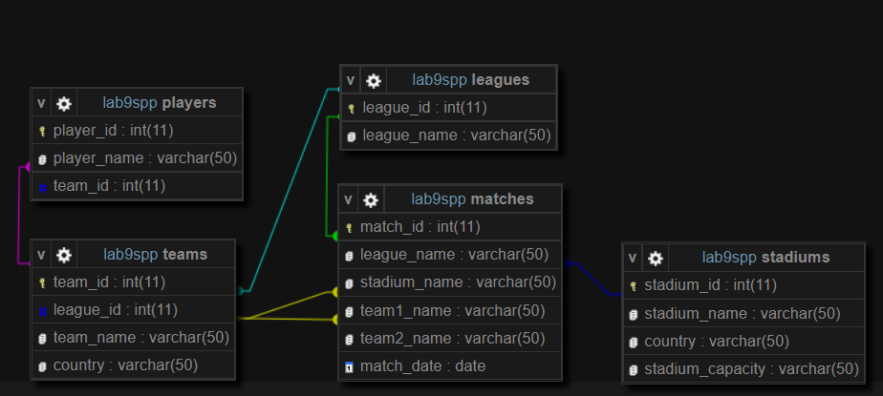

Схема БД

Вывод: приобрел практические навыки разработки баз данных и начальной интеграции БД с кодом Java с помощью JDBC