Министерство образования Республики Беларусь

Учреждение образования «Брестский государственный технический университет»

Кафедра ИИТ

Отчёт по лабораторной работе №3

Выполнил:

студент 3 курса

группы ПО-5

Лозейко П. А.

Проверил:

Крощенко А. А.

Брест 2022

Структкра БД:

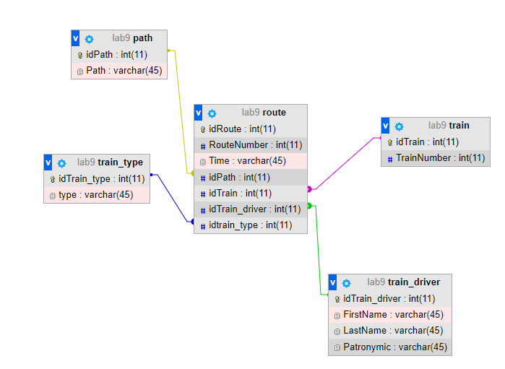

Таблицы:

CREATE TABLE `lab9`.`path` (

`idPath` INT NOT NULL AUTO_INCREMENT,

`Path` VARCHAR(45) NOT NULL,

PRIMARY KEY (`idPath`));

CREATE TABLE `lab9`.`train` (

`idTrain` INT NOT NULL AUTO_INCREMENT,

`TrainNumber` VARCHAR(45) NOT NULL,

PRIMARY KEY (`idTrain`));

CREATE TABLE `lab9`.`train_driver` (

`idTrain_driver` INT NOT NULL AUTO_INCREMENT,

`FirstName` VARCHAR(45) NOT NULL,

`LastName` VARCHAR(45) NOT NULL,

`Patronymic` VARCHAR(45) NOT NULL,

PRIMARY KEY (`idTrain_driver`));

CREATE TABLE `lab9`.`train_type` (

`idTrain_type` INT NOT NULL AUTO_INCREMENT,

`type` VARCHAR(45) NOT NULL,

PRIMARY KEY (`idTrain_type`));

CREATE TABLE `lab9`.`route` (

`idRoute` INT NOT NULL AUTO_INCREMENT,

`RouteNumber` INT NOT NULL,

`Time` VARCHAR(45) NOT NULL,

`idPath` INT NOT NULL,

`idTrain` INT NOT NULL,

`idTrain_driver` INT NOT NULL,

`idTrain_type` INT NOT NULL,

PRIMARY KEY (`idRoute`),

INDEX `idPath_idx` (`idPath` ASC) VISIBLE,

INDEX `idTrain_idx` (`idTrain` ASC) VISIBLE,

INDEX `idTrain_driver_idx` (`idTrain_driver` ASC) VISIBLE,

INDEX `idTrain_type_idx` (`idTrain_type` ASC) VISIBLE,

CONSTRAINT `idPath`

FOREIGN KEY (`idPath`)

REFERENCES `lab9`.`path` (`idPath`)

ON DELETE NO ACTION

ON UPDATE NO ACTION,

CONSTRAINT `idTrain`

FOREIGN KEY (`idTrain`)

REFERENCES `lab9`.`train` (`idTrain`)

ON DELETE NO ACTION

ON UPDATE NO ACTION,

CONSTRAINT `idTrain_driver`

FOREIGN KEY (`idTrain_driver`)

REFERENCES `lab9`.`train_driver` (`idTrain_driver`)

ON DELETE NO ACTION

ON UPDATE NO ACTION,

CONSTRAINT `idTrain_type`

FOREIGN KEY (`idTrain_type`)

REFERENCES `lab9`.`train_type` (`idTrain_type`)

ON DELETE NO ACTION

ON UPDATE NO ACTION);

Код программы:

package com.company;

import java.sql.*;

public class Main {

public static final String userName = "root";

public static final String password = "root";

public static final String connectionURL = "jdbc:mysql://localhost:3306/mysql";

public static void main(String[] args) throws SQLException {

String query="INSERT INTO lab9.train_driver (FirstName, LastName, Patronymic) VALUES ('Павел', 'Павлов','Павлович');";

String query2="DELETE FROM lab9.train_driver WHERE (FirstName='Павел');";

String query3="UPDATE lab9.train_driver SET FirstName='Василий',LastName='Васильев', Patronymic='Васильевич' WHERE (FirstName='Павел');";

String query4="SELECT * FROM lab9.train_driver;";

// String query22="INSERT INTO lab9.route (RouteNumber, Time,idPath, idTrain, idTrain_driver,idTrain_type ) VALUES ('444','29.03.2022','1','1','1','1');";

try(Connection connection = DriverManager.getConnection(connectionURL, userName, password)){

if(connection.isValid(30)){

Statement statement = connection.createStatement();

//statement.execute(query3);

ResultSet resultSet = statement.executeQuery(query4);

while(resultSet.next()){

System.out.print("Имя: "+resultSet.getString("FirstName")+" ");

System.out.print("Фамилия: "+resultSet.getString("LastName")+" ");

System.out.println("Отчество: "+resultSet.getString("Patronymic"));

}

}

}catch (SQLException e){

e.printStackTrace();

}

}

Результат работы:

