Artificial Neural Networks
In this exercise, we will build a pen-and-paper neural network for two datasets:
Logical AND |  |  |  | Logical OR
x1 | x2 | output |  | x1 | x2 | output
0 | 0 | 0 |  | 0 | 0 | 0
0 | 1 | 0 |  | 0 | 1 | 1
1 | 0 | 0 |  | 1 | 0 | 1
1 | 1 | 1 |  | 1 | 1 | 1

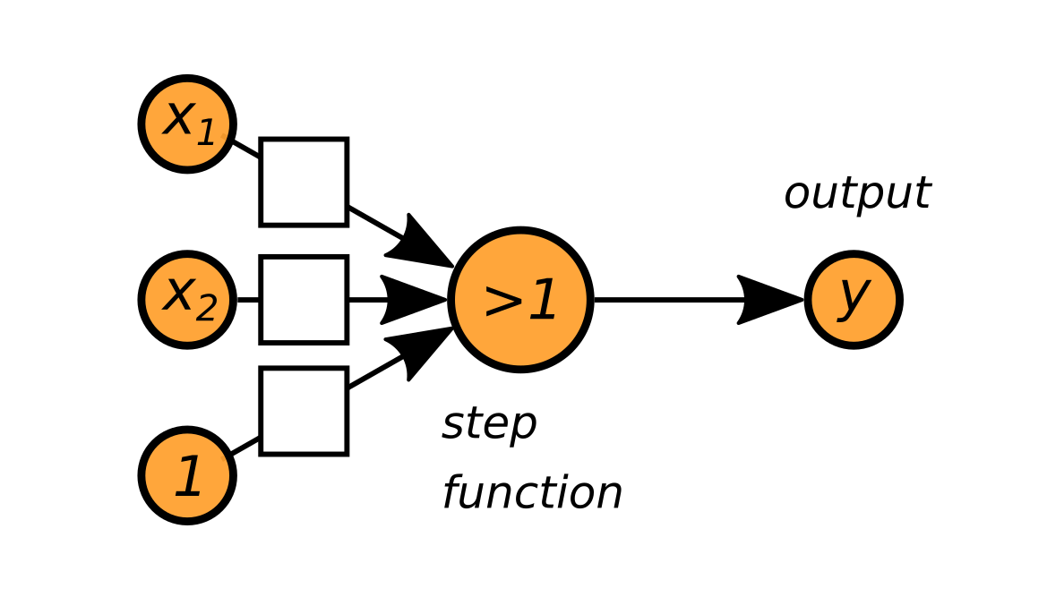
Your task is to set the weights in the two networks (for AND and OR) in such a way that it gives the correct result for all four data points. As an activation function we use the step function: it returns 1 if the weighted sum of the inputs is larger than 1.

Feed-Forward-Network
Now let’s try something more complicated: The XOR function, a nonlinear function.

Logical XOR
x1 | x2 | output
0 | 0 | 0
0 | 1 | 1
1 | 0 | 1
1 | 1 | 0

To model this dataset we need a neural network with two layers. You will need to set the weights for all three neurons.
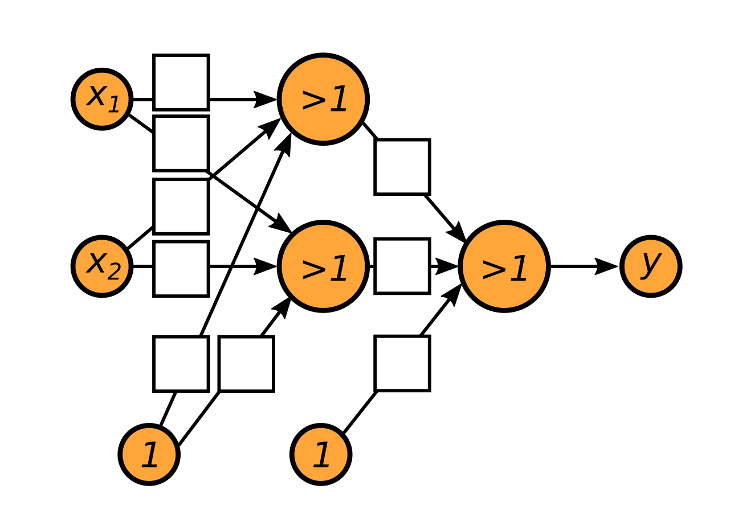
Hint: The XOR function can be expressed as:
XOR(x1, x2) = OR( AND(x1,-x2), AND(-x1,x2))

