Probably Fun Quiz
This is a team quiz. Solve as many of the following tasks in the given time together. Distribute the sheets within the team if it helps. Then exchange the sheets with another team for checking.
No computers / phones allowed!

Team Name:

Question 1
Identify the following LLMs: (2 points each)
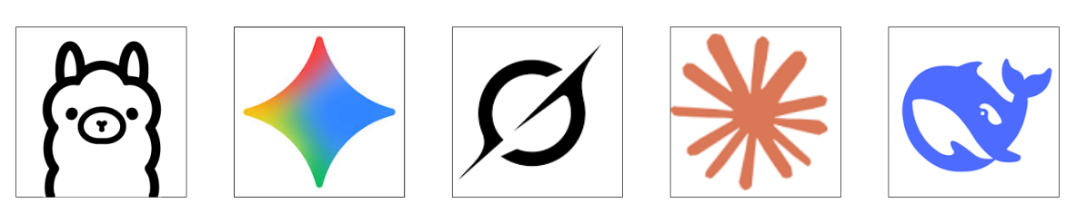

Question 2
You have the following series of numbers
x | 1 | 3 | 4 | 5 | 6 | 7 | 8 | 10
y | 4 | 19 | 25 | 30 | 41 | 46 | 52 | 67

Given a Linear Regression model, estimate the following: (3 points each)

slope
intercept
Mean Absolute Error (MAE)
Mean Squared Error (MSE)

Question 3
Estimate the correlation coefficient of the image (rounded to 1 decimal place). (5 points)
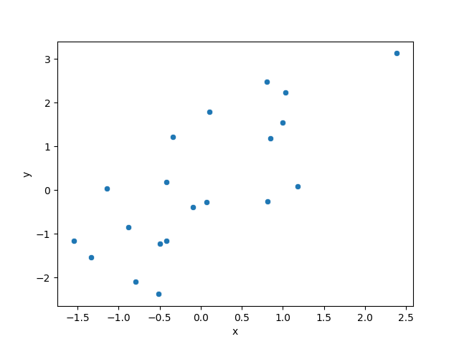

Question 4
Name the functions / equations. (3 points each)

Question 5
Decypher the following words by checking permutations. (2 points each)
ARMORED FONTS
ELSINORE EARRINGS
EBAY NAVIES
ANTIOCH PROVE SPECTRUM
ALIGNMENT SUCKERS

Question 6
Find 10 bugs: (10 points)

// read baby names and sum up count
for year in range(1900, 2000, 1):
total = 0
filename = 'names\yob{year}.txt'
for line in open(filename, 'w')
columns == line.split(',').strip()
total =+ columns[2]
print("Result: {} births total".format(year)

Question 7
The following people have all contributed to the advance of Data Science (2 points each)
in one way or the other. Name them.
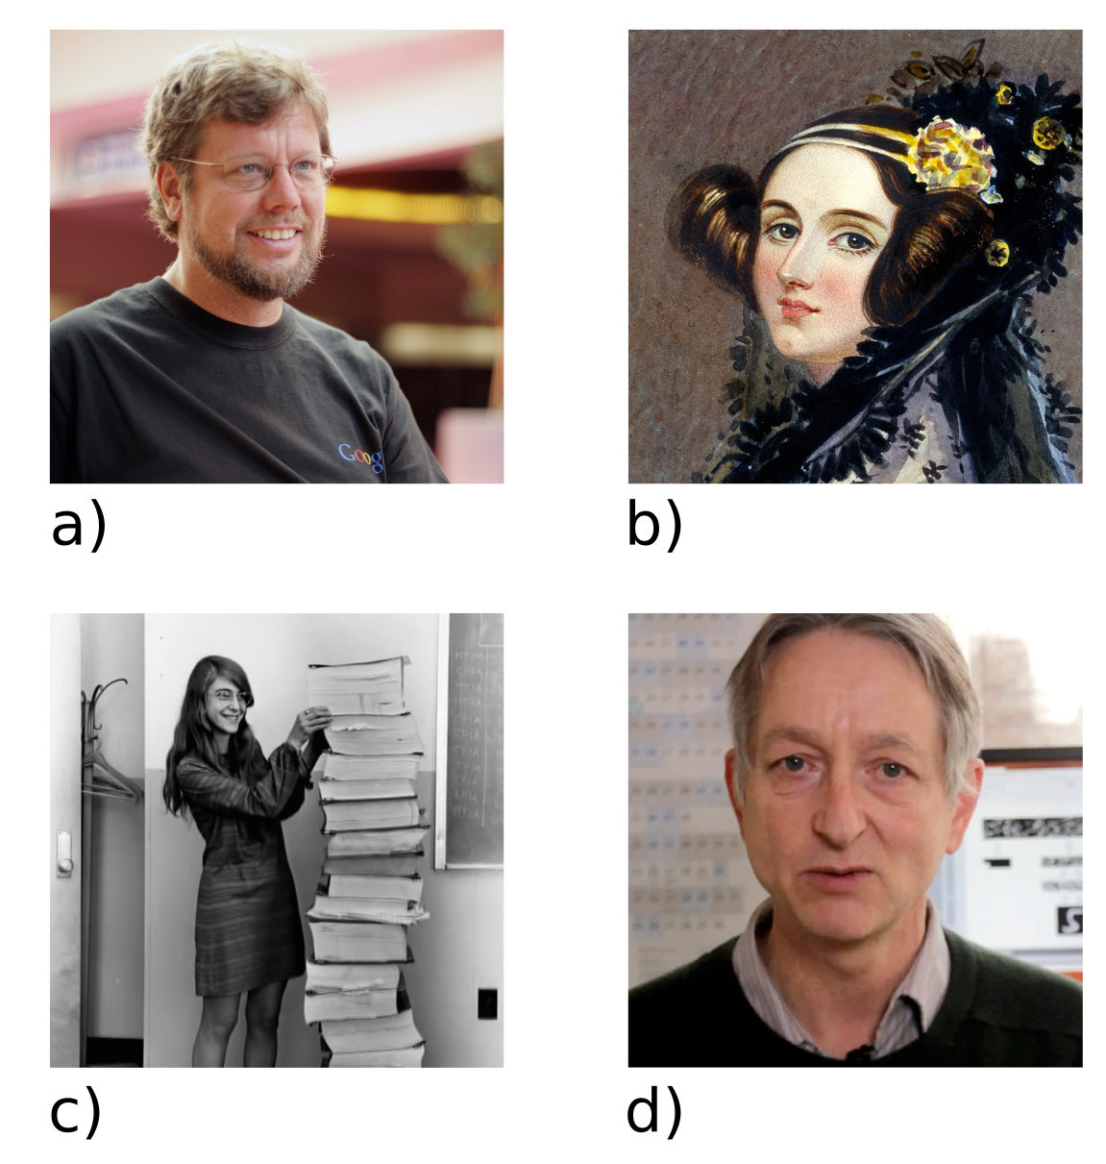


Question 8
Name the following series of numbers (3 points each)

0 | 1 | 1 | 2 | 3 | 5 | 8
1 | 1 | 2 | 6 | 24 | 120 | 720
2 | 7 | 1 | 8 | 2 | 8 | 1

Question 9
Match the machine learning models with their hyperparameter settings. (2 points each)

Decision Tree |  | alpha = 0.1
Ridge Regression |  | kernel size = (3 x 3)
Support Vector Machine |  | maximum depth = 3
CNN |  | activation = ReLU
Multilayer Perceptron |  | kernel = RBF

Question 10
Name the AI systems that made the following statement (2 points each)
(or the place they were deployed to):

I’ll be back.
I’m sorry Dave, I’m afraid I can’t do that.
I’ve seen things, people wouldn’t believe. Attack ships on fire off the shoulder of Orion.
Sir, the possibility of successfully navigating an asteroid field is approximately three thousand seven hundred and twenty to one!"

Total score (by referee team):

