
Create a Decision Tree
Train your own decision tree by writing questions that correctly predict the four animals in the picture. You may ask about any features of an animal e.g. (“is it grey”) but not its name (“it is an elephant?”). Write the names of the animals into the according boxes marked “prediction”.

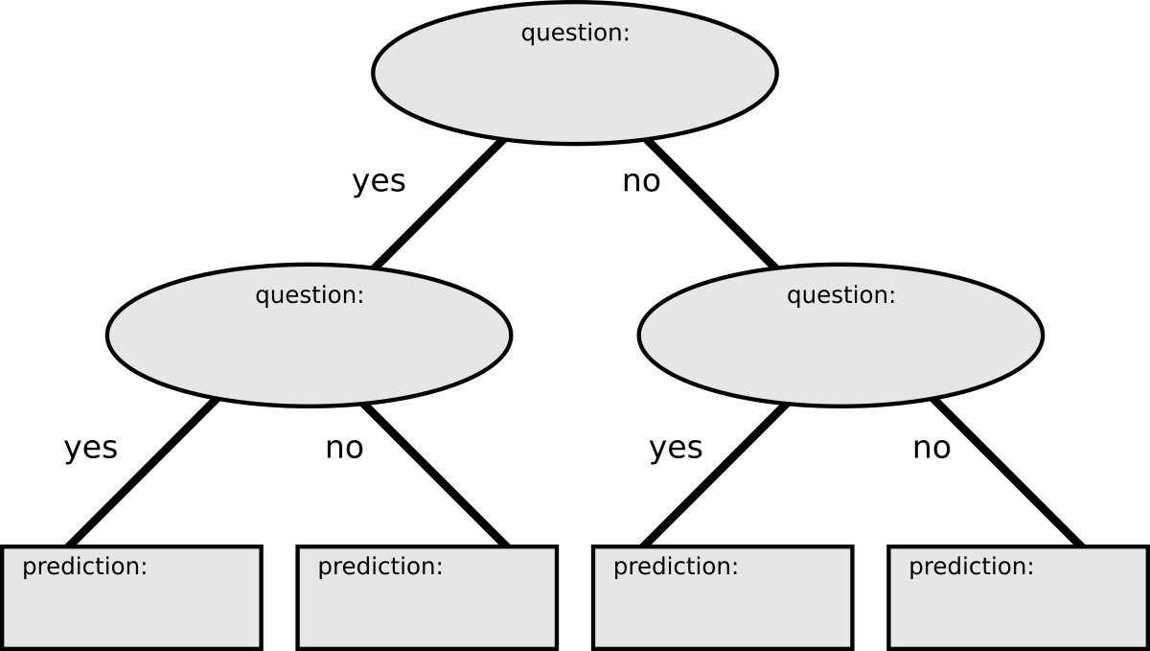

Results on test data (done together):
animal | prediction | correct

Accuracy on the test data
(number of correct predictions divided by number of data points):

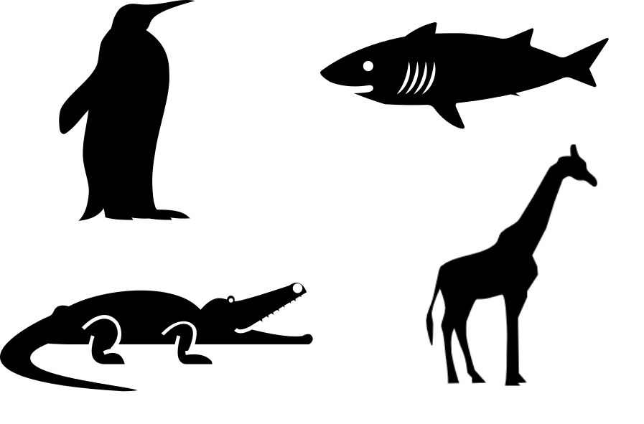
Create a Decision Tree
Train your own decision tree by writing questions that correctly predict the four animals in the picture. You may ask about any features of an animal e.g. (“is it grey”) but not its name (“it is an elephant?”). Write the names of the animals into the according boxes marked “prediction”.

Results on test data (done together):
animal | prediction | correct

Accuracy on the test data
(number of correct predictions divided by number of data points):

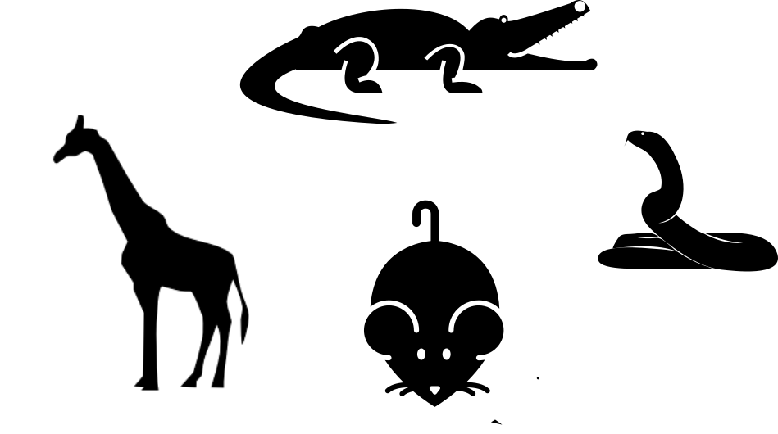
Create a Decision Tree
Train your own decision tree by writing questions that correctly predict the four animals in the picture. You may ask about any features of an animal e.g. (“is it grey”) but not its name (“it is an elephant?”). Write the names of the animals into the according boxes marked “prediction”.

Results on test data (done together):
animal | prediction | correct

Accuracy on the test data
(number of correct predictions divided by number of data points):

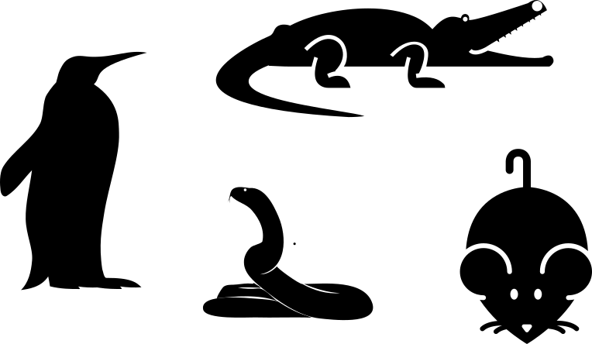
Create a Decision Tree
Train your own decision tree by writing questions that correctly predict the four animals in the picture. You may ask about any features of an animal e.g. (“is it grey”) but not its name (“it is an elephant?”). Write the names of the animals into the according boxes marked “prediction”.

Results on test data (done together):
animal | prediction | correct

Accuracy on the test data
(number of correct predictions divided by number of data points):

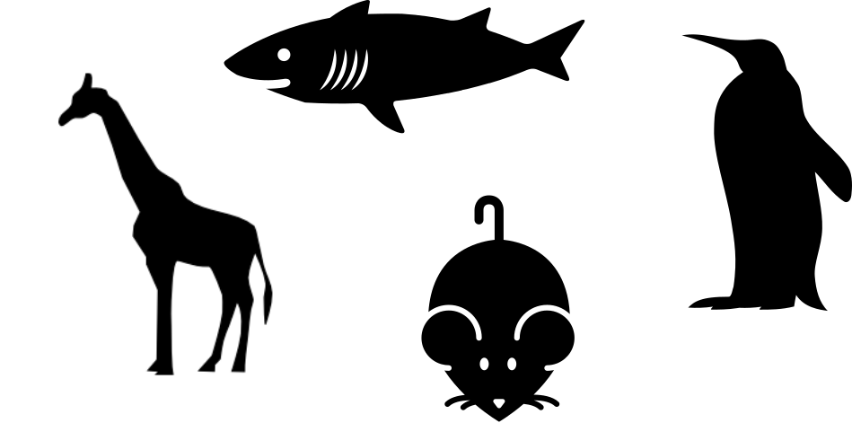
Create a Decision Tree
Train your own decision tree by writing questions that correctly predict the four animals in the picture. You may ask about any features of an animal e.g. (“is it grey”) but not its name (“it is an elephant?”). Write the names of the animals into the according boxes marked “prediction”.

Results on test data (done together):
animal | prediction | correct

Accuracy on the test data
(number of correct predictions divided by number of data points):

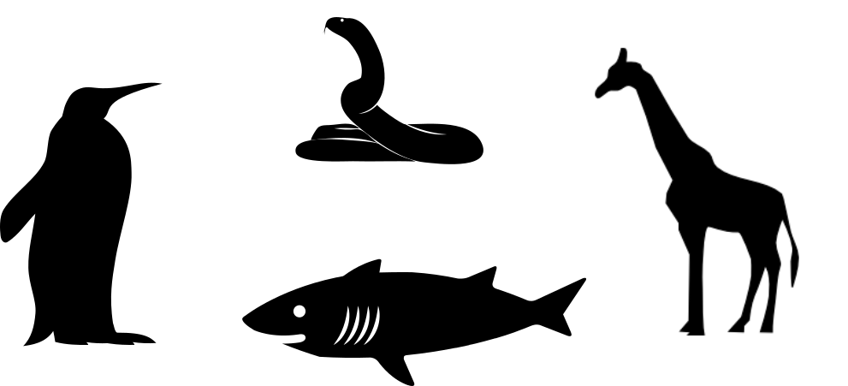
Create a Decision Tree
Train your own decision tree by writing questions that correctly predict the four animals in the picture. You may ask about any features of an animal e.g. (“is it grey”) but not its name (“it is an elephant?”). Write the names of the animals into the according boxes marked “prediction”.

Results on test data (done together):
animal | prediction | correct

Accuracy on the test data
(number of correct predictions divided by number of data points):

