Data Protection Quiz 2022
This quiz is a team challenge. There are 10 questions, covering various aspects of data protection.
Work through the tasks together in 30’.
1. Team
Put your nick names here.

2. Famous Data Protectors
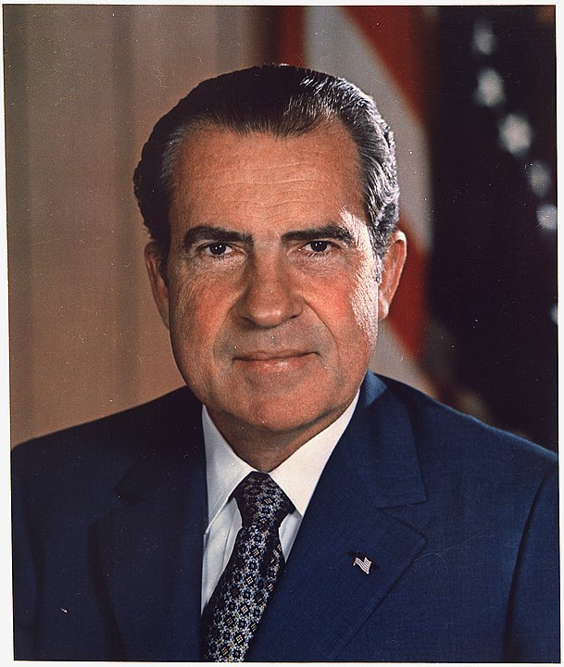


Who are the persons on the pictures? (4 points per person)

3. What is personal data?
Enumerate 10 things that are personal data (1 point per answer)

4. GDPR principles
Which of the following are true of the GDPR? (1 point per correct answer)
- before personal data is collected, you have a right to informed consent
- you are allowed to privately share personal data without consent
- every organization above 10 employees needs to have a data protection officer
- you have the right that your data is deleted, with some exceptions like tax records
- when your personal data is unvoluntarily disclosed, you have a right to be informed
- you have the right to request what data about you is stored
- you have a right to obtain your personal data in an accessible format
- you have a right to obtain data in CSV format or get API access
- when you are declined a loan, you have a right that the decision is checked by a human
- when collecting data from children below 18, parental consent is required
- the right to be forgotten has exceptions for research purposes

5. Data Breaches
Sort the data privacy violations below by the fine that the perpetrator was given.
(16 point minus the number of swap operations)

a) A small company used outdated web apps that did not receive security updates, and passwords were not kept securely enough, as found during a security audit after a data breach.
b) Marriott had their customer database hacked, exposing names, addresses and passport numbers of guests.
c) A police officer repeatedly accessed a police database for private purposes.
d) A private person took images of vehicles and sent the photographs via unencrypted email to report violations of road traffic regulations (Strassenverkehrsordnung).
e) Amazon failed to get sufficient cookie consent on its website after being fined for similar issues the year before.
f) The soccer club VfB Stuttgart was responsible for a negligent breach of data protection accountability but assisted in the investigation and responded by their own initiative.
g) H & M recorded obligatory online meetings of several hundred employees after they returned from vacations or sick leave, the meetings contained details from their private lives.

Correct order (from lowest to highest fine):

6. Fines
Estimate the minimum and maximum fine (in EUR) in the previous question
(up to 5 points each, -1 point per decimal place off)

7. Vocabulary
Assemble GDPR terms from the syllables below (2 points per term)
ACH AN AS BRE CER CY DA DA DA DA DA FI GE GRUND GU IM LA MENT NE NUNG OF ON ON ON ON ON ORD PACT PRI PRO PRO RAL RE SESS SCHUTZ TA TA TA TA TEN TEC TEC TI TI TI TI VA VER YMI ZA

a) what GDPR stands for

b) the process of making personal data non-personal

c) the German name for the GDPR

d) a violation of data protection rights (accidental or deliberate)

e) person responsible for policies regarding personal data in an organization (DPO)

f) document describing a policy for handling data that is required if the data is sensitive or a company processes large amounts of it (DPIA)

Text: © 2022 Dr. Kristian Rother, distributed under the conditions of the Creative Commons Attribution License 4.0.

Image sources:
- U.S. National Archives and Records Administration, Public Domain
- Wikipedia / CC-BY 3.0 , derived from www.youtube.com/user/TheWikiLeaksChannel
- Wikipedia / Tobias Klenze / CC-BY-SA 4.0

