Creating interactive workshops
Kristian Rother

I. Intro + Motivation
- Alpha Centauri, 4.3 Lichtjahre, Besucher, Erdnuss
- In diesem Workshop geht es ums Lehren.
- Wer hat schon einmal vor einer Gruppe gestanden und gelehrt?
- Dieser Workshop ist
- Fuer Dozenten, die Dutzende und hunderte von Studenten vor sich sehen.
- Fuer Trainer, die sich mit professioneller Ausbildung ihre Broetchen verdienen.
- Fuer Toastmaster, die selbst einmal einen Workshop auf einer Konferenz halten wollen.
- Fuer die naechste Ausbildungsrede in Eurem Club.
- Fuer zwei Kollegen, oder fuer nur einen einzigen.
- Dieser Workshop ist fuer alle von Euch.
- Die Frage ist: wie bereite ich einen guten Workshop vor? Wie halte ich einen Workshop bei dem die Teilnehmer etwas lernen?
- Heute moechte ich Euch ein Modell in die Hand geben, das Euch dabei hilft.

II. Konstruktion
Grundidee: Konfuzius
Der Hirnforscher Gerald Hüther sagt: Wir können es uns einfach nicht mehr leisten, Schüler durch Systeme zu schleusen, wo sie genau das verlieren, was sie für ihre Zukunft dringend brauchen: Leidenschaft, Eigenverantwortung und Lust, die Welt gemeinsam zu gestalten.
- 4 Phasen-Modell
- Warm-up: Aufwecken. Teilnehmer motivieren, Bewusstsein fuer das Problem schaffen.
Beispiel: etwas machen lassen. Explosive Activity Craig Valentine
- Konstruktion: Inhalt vermitteln. Struktur schaffen. Inhalt in mundgerechte Haeppchen zerlegen.
Beispiel: Speech.
- Anwendung: Den Teilnehmern die Moeglichkeit geben, sich aktiv mit dem Inhalt zu beschaeftigen.
Beispiel: Gruppenarbeit
- Schluss: Offene Fragen. Weiterfuehrende Hinweise. Zusammenfassund. Wiederholung.
Beispiel: Fragerunde

III. Anwendung
- Uebung:
  - Was kann man alles in den 4 Phasen tun?
  - Schreibt 3-5 Dinge auf die Ihr als Workshopleiter in einer der vier Phasen tun koennt, um mit dem Publikum zu interagieren.
  - Stellt Euer Ergebnis in 1-2 Minuten vor.
  - (Raum, Karten, Stifte, Kreppband)

IV. Abrundung
- Was haben wir heute getan?

V. Feedback:
- Emails auf PDF

Mephisto
Ich moechte Euch jemanden vorstellen, der weiss wie es geht:

<< Upside-Down: raspy voice, horns, change position!! >>

Gestatten, mein Name ist Mephisto.
Ich weiss eine Menge - aber ich sag's Euch nicht weiter!

Denkt mal an schlechte Lehre. Ausbilder die Euch zu Tode quatschen? Lehrer bei denen Ihr einschlaft. Professoren vor denen Ihr davonrennt. Das alles ist mein Werk.

Denn ich bin ein daemonischer Toastmaster (kurz DTM).

Fuer heute habe ich mir vorgenommn, diesen Workshop zu korrumpieren. Sagt mir doch einmal, was koennte ich tun, damit keiner von Euch etwas sinnvolles lernt? Was kann ich tun, damit das hier der schlechteste Workshop aller Zeiten wird? Fragt mal Euren Nachbarn.

<< wait, collect 5-7 results >>

Good, we now know how to make a bad workshop. Let's see how to try something better.

1. WARMUP
Imagine two students of bioinformatics. Both of them competent, ambitious, and highly motivated. Now look at them after 20 years: one of them has become an able trainer, a respected mentor, and if anyone misses a training by him sincerely feels he missed something good. The other student however, has cultivated the ability to talk trainees to sleep.
What did happen in between? Why did one student become a good trainer, and the other didn't? I think we are all here because of that question.

2. CONTENT
2.1 TEACHING METHODS
Ladies & Gentlemen, today I will talk about “How to find the best training methodology”. I would like to present you a simple model that helps bioinformaticians to make training more interesting and more effective.
My talk is based on two assumptions:
- You all have delivered successful bioinformatics training.
- You very much like doing so.

<< ask for a big yes >>

I have a question: What do you particularly like to do in the classroom?

<< collect 3-4 answers on flipchart >>

These are training methods. There are many many more. Literally, hundreds. Just as methods for research, training methods need to be developed, validated, and improved.

But how to build a training session using such methods? You cannot just throw a few training methods together randomly, right. You cannot use only one method either. You cannot even copy the training methods from one training to the other. I will tell you why:
- No two training objectives are the same. Science evolves, and so do training contents.
- No two training rooms are the same. Moving a single piece of furniture can influence the training outcome.
- No two groups are the same. Groups can be homogeneous, heterogeneous.
- No two trainees are the same. Some know exactly what they want, others want to be entertained.
- And most importantly, no two trainers are the same. All of you have their individual preferences.
This is why a single set of training methods applies to only one event?
Each training is a new invention! This is what makes training so rewarding.

2.2 THE FOUR-PHASE MODEL
But how can you create good trainings then? How to create a balanced set of training methods to reach your training goals?

HOW TO CHOOSE TRAINING METHODS:
circle concept map
Present 4 phases: Warm-up, introducing content, internalize content, repeat.

A general model that helps to choose the right methods is to divide a training unit into four phases:
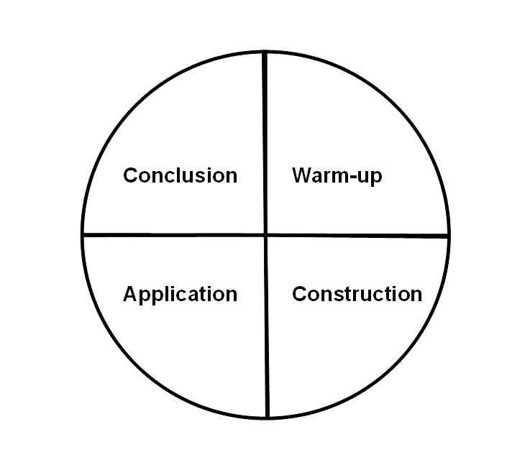
- Warm-up: Motivate trainees and connect the problem at hand to their present knowledge.
- Construct: Deliver new content in appropriately structured bite-size chunks.
- Apply: Trainees apply the new content actively to the initial problem.
- Conclude: Create links to related topics, repeat and summarize the training.

PYMOL EXAMPLE
I am searching for my teaching masterpiece.

3. APPLICATION
Collect 3 me
since we got experts here: gather 3 methods, in 4 groups.
[ PUT BIG CARDS ON WALLS, ASK WHETHER THAT IS POSSIBLE ]
[ 4 phases - four colors ]
[ check outfit colors ]

4. CONCLUSION
In a single training, you may go through these phases several times, once for each topic or learning goal. This is why the model is circular (see Figure). You can compose your training by picking at least one method for each of these four phases. For instance you could warm-up by showing a video, doing a brainstorming session, or running a quiz. Each of these methods will sets a characteristic tone for the entire training.

I collect methods. Well-filled method toolxbox helps me to make good training.

The key to successful training is to collect yourself a treasure box of training methods and adapt them to your preferences and needs. In my personal view, choosing the optimal training methodology is a trainers' daily exercise, because no two trainings are the same.

Which methods are best suited for bioinformatics training sessions? The ECCB workshop talk will explore this question.

A PDF with 7 example methods is available –> clipboard

Gerald Hüther: We cannot afford to educate students in a system where they loose what they desperately need for their future: passion, self-responsibility, and motivation to shape the world together.

What about the two students in the beginning? One of them reached greatness as a teacher, the other developed a talent to talk people to sleep. As a parent, I certainly value the ability of talking people to sleep. Yet I'd prefer to keep that out of the classroom.
For sure, this model is not enough to make a good trainer over 20 years. But I am pretty sure the good trainer knows more than one method.

END

SPS: Persuade that interaction is a good thing.

4 PHASES:
BLAST EXAMPLE: You need a good model
Phase II: show structure. More important than transmitting information. Information is free, and if students need it they will find it. But not if they don't know what to look for.

QUOTES:
WARMUP: "check Daphne: learners are fire that wants to be set ablaze"
APPLY: "confucius about remembering"
REPEAT:

GO ANALOG
FOCUS ON F2F INTERACTION, ANALOG METHODS
bioinformatics students use computers all the time anyway.
bioinformaticians are good at using electronic media anyway.
balance.

TEACHING IS FUN
when in the trenches between grant deadlines, dodging paper revisions, what can you do with teaching?
You can make teaching fun. Not entertainment for students, not edu-tainment. No fun for yourself. Relief from the routine. And that radiates.
ASK A QUESTION [SPS]

TEACHING IS SCIENCE
whenever you go into a classroom, you are conducting an experiment.
The hypothesis is: When I teach subject X with method Y, students will learn Z.
Here I will focus on the method section.
What is the optimal method to do bioinformatics research?
Weird question, right?
you need a repertoire

Summary:
GO ANALOG! [SPS]
INTERACTION IS GOOD [SPS]
REVIEW & DEBRIEF [SPS]
HANDOUT / EMAILS!!

INTRO:
Taking care of bioinformatics teaching is like being a medical doctor.
This is what I do.

First patient: a young PhD student, 25. Has his first course to teach next
week. Lets see. You just want to check whether everything is OK.
You're bright, you're ambitious, you want to deliver a good course, and
don't go there just because there are some nice girls, do you?
Just make sure to include some practical examples and check some current
literature before.

Next patient: Postdoc, 35, a little cushion around the waist.
You are a good scientist. Ah, you are sometimes feeling a little stiff
when teaching. How often do you prepare exercises? Once or twice a week?
I know I should do but got this big grant application coming up. Do you
drink coffee in your courses? Hm. Are your students heads smoking
sometimes?
Yes, I tried to stop that many times, but I never found the energy.

OK, your're a good scientist. I will prescribe you alternative teaching methods. But to be honest, this is not the main problem. You need to alter your style of research. I know your career is important, but you should
spend less time in the lab and a little more time with your students.

Next patient: Professor, 55 years. He's got Basics of Bioinformatcs. When did it start? 10 minutes ago? Quick, we need to move him into the lecture hall! Lets see what we have: Oh this is worse than I expected. He hasn't changed anything in his material in the last 3 years. I will try to remove some outdated examples. Students' blood pressure and breathing are slowing down. Lets email him the exam questions. He's not responding. students are falling unconscious.

There is nothing we can do now. Lets keep the students in artificial coma until we found a solution. This patient is in a critical condition. That is the situation we have today. Time to turn to the experts - You.

Advantages in attending
Get inspiration for your own training
Be acquainted with training methods that are effectively used by expert trainers
Have the opportunity to connect to the network of trainers & organizers (BTN)
Be recognized by and become part of the training community

Alle Kinder haben das Zeug zum Überflieger, sagt der Hirnforscher Gerald Hüther. Die meisten Lehrer wissen nur nicht, wie sie das Genie aus ihren Schülern herauslocken sollen. Der Schulkritiker rät: weg mit Frontalunterricht, starren Lehrplänen und einem Schulsystem, das aussortiert.

Die Lehrer können ja auch nichts dafür, dass unser Schulsystem so geworden ist. Doch in Zukunft müssen wir Pädagogen dazu ausbilden, nicht primär Wissen zu vermitteln, sondern die in den Kindern steckenden Talente zur Entfaltung zu bringen.

Genau mit dieser Einstellung sind auch die Kinder mit Trisomie 21 noch vor einigen Jahren betrachtet und als unbeschulbar abgeschoben worden. Selbst Experten hielten Menschen mit Down-Syndrom für schwachsinnig und unbegabt fürs Lernen. Jetzt haben die ersten Abitur gemacht und studieren. Heute weiß man: Wofür sie tatsächlich unbegabt sind, ist Frontalunterricht. Sie sind aber sehr sensibel für eine Art Potentialentfaltungskunst. Es braucht jemanden, der ihnen nichts eintrichtern, sondern etwas aus ihnen herausholen will.

Der Hirnforscher Gerald Hüther sagt: Wir können es uns einfach nicht mehr leisten, Schüler durch Systeme zu schleusen, wo sie genau das verlieren, was sie für ihre Zukunft dringend brauchen: Leidenschaft, Eigenverantwortung und Lust, die Welt gemeinsam zu gestalten.

