Teacher Training Quiz
This quiz was created to help you to grow into a teaching job. If you have not worked in a teaching role before, it can be quite a bit of work. Take your time to do background research and work through the tasks slowly. Please contact your mentor if you get stuck.
Work and discuss the tasks with your colleagues. Prepare and submit your answers as a team.

1. Famous Teachers

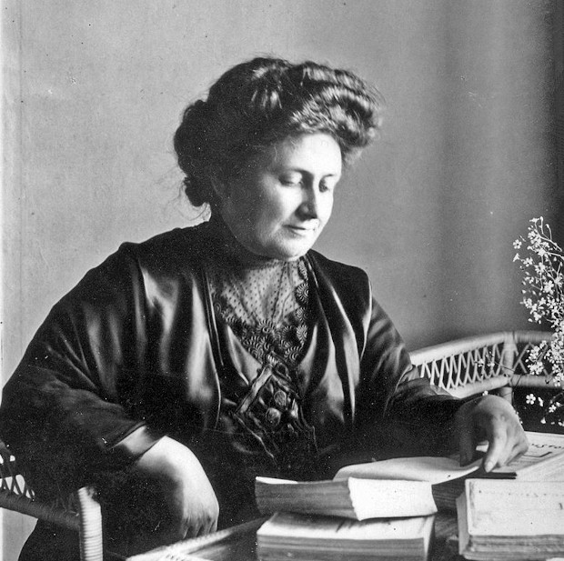
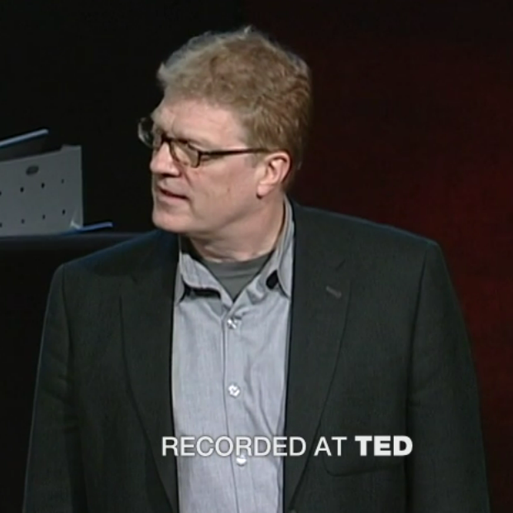

Task 1.1
Who are the teachers in the pictures?

Task 1.2
What did they teach?

Task 1.3
Match the quotes to the persons:
“Who is reviewing what they have learned and acquires new knowledge is fit to be a teacher.”

“Help me to do it on my own.”

“If you are not prepared to be wrong, you will never come up with anything original.”

2. Teaching Skills

Task 2.1
Name 3 skills that are important for a teacher

Task 2.2
Provide one or more references that support your statement in 2.1

3. Cognitive Load

Task 3.1
What is the 7 ± 2 rule?

Task 3.2
Describe how a teacher might apply the rule when preparing a lesson?

4. Learning Goals

Task 4.1
Where on Blooms Taxonomy would you place the following tasks:
- Write a program that puts the numbers from 1 to 100 into a list.
- Which method adds an element to a Python list?
- When are lists and when are dictionaries better?
- Explain how to select a sequence of consecutive elements from a list.

Task 4.2
Roughly what proportions should be spent on which level of Blooms Taxonomy in the classroom and/or exercises?

5. Concept Maps

Task 5.1
Imagine you are preparing a lesson on list data structures.
- Draw a concept map for the topic on a piece of paper.
- Measure the time it takes.
- Use the examples on www.academis.eu/posts/teaching/planning/concept_maps.md and/or your course material for inspiration.

Task 5.2
How could you produce a version of your concept map that can be used in the classroom?
Name three alternatives.

Task 5.3
Select one of the alternatives from 5.2.
- Produce the concept map.
- Attach a photograph of the results.
- Measure the time it takes.

6. Feedback

Task 6.1
You want to conduct a “temperature check” to find out how your group of 15 students is feeling, what they feel confident about and what they are struggling with. Name a few reasons why simply asking them might not give you the desired information.

Task 6.2
Propose 3 methods that you could use instead.
- Make sure you do not spend more than 15 minutes classroom time.
- Conduct research on
- gamestorming.com/
- www.academis.eu/teaching

Text sources:
© 2021 Dr. Kristian Rother, distributed under the conditions of the Creative Commons Attribution License 4.0

Image sources:
from left to right: Wikipedia, public domain, ted.com.

