**Oxygen Framework**

**1. Installing the Oxygen Framework**

**Prerequisites**

* Oxygen XML Editor is installed.
* Github Desktop

**Step 1: Get the Framework data**

* Open Github Deskop
* Clone the Software Repository (in a directory easy to find ;))

**Step 2: Associate the Framework**

1. Open the Oxygen Editor
2. Navigate to Options > Preferences > Document Type Association > Locations // 'Optionen > Einstellungen > Dokumententypen-Zuordnung > Orte'.
3. Click Add // 'Hinzufügen', browse to the cloned repository folder and navigate to the Folder frameworks.
4. Click OK.
5. At the bottom of the page switch from text mode (XML code view) to author mode (framework view) to see the rendered file.

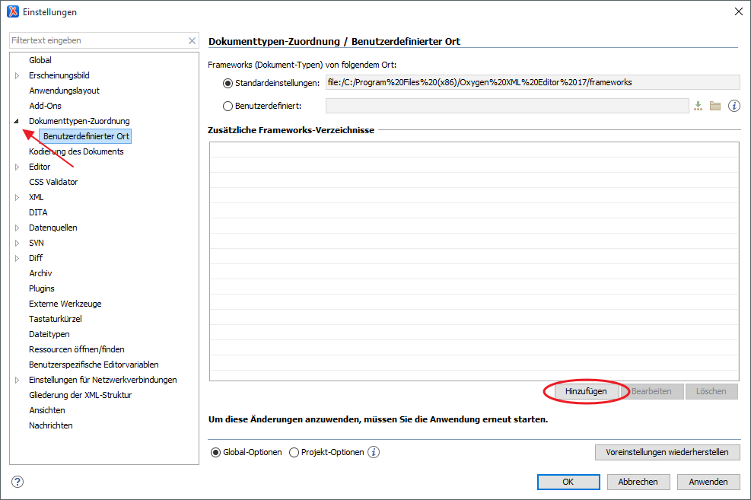

**Step 2.5 (Optional but Recommended) - Author Mode View as 'First View'**

- Open `Options > Preferences > Editor > Edit Modes` // 'Optionen > Einstellungen > Bearbeitungsmodus.

- Set `XML Editor > Edit` to "Author" (instead of "Text").

- Click `OK`.

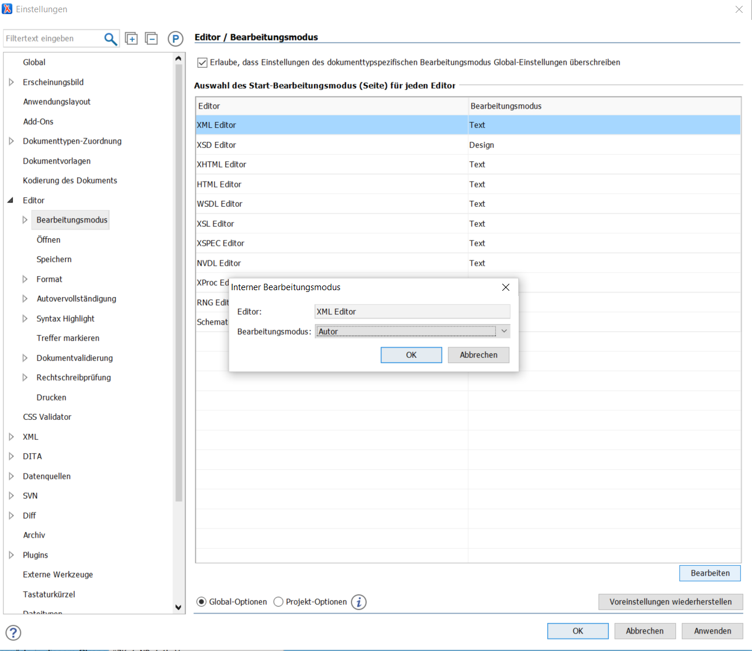

**Step 3: Test if everything went to plan**

* Open any Manuscript TEI.
* The framework was correctly assigned if it looks like this (if not, something went wrong):

