Midterm Problem Set  
Report

short line

Kevin Chen  
March 21 2023

# Problem 1

## Method Implementations

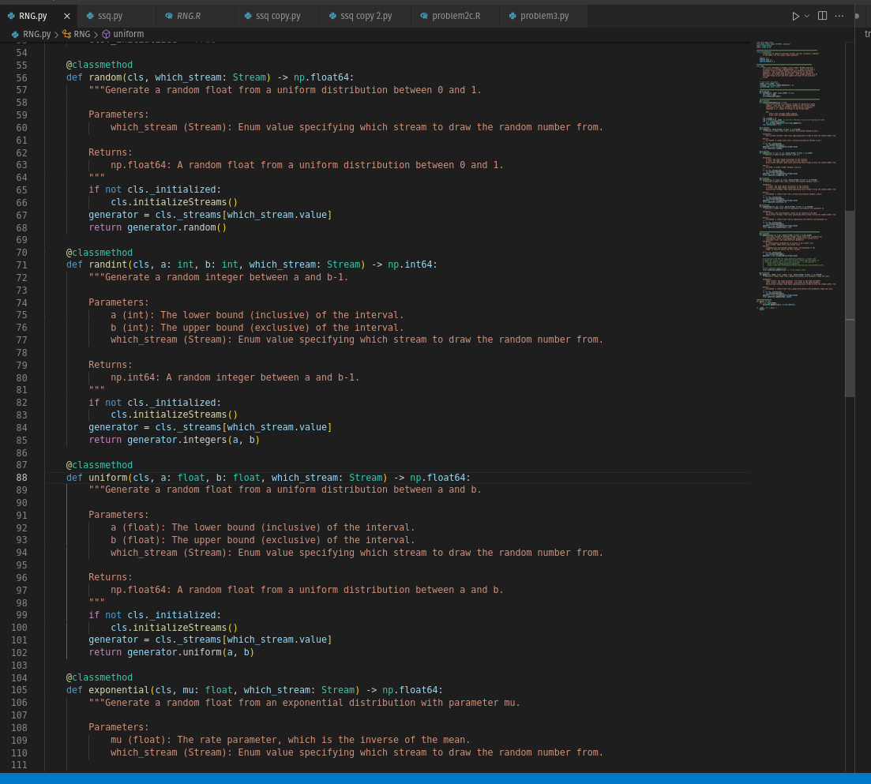

# 

## 

## 

## 

## 

## 

## Variates Histogram

### Geometric

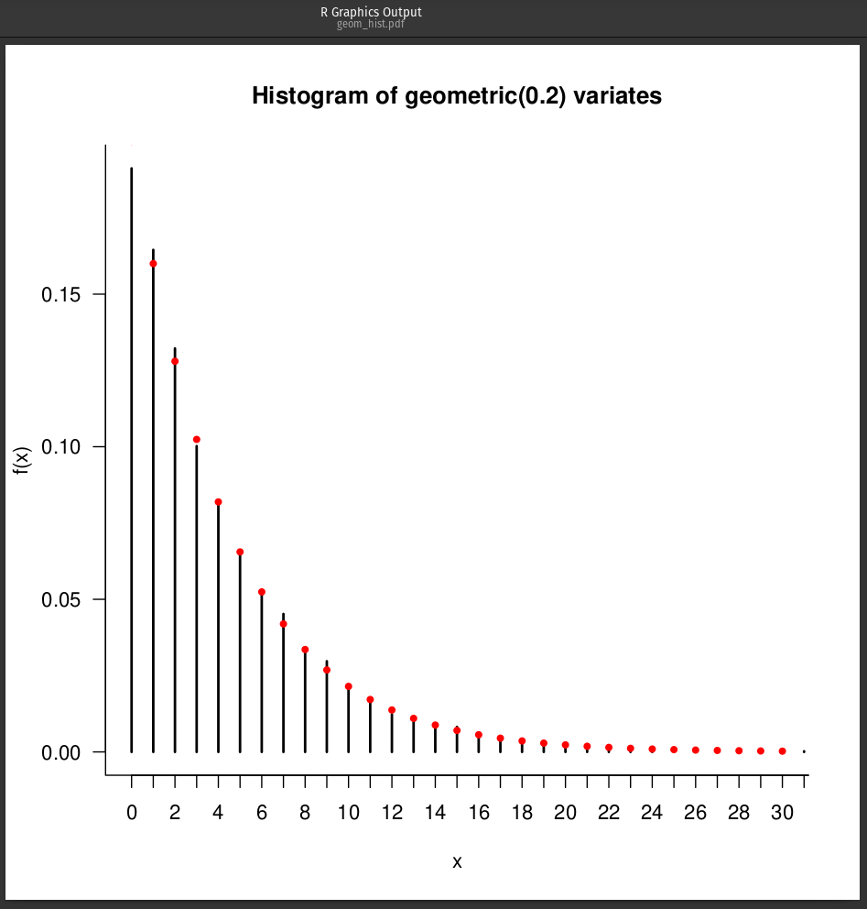

### Random

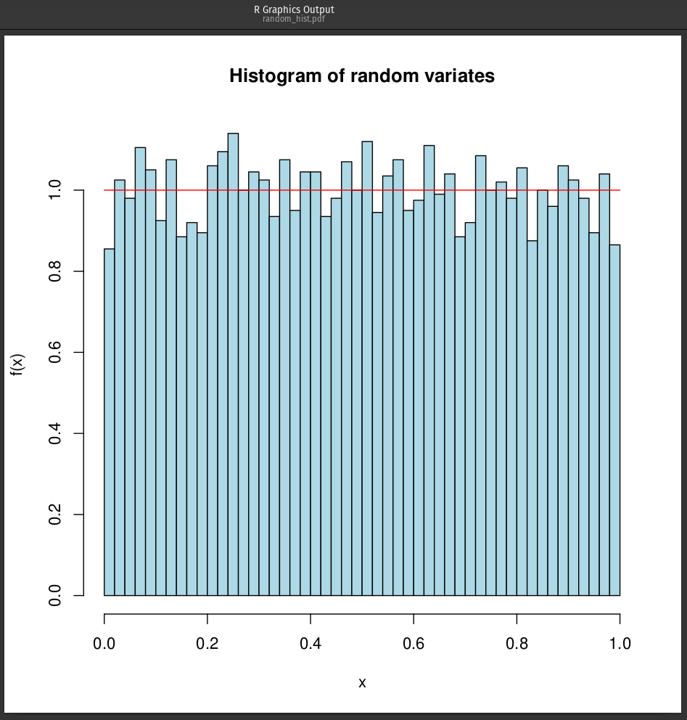

### Randint

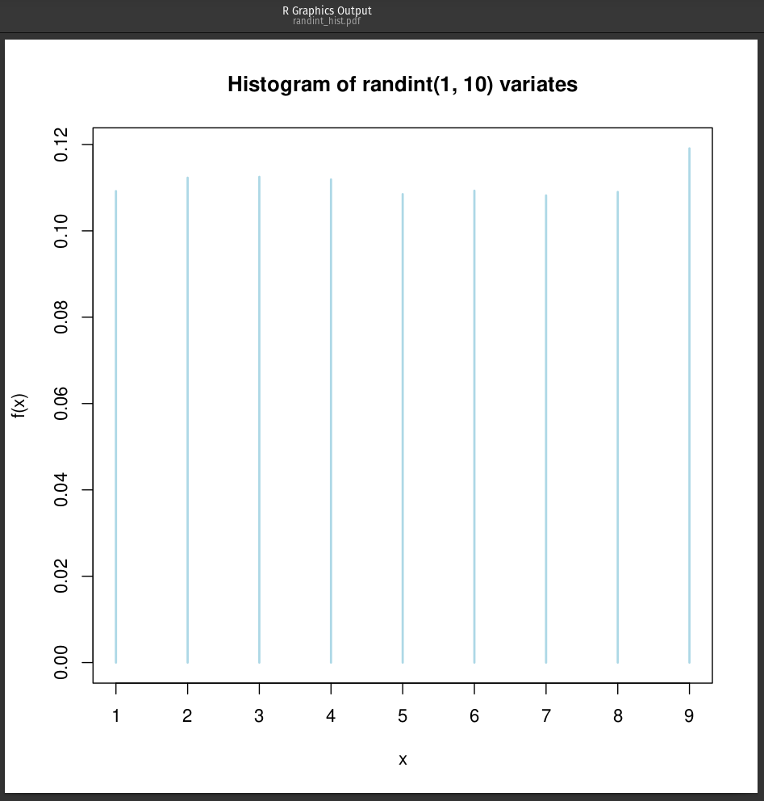

### Uniform

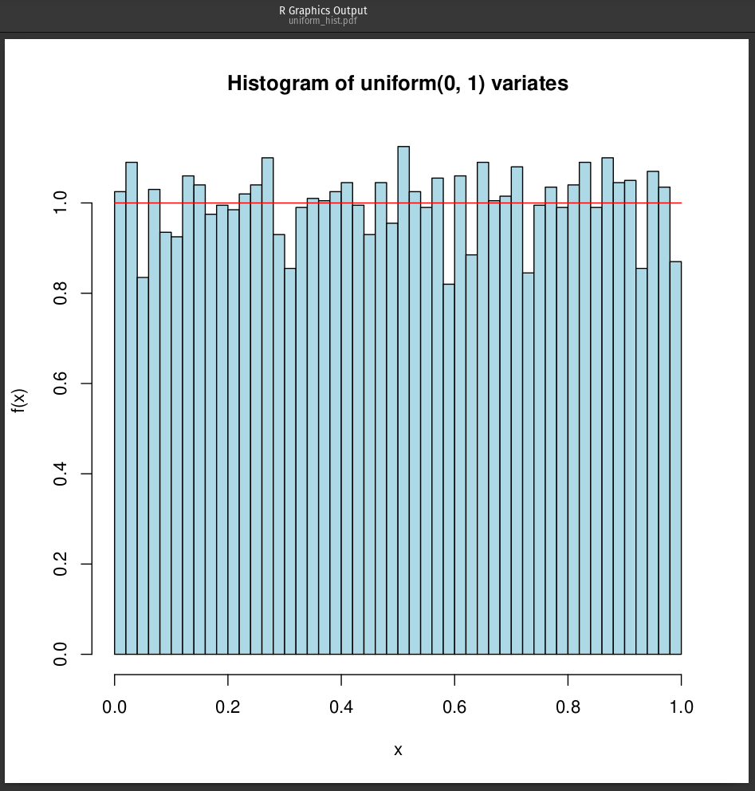

### Exponential

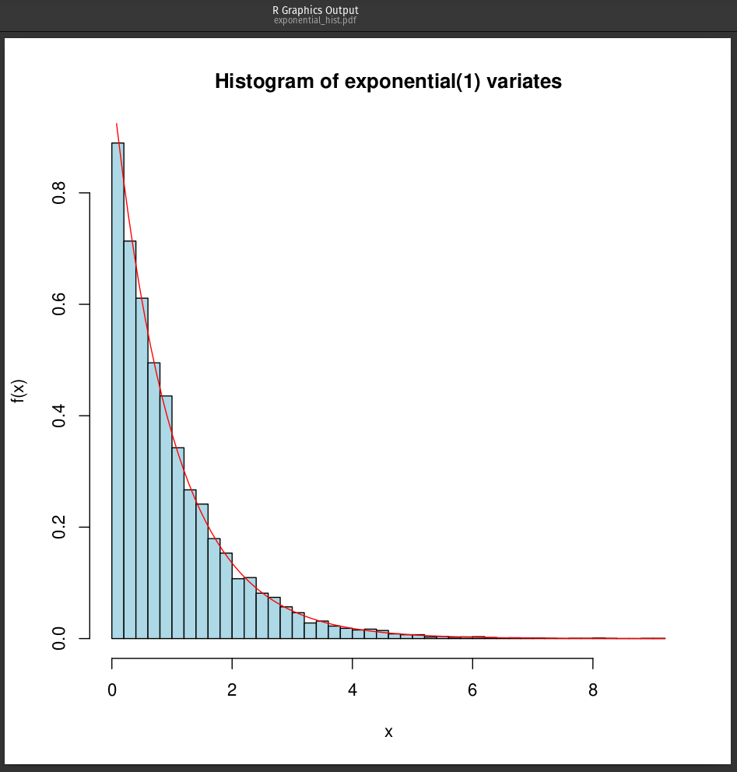

### Gamma

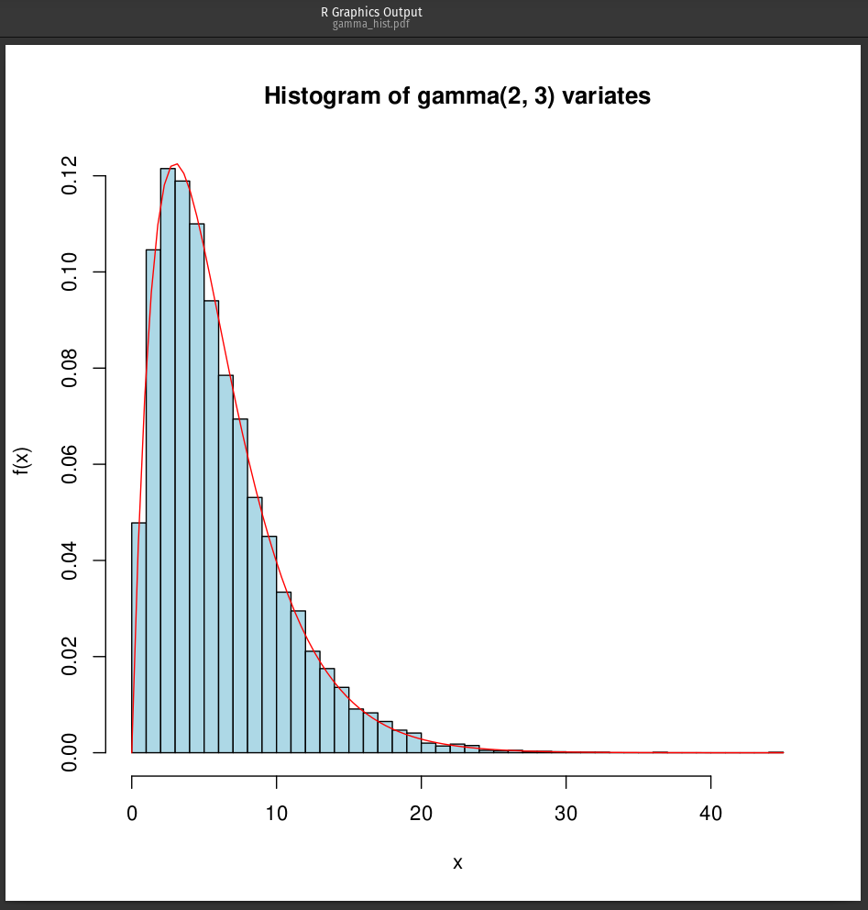

## 

# Problem 2

1. Based on approximately 1 000 000 processed customers:  
   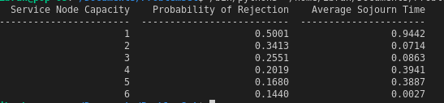
2. Service task is changed to be uniform(0.1, 0.3):  
   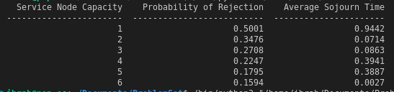
3. 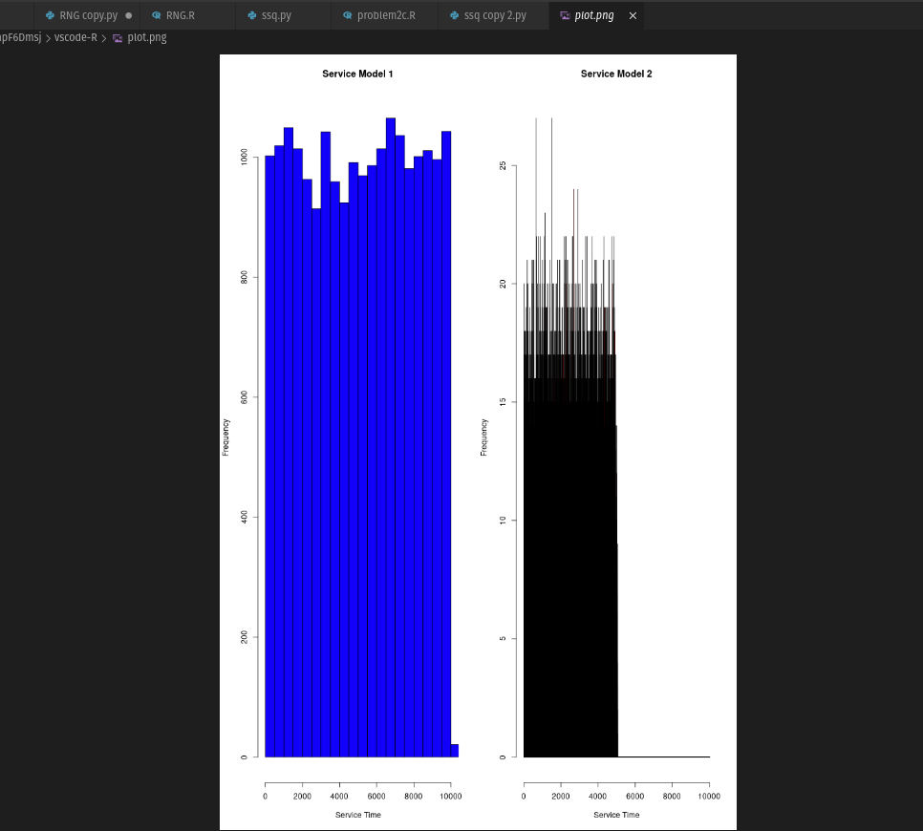

Service Model 1 represents a scenario where the service times are consistently around a specific value, leading to a more predictable queuing system. This model would be appropriate if the service times for tasks are relatively uniform and follow a known pattern.

Service Model 2 represents a more varied range of service times, possibly indicating that tasks have different complexities, and the service provider has varying levels of efficiency. This model might be more realistic in situations where tasks are diverse and the server's performance is influenced by external factors.

The appropriateness of the service models depends on the specific context of the single-server queuing system. If the service times are consistent and predictable, then Service Model 1 is more appropriate. However, if there is variability in the service times, then Service Model 2 would be more suitable.

1. *Probability of Rejection:*

The probability of rejection is the likelihood that an arriving customer is rejected because the system has reached its capacity. This probability is influenced by the service process in the following ways:

If the service process is slow, meaning it takes a long time to serve each customer, the system will be more likely to reach its capacity. As a result, the probability of rejection will increase.

Conversely, if the service process is faster, the system will have more capacity to serve new arrivals, reducing the probability of rejection.

In our simulation, the service process is determined by the time it takes to complete a series of tasks. If the tasks have a larger time range (i.e., tasks take longer to complete), the probability of rejection is likely to increase as it takes longer to serve each customer.

*Average Sojourn Time:*

The average sojourn time is the average time a customer spends in the system, including both waiting in the queue and being served. It is affected by the service process in the following ways:

If the service process is slow, customers will spend more time being served, increasing the average sojourn time.

If the service process is fast, the time spent being served will be shorter, reducing the average sojourn time.

In our simulation, the average sojourn time is influenced by the service process, which consists of a series of tasks. If the tasks have a larger time range or a higher probability of adding more tasks (i.e., lower probability in the geometric distribution), the average sojourn time will likely increase.

The probability of rejection and average sojourn time are influenced by the underlying service process. Faster service processes generally result in lower probabilities of rejection and shorter average sojourn times, while slower service processes tend to result in higher probabilities of rejection and longer average sojourn times.



* Basic checks: Ensure that the total number of arrivals, departures, and rejections are consistent with the simulation parameters, and the sum of departures and rejections equals the total number of arrivals.
* Conservation equation: Verify if n̄ = q̄ + x̄, where n̄ is the average number of customers in the system, q̄ is the average number of customers in the queue, and x̄ is the average number of customers in service. These statistics should be collected and computed independently during the simulation.
* Utilization: Ensure that the server utilization remains within the expected range (0 to 1) and is consistent with the arrival rate and service rate. Utilization should increase with a slower service process or higher arrival rate.
* Little's Law: According to Little's Law, n̄ = λ * W̄, where n̄ is the average number of customers in the system, λ is the arrival rate, and W̄ is the average time a customer spends in the system (average sojourn time). We can verify if the results from our simulation adhere to Little's Law.
* Probability of rejection: When the capacity is 1 (server with no queue), the probability of rejection should be very high, close to 1, as any new customer arriving when the server is busy will be rejected. When the capacity is 2 (server with a queue length of 1), the probability of rejection should be lower than with a capacity of 1, as now the system can accommodate one customer in the queue. As the capacity increases, the probability of rejection should decrease.
* Monte Carlo analysis: Perform multiple runs of the simulation with different random seeds and ensure that the results are consistent across different runs. This will help confirm that the results are not an artifact of a particular random sequence.

# Problem 3

### Steps:

1. Randomly select 12 questions from the pool of 120 questions.
2. For each question, determine its class (I or II) and generate a grade based on the given probabilities.
3. Sum the scores for the 12 questions to get the total score for that test.
4. Repeat this process a large number of times (e.g., 10,000 or more) to generate a histogram of scores.
5. Calculate the probability of passing the test based on the histogram.
6. Estimate the uncertainty in the result.

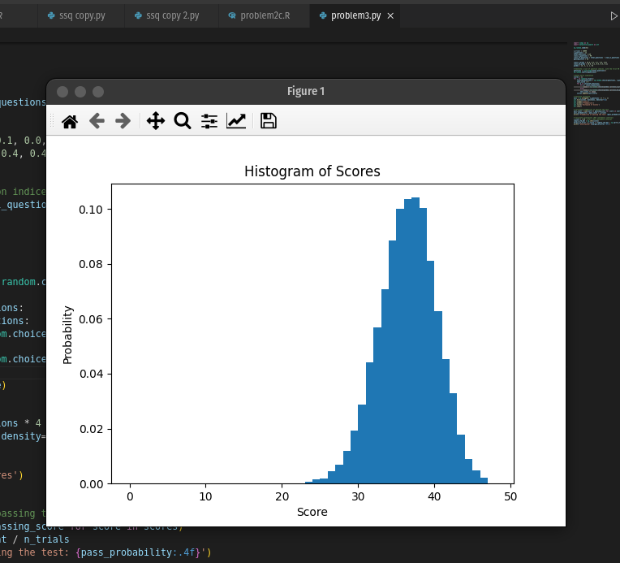

1. The Probability of passing the test: 0.5643

Based on the Monte Carlo simulation I ran, the probability of passing the test is 0.5643, or 56.43%. This means that given the distribution of Class I and Class II, there was 56.43% chance of scoring 36 or higher on the test, which is the requirement to pass.

1. Uncertainty: ±0.0736

The uncertainty of the result, ±0.0736, is a measure of the precision of the estimated probability. This uncertainty is calculated using a 95% confidence interval, which means that we can be 95% confident that the true probability of passing the test lies within the range of (0.5643 - 0.0736) to (0.5643 + 0.0736), or approximately between 0.4907 and 0.6379. This range provides an indication of how much the probability might vary if we were to repeat the Monte Carlo simulation with a different random seed or under slightly different conditions.

Based on the study and classification of the questions, there was a 56.43% chance of passing the test. However, there is some uncertainty in this estimate, and the true probability could lie within the range of 49.07% to 63.79%.