Configuration :-

* First find Mac address & configure it
* Second pull the automation or import the TUI project.

To find the Mac address

C:\TUI Projects deatils\Automation\SahiPro\userdata\bin

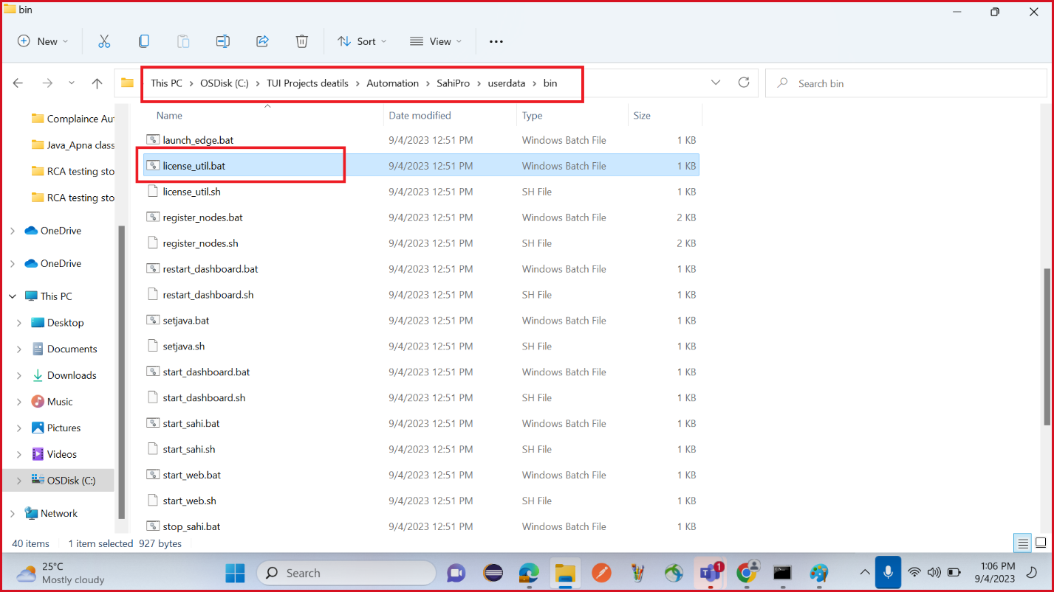

Adding of Mac adrres>

Click on manage access list

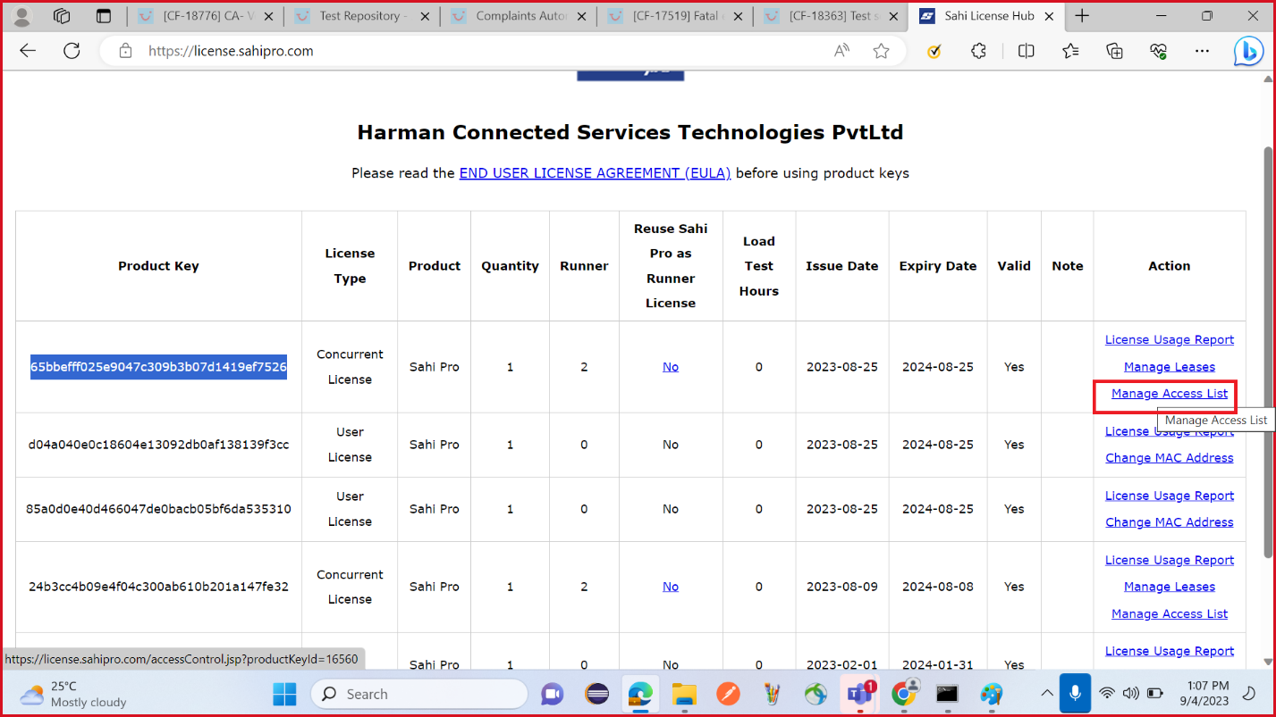

Select the MAC address from the Access Control Type drop-down > enter the mac address in value filed and click on Add

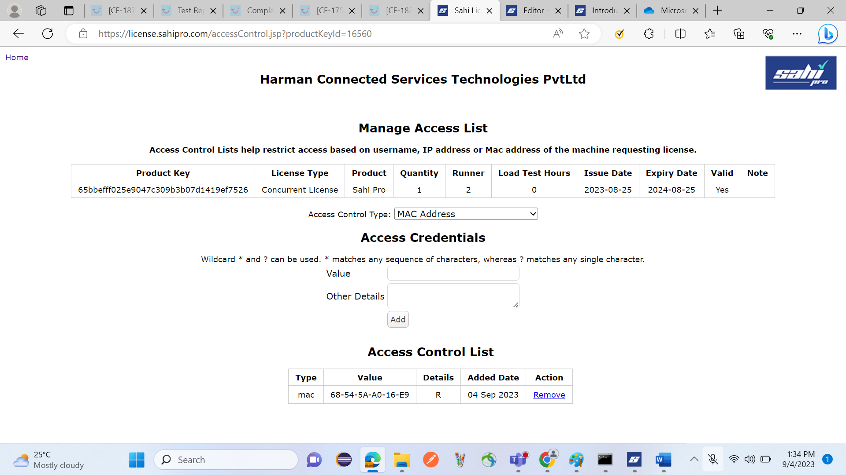

Now open the sahi pro app it show open

Now import the TUI project.

How to pull or import automation framework in Shai-pro tool :-

Click on script

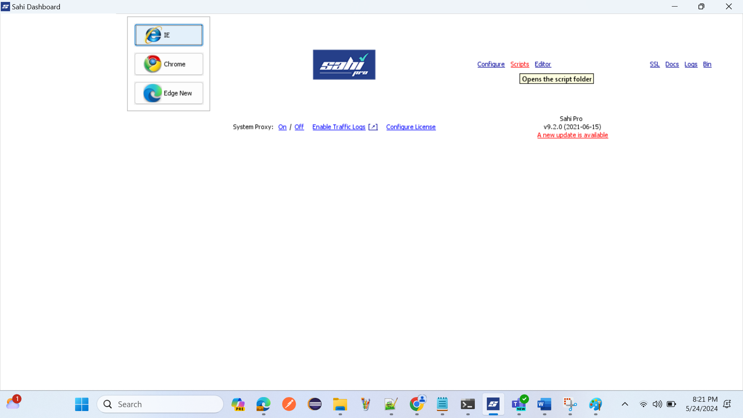

Open common path

C:\TUI Projects deatils\Automation\SahiPro

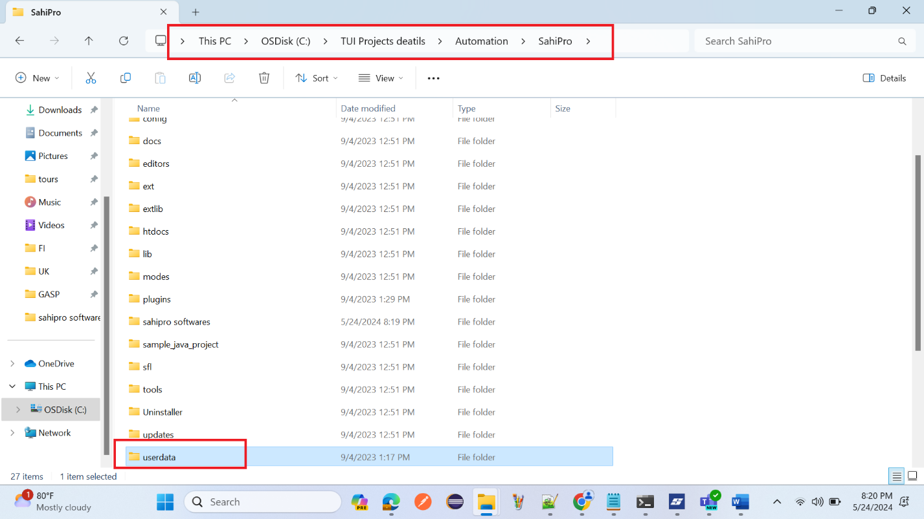

User data>scripts> pull TUIAutomationFramework

To find the product key

Follow below navigation and click productkey.txt and you will see the product key

C:\TUI Projects deatils\Automation\SahiPro\userdata\config

