

ONINE PROPERTY BOOKING

REPORT



2019-2020

GROUP MEMBERS

ABHISHEK KUMAR SINGH & KULDEEP SINGH RAJPUROHIT

**G.H RAISONI COLLEGE OF ENGINEERING AND MANAGEMENT**

**MINI PROJECT**

**2019-2020**

REPORT

**ONLINE PROPERTY BOOKING**

**Under Supervision**

**Ms.Chhaya nayak**

**Group Members**

**1. Kuldeep singh rajpurohit (TCOA 31)**

**2. Abhishek kumar singh (TCOA 40)**

**INDEX**

|  |  |  |
| --- | --- | --- |
| **Chapters** | **Title** | **Page No.** |
| **1** | **INTRODUCTION** | (3-7) |
|  | 1.1 Aims and Objectives | 4 |
|  | 1.2 Objectives | 4 |
|  | 1.3 Scope of Project | 5 |
|  | 1.4 Operating Environment – Hardware and Software | 7 |
| **2** | **PROPOSED SYSTEM** | (8-10) |
|  | 2.1 Proposed System | 8 |
|  | 2.2 Need of System | 9 |
| **3** | **ANALYSIS AND DESIGN** | (10-14) |
|  | 3.1 Class Diagram | 10 |
|  | 3.2 Use Case Diagram | 11 |
|  | 3.3 Activity Diagram | -- |
|  | 3.4 Test Procedure and Implementation | 12 |
| **4** | **USER MANUAL** | (15-17) |
|  | 4.1 User Manual | 15 |
|  | 4.2 Menu Explanation | 16 |
| **5** | **DRAWBACKS AND LIMITATIONS** | 18 |
| **6** | **CONCLUSION** | 19 |
| **7** | **BIBLIOGRAPHY** | 20 |

**Introduction**

Online property booking is an online real estate software application that manages the overall operational activities and processes, starting from the management of the property, to the management of real estate agencies, agents, clients and financial transactions. It provides comprehensive reports for managing the Real Estate agency performance and efficiency, and enables the management for a better decision-making. This online property booking is a web application where property details such as available house details, schedules, address, and others are been setup by an administrator. Memebers should be able to get information of property like area, location and price.

**1.1 Aims and Objectives**

* The main aim of this project is to ensure that management abides by regulations and laws when interacting with tenants and vendors.
* Another aim is to match with properties for sale by number of bedrooms / price criteria.
* Create Letters & contracts easily using templates.
* It also aim to allow easy entry of Property and vendor details.

**1.2 Objectives**

* **Time Effective and Cost Effective**

Property site is available to anybody and anywhere. This saves a lot of time of the customer and in a very little span the register user may look the “what’s an offer on the special products purchasing”. This plan cost offered in economic too.

* **Database Creation**

A database of the registered users will be created and this will help the users to fetch the details of recent property as per requirements. There is a separate database for administrator for updating the site.

* **Mobility**

Internet is available to everybody anywhere anytime now a days, this makes the site highly mobile.

* **Informative**

The site has all the necessary details about the concerned property and materials hence, provide all the relevant information therefore. For example, searching of appropriate property has done, and then their information of purchasing is provided to registered users.

* **Wide Approach**

Any person can visit it. User can register with or without photographs. Therefore it has a wide range of users.

* **Security**

Proper authorization and authentication provisions have been made for the security by Django framework itself and also some corner cases are also been made secured of the site so that only the registered user can look the special offer details. Without proper login no one is allowed to access the list of this site.

* **Flexible**

The site is flexible to any expansion or contraction in the future. For example: sending email confirmation to the email as well as through sms after the registration. If new property added on the website, the sms alert will be available for mobile users.

**1.3 Scope of Project**

The system is highly flexible one and is well efficient to make easy interactions with the client. This project is very mayor to all real estate departments. The key focus is given on data security, as the project is online and will be transferred in network. The speed and accuracy will be maintained in a proper way.

This proposed system maintains all the property information online. The system identifies various sources of properties and accordingly provides information. It provides information to all who visits site but to upload a property for sale and rent and to send a request to buy a desire property can only be made who register with the site.

Through this project we have tried to automate the task of :

* + Available property information
  + Price Details
  + Details of Property
  + Features of Property
  + Category of Property
  + Entering the detail contact information, and other information.
  + Checking password and confirm password.
  + Checking username available or not during the registration process.
  + Member id is generated automatically from the table by auto generation.
  + Entering the details like primary information, professional information, contact information and other information.
  + Add property images
  + Save time of search
  + Give a modification power to site’s owner. So, Administrator of site can make any changes such as can add a new property category and property type details.
  + Administrator can also change the Banner.

**1.4 Operating Environment – Hardware and Software**

Tools refer to the hardware and software that can be used to achieve the project goals.

**Hardware Requirement**

**Client Side**

* **Processor:** Celeron 500 MHz or more, Intel Pentium III (or above)
* **RAM:** 128 MB RAM (or above)
* **Hard disk:** 10GB (or above)

**Software Requirement**

* **Web Browser:** IE 4 or Netscape 4x or upwards or Chrome or Safari
* **Development Tool:** JavaScript, HTML, CSS , PYTHON
* **Development frameworks:** Bootstrap (Styling), Django (Backend)
* **Database:** SQLite.

**PROPOSED SYSTEM**

**2.1 Proposed system**

* The Proposed system which will allow the user to quickly and easily search a property for Buying and selling.
* The registered user can upload his property for sale or rent out.
* The system is design and developed in such a way that it tries to overcome all the currently existing problems.
* The system being an online system will give accurate information regarding the property which helps to view all the property information directly from anywhere.
* Designing of site is such that it provides easy access of the information.
* If user wants to avail/buy any property of site they should register.
* Search option facility is provided for users to search desired properties.
* For avail services for selling and buying property, members should be able to access property details.
* Member have to enter all the necessary description of their property for sale.
* Members can easily delete property.
* Administrator can only be able to make changes on the site.
* Administrator can maintain all possible results for search option.
* Proposed system is flexible and user friendly.
* The proposed system ensure security, reliablity and productivity on large scale.

**2.2 Need for System**

* The existing system is very slow and needs more time to search and maintain each and every detail.
* As calculations are done manually it is tedious and difficult to major more figures accurately.
* Retrieval of required information is become difficult and time consuming.
* Security of data is very critical issue which has to be considered in the current system, there is no data security in current system.
* Same data is maintained in various file which is leading to redundant data.
* Report generation is very tedious job. The in-charge of preparing report has to refer more than one file.

­

**ANALYSIS AND DESIGN**

**3.1 Class Diagram**

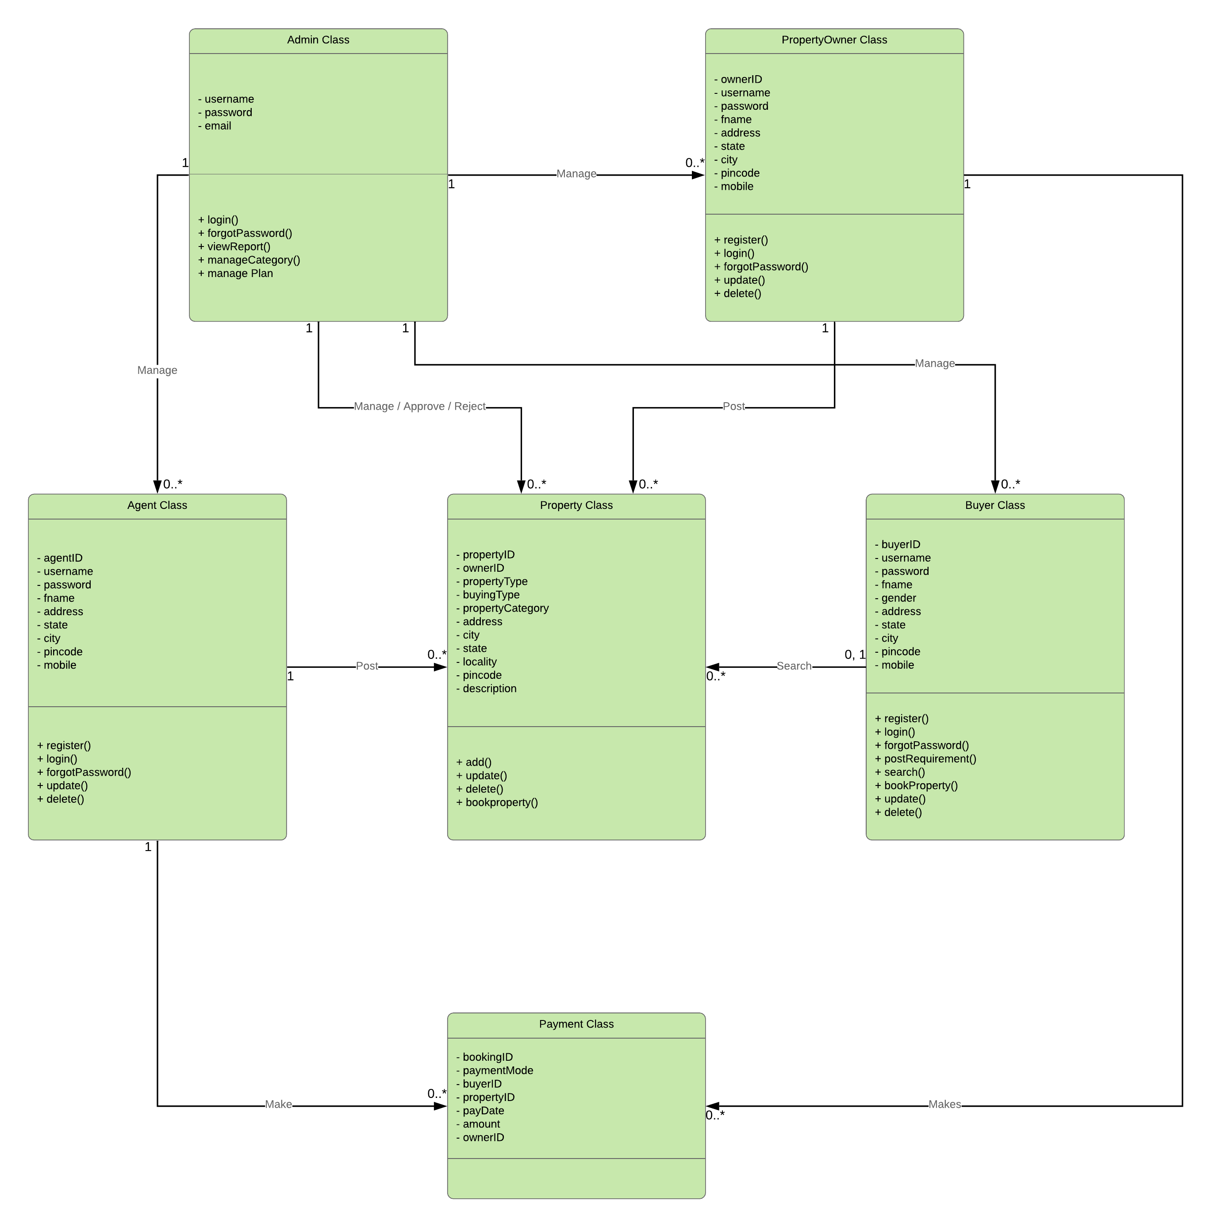

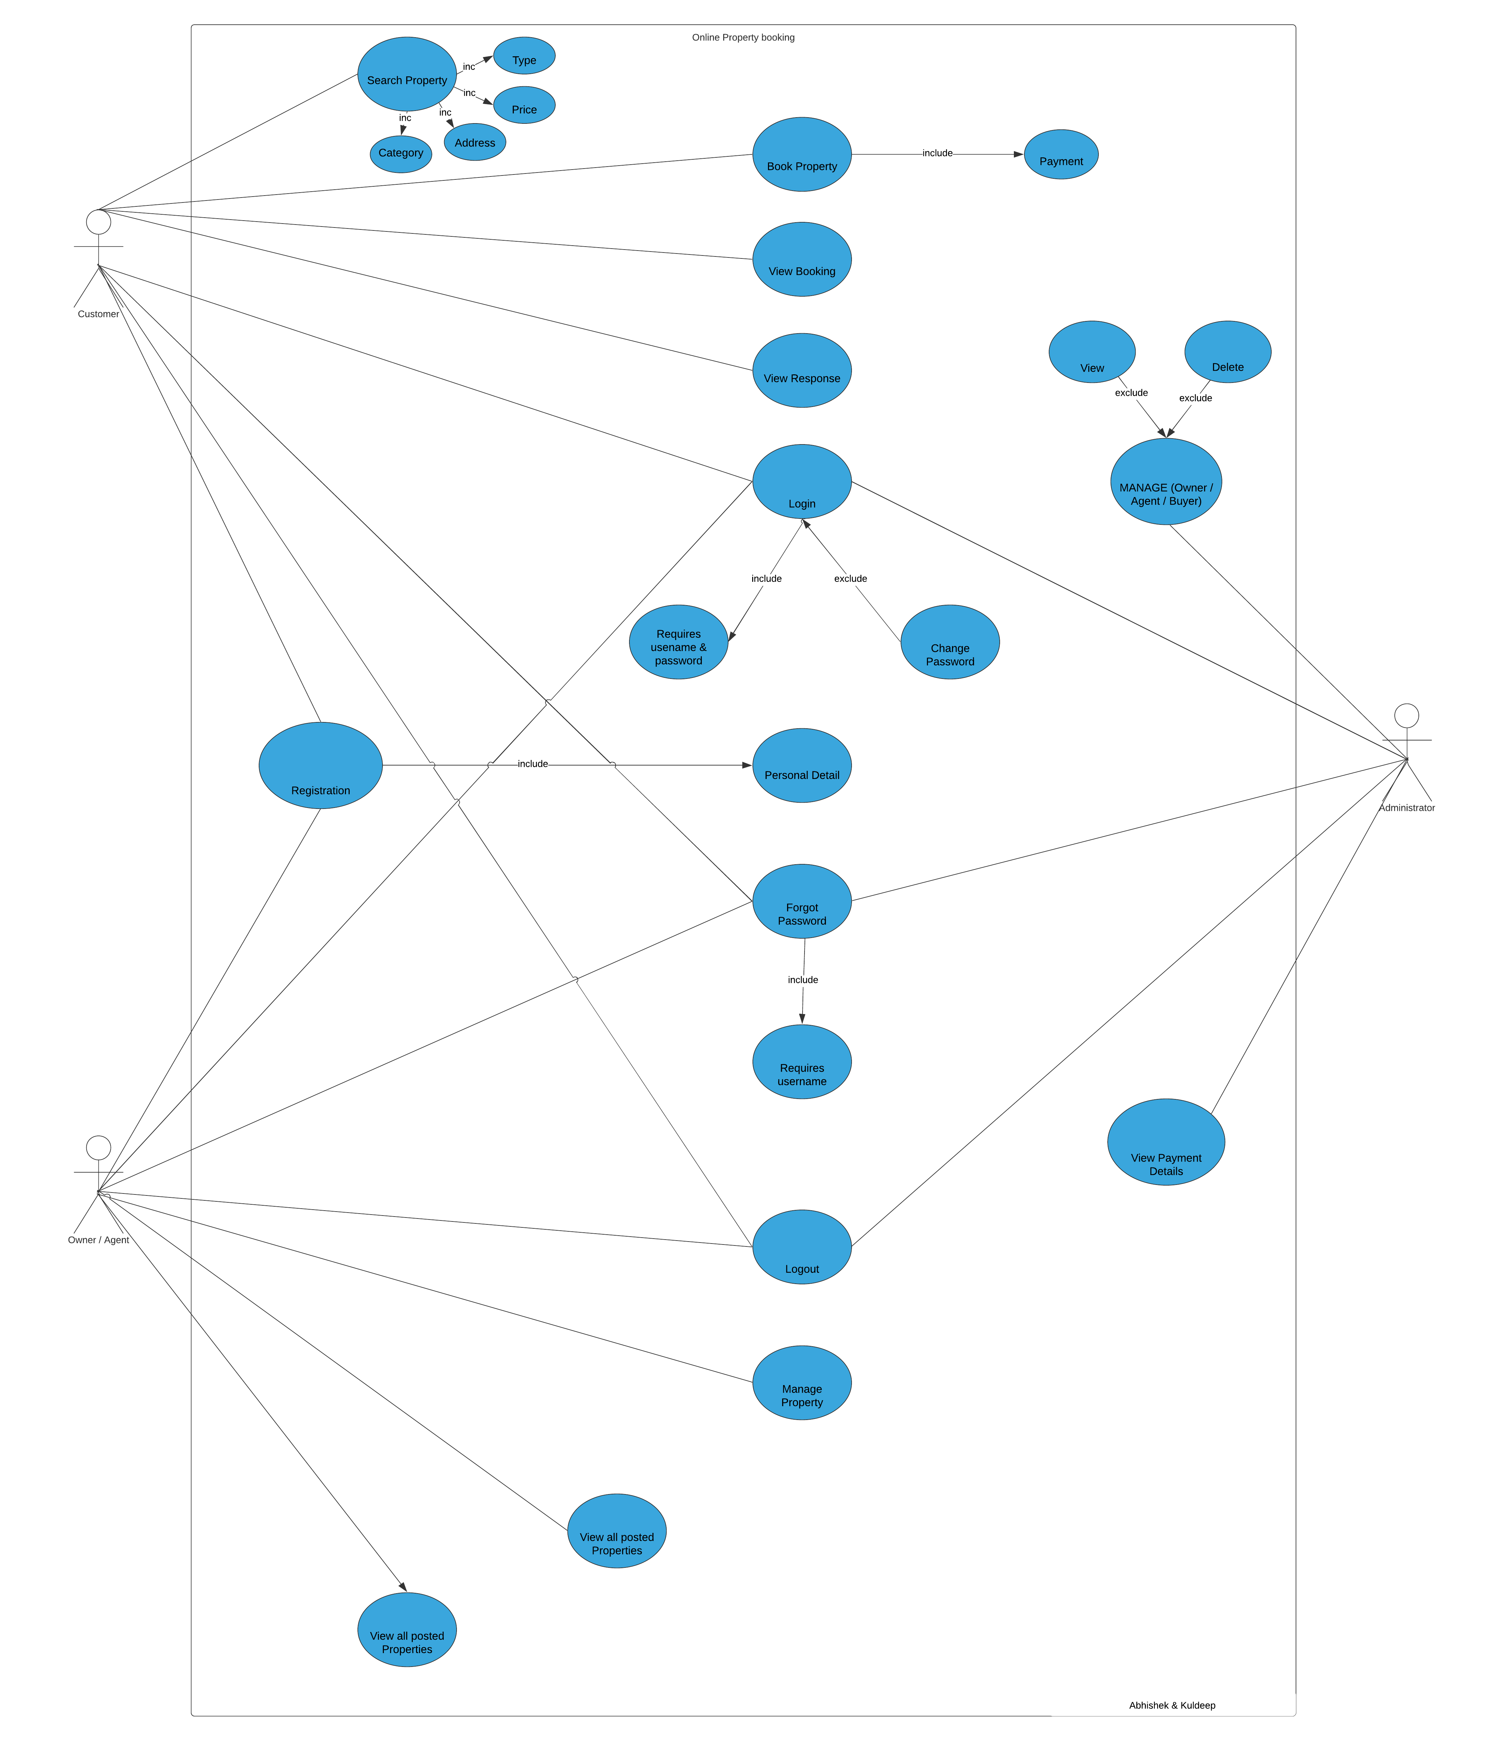**3.2 Use Case Diagram**

**3.4 Test Procedure and Implementation**

**Testing**

Testing plays a vital role in the success of the system. System testing makes a logical assumption that if all parts of the system are correct, the goal will be successfully achieved. Once program code has been developed, testing begins. The testing process focuses on the logical internals of the software, ensuring that all statements have been tested, and on the functional externals, that is conducted tests to uncover errors and ensure that defined input will produce actual results that agree with required results.

**Objective of Testing**

* Testing is a process of executing a program with the intent of finding the error.
* A good test case is one that has a high probability of finding on unpredictable error.
* A successful test is one that provides solution for unpredictable error.
* The Minimum aim of testing process is to identify all defects existing in software product. Software product testing accomplishes a variety of things, but most importantly it measures the quality of the software that is developed. This view presupposes that there as defects in the software waiting to be discovered and this view is rarely disproves or even dispute.

**Testing Plan**

* Functions of the system.
* Response criteria
* Volume constraints (no. of users)
* Stability criteria (24 hour)
* Database responses (flushing, cleaning)
* Network criteria (network traffic)
* Compatibility (Environment & Browsers)
* User Interface / Friendliness criteria
* Modularity (ability to easily interface)
* Security

**Testing Strategy**

* As each module is developed it is tested and if found faultless is integrated in main module.
* If the module is not perfect it is built again.
* Each test plan item should have the following specific characteristics:
* It should be uniquely identifiable.
* It should be unambiguous.
* It should have well-defined test-data (test parameters)
* It should have well-defined pass/fail criteria for each sub-item and overall-criteria for the pass/fail of the entire test itself.
* It should be easy to record.
* It should be easy to demonstrate repeatedly
* To prepare test plans.
* To specify conditions for user acceptance testing.
* To prepare test data for transaction path testing.
* To plan user training.

**Testing Methodology**

To be truly robust, distributed applications require more than simple functional testing before release into production. At least one and preferably all of the following types of testing before releasing application to customers should be performed.

* + Performance Testing
  + Load Testing
  + Stress Testing
  + Endurance Testing

**Testing Procedure**

The testing part forms an important aspect of any System and is vital for success of the system. System testing makes a logical assumption that if all the parts of the system are correct, the goal will be successfully achieved. Philosophy behind testing the system is to find errors & rectify it. The system test change is transitional one, as it represents the period during which control of the newly developed system passes from the hands of the development team to final users. It is therefore a critical point as it is the last opportunity to check the system before it is being used. The testing stage seeks to ensure following aspects of system from user point of view:

* + Completeness
  + Correctness
  + Reliability

Thus a testing plan is necessary, as it will aid to maximize the effectiveness of discovering error by early & controlled production of test plans & test specification.

**User Manual**

**4.1 User Manual**

User manual is guide for using the online property booking system following or the steps for user to excess the site.

First users see the home page of the sites which gives the site

Description there is Registration link for new user. The existing system

Includes following users:

* Admin
* Individual Buyer
* Individual Property Owner
* Agent

All these above user have to perform the various tasks when they log on to home page of the web application. There are link for property, post, search properties. If the user want to register directly click on register link to proceed ahead. After clicking registration link new window open showing forms which must filled by user which contain general information of user. After clicking on submit button all data will be stored in the database. On successful registration welcome window will come.

After log in user will see a welcome screen where user can edit profile

Or can sign-out. User can also upload property and search agent,

Property owner, and change password.

**4.1 Menu Explanation**

**ADMINISTRATOR**

* Change Password: Admin can Change Password on clicking respected link.
* Manage Property: Admin performs different operations on property.

This menu is divided into 3 sub menus.

* + Approve/Reject property: Admin verifies the properties and then he can approve/Reject property posting requests.
  + Property Type: Admin can add/update/ delete property types.
  + Property Category: Admin can add/update/delete property categories.
* Manage Property Owner: Admin can view and delete the property owner.
* Manage Agent: Admin can view and delete the Agent.
* Manage Buyer: Admin can view and delete the Buyer.
* View Requirement: Admin can view all the requirements which are posted by the buyer.

**AGENT / OWNER**

* Change Password: Admin can Change Password on clicking respected link.
* Manage Owner: This menu is divided into 3 sub categories.
  + Owner Registration: Owner registration is done by the agent.
  + View Registered Owner: View all the registered owner by the agent.
  + View Registered Property: View all property registered by the agent.
* Manage property :
  + Post Property
    - Post property by the agent.
  + Edit/Delete Property
    - Agent can edit/delete the property.
* Search Property Owner: Searching of property owner can be done here.
* Search Buyer: Searching of Buyer can be done over here.
* Update profile: Agent can make changes in his profile.

**BUYER**

* Change password: Buyer can change password on clicking respected link.
* Search property Owner: Buyer can search property owner on clicking this link.
* Search/Book Property: Buyer can search property. If property is found in respected location then he/she can book the property.
* Booked History: Buyer can view all booked property by him/her.
* Search Agent: Searching of Agent is done over here.
* Manage Requirement:
  + Post Requirement
    - If property is not found during the searching in respected location then Buyer can post his requirement to the admin.
  + View all Requirements
    - Buyer can view all the requirements which are posted by him.
* View Response : Buyer can view the response which is sent by the admin.
* Update Profile : Buyer can make changes in his profile.

**Drawbacks and Limitations**

There are few limitations in this web application which are following:

* + - Property is displayed for the limited number of days.
    - Maps are not provided for the convenience of the user.
    - It doesn’t cover the international market.
    - Advance search facility is available for only registered user.
    - Only few cities property can be uploaded.
    - It doesn’t have online agreement facility.

**Conclusions**

Working on the project was good experience. I understand the importance of Planning and Designing as a part of software development. But it’s very difficult to complete the program in such a short period of time.

Developing the project has helped us get alot of experience on real- time development procedures.

**Bibliography**

* Learning Django web development 2015
  + -By Ratan kumar
  + -Sanjeev jaiswal
* SQL Server 2005
  + -By Wrox
* The Definitive Guide to SQLite
  + -By Michael Qwens
* Software Engineering a Practitioner’s Approach
  + -By Roger S. Pressman
* Object Oriented Analysis & Design
  + -By Rambaugh
* [http://www.99acres.com](http://www.99acres.com/)
* [http://www.zameen-zaidad.com](http://www.zameen-zaidad.com/)