DOCKERIZING APPLICATION – BUILD & RUN

1. **docker build -t ec2-user/web:v1 .**

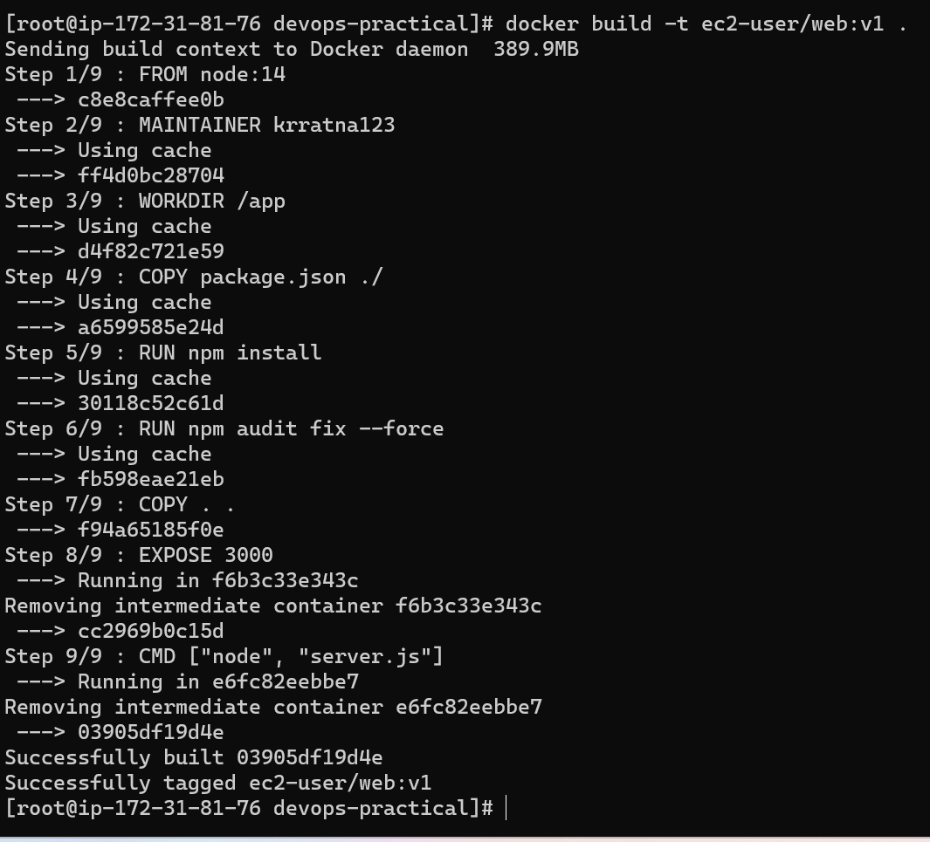

1. **docker run -d -p 3000:3000 ec2-user/web:v1**



1. **docker ps || docker ps -a**

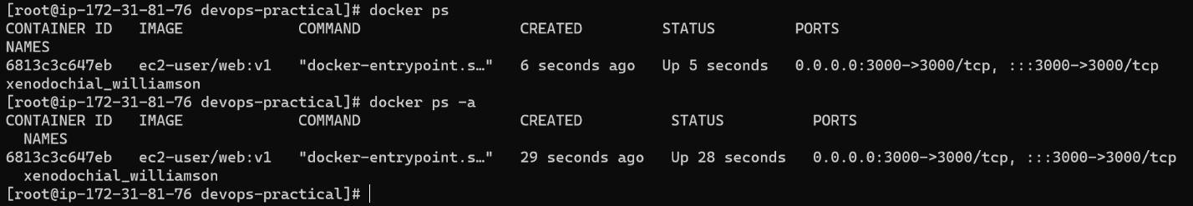

**CREATE MONGO CLUSTER:**

1. **docker run -d --rm -p 27017:27017 --name mongo1 --network mongoCluster mongo:5 mongod --replSet myReplicaSet --bind_ip localhost,mongo1**

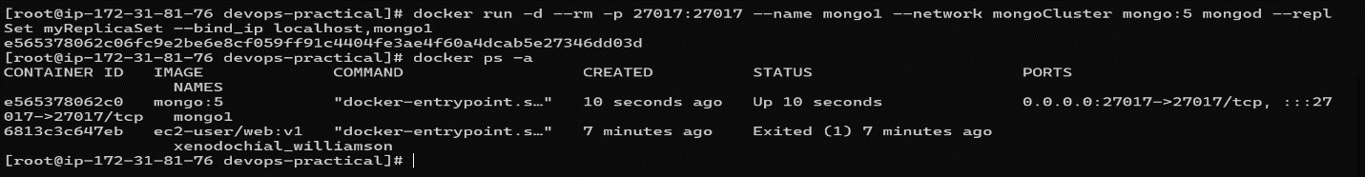

1. **Install Mongosh and connect**

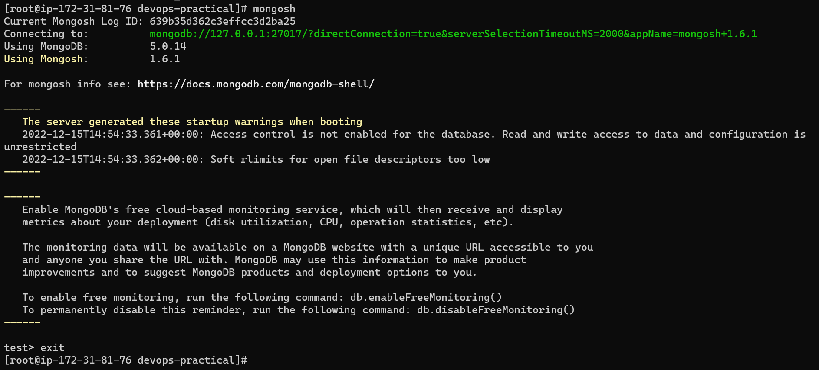

1. **docker exec -it mongo1 mongosh --eval "rs.initiate({ _id: \"myReplicaSet\", members: [ {_id: 0, host: \"mongo1\"}]})"**

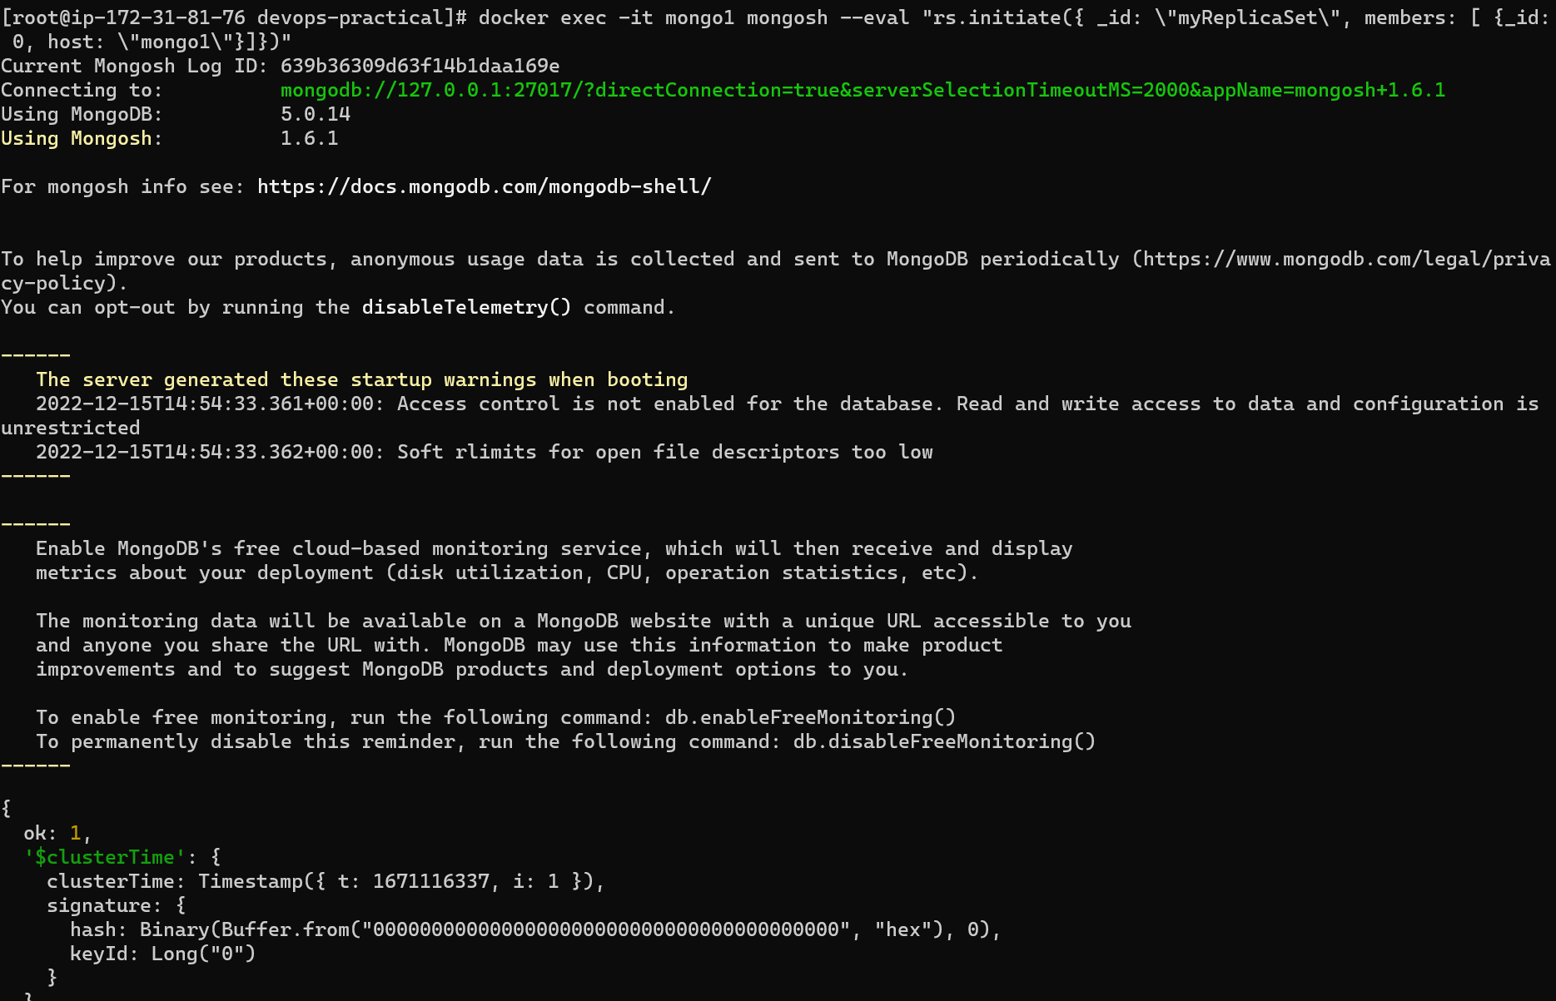

1. **docker exec -it mongo1 mongosh --eval "rs.status()"**

