**10.) weighted interval**

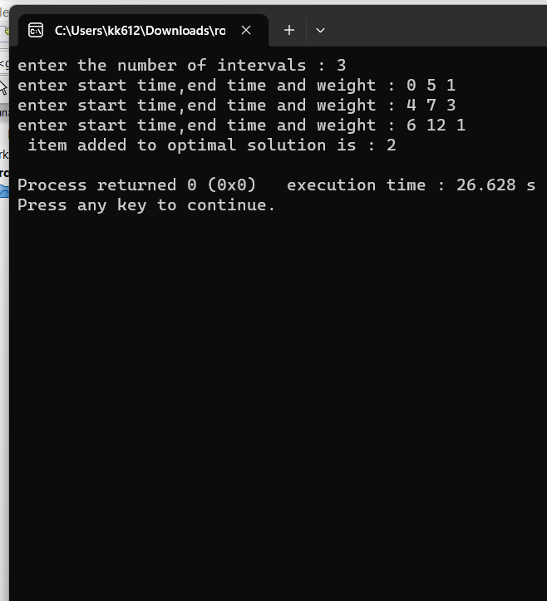

#include <iostream>

using namespace std;

class interval{

public:

int weight;

int start;

int finish;

int number;

interval(){

start =0;

finish = 0;

weight = 0;

number = 0;

}

void set_data(int s,int f,int w,int num){

start =s;

finish = f;

weight = w;

number = num;

}

};

int memoization(int j,int *m ,int size){

if(j=0){

return 0;

}else if(m[j] != 0){

return m[j];

}else{

}

}

int p(int i, int size,interval *interval_list){

for(int j=i-1;j>=0;j--){

if(interval_list[j].finish <= interval_list[i].start ){

return j;

}

}

return 0;

}

//complete iteration and memoization

void weighted_interval_scheduling(int size,interval *interval_list){

int *m = new int[size+1]; //to save the optimal answers

int *pp = new int[size+1]; //it stores the rest compatible intervals for every interval

for(int j=1;j<=size;j++){

pp[j] =p(j, size, interval_list);

m[j] = max(interval_list[j].weight + m[pp[j]] , m[j-1]);

}

for(int j=size;j>=1;){ //start from last

if( interval_list[j].weight+ m[pp[j]] >= m[j-1]){

cout<<" item added to optimal solution is : "<<j<<endl;

j = pp[j];

}else{

j--;

}

}

}

//only recursion

int weighted_interval_recursive(int size,interval *interval_list,int n){

int *pp = new int[size+1]; //it stores the rest compatible intervals for every interval

for(int j=1;j<=size;j++){

pp[j] =p(j, size, interval_list);

}

if(n==0){

return 0;

}

return max( interval_list[n].weight + weighted_interval_recursive(size,interval_list,pp[n]),weighted_interval_recursive(size,interval_list,n-1));

}

//recursion + memoization

int mm[100];

int weighted_interval_recursive(int size,interval *interval_list,int n, int *pp){

if(n==0){

return 0;

}

if(mm[n]==-1)

return mm[n] = max( interval_list[n].weight + weighted_interval_recursive(size,interval_list,pp[n],pp),weighted_interval_recursive(size,interval_list,n-1,pp));

else

return mm[n];

}

int main()

{

int size =0;

cout<<"enter the number of intervals : ";

cin>>size;

interval *interval_list = new interval[size+1];

for(int i=1;i<=size;i++){

cout<<"enter start time,end time and finish time : ";

int s=0,f=0,w=0;

cin>>s>>f>>w;

interval_list[i].set_data(s,f,w,1);

}

weighted_interval_scheduling(size,interval_list);

/* int *pp = new int[size+1]; //it stores the rest compatible intervals for every interval

for(int j=1;j<=size;j++){

pp[j] =p(j, size, interval_list);

}

for(int i=0;i<50;i++){

mm[i] =-1;

}

cout<<"RESULT : "<<weighted_interval_recursive(size,interval_list,size,pp);

*/

return 0;

}