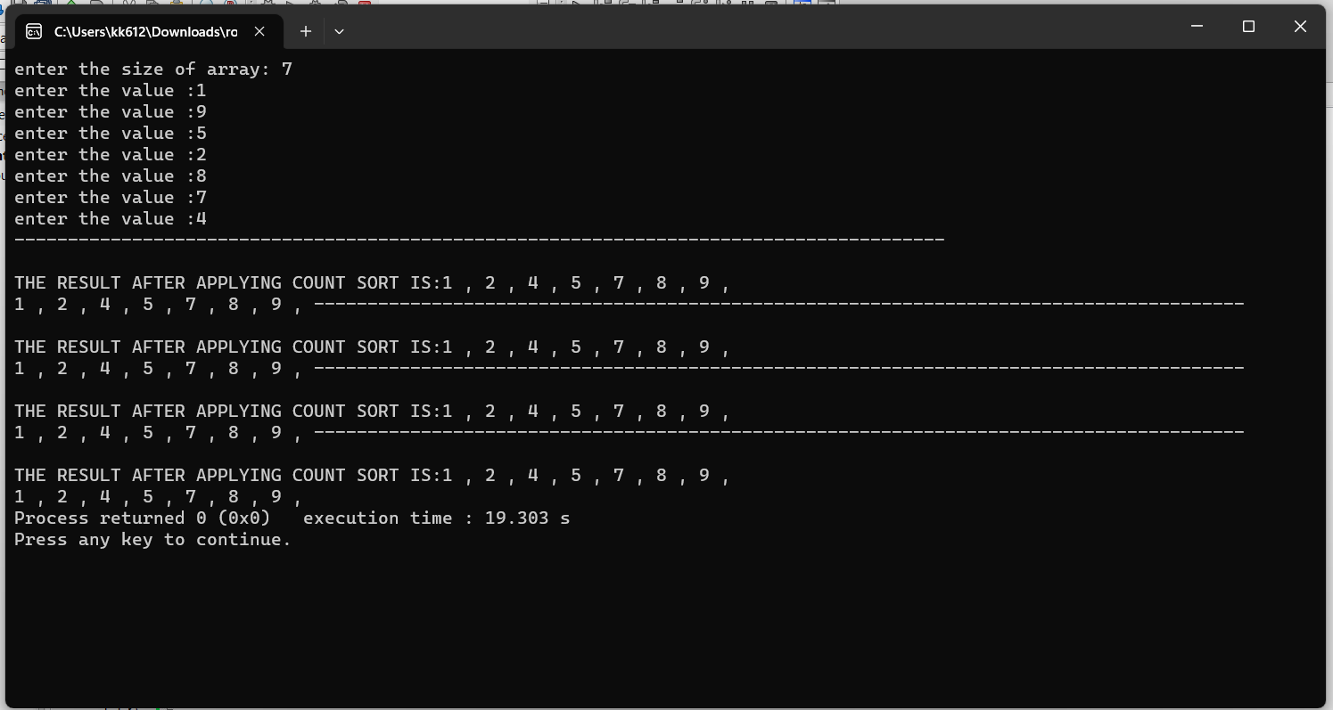

**4.RADIX SORT**

#include <iostream>

using namespace std;

//count sort

int getDigitAtIndex(int num,int i){

if(i==1){

return num%10;

}

return getDigitAtIndex(num/10,i-1);

}

void countsort(int *A,int s,int *B,int *c,int index){ //index is 1 2 3 4 for 1000

int *temp = new int[s];

for(int i=0;i<s;i++){

temp[i] = getDigitAtIndex(A[i],index); // 9 9 0 4 5 7 4 9 9 6 7 8 3 4 5

}

for(int j=0;j<s;j++){

c[temp[j]] = c[temp[j]] + 1;// A[j] is element value which is passed as index in C

// so that at same index its frequency is saved

}

for(int i=1;i<10;i++){

c[i] =c[i]+c[i-1]; // converting array c into cumulative frequency

}

cout<<"---------------------------------------------------------------------------------------"<<endl;

for(int j= s-1 ;j>=0;j--){

B[c[temp[j]]-1]=A[j]; //A[j] is the value at the last index in original array

c[temp[j]] =c[temp[j]]-1; // c [ A [j] ] is the cumalative value --> how many elements are behind it

} // B [ c [ A [j] ] ] is the correct index of the value A[j]

//than decreasing c [ A [j] ] by 1

cout<<endl;

cout<<"THE RESULT AFTER APPLYING COUNT SORT IS:";

for(int i=0;i<s;i++){

A[i] = B[i];

cout<<B[i]<<" , ";

}

}

void radixSort(int *arr,int size){

//now count the unit's digit

//also pass the max digit -> for 1000 --> 4

for(int i =1 ;i<=4;i++){

int *c=new int[10]; //for numbers 0 , 1 ,2 ,3 , 4, 5, 6, 7, 8, 9,

int *B = new int[size];

for(int i=0;i<10;i++){

c[i]=0;

}

countsort(arr,size,B,c,i); //i is the index

cout<<endl;

for(int j=0;j<size;j++){

cout<<arr[j]<<" , ";

}

}

}

int main(){

int siz;

cout<<"enter the size of array: ";

cin>>siz;

int *arr = new int[siz];

for(int i=0;i<siz;i++){

cout<<"enter the value :";

cin>>arr[i];

}

radixSort(arr,siz);

// example --> 456

// --> 980

// --> 567

// --> 967

//start from unit digit

// than go to the tenth

// than hundred

//in subroutine use count sort to sort

return 0;

}